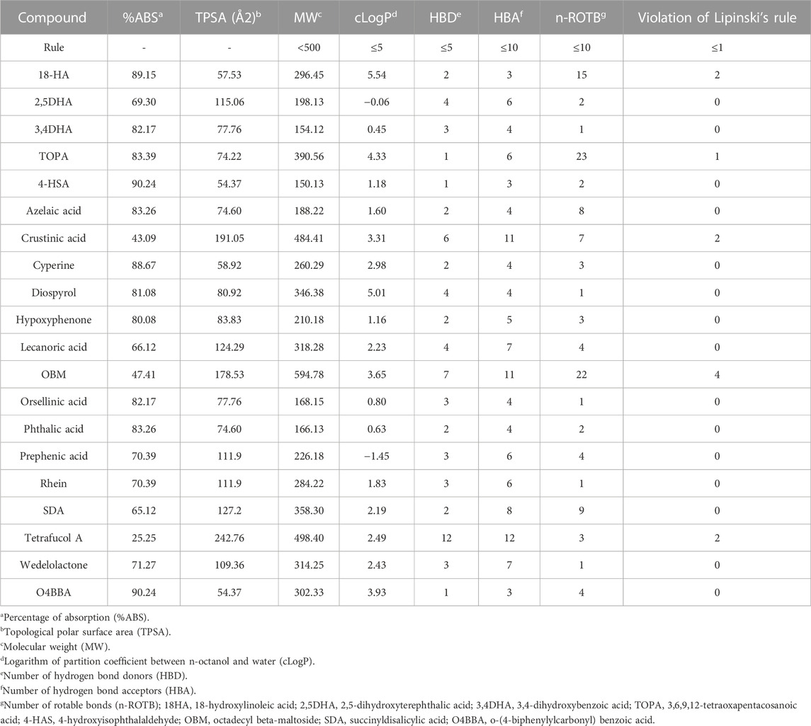
Table 1- Pharmacology properties obtained lichens based on Lipinski’s rule.

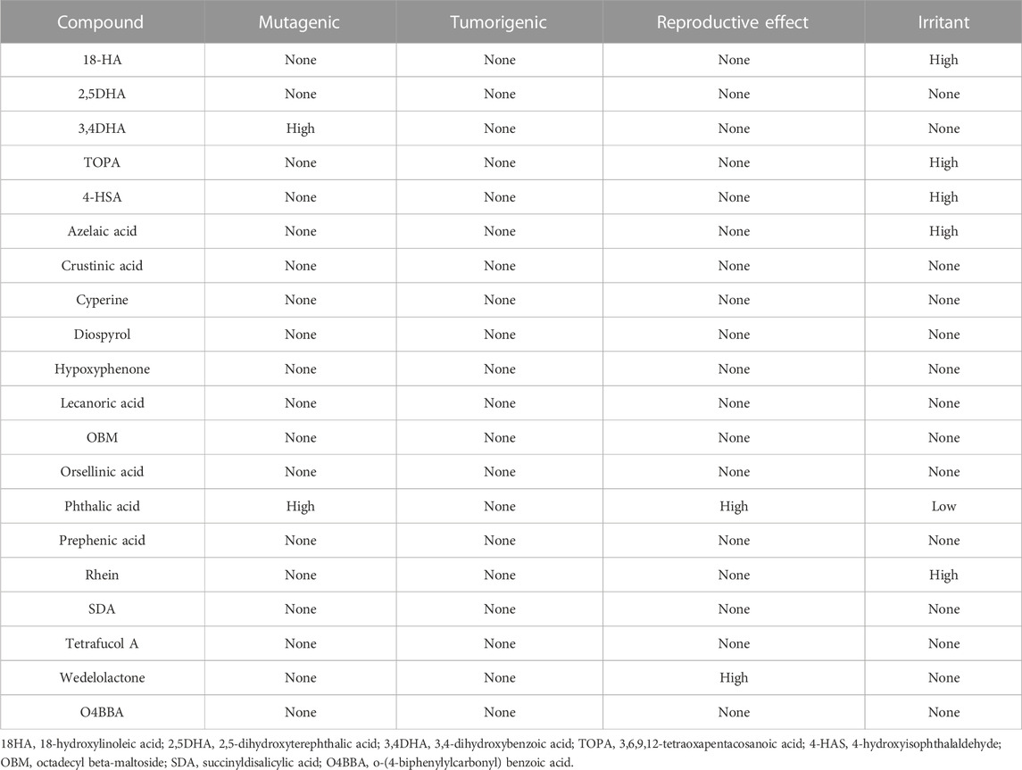
Table 2 -Toxicity risk of the phytochemicals obtained
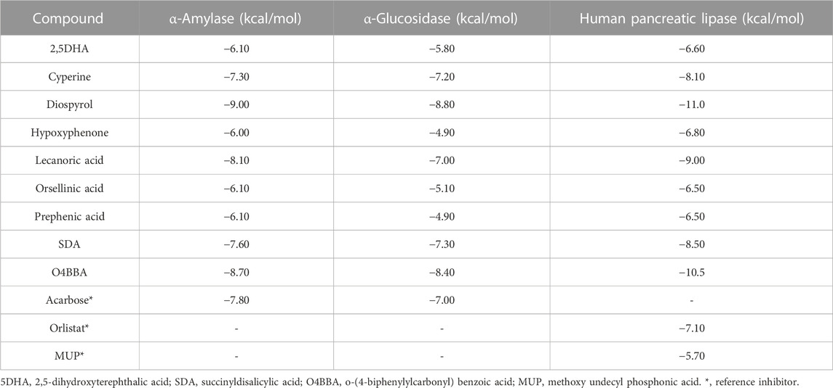

Table 3 Binding affinities of lichen compounds with α-amylase, α-glucosidase, and pancreatic lipase.

