Supplementary Materials for
Structure of human sodium leak channel NALCN in complex with FAM155A
Jiongfang Xie, Meng Ke, Lizhen Xu, Shiyi Lin, Jin Huang, Jiabei Zhang, Fan Yang∗, Jianping Wu∗, and Zhen Yan∗

∗To whom correspondence should be addressed: Z. Yan (yanzhen@westlake.edu.cn), J. Wu (wujianping@westlake.edu.cn) or F. Yang (fanyanga@zju.edu.cn)

This file includes:
Supplementary Tables 1-3
Supplementary Figs. 1-10
Legend for supplementary movie 1

Supplementary Table 1. Data collection and model statistics
Data collection
EM equipment | Titan Krios
Voltage (kV) | 300
Detector | Gatan K3
Energy filter | Gatan GIF Quantum, 20 eV slit
Pixel size (Å) | 1.087
Electron dose (e⁻/Å²) | 50
Defocus range (μm) | -0.5~-2.5
Data set | NALCN-FAM155A complex
Number of images | 17,922
Reconstruction
Software | RELION 3.0 / CryoSPARC v2
Number of used Particles | 65,177
Symmetry | C1
Final Resolution (Å) | 3.1
Map sharpening B-factor (Å²) | -86.5
Model building and refinement
Model building software | Coot
Refinement software | Phenix
Model composition
Protein residues | 1,477
Side chains | 1,463
Sugar | 7
Lipid | 2
Validation
R.m.s deviations
Bonds length (Å) | 0.004
Bonds Angle (˚) | 1.287
Ramachandran plot statistics (%)
Preferred | 89.3
Allowed | 10.7
Outlier | 0.0

Supplementary Table 2. Summary of contact interfaces between NALCN and FAM155A
NALCN | Residue | FAM155A | Residue
ECL_{III} | W1085 (O) | H5 | Y308
ECL_{III} | W1085 | H3 | E281
ECL_{III} | R1062 | H3 | E281
ECL_{I} | I224 (N) | H3 | K288 (O)
ECL_{III} | R1054 | L2 | E366
ECL_{III} | W1090 (O) | L2 | L364 (N)
ECL_{III} | D1099 | L2 | Y365
ECL_{III} | N1047 | L2 | Y353
ECL_{III} | N1064 (O) | L2 | D347 (N)
ECL_{III} | K1069 | L2 | D347
ECL_{III} | K1069 | L2 | N348 (O)
ECL_{III} | NAG (O3) | L2 | E350
P2_{III} | R1127 | L2 | I352 (O)
ECL_{III} | R1094 (N) | L2 | G354 (O)
ECL_{IV} | P1403 (O) | H6 | T339
ECL_{III} | D1048 | L1 | K298
ECL_{IV} | A1414 (O) | L1 | K298
ECL_{IV} | D1416 | L1 | S296
ECL_{IV} | Y1362 (N) | L1 | Y295 (O)
ECL_{IV} | R1368 | L1 | Q291
ECL_{IV} | K1361 | H6 | C341 (O)
ECL: Extracellular loop

Supplementary Table 3 Disease related mutations on human NALCN.
Protein | Mutations | Diseases | Structural Mapping | Reference
hNALCN | R43Q | EBD | S1_{I} | (1)
hNALCN | W107* | IHPRF1 | S3 _{I} | (2)
hNALCN | Q177P | CLIFAHDD | S5_{I} | (3)
hNALCN | W179* | IHPRF1 | Gene shift | (2)
hNALCN | L312I | CLIFAHDD | S6_{I} | (3)
hNALCN | L312V | NDH | S6_{I} | (1)
hNALCN | V313G | CLIFAHDD | S6_{I} | (3)
hNALCN | F317C | DACH | S6_{I} | (4)
hNALCN | E327K | CLIFAHDD | S6_{I} | (3)
hNALCN | Y497T | ARSSHSICD | S4-S5_{II} | (5)
hNALCN | L509S | CLIFAHDD | S5_{II} | (3)
hNALCN | F512V | CLIFAHDD | S5_{II} | (3)
hNALCN | T513N | CLIFAHDD | S5_{II} | (3)
hNALCN | Y578S | CLIFAHDD | S5_{II} | (3)
hNALCN | L590F | CLIFAHDD | S6_{II} | (3)
hNALCN | V595F | DACH | S6_{II} | (4)
hNALCN | Q642* | INAD | II-III linker | (6)
hNALCN | C675L | IHPRF1 | II-III linker | (7)
hNALCN | E813G | IHPRF1 | II-III linker | (2)
hNALCN | Q877N | IHPRF1 | S0-S1 _{III} | (2)
hNALCN | V891S | IHPRF1 | S1 _{III} | (2)
hNALCN | I920L | IHPRF1 | S2 _{III} | (2)
hNALCN | V956-L963del | IHPRF1 | S3 _{III} | (2)
hNALCN | V1006A | CLIFAHDD | S4-S5_{III} | (3)
hNALCN | R1008W | IHPRF1 | S4-S5_{III} | (2)
hNALCN | I1017T | CLIFAHDD | S5_{III} | (3)
hNALCN | L1019F | IHPRF1 | S5_{III} | (2)
hNALCN | V1020F | NDH | S5_{III} | (1)
hNALCN | T1165P | CLIFAHDD | III-IV linker | (3)
hNALCN | R1181Q | NDH | III-IV linker | (1)
hNALCN | Q1186* | IHPRF1 | III-IV linker | (2)
hNALCN | W1287L | IHPRF1 | S3_{IV} | (5)
hNALCN | R1304X | PB | S4 _{IV} | (7)
hNALCN | R1384* | IHPRF1 | P1 _{IV} | (2)
hNALCN | F1427L | IHPRF1 | S6 _{IV} | (2)
hNALCN | I1445L | IHPRF1 | S6 _{IV} | (2)
hNALCN | I1446M | CLIFAHDD | S6 _{IV} | (3)
hNALCN | 1489ΔT | IHPRF1 | Gene shift | (5)

Note：* represents premature translational termination
CLIFAHDD: Congenital contractures of the limbs and face, hypotonia, and developmental delay; EBD: Exaggerated body dends; IHPRF1: Hypotonia, infantile, with psychomotor retardation and characteristic facies 1; DACH: Distal arthrogryposis and central hypertonia; NDH: Neurodevelopmental Disease and Hypotonia; PB: Periodic breathing; ARSSHSICD: Autosomal recessive syndrome with severe hypotonia, speech impairment, and cognitive delay; INAD: Infantile neuroaxonal dystrophy

Supplemental Figures and Legends
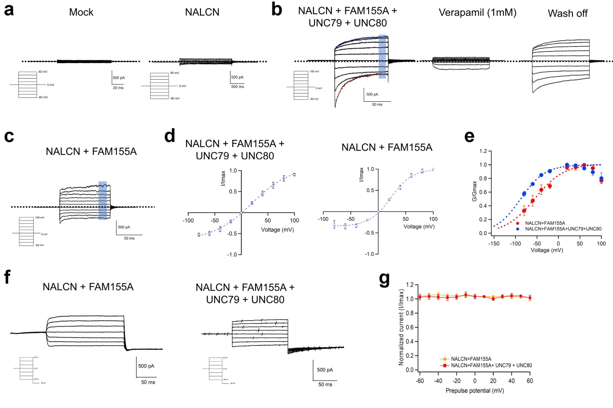
Supplementary Fig. 1. Electrophysiological properties of NALCN characterized by patch-clamp recordings. (a) Representative whole-cell recordings of HEK293 with mock transfection and NALCN channel transfected, respectively. Dashed line indicates the zero-current level. (b) Representative whole-cell recordings of NALCN, FAM155A, UNC79 and UNC80 co-expressed in HEK293 cells. Data points in shaded rectangle were averaged for plotting current-voltage curve in (d). Dashed line in black indicates the zero-current level. Dashed curves in red and blue are fitted curves to the inactivation and activation kinetics with exponential functions, respectively. NALCN current was inhibited by 1 mM verapamil and the current could be recovered after washing off. The same whole-cell patch was used during verapamil inhibition. (c) Representative whole-cell recordings of NALCN channel and FAM155A co-expressed in HEK293 cells. Data points in shaded rectangle were averaged for plotting current-voltage curve. (d) Current-voltage curve of NALCN co-expressed with FAM155A only (n = 6) and co-expressed with FAM155A, UNC79 and UNC80 (n = 7). The currents were normalized to the maximum current level. (e) Conductance-voltage (G-V) curves of NALCN co-expressed with FAM155A (Red: V_{1/2} = -44.66 ± 1.91 mV; apparent gating charge (Z_{app}) = 1.22 ± 0.18 e₀ ) and co-expressed with FAM155A, UNC79 and UNC80 (Blue: V_{1/2} = -65.07 ± 2.11 mV; apparent gating charge (Z_{app}) = 1.25 ± 0.55 e₀ ). G-V curves were fitted to a single-Boltzmann function (equation (1) in Methods, dash curves). Co-expression with FAM155A, UNC79 and UNC80 shifted the G-V curve of NALCN channel towards the hyperpolarization voltage. All data are given as mean ± s.e.m. (f) Representative whole-cell recordings of the steady-state inactivation of NALCN co-expressed with FAM155A (left) or with FAM155A, UNC79 and UNC80 (right). (g) Prepulse voltage dependence of steady-state inactivation of NALCN channel co-expressed with auxiliary subunits measured from -80 mV (n = 7).

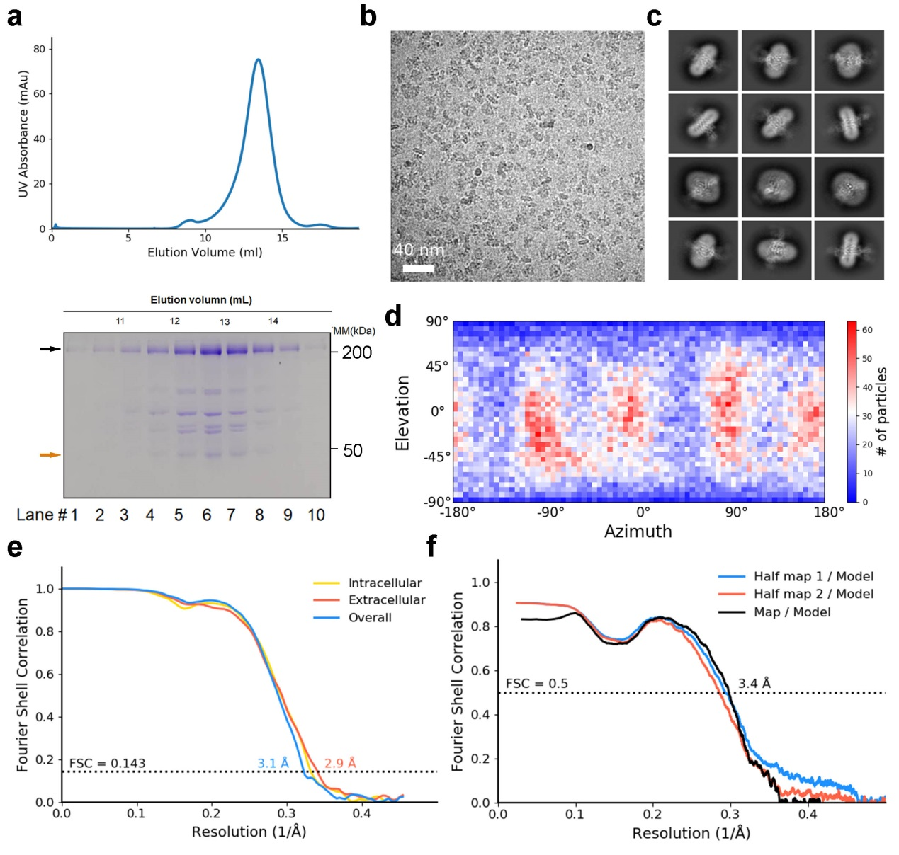

Supplementary Fig. 2. Cryo-EM analysis of human NALCN in complex with FAM155A. (a) Last step purification of recombinantly expressed NALCN-FAM155A complex. A representative chromatogram of gel filtration purification is shown. The indicated fractions were resolved by SDS-polyacrylamide gel electrophoresis followed by Coomassie blue staining. The bands corresponding to NALCN and FAM155A are indicated by black and orange arrows, respectively. The protein identity of each band was confirmed by mass spectrometric analysis. (b) Representative micrograph of the NALCN-FAM155A complex. Scale bar, 40 nm. (c) Representative two-dimensional class averages for NALCN-FAM155A complex. Box size: 240 Å; circle mask: 220 Å. (d) Angular distribution of the particles of the final reconstruction generated by cryoSPARC. (e) Gold standard FSC curves for the 3D reconstructions. The curves for the reconstructions of the overall map, map of the intracellular region and map of the extracellular region are indicated by blue, yellow, and red lines, respectively. (f) Validation of the final structure models. FSC curves of the final refined model versus the corresponding map that it was refined against (black); of the model refined in the first of the two independent half maps used for the gold-standard Fourier shell correlation curves versus that same map (blue); and of the model refined in the first of the two independent maps versus the second independent map (red). The small difference between the blue and red curves indicates that the refinement of the atomic coordinates did not suffer from overfitting.

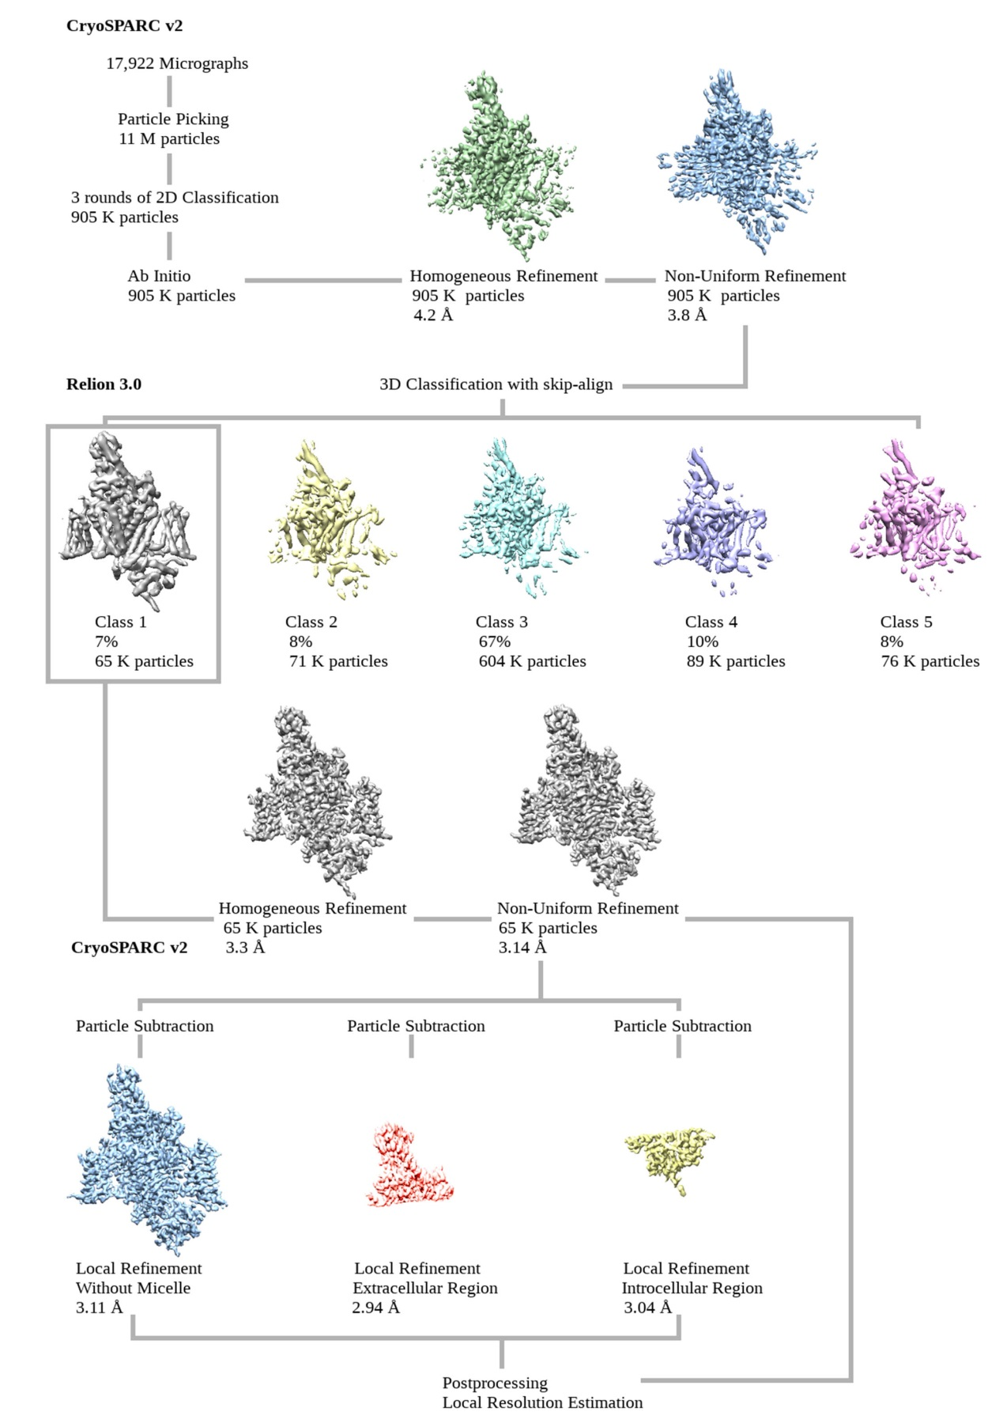
Supplementary Fig. 3. Flowchart for EM data processing. Please refer to “Image processing” session in Methods for details.

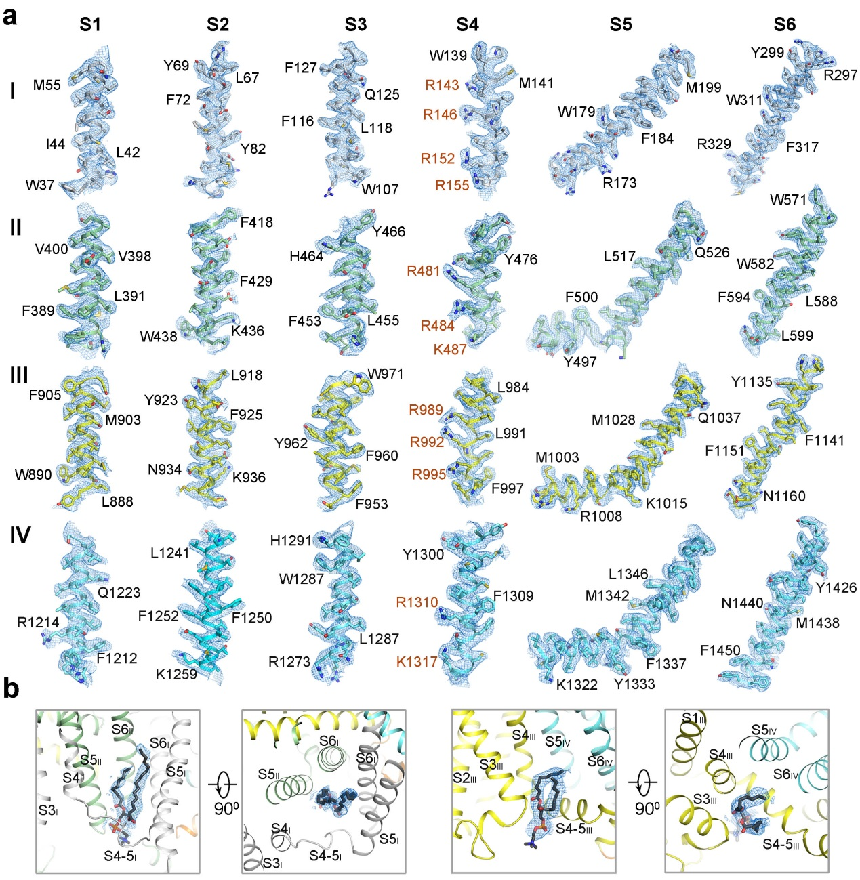
Supplementary Fig. 4. EM maps of human NALCN. (a) EM maps for the S1-S6 segments in the four repeats of NALCN. The side groups of representative bulky residues are labeled. The gating charges in S4 helices are highlighted in brown. The densities, shown as blue meshes, are contoured at 4-5 σ in PyMol. (b) EM maps for the two resolved lipid molecules that located in the inner side of the membrane. Two perpendicular views are shown for each lipid. The lipid densities are contoured at 3-4 σ in PyMol.

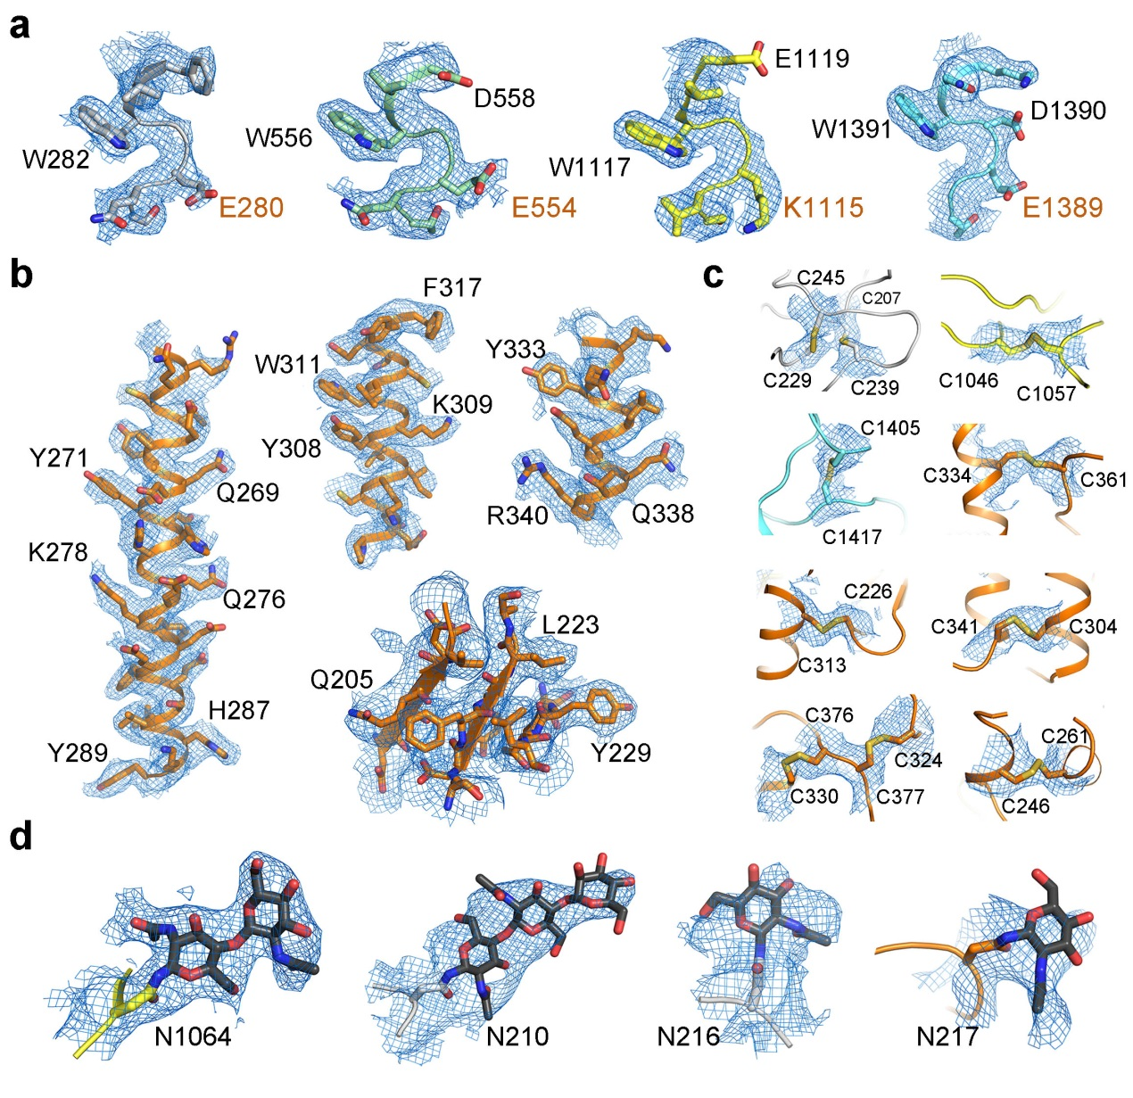
Supplementary Fig. 5. EM maps of NALCN-FAM155A complex. (a) All residues that constitute the SF in four repeats of NALCN are clearly resolved. The densities are contoured at 4-5 σ in PyMol. The EEKE residues are labeled orange. (b) Representative EM maps of FAM155A. The side groups of bulky residues are labeled. (c) EM maps of the disulfide bonds in the complex structure. The densities are contoured at 3-4 σ in PyMol. (d) EM maps of the sugar moieties in the glycosylation sites. The densities are contoured at 2-4 σ in PyMol.

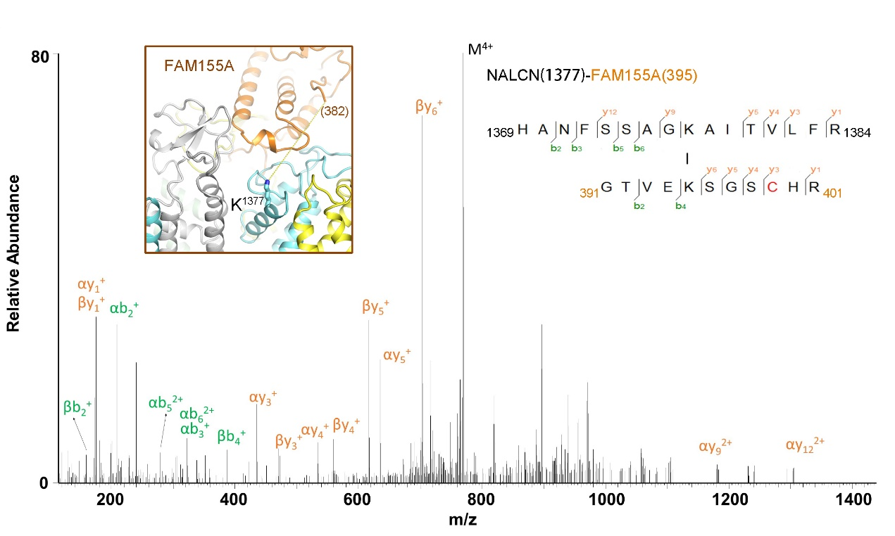
Supplementary Fig. 6. Mass Spectrometric analysis of crosslinked NALCN-FAM155A complex. Shown here is a high resolution HCD spectra of the inter-subunit crosslinked peptides from NALCN-FAM155A complex. The number shown in the brackets refer to the residue number in the indicated subunit. Inset: Structure of the NALCN-FAM155A interaction interface. K1377 of NALCN is shown in stick. The C-terminal residue in the resolved FAM155A structure is E382, which is about 27 Å from K1377 of NALCN. K395 of FAM155A, 13 residues after E382, is likely to be in the vicinity of cross-linking range with K1377 of NALCN. The cross-linking MS result is consistent with our structure observation.

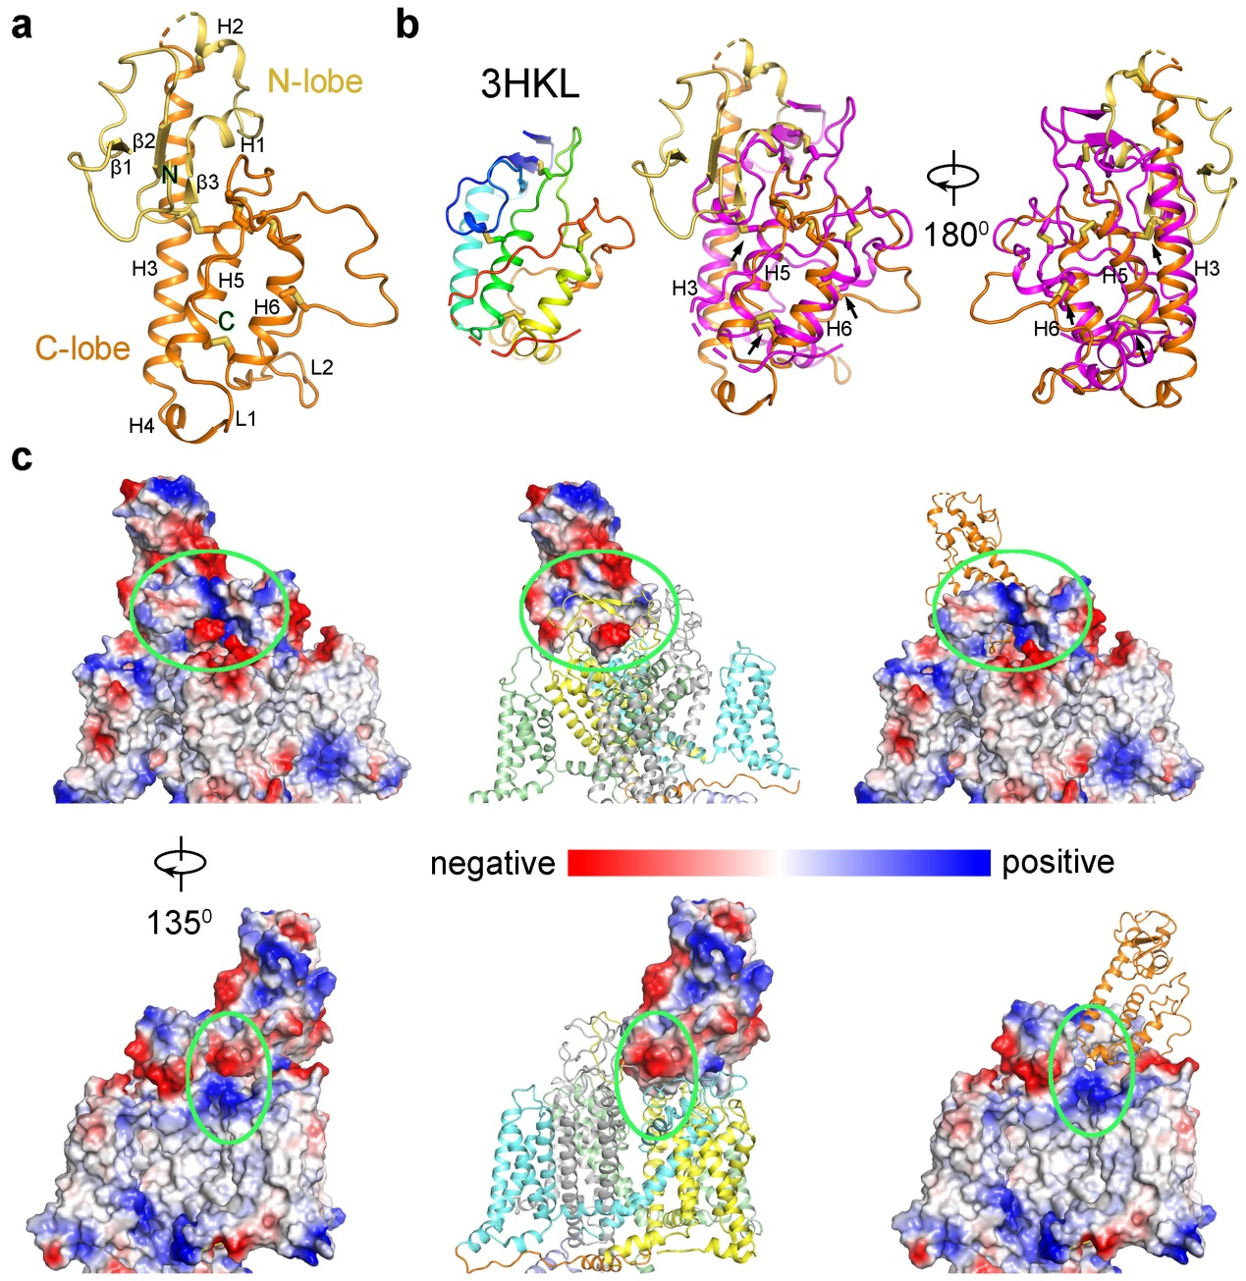
Supplementary Fig. 7. Interaction interfaces between NALCN and FAM155A. (a) Structure of the FAM155A. The N-lobe and C-lobe were colored in gold and orange, respectively. The secondary elements are labeled based on the definition in Figure 3. (b) Crystal structure of the CRD domain of MuSK and its superimposition with FAM155A. The conserved disulfide bonds between the two structures are highlighted by black arrows. (c) Electrostatic surface of the interaction interfaces between NALCN and FAM155A. The structures are shown with both subunits in electrostatic surface (left), with NALCN in cartoon and FAM155A in electrostatic surface (middle), or with FAM155A in cartoon and NALCN in electrostatic surface (right). Two side views are presented. The green circles highlight the interaction interfaces that have complementary electrical potential between NALCN and FAM155A.
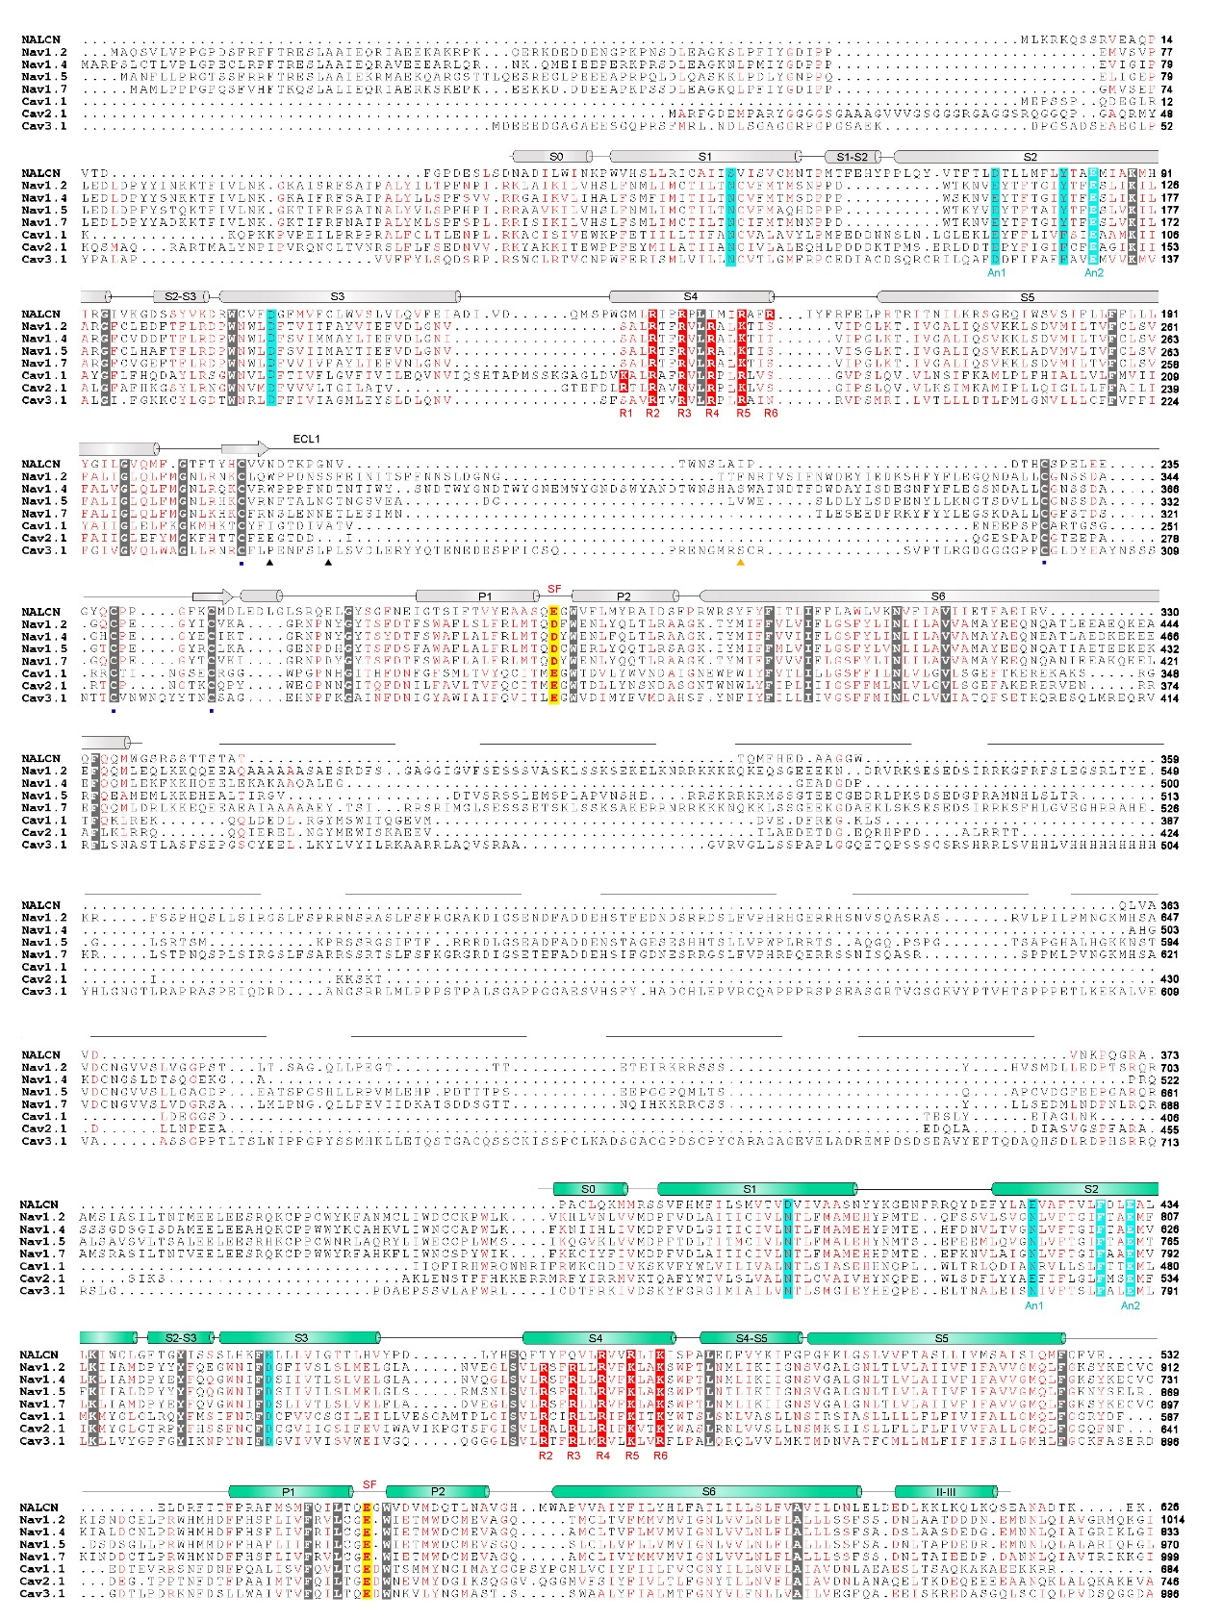
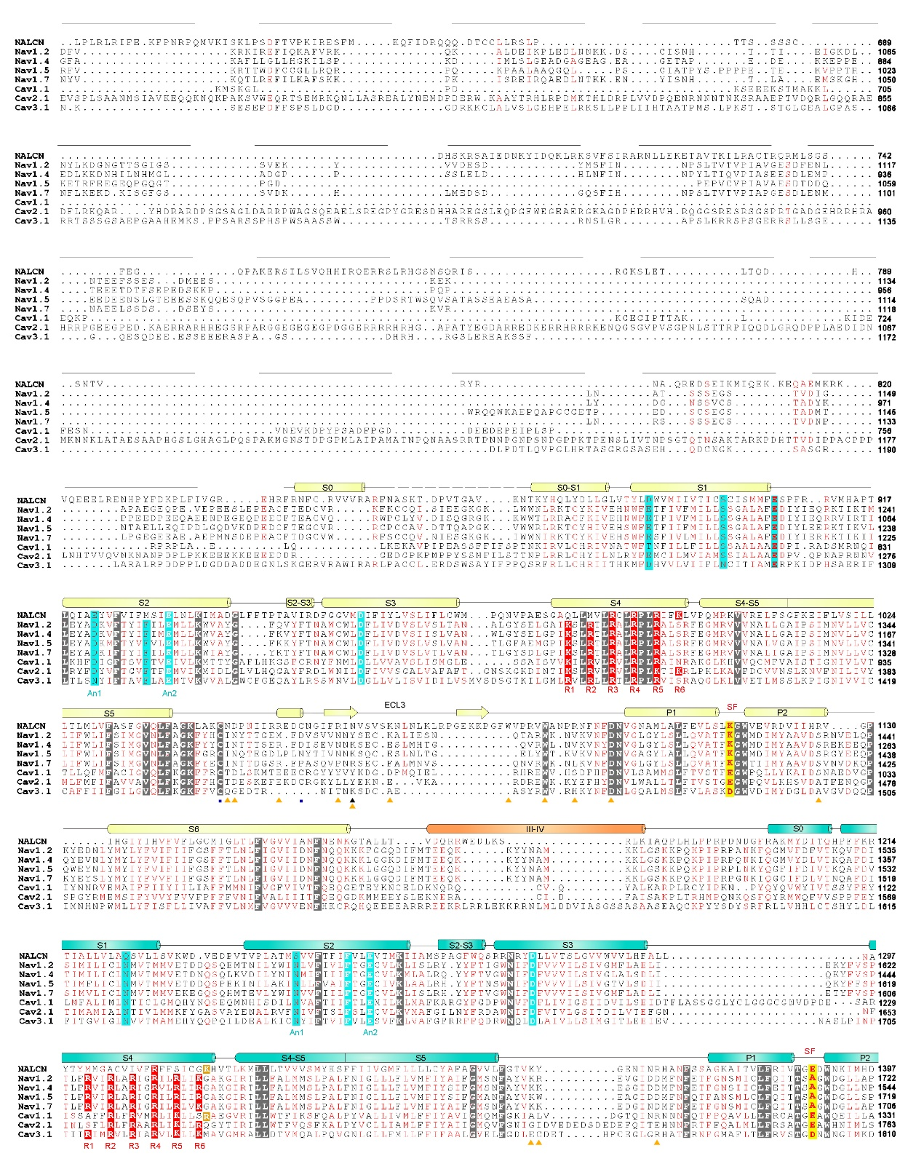
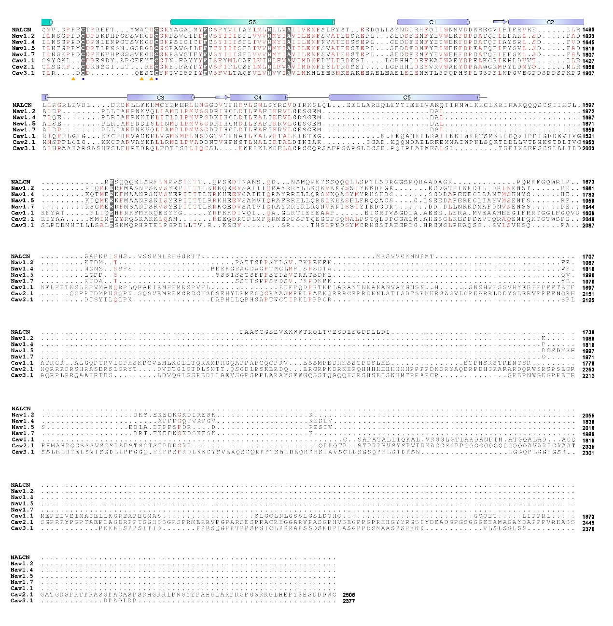
Supplementary Fig. 8 Sequence alignment among NALCN and selected Na_{v}/Ca_{v} channels.
The primary sequences of four human Na_{v} subtypes and three human Ca_{v} subtypes are compared with that of human NALCN using Clustal W (8). The invariant residues are shaded gray and the conserved residues are colored red. Secondary structural elements of human NALCN are presented above the sequence alignment and color-coded for each repeat. The critical EEKE residues in the selectivity filter are colored red and shaded yellow. The gating charge residues (labeled R1-R6) in each S4 segments are colored white and shaded red. The residues on S1-S3 that may facilitate the gating charge transfer, including the labeled An1 and An2 sites and the occluding residues on S2, are shaded cyan. The residues that form disulfide bonds are labeled with squares below the sequence alignment. The glycosylation sites are labeled with black triangles and the residues that mediate interaction with FAM155A are labeled with orange triangles. The Uniprot IDs for the aligned sequences are: hNALCN: Q8IZF0; hNa_{v}1.2:Q99250; hNa_{v}1.4:P35499; hNa_{v}1.5:Q14524; hNa_{v}1.7:Q15858; hCa_{v}1.1: Q13698; hCa_{v}2.1: O00555; hCa_{v}3.1: O43497.

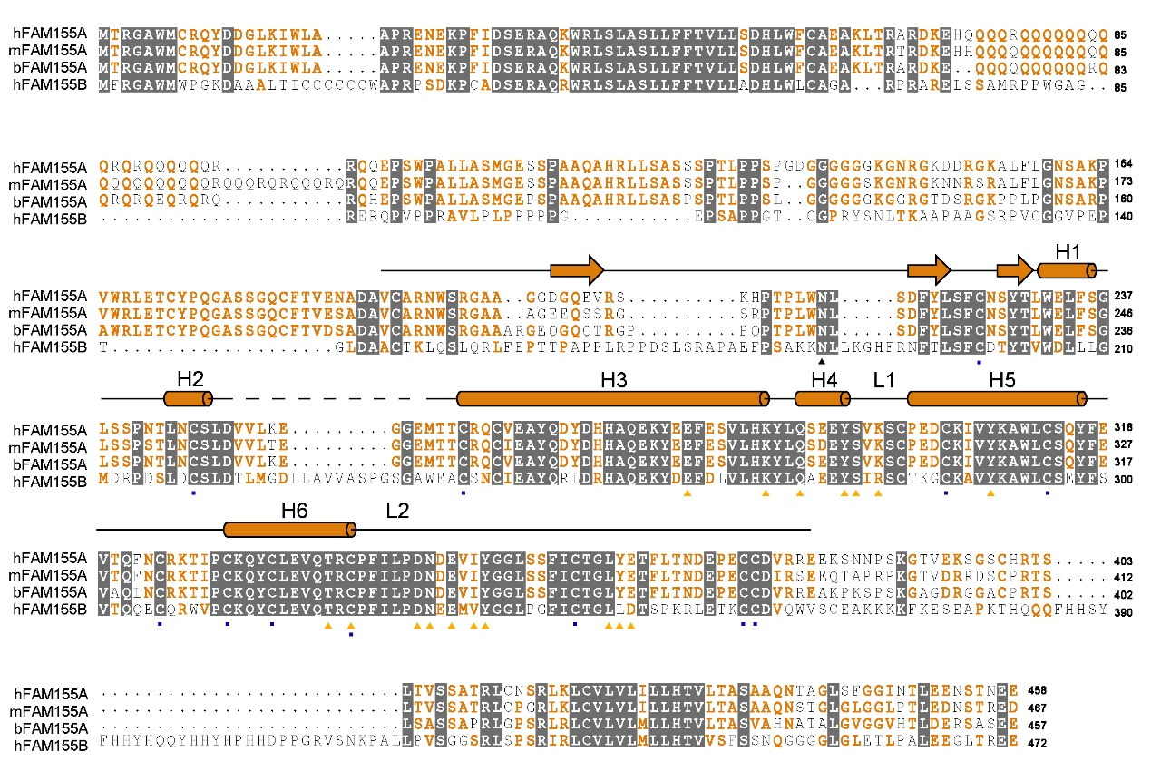
Supplementary Fig. 9. Sequence alignment of FAM155A. The primary sequences of FAM155A from human, mouse, and bovine and FAM155B from human are aligned using Clustal W. The invariant residues are colored white and shaded gray. The conserved residues are colored orange. The secondary structure elements of human FAM155A are indicated above the sequence alignment. The residues that form disulfide bonds are labeled with squares below the sequence alignment. The glycosylation site is labeled with black triangle and the residues that mediate interaction with NALCN are labeled with orange triangles. The Uniprot IDs for the aligned sequences are: hFAM155A: B1AL88, mFAM155A: Q8CCS2; bFAM155A: A4IFM1, hFMA155B:O75949.

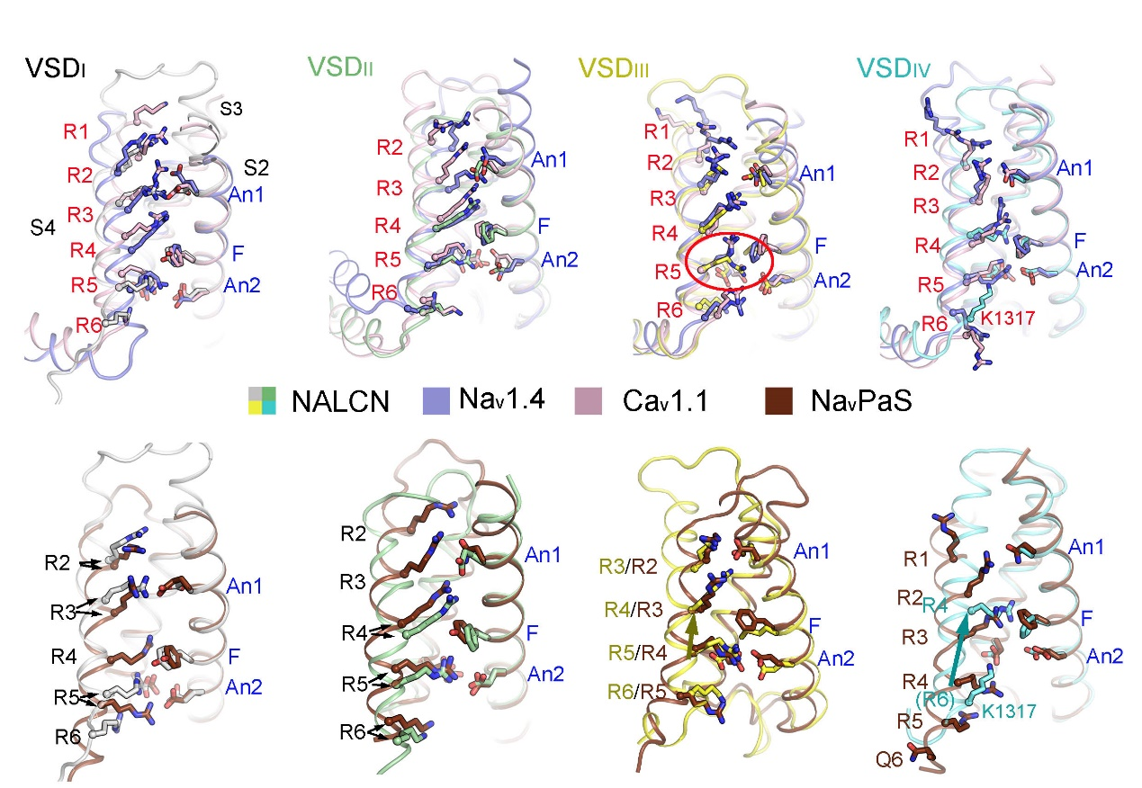
Supplementary Fig. 10. All four VSDs adopt up conformations. Each VSD of NALCN is superimposed with their counterpart in Na_{v}1.4 (PDB: 6AGF) and Ca_{v}1.1 (6JP5). The VSDs are aligned relative to CTC residues and An1 on S2 (labeled blue). S1 segments were omitted by visual clarity. The gating charges (GCs), charge transfer center (CTC) and An1 on S2 are shown as stick and Cα atoms of the GCs are shown as spheres. The GCs on S4 are labeled as R1-R6. The positions of the GCs in NALCN are similar as that of Na_{v}1.4 and Ca_{v}1.1, which represent up or depolarized conformations. By contrast, the positions of GCs in VSD_{III} and VSD_{IV} show an upward shift compared to that of Na_{v}PaS, whose VSD_{III/IV} may represent resting state.

Supplementary Movie 1. MD simulation of NALCN pore domain for sodium binding site identification. Left panel. Top view of selectivity filter. Ion binding residues are highlighted in stick representation. Probability density of sodium is illustrated in mesh grid. Sodium ions are colored in magenta. Right panel. Side views of selectivity filter.
References
1. R. Fukai et al., De novo missense mutations in NALCN cause developmental and intellectual impairment with hypotonia. J Hum Genet 61, 451-455 (2016).
2. N. C. Bramswig et al., Genetic variants in components of the NALCN-UNC80-UNC79 ion channel complex cause a broad clinical phenotype (NALCN channelopathies). Hum Genet 137, 753-768 (2018).
3. J. X. Chong et al., De novo mutations in NALCN cause a syndrome characterized by congenital contractures of the limbs and face, hypotonia, and developmental delay. Am J Hum Genet 96, 462-473 (2015).
4. M. Karakaya et al., Novel Mutations in the Nonselective Sodium Leak Channel (NALCN) Lead to Distal Arthrogryposis with Increased Muscle Tone. Neuropediatrics 47, 273-277 (2016).
5. M. D. Al-Sayed et al., Mutations in NALCN cause an autosomal-recessive syndrome with severe hypotonia, speech impairment, and cognitive delay. Am J Hum Genet 93, 721-726 (2013).
6. C. Koroglu, M. Seven, A. Tolun, Recessive truncating NALCN mutation in infantile neuroaxonal dystrophy with facial dysmorphism. J Med Genet 50, 515-520 (2013).
7. D. K. Bourque et al., Periodic breathing in patients with NALCN mutations. J Hum Genet 63, 1093-1096 (2018).
8. M. A. Larkin et al., Clustal W and Clustal X version 2.0. Bioinformatics 23, 2947-2948 (2007).

