Table 2.1(a): Maximum Amount of Compound Detected by GCMS In Propolis
S.No | Compound Name | Peak Area (%) | Retained Time | Molecular Formula | Molecular  Weight  (g/mol) | Biological activity | Reference for Biological Activity
1. | Benzene, 1-(1,5-dimethyl-4-hexenyl-4-methyl | 2.55 | 12.941 | C₁₅H₂₂ | 202.33 | Antioxidant, anti-inflammatory | Nirmal SA, Ingale JM, Pattan SR, Bhawar SB. Amaranthus roxburghianus root extract in combination with piperine as a potential treatment of ulcerative colitis in mice. J Integr Med. 2013 May;11(3):206-12. doi: 10.3736/jintegrmed2013022. PMID: 23570686.
2. | Thiophene, tetrahydro-2-methyl-(Methylthio)-acetonitrile | 18.27 | 16.063 | C₅H₁₀S | 102.2 |  | -
3. | Hexadecanoic acid | 9.65 | 18.252 | C₁₆H₃₂O₂ | 256.42 | Antioxidant activity | Karthika Krishnamoorthy and Paulsamy Subramanian.,2014
4. | Octadecanoic acid | 7.29 | 20.129 | C₁₈H₃₆O₂ | 284.5 | Antimicrobial activity | Mustapha N. et al 2016
5. | Pentadecanoic acid | 7.29 | 20.129 | C₁₅H₃₀O₂ | 242.2 |  | -
6. | 2-Propen-1 | 9.45 | 18.252 | C₈H₇NO | 133.1 |  | -
7. | 4H-1-Benzopyran-4-one, 2,3-dihydro,7-dihydroxy-2-phenyl-, (S) | 6.03 | 22.985 | C₁₅H₁₂O₄ | 256.25 | No activity reported | -
8. | Dinaphtho[2,1-b:1',2'-d]furan | 11.45 | 23.829 | C₂₀H₁₂O | 268.3 | Antimicrobial activity | Cumhur Kirilmis et al.,2008
9. | Retinal | 2.70 | 24.096 | C₂₀H₂₈O | 284.4 | Vitamin A | Pubchem.com
10. | Chrysin | 6.43 | 24.578 | C₁₅H₁₀O₄ | 254.241 | Anti-oxidant and anti-inflammatory property | www.sciencedirect.com

Table 2.1 (b) Chemical Structure of Compounds Present in Propolis
S.NO | COMPOUND | STRUCTURE
1. | Benzene, 1-(1,5-dimethyl-4-hexenyl-4-methyl) | 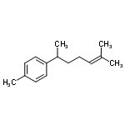
2. | Thiophene, tetrahydro-2-methyl-(Methylthio)-acetonitrile | 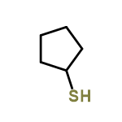
3. | Hexadecenoic acid | 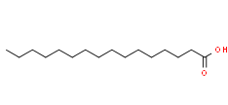
4. | Octadecanoic acid | 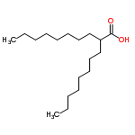
5. | Pentadecanoic acid | 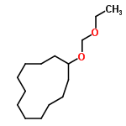
6. | 2-propen-1 | 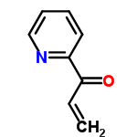
7 | 4H-1-Benzopyran-4-one, 2,3-dihydro,7-dihydroxy-2-phenyl-, (S) | 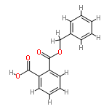
8 | Dinaphtho[2,1-b:1',2'-d]furan | 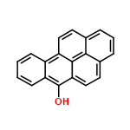
9 | Retinal | 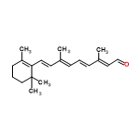
10 | Chrysin | 