Supplementary information

Behavioral Improvement Through In Vivo Base Editing in a Mouse Model of Snijders Blok-Campeau Syndrome

Kan Yang^{1, 3, 6, #, *}, Wei-Ke Li^{2, #}, Yan-Bo Cheng^{4, 5, #}, Yi-Xiao Geng^{3, 8, #}, Zhan-Kui Xu⁶, Yi-Ting Yuan³, Tan-Ying Zhang⁶, Zheng-Hui Li⁷, Ruo-Chuan Xu⁸, Chen-Xi Lin⁸, Wen-Xin Wang⁹, Wen-Xiu Yang¹⁰, Jia-Shuo Wen¹⁰, Xin-Yi Zhang², Jie Li², Shu-Qian Zhang¹¹, Jun Wu³, Jun-Wen Wang³, Yue-Fang Zhang³, Ru Zhang⁶, Shi-Hao Wu¹⁰, Zun-Yuan Yang¹², Li Gong¹², Wen Zeng¹², Jin-Song Li^{4, 5}, Fei Li^{1, *}, Tian-Lin Cheng^{2, *}, Zilong Qiu^{3, 13,*}

Extended data Figure 1-5
Methods and materials
Supplemental Figure 1
Supplemental Table 1-6

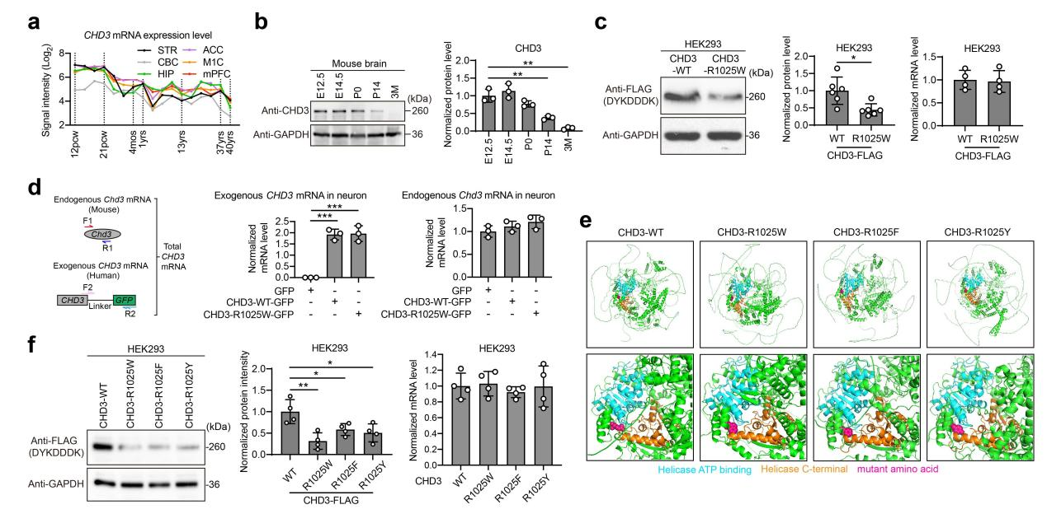
Extended Date Fig.1 | Additional characterization of the SNIBCPS associated CHD3 mutation leading to protein degradation. a, CHD3 transcript levels in the human brain. Date from the Human Brain Transcriptome. b, Immunoblotting and quantitative analysis of CHD3 protein in mouse brain as the mouse development (n=3). c, Immunoblotting of human CHD3-WT/R1025W expressed in HEK293 cells and quantitative analysis of mRNA and protein (n=6). d, Quantitative analysis of expression of exogenous and endogenous CHD3 mRNA in primary neurons. Different primers were used for identification. e, Alphafold3-predicted structure of CHD3-WT/R1205W/R1025F/R1025Y. Enlarged diagram illustrates the connectivity between key functional domains. Blue: Helicase ATP binding domain; Orange: Helicase C-terminal domain; Red: mutant amino acid; Green: other amino acid. f, Immunoblotting of human CHD3-WT/R1025W/R1025F/R1025Y expressed in HEK293 cells and quantitative analysis of mRNA and protein (n=4). n represents biologically independent experiments. Statistical values represent the mean ± SD *P < 0.05, **P < 0.01, ***P < 0.001 by Student’s unpaired two-sided t-test.

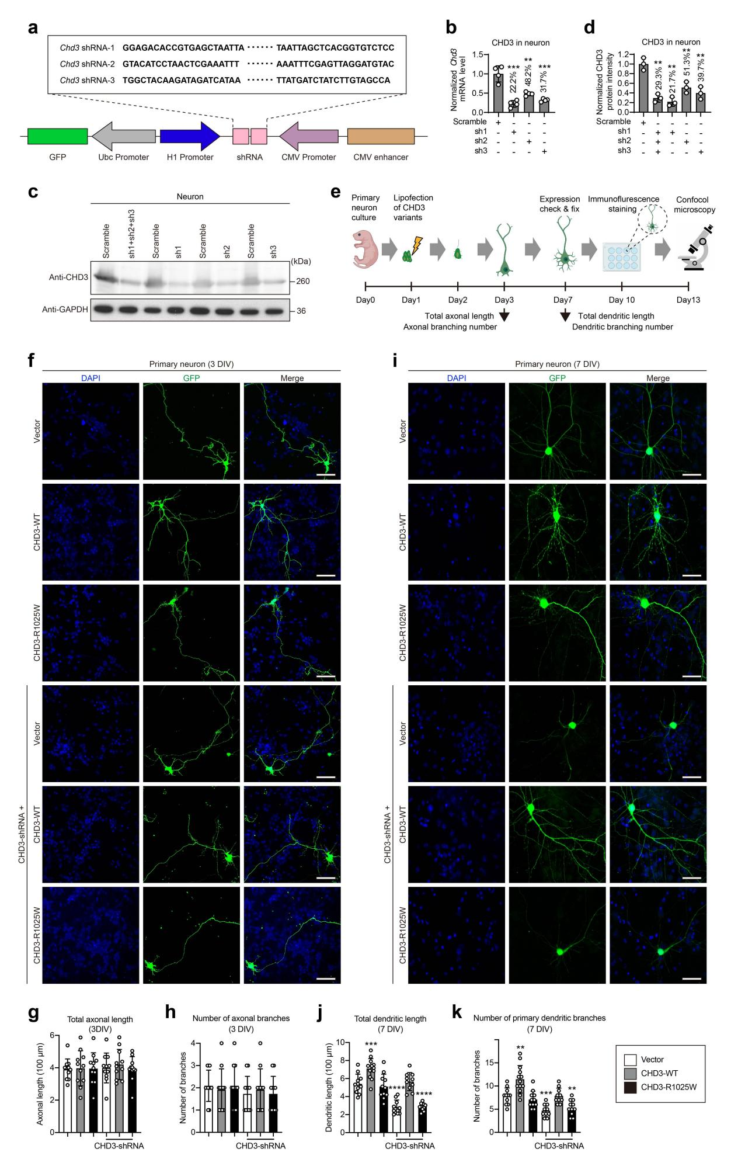
Extended Date Fig.2 | CHD3-R1025W mutation hampers dendritic morphology. a, Schematic representation of the three constructed shRNAs targeting the mouse Chd3 gene. b, Quantitative analysis of CHD3 mRNA levels in mouse cortical neurons in the presence of sh1, sh2, sh3 or scramble (n=4). c, Immunoblotting of CHD3 in mouse cortical neurons in the presence of sh1, sh2, sh3 or all or scramble. d, Quantitative analysis of the CHD3 expression shown in c (n=3). e, Protocol for in vitro culture, transfection and observation of primary mouse neurons. f, Immunofluorescence images of mouse primary neurons transfected into vector, CHD3-WT, CHD3-R1025W and co-transfected with shRNAs at day 3. g,h, Statistical results of total axonal length and axonal branch number of transfected primary mouse neurons in f. Each dot represents a neuron. i, Immunofluorescence images of mouse primary neurons transfected into vector, CHD3-WT, CHD3-R1025W and co-transfected with shRNAs at day 7. j,k, Statistical results of total dendritic length and dendritic branches number of transfected primary mouse neurons in i. Each dot represents a neuron. Statistical values represent the mean ± SD **P < 0.01, ***P < 0.001, ****P < 0.0001 by Student’s unpaired two-sided t-test.

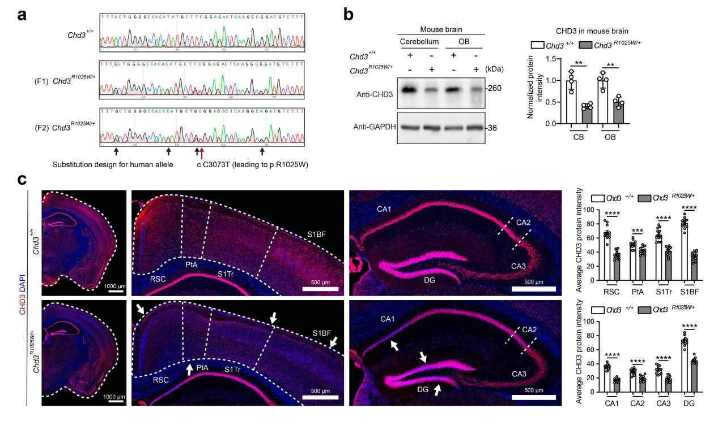
Extended Date Fig.3 | Validation of decreased protein levels in Chd3^{R1025W/+} mice. a, Sequencing validation results for the genotypes of the constructed Chd3^{R1025W/+} mutant mice. b, Additional date to immunoblotting and quantitative analysis of CHD3 protein levels in Chd3^{+/+} and Chd3^{R1025W/+} mice (n=4). CB, cerebellum; OB, olfactory bulb. c, Immunohistochemical staining and quantitation of fluorescence for CHD3 (red) and 4,6-diamidino-2-phenylindole (DAPI) (nuclei marker, blue) in the cerebral cortex and hippocampus of Chd3^{+/+} and Chd3^{R1025W/+} mice. PtA, parietal association cortex; S1Tr, primary somatosensory cortex trunk area; S1BF, primary somatosensory cortex barrel field area; CA1, cornu ammonis 1; CA2, cornu ammonis 2; CA3, cornu ammonis 3; DG, dentate gyrus. n represents the number of mice. Statistical values represent the mean ± SD **P < 0.01, ***P < 0.001, ****P < 0.0001 by Student’s unpaired two-sided t-test.

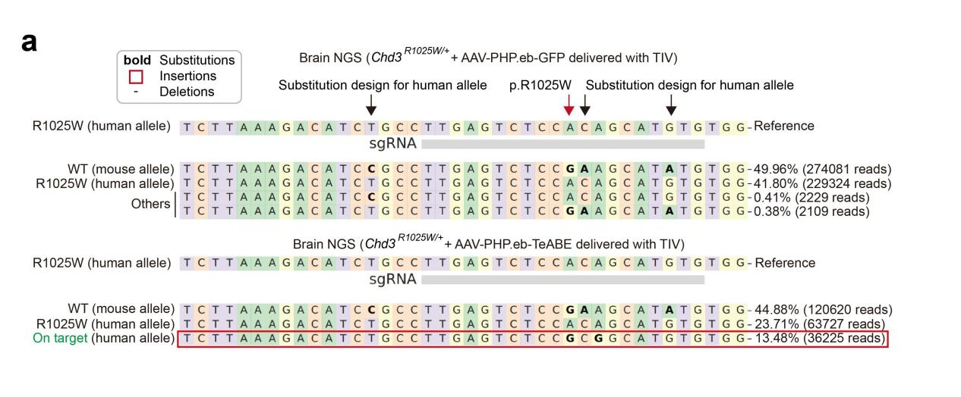
Extended Date Fig.4 | In vivo on-target base editing efficiency analysis through next-generation sequencing. Chd3^{R1025W/+} mice were injected via tail intravenous injection with TeABE or GFP via tail intravenous injection at 6 weeks and subjected to next-generation sequencing at 10 weeks. Bold letters represent substitutions. The red box in the figure indicates the reads after the correction of dual-AAV-mediated TeABE delivery.

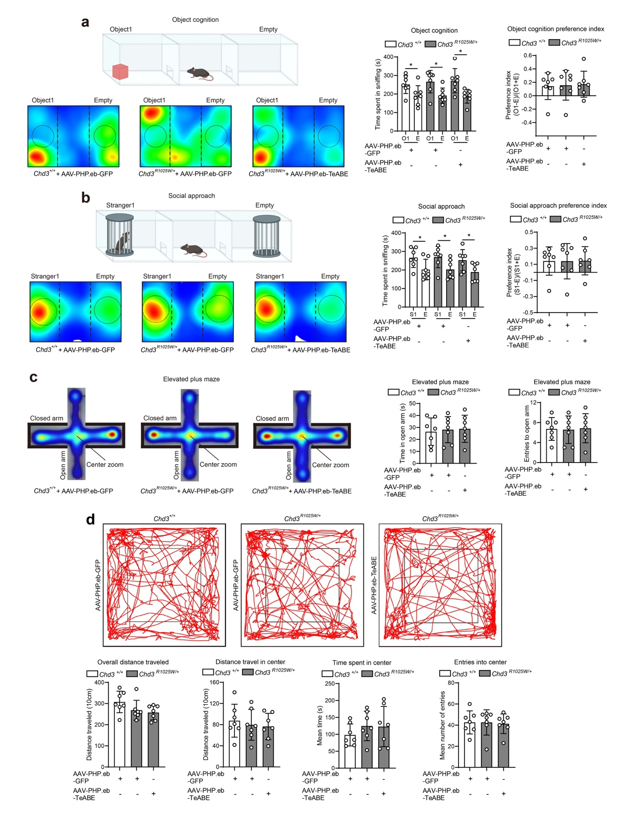
Extended Date Fig. 5 | Additional data to validate Amelioration of autism-like behaviors in Chd3^{R1025W/+} mice. a, The model and representative locomotion heatmaps in the three-chamber novel object recognition test of Chd3^{+/+} (GFP), Chd3^{R1025W/+} (GFP) and Chd3^{R1025W/+} (TeABE) mice when only object 1 is placed. Quantification of time spent in sniffing (n=7). b, The model and representative locomotion heatmaps in the three-chamber novel object recognition test of Chd3^{+/+} (GFP), Chd3^{R1025W/+} (GFP) and Chd3^{R1025W/+} (TeABE) mice when only stranger 1 is placed. Quantification of time spent in sniffing (n=7). c, Representative heat maps of Chd3^{+/+} (GFP), Chd3^{R1025W/+} (GFP) and Chd3^{R1025W/+} (TeABE) mice in the elevated plus maze (open arm indicates top and bottom arms; closed arm indicates left and right arms). Quantification of time in open arm and entries to open arm (n=7). d, Representative locomotion track traces of Chd3^{+/+} (GFP), Chd3^{R1025W/+} (GFP) and Chd3^{R1025W/+} (TeABE) mice in the open field test. Quantitative analysis of overall distance traveled, distance travel in center, time spent in center and entries into center (n=7). n represents the number of mice. Statistical values represent the mean ± SD *P < 0.05 by one-way analysis of variance.

Methods
Discovery of a rare de novo SNV in CHD3 and clinical information on the individual harboring CHD3-R1025W
Previously, we collected and sequenced blood samples from a 3.5-year-old female clinically diagnosed with ASD based on the definition in the Diagnostic and Statistical Manual of Mental Disorders, Fifth Edition (DSM-5), as well as from her parents, at Xinhua Hospital affiliated with Shanghai Jiao Tong University School of Medicine. The child presented with global developmental delay, speech delay, hypotonia and restrictive behaviors, and was found to carry a rare de novo missense variant in CHD3, c.C3073T (leading to Arg1025Trp). For bioinformatics analysis, the reference sequence for the longest CHD3 transcript isoform was used (NM_001005271.3, NP_001005271.2). This study received ethical approval (no. XHEC-F-2024-086) from the Ethics Committee of Xinhua Hospital. All procedures complied with the principles of the Declaration of Helsinki (2013), and the child’s parents provided written informed consent.

Genetically modified mice
The bicistronic expression vector px330-Cas9 (Addgene, cat. no. 42230) containing Cas9 coding region and sg sequence (5′-ACATATGCTTCGGAGACTCA-3′), was directly used for microinjection. A 134 bp oligo, synthesized by Sangon Biotech (Shanghai) Co., Ltd, acted as donor ssDNA for intracytoplasmic DNA microinjection. (134 bp oligo sequence: 5′-gagtttgccgacatatccaaagaggaccagattaagaaactgcatgatttGctggggccacaCatgctGTggagactcaaggcAgatgtctttaagaacatgccagccaagaccgagctcattgttcgagtgga-3′). For zygote intracytoplasmic DNA microinjection, the mixture of px330-Cas9-sg plasmid (50 ng/μl) and 134 bp ssDNA donor (100 ng/μl) was diluted in RNAase-free water.
All mice were bred and maintained according to Shanghai Laboratory Animal Center Institutional Animal Regulations. Mice were housed in the specific pathogen-free animal facility at the Center for Excellence in Molecular Cell Science (CEMCS) with autoclaved food, bedding and water. Animals were maintained at room temperature (20-25 °C) at a humidity of 30-70% on a 12/12-h light/dark cycle (7:00-19:00). All mouse studies were carried out following the guidelines of the Institutional Animal Care and Use Committee (IACUC) at the CEMCS. B6D2F1 mice (C57BL/6 J♀ × DBA/2♂), age 6-8 weeks, were used for zygote collection. ICR mice, purchased from Beijing Vital River Laboratory Animal Technology Co., Ltd, were used for pseudo-pregnant foster mother and vasectomized males. Mice were generated through standard mouse breeding procedures within the CEMCS animal facility The Chd3^{emh34} (endonuclease-mediated mutation-human 34 bp) mouse line was generated by homologous recombination (HR) using CRISPR/Cas9 technology. For the Chd3^{emh34} mouse line, a 34 bp mouse sequence (5′-ActggggccacaTatgctTCggagactcaaggcG -3′) were exchanged for human sequence (5′-GctggggccacaCatgctGTggagactcaaggcA-3′).
B6D2F1 female mice (8 weeks old) were injected with 7 IU (international units) of pregnant mare’s serum gonadotropin (PMSG). Subsequently, 7 IU of human chorionic gonadotropin (hCG) was injected over 46-48 h. House female mice with B6D2F1 male mice overnight. Zygotes were collected from oviducts of B6D2F1 females after 24 h post-hCG injection using hyaluronidase (Sigma, Cat# H3884). Completely mix the px330-Cas9-sg plasmid and 134 bp ssDNA donor as the injection mixture. Using a micromanipulator (Olympus) and a FemtoJet microinjector (Eppendorf), the injection mixture was injected into zygotes. The injected zygotes were cultured in AA-KSOM (Millipore, Cat#MR-106-D) medium for 24 h until they developed into two-cell embryos in an incubator at 37 °C with 5% CO₂.
The pseudo-pregnant foster mothers were prepared by mating estrous ICR female mice with vasectomized male mice on the same day as injection. The two-cell embryos were transferred into oviducts of 0.5 days post coitum (d.p.c.) recipient. Recipient mothers delivered pups at 19.5 d.p.c.
The neonatal mouse tissues were lysed with lysis buffer (100 mM Tris HCl (pH=7.8), 0.2% SDS, 5 mM EDTA, 200 mM NaCl, and 100 μg/ml proteinase K) at 55°C for more than 6 hours, and then the mixture was boiled at 95°C for 10 minutes to deactivate the proteinase K. All mice were genotyped with specific primers (primer-F: 5′-TTAGCAACTTGGAGGGCTTC-3′; primer-R: 5′-TCTGCATGGGGCCTAGCTCC-3′) and verify the Chd3-R1025W mutation by Sanger sequencing.

Primary mouse cortical neuron culture
Mouse cortical neurons were extracted from 14.5-day-old embryos of either sex. Cerebral cortices were dissected and digested with 20 U/ml papain (catalog no. LS003126, Worthington) at 37 °C for 30 minutes, then cultured at 100,000 cells per cm² on Lab-Tek II Chamber Slides (catalog no. 154941, Thermo Fisher Scientific) in 0.5 ml per well of Neurobasal medium (catalog no. 21103-049, Gibco) supplemented with 0.2% B27 (catalog no. 17504-044, Gibco) and 2 mM GlutaMAX (catalog no. 35050-061, Gibco). Lipid transfection using Lipofectamine 2000 (catalog no. 11668-019, Invitrogen) with 0.2μg of each vector was performed after 24 hours of cultivation, following the manufacturer’s protocol. The medium was changed every two days. For morphological analyses, neurons were immunofluorescently stained at DIV3 to assess axonal morphology and at DIV7 to evaluate dendritic morphology. Confocal microscopy was used to acquire images, and the total axonal length, axonal neurite length, dendritic branch numbers, and dendritic branch length were quantified using the Simple Neurite Tracer plugin in ImageJ.

HEK293 cell culture and preparation of protein samples
HEK293 cells were cultured to approximately 90% proportion in a culture dish (Corning) with DMEM (catalog no. 11965092, Gibco) and 10% FBS. Cells were transfected with the corresponding expression plasmids using Lipofectamine 2000 (catalog no. 11668-019, Invitrogen) according to the manufacturer’s instructions. After a 72-hour incubation, the cells were washed with 1× PBS, collected via gentle pipetting, and lysed in loading buffer. The lysates were heated at 100 °C for at least 30 minutes to ensure complete protein denaturation and stored at −20 °C. Proteins from cultured neuronal cells were extracted using the same protocol as for HEK293 cells.

RNA extraction and reverse transcription
Total RNA was extracted from cultured mouse cortical neurons or HEK293 cells using TRIzol reagent (catalog no. 15596018, Invitrogen) following the manufacturer’s instructions. Reverse transcription was performed with the PrimeScript RT Master Mix (catalog no. RR036A, Takara Bio) according to the provided protocol, using 500-1,000 ng of total RNA as the template for each PCR reaction.

Quantitative PCR
Quantitative PCR (qPCR) was performed to measure the relative mRNA expression of Chd3, normalized to Gapdh. The experiments were conducted using SYBR Green PCR Premix (catalog no. QPK-201, TOYOBO), and data were analyzed on the StepOnePlus Real-Time PCR System (Applied Biosystems). The qPCR program included an initial denaturation at 95 °C for 10 minutes, followed by 40 cycles of amplification at 95 °C for 10 seconds, 60 °C for 15 seconds, and 72 °C for 20 seconds. Relative mRNA levels of Chd3 were calculated and normalized using the ΔCT method, with Gapdh serving as the internal control. The primers used were as follows: human CHD3 forward: 5′-TGATCTGTATAGACGACGGCGG-3′ reverse: 5′-GGGTCAGCTTGCCGTAGGTG-3′; mouse Chd3 forward: 5′-ATGAGGAACGAGCAGCTATTTC-3′, reverse: 5′-CAAACTGAGCGTCATTCTGGAT-3′; mouse Gapdh forward: 5′-ACGGCCGCATCTTCTTGTGCAGTG-3′, reverse: 5′-GGCCTTGACTGTGCCGTTGAATTT-3′.

Immunoblotting
Protein samples from mouse tissues were lysed using radioimmunoprecipitation assay (RIPA) buffer containing 150 mM NaCl, 1% sodium deoxycholate, 0.1% SDS, 50 mM Tris-HCl (pH 7.4), 1% Triton X-100, and protease inhibitor cocktail tablets (catalog no. 04693159001, Roche). The tissues were thoroughly digested on a rotating shaker at 4 °C, and the lysates were centrifuged at 10,000g for 10 minutes at 4 °C. The resulting supernatant was collected as the protein sample and heated at 100 °C for at least 30 minutes to ensure complete denaturation. The samples were then subjected to gel electrophoresis using SDS-polyacrylamide gels (Precast gel Tris-Gly 4-20%, 10wells, 1.5mm, GSG2001-420T) at a constant voltage of 80 V for stacking and 120 V for separation. Proteins were transferred onto polyvinylidene fluoride membranes (pore size 0.45 μm, Merck Millipore) at a constant current of 200 mA. Membranes were blocked with 5% BSA diluted in 1× Tris-Buffered Saline (TBS)-Tween 20 for 3 hours at room temperature, followed by overnight incubation at 4 °C with primary antibodies. After washing with 1× TBS-Tween 20, membranes were incubated with secondary antibodies for 3 hours at room temperature. Protein bands were visualized using chemiluminescence (ECL ImmunoBlotting Substrate, catalog no. 32106, Pierce).

AAV plasmids construction and production
The plasmid vectors related to AAV virus packaging were constructed as previously reported (Li et al., Nature Neuroscience, 2023). Briefly, we generated the AAV vector through golden gate assembly and restriction enzyme digestion, the first part of which contains the human U6 promoter to initiate the expression of single gRNA, and the human synapsin promoter to express split spCas9 protein (a.a 1-1029) conjugated to the intein-N element. In addition, the second part of AAV vector includes the human synapsin promoter to trigger the expression of split spCas9 protein (a.a 1030-1368), which TadA*(LOF)-TadA*(F148A) segment is embedded at the 1249 site. It should be mentioned that the WPRE3 element was integrated upstream of the PolyA to enhance the expression and translation of the entire cassette. Cloning of the plasmids was done individually and confirmed by Sanger sequencing or whole plasmid sequencing. The gRNA design was completed using the online platform benchling.com. The packaging of AAV viruses and titration were performed by PackGene Bioscience Co., Ltd, Guangzhou.

Fluorescence-Activated Cell Sorting (FACS)
Firstly, we perfused each mouse with 1×PBS, and isolated the mouse brain cortex tissue, and then treated the tissue with the neural tissue dissociation kit (Miltenyi Biotechnology) to fully lyse the cells and isolate single cells. Then, we used the BD Fusion FACS can flow cytometer (BD) to sort and collect the single cells. To be mentioned, for each sorting and collection experiment, we maintained consistent parameters, such as voltage. Additionally, we used the 488-513 nm fluorescence channel to sort EGFP-positive cells and collected single cells with fluorescence intensity above log10³.

Analysis of on-target editing efficacy and by-stander effect
In brief, for the in vitro single-base editing efficiency and by-stander effect analysis, we used the EditR online analysis tool (https://moriaritylab.shinyapps.io/editr_v10/) to analyze and quantify the Sanger sequencing chromatograms. For the in vivo base editing efficiency analysis, we first extracted genomic DNA from the single cells sorted by flow cytometry. Then, we constructed the next-generation sequencing library using different index sequences. The library samples were sent to Shanghai JMDNA Biology Co., Ltd. for next-generation sequencing. After obtaining the sequencing data, we used CRISPResso2 to analyze and quantify the results with support from the Medical Science Data Center of Fudan University.

Immunohistochemistry
For immunofluorescence staining of cultured primary neurons, the cell medium was discarded; cells were then washed with 1× PBS. 4% paraformaldehyde (PFA) diluted with 1× PBS was used to fix cells for 20 min at room temperature. Following fixation, cells were washed with 1× PBS and blocked in a solution containing 5% BSA and 0.4% Triton X-100 in 1× PBS for 2 hours at room temperature. Cells were incubated with primary antibodies prepared in the same blocking solution overnight at 4 °C, followed by secondary antibody incubation for 3 hours at room temperature. For brain tissue preparation, mice were perfused transcardially with 1× PBS, followed by 4% PFA. Brains were post-fixed in 4% PFA overnight and dehydrated in 30% sucrose in 1× PBS. Dehydrated brains were sectioned into 40-μm slices using a Leica CM1950 cryostat. Sections were washed with 1× PBS, blocked with 5% BSA and 0.4% Triton X-100 in 1× PBS for 3 hours at room temperature, and incubated with primary antibodies overnight at 4 °C. Secondary antibody incubation was performed for 3 hours at room temperature. Images were acquired using an Olympus VS200 high-throughput fluorescence microscope or an Olympus FV3000 confocal fluorescence microscope.

Antibodies
The primary antibodies used in this study and their dilutions are as follows: rabbit anti-CHD3 (1:1,000 dilution, catalog no.ab109195, Abcam); rabbit anti-GAPDH (1:3,000 dilution, catalog no.D264398, Sangon Biotech); rabbit anti-CRISPR-Cas9 (1:500 dilution, catalog no. ab204448, Abcam); chicken anti-NeuN (1:1000 dilution, catalog no ABN91, Millipore); rabbit anti-FLAG (1:3,000 dilution, catalog no.D110005, Sangon Biotech); Donkey anti-DAPI (1:1,000 dilution; catalog no.28718-90-3, Sigma-Aldrich); Donkey anti-rabbit IgG Alexa 488 (1:1,000 dilution; catalog no.A32790; Thermo Fisher Scientific); Donkey anti-rabbit IgG Alexa 555 (1:1,000 dilution; catalog no.A32794; Thermo Fisher Scientific); Donkey anti-mouse IgG Alexa 488 (1:1,000 dilution; catalog no.A32766; Thermo Fisher Scientific); Donkey anti-mouse IgG Alexa 555 (1:1,000 dilution; catalog no.A32773; Thermo Fisher Scientific); Donkey anti-chicken Alexa Fluor 488 (1:1,000; catalog no.20166; Biotium);

Tail intravenous injection of AAV for mouse
To investigate the effect of ameliorating the aberrant phenotype in Chd3^{R1025W/+} mice after delivery of the TeABE system, AAV-PHP.eB-hSyn-GFP, AAV-PHP.eB-hSyn-nCas9-1-1029 and AAV-PHP.eB-hSyn-nCas9-1030-1248-TadA-F148A-nCas9-1264-1368-U6-sgRNA were packaged by PackGene Biotech. Corporation and titered using both qPCR and fluorescence intensity detection after virus infection. Anesthetized 6-weeks-old Chd3^{R1025W/+} mice (for the treatment group) were injected into the tail vein with a mixture of AAV-PHP.eB-hSyn-nCas9-1-1029 (100 μl of 5 × 10¹² vg ml⁻¹), AAV-PHP.eB-hSyn-nCas9-1030-1248-TadA-F148A-nCas9-1264-1368-U6-sgRNA (100 μl of 5 × 10¹² vg ml⁻¹), and AAV-PHP.eB-hSyn-GFP (10 μl of 5 × 10¹² vg ml⁻¹). The Chd3^{+/+} mice (for the blank control group) and Chd3^{R1025W/+} mice (for the negative control group) were injected with AAV-PHP.eB-hSyn-GFP (210 μl of 2.5 × 10¹¹ vg ml⁻¹), respectively.

Behavioral tests
The age of the mice subjected to behavioral tests is detailed in Supplemental Table 1. These mice were handled for 4 days prior to testing. Behavioral data were recorded and analyzed using Ethovision XT software (research resource identifier: SCR_000441, Noldus), with investigators blinded to the mice's genotypes. Before testing, mice were habituated to the behavioral test room for at least 1 hour to acclimate to the environment. The apparatus was thoroughly cleaned, and any residual odors were removed with deodorizer before and after each trial. During the tests, mice were allowed to move freely and explore the apparatus. All behavioral tasks were performed between 9:00 and 18:00, corresponding to the light phase of the light-dark cycle. Light intensity was standardized to 50 lux for the open field, self-grooming, buried-marble and home cage intruder social interaction tests. An intensity of 80 lux was used for the three-chamber social interaction, novel object recognition, tail suspension, joint analysis, gait analysis, stride analysis and rota-rod test. The maximum light intensity was set to approximately 300 lux as an aversive stimulus for the elevated plus maze and Barnes maze.

Ultrasonic vocalizations (USVs) test
USVs were elicited through a rapid maternal separation procedure conducted on pups at P3. To record USVs, pups were individually placed into a clean plastic container (containing bedding material) and subsequently placed inside a clean polystyrene container. The lid of the container was securely closed to minimize external noise and testing began immediately upon placement. Each trial lasted for 5 minutes. The USVs were detected using an ultrasonic microphone (Ultravox Noldus), connected via the Ultravox device (Noldus, Netherlands), positioned near the pup’s location. The date was analysised by DeepSqueak (Version 2.6.2) and the investigator conducting data analysis was blinded to the mice’s genotypes.

Open field test
The open field test was performed in a custom-built apparatus made from 0.75-cm-thick white plastic, measuring 40 cm × 40 cm × 40 cm. At the start of each trial, a single mouse was placed at the center of the box and allowed to explore freely for 10 minutes. Behavior was recorded using a Da Hua high-definition video camera. For analysis, the total distance moved, average velocity, movement tracks, and time spent in the center zone (20 cm × 20 cm) were assessed using Ethovision XT software, and results were visualized with ImageJ. The investigator conducting data analysis was blinded to the mice's genotypes.

Buried marble test
A symmetrical 6 × 6 grid of 36 black glass marbles was arranged on 7 cm of bedding in a clean standard mouse cage measuring 40 × 40 cm². Mice were introduced into the cage and allowed to explore for 10 minutes. Photographs were taken at the start and end of the exploration period to determine the number of marbles buried. A marble was considered "buried" if more than 50% of its surface was covered by bedding.

Social intruder test
The task was conducted in the home cage of the experimental mouse, with the feed trough, food, and water bottles removed. Mice were individually housed for five days to ensure social isolation and were acclimated to the experimental environment for 1 hour prior to the task. The social recognition task consisted of two phases: a social approach and familiarity session, followed by a social novelty and recognition session. During the social approach and familiarity session, a stranger mouse (mouse 1; C57BL/6J adult male, 6 weeks old) was introduced into the cage for 3 minutes, allowing free exploration and interaction. This was followed by three additional trials with 5-minute intertrial intervals to facilitate familiarity with mouse 1. In the social novelty and recognition session, a new stranger mouse (a littermate of mouse 1) was introduced into the cage. Cumulative sniffing time was recorded to analyze social interaction, specifically when the test mouse actively sniffed or made physical contact with the stimulus mouse via nose touching. The recognition index was calculated as the difference in cumulative sniffing time between trial 5 and trial 4. Video recordings were captured using a Da Hua high-definition camera, and cumulative sniffing time was measured with a split-second chronograph. The investigator conducting data analysis was blinded to the mice's genotypes.

The three-chamber social interaction test
The three-chamber test was conducted using a behavioral apparatus made of 0.75-centimeter-thick white plastic (dimensions: 60 × 40 × 30 cm³). Each chamber was equipped with 4 × 4 cm² cut-out doors in the partition walls to permit free movement between the chambers. Small iron cages were placed in each side chamber to house the social partner mice. The day before the testing, mice were habituated to the apparatus for one hour with empty cages in both side chambers. Social partner mice (C57BL/6J adult male, 6 weeks old) were placed in the iron cages for 10 minutes to minimize stress and anxiety. The test comprised habituation, social approach, and social novelty. On the day of the test, the subject mouse was placed in the center chamber and allowed to freely explore all three chambers during the habituation session. During the social approach session, while the test mouse remained in the center chamber, a social partner mouse (mouse 1) was placed in the iron cage in one of the side chambers while the other iron cage was empty. The test mouse was then allowed to explore the entire apparatus for 10 minutes. In the social novelty session, the test mouse was returned to the center chamber, and a new stranger mouse (mouse 2) was placed in the iron cage in the opposite side chamber. The test mouse was allowed to explore for another 10 minutes. The apparatus was thoroughly cleaned with a deodorizer between trials to eliminate any olfactory cues. Video recordings were captured using a Da Hua high-definition camera, and the time spent interacting with the social partner or the empty cage (20 × 10 cm²) and locomotion heatmaps were analyzed using Ethovision XT software and plotted with ImageJ. The investigator analyzing the data was unaware of the genotypes of the mice.

Novel object recognition test
The novel object recognition task was carried out using an apparatus made of 0.75-centimeter-thick white plastic, measuring 24 × 24 × 24 cm³. One day before the test, each mouse was placed individually into the apparatus for one hour to habituate to the environment. During the habituation session, each test mouse was placed in the center of the apparatus and allowed to freely explore for 10 minutes. On the training day, which took place one day after habituation, the test mouse was again placed in the center of the apparatus and allowed to freely explore for 10 minutes. On the recognition session, held one day after the training session, the test mouse was placed in the center of the apparatus and allowed to freely explore for 10 minutes. In the object recognition session, one red cube (object 1) was placed at the top corners of the apparatus. Then the test mouse was taken out and the box was deodorized with the deodorant. In the novel object recognition session, the test mouse was again placed in the center of the apparatus and allowed to freely explore for 10 minutes. In this session, the red cube (object 1) and one green cylinder (novel object) were placed at the top corners of the apparatus. Video recordings were captured using a Da Hua high-definition camera during the task. The time spent interacting with each object (within a nose point range of ≤ 3 cm) and the locomotion heatmaps were analyzed using Ethovision XT software and plotted using ImageJ. The investigator analyzing the data was unaware of the genotypes of the mice.

Elevated plus maze test
The elevated plus maze test was performed using a specialized behavioral apparatus. The closed arms were made of 0.75-cm-thick white plastic boards, each measuring 30 × 5 × 15 cm, while the open arms measured 30 × 5 × 15 cm. The total height of the apparatus was 50 cm. Each test mouse was placed at the center of the maze and allowed to freely explore for 5 minutes to fully navigate the maze. Video recordings were captured with a Da Hua high-definition camera. The time spent in the open and closed arms was recorded, and data analysis was conducted using Ethovision XT software and plotted with ImageJ. The investigator performing the analysis was unaware of the genotype of each mouse.

Barnes maze test
The Barnes maze consisted of a circular, thick, white plastic board with a diameter of 122 cm, featuring 40 evenly spaced holes, each 5 cm in diameter, around its perimeter. The maze stood 80 cm above the ground and was designed to rotate around its center. An escape cage, made of black lightproof plastic, was positioned beneath the target hole for accessibility. Two bright supporting lamps placed at opposite ends provided maximum light intensity as an aversive stimulus. Between each trial, the maze and escape cage were thoroughly cleaned with deodorizer to eliminate residual odors, and the maze was randomly rotated to avoid olfactory cues. The Barnes maze test included five consecutive days of training followed by two test sessions on the sixth and thirteenth day. Prior to training, mice were habituated to the environment for at least one hour. During each trial, a mouse was placed at the maze's center under a dark opaque plastic cover for approximately 10 seconds and then released to explore. Each mouse had up to 3 minutes to locate the escape hole; if unsuccessful, the mouse was guided to the target hole and allowed to familiarize itself with the location for 1 minutes inside the escape box, which was covered with an opaque plastic shield to reduce light exposure. Each mouse underwent two training trials daily (10 trials in total over five days) to memorize the target hole location and learn to navigate to it independently. On the test day, the escape box was removed, and each mouse was allowed to explore the maze freely for 180 seconds. Video recordings were captured using Da Hua Smart video recording software. The primary latency to reach the target or opposite zone was calculated within 180 seconds, and locomotion traces were analyzed using Ethovision XT software and plotted with ImageJ. All analyses were performed by investigators who were unaware of the genotype of the mice.

Tail suspension test and joint laxity analysis
The tail suspension test was employed to assess cerebellar ataxia in mice by observing limb clamping. Mice were suspended by their tails, and high-definition digital camera was used to captured real-time images. The position of the limbs was monitored for 10 seconds. A scoring system was applied based on the limb posture: a score of 0 was assigned if both hindlimbs and forelimbs were consistently splayed outward, away from the abdomen; a score of 1 was given if one limb was retracted toward the abdomen for more than 50% of the suspension time; a score of 2 was assigned if half of the limbs were partially retracted toward the abdomen for more than 50% of the time; and a score of 3 was given if the three limbs were fully retracted and touching the abdomen for more than 50% of the time; and a score of 4 was given if both hindlimbs and forelimbs were fully retracted and touching the abdomen for more than 50% of the time. The clasping scores of the mice were recorded and analyzed with all analyses performed by investigators blinded to the genotype of the mice.
For the analysis of joint laxity: a score of 0 indicated normal joints with no observable redness or swelling; a score of 1 indicated mild redness and swelling localized to the ankle or wrist, or limited redness and swelling confined to individual digits; a score of 2 indicated for moderate redness and swelling affecting the ankle or wrist; a score of 3 indicated severe redness and swelling involving the entire paw, including the digits; a score of 4 indicated maximal inflammation extending to multiple joints within the limb. To ensure objectivity, all joint laxity scores were recorded and analyzed by investigators blinded to the genotype of the mice.

Gait analysis and stride analysis
Step pattern tracking was performed using a tunnel constructed from three pre-cut clear acrylic panels, each 10 mm thick, allowing mice to walk comfortably and take at least four steps. The hindlimb foot angle and spacing were recorded using an electronic camera taken from their abdomen. Thick, smooth paper, such as watercolor paper, was cut into strips slightly larger than the tunnel dimensions (approximately 380 mm long and 90 mm wide). Two contrasting non-toxic, washable, water-based paints (e.g., blue and red) were applied to distinguish between hindlimb (blue) and forelimb (red) steps. The selected paints were safe for ingestion, as mice tended to lick residual paint off their feet after testing. Step intervals were recorded for subsequent analysis.

Rota-rod test
This test requires mice to balance on a rotating rod, and their latency to fall is recorded as the endpoint measure. The rotarod consists of a circular rod turning at a constant or increasing speed. Animals placed on the rotating rod try to remain on it rather than fall onto a platform some 30 cm below. Before the test, all mice are trained for one day to adapt to the rotarod instrument; On the test day, the mice are placed on the rotating lane of the rotarod instrument and the test starts. The time of the mice staying on the stick and the final velocity is recorded while the investigator conducting data analysis was blinded to the mice genotypes.

Intrathecal injections of AAV for monkeys
All rhesus macaque monkeys (Macaca mulatta) were bred and maintained according to the Institutional Animal Care and Use Committee of PriMed Non-Human Primate Research Center of Sichuan Primed Shines Bio-tech Co., Ltd,. All monkeys were pair-housed in accordance with standard operating procedures of PriMed in a climate-controlled room at 18 °C to 26 °C with a relative humidity of 40% to 70%, a 12-hour light/12-hour dark cycle, and a ventilation rate of eight times/hour. Monkeys had free access to drinking water and were continually fed with monkey chow (4% calories from fat, 16% calories from protein, and 80% calories from carbohydrates) at 200 to 300 g/d. Monkeys were also provided a daily allotment of fruits, vegetables, or additional supplements and various toys. This study complied with the National Institutes of Health Guide for the Care and Use of Laboratory Animals.
Monkeys were anesthetized with an intramuscular injection of ketamine hydrochloride (5 mg/kg) followed by an intravenous injection of propofol (1 mg/kg) to induce and maintain anesthesia. Following anesthesia induction, the lumbar area was shaved and disinfected with povidone-iodine. The animals were positioned in lateral recumbency on the surgical table with the lumbar spine flexed to facilitate access to the intervertebral spaces. A spinal needle was inserted at an approximately 70° angle to the dorsal midline axis into the intervertebral space between L3 and L4. The needle advanced through the skin and subcutaneous tissue into the subarachnoid space, which was identified by a distinct loss of resistance and confirmed by the appearance of cerebrospinal fluid upon gentle aspiration. The mixture of AAV9-hSyn-nCas9-1-1029 (1500 μl of 1.13 × 10¹⁴ vg ml⁻¹ for monkey NO.9402, 1500ul of 3.00 × 10¹³ vg ml⁻¹ for monkey NO.9500) and AAV9-hSyn-nCas9-1030-1248-TadA-F148A-nCas9-1264-1368-U6-sgRNA (1500 μl of 1.49 × 10¹⁴ vg ml⁻¹ for monkey NO.9402, 1500ul of 3.00 × 10¹³ vg ml⁻¹ for monkey NO.9500)) was then administered slowly into the subarachnoid space over a period of 60 seconds. Following the injection, the needle was removed, and the site was closed and disinfected. Monkeys were monitored post-procedure for recovery and potential adverse effects. All procedures adhered to institutional ethical guidelines and were conducted by personnel blinded to the experimental groups (The Institutional Animal Care and Use Committee of PriMed Non-Human Primate Research Center of Sichuan Primed Shines Bio-tech Co., Ltd. reviewed and approved the experimental protocols AW2334).

Immunohistochemistry staining for monkey
Monkey was anesthetized with ketamine (Veterinary Drug approval number (2015)100761663, 10 mg/kg, i.m.) and pentobarbital (45 mg/kg, i.m) and transcardially perfused with 2000 mL of 4 °C phosphate-buffered saline (PBS) and 500 mL of 4% paraformaldehyde (Sigma-Aldrich, Cat#16005) in PBS. After perfusion, the hemispheres of the brain were dissected, cut into small blocks (segmentation of subregion for monkey brain were selected and collected by a skilled technician with over a decade of experience), fixed with 4% paraformaldehyde in PBS. The fixed brain tissue blocks were then cut into 50-μm cortical sections with a Leica Biosystems (Leica CM1950, Germany). Sections were washed for 5 min in PBS containing 5% bovine serum albumin (BSA) and 0.3% Triton X-100, and incubated with primary antibodies (in PBS with 1% BSA and 0.3% Triton X-100) overnight at 4 °C and subsequently with corresponding secondary antibodies. DAPI (1:1,000 dilution; catalog no.28718-90-3, Sigma-Aldrich) was used to label the nuclei and sections were mounted with 75% glycerol. A classical rabbit anti-Cas9 antibody (1:500 dilution, catalog no. ab204448, Abcam) was used to label Cas9.

Statistical analysis
All statistical data are presented as the mean ± SD, with "n" representing the number of individual experiments or mice. Statistical analysis was conducted using Prism v.6.01 (GraphPad Software) and Origin v.2019b to assess group differences. The significance of differences between groups was evaluated using a paired or unpaired two-tailed Student’s t-test, one-way repeated-measures ANOVA, or two-way ANOVA, as indicated in the figure legends. A paired two-tailed t-test was used to compare the cumulative time spent interacting with the mouse during the social approach and social novelty sessions in the three-chamber test for each mouse. A one-way repeated-measures ANOVA was used to analyze differences among more than two groups under a single-factor assumption. Two-way ANOVA was applied to examine interactions between two factors. An unpaired two-tailed t-test was used in other comparisons. Statistical significance was determined as follows: *P < 0.05, **P < 0.01, ***P < 0.001, and ****P < 0.0001. Sample sizes were determined prior to the experiments without using any statistical methods. Mice were randomly assigned to experimental groups. Data collection and analysis were not conducted in a blinded manner except for the immunohistochemical and behavioral tests, which were performed blind to mouse genotype. Data distribution was assumed to be normal, though this was not formally tested. Outliers identified by the Grubbs' test were excluded from the analysis.

Reporting summary
Further information on research design is available in the Nature Portfolio Reporting Summary linked to this article.

Data availability
The datasets generated and analyzed during the present study are available from the corresponding authors upon reasonable request. Source data are provided with this paper.

Code availability
The present study does not contain any customized code.

Supplementary Fig.1. The full unprocessed blots of immunoblotting.
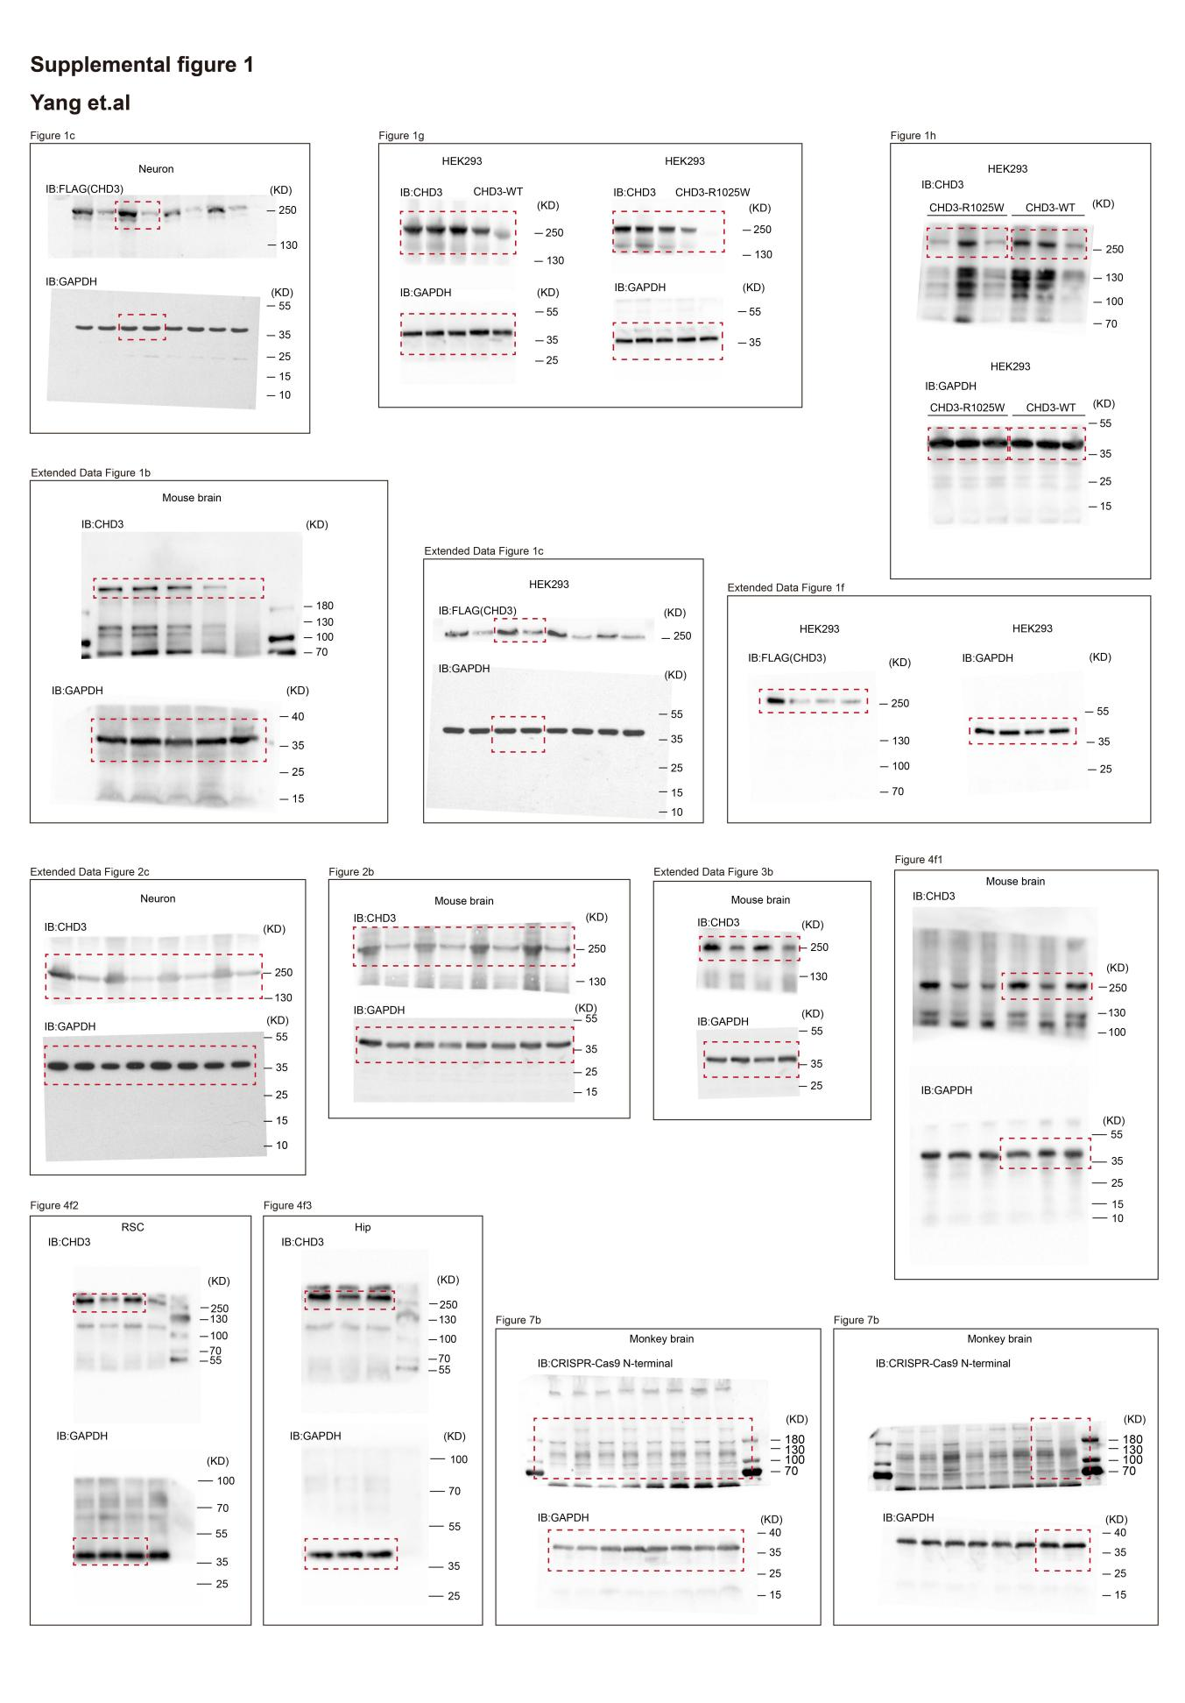

Supplementary Table 1. Statistics analysis for the behavioral test in this study.
AAV | Time of AAV injection | Age of mice | Behavior test | Group | n | Statistical method | vs | P value | Significant¹ | Figure
No | No | P3 | Number of calls | G1:Chd3^{+/+} | 7 | unpaired two-tailed Student’s t-test | G1 vs G2 | 0.0043 | ** | fig.2c
 |  |  |  | G2:Chd3^{R1025W/+} | 7
No | No | P3 | Duration of calls | G1:Chd3^{+/+} | 7 | unpaired two-tailed Student’s t-test | G1 vs G2 | <0.0001 | **** | fig.2c
 |  |  |  | G2:Chd3^{R1025W/+} | 7
No | No | P3 | Classification for USVs test | G1:Chd3^{+/+} | 7 | unpaired two-tailed Student’s t-test | G1 Complex vs G2 Complex | <0.0001 | **** | fig.2c
 |  |  |  |  |  |  | G1 Trailing vs G2 Trailing | 0.0036 | ** | fig.2c
 |  |  |  |  |  |  | G1 U-shape vs G2 U-shape | 0.0029 | ** | fig.2c
 |  |  |  |  |  |  | G1 Chevron vs G2 Chevron | 0.0764 | ns | fig.2c
 |  |  |  | G2:Chd3^{R1025W/+} | 7 | unpaired two-tailed Student’s t-test | G1 Down vs G2 Down | 0.0065 | ** | fig.2c
 |  |  |  |  |  |  | G1 Up vs G2 Up | 0.6591 | ns | fig.2c
 |  |  |  |  |  |  | G1 Flat vs G2 Flat | 0.0053 | ** | fig.2c
 |  |  |  |  |  |  | G1 Short vs G2 Short | 0.0087 | ** | fig.2c
No | No | 10 weeks-old | Novel object recognition test | G1:Chd3^{+/+} | 12 | unpaired two-tailed Student’s t-test | G1 O1 vs G1 NO | <0.0001 | **** | fig.2d
 |  |  |  | G2:Chd3^{R1025W/+} | 12 | unpaired two-tailed Student’s t-test | G2 O1 vs G2 NO | 0.3791 | ns | fig.2d
 |  |  |  |  |  |  | G1 vs G2 | 0.0169 | * | fig.2d
No | No | 10 weeks-old | Three-chamber social novelty test | G1:Chd3^{+/+} | 12 | unpaired two-tailed Student’s t-test | G1 F1 vs G1 S2 | <0.0001 | **** | fig.2e
 |  |  |  | G2:Chd3^{R1025W/+} | 12 | unpaired two-tailed Student’s t-test | G2 F1 vs G2 S2 | 0.8602 | ns | fig.2e
 |  |  |  |  |  |  | G1 vs G2 | 0.0205 | * | fig.2e
No | No | 10 weeks-old | Marble-burying test | G1:Chd3^{+/+} | 12 | unpaired two-tailed Student’s t-test | G1 vs G2 | 0.0041 | ** | fig.2f
 |  |  |  | G2:Chd3^{R1025W/+} | 12
No | No | 10 weeks-old | Self-grooming test | G1:Chd3^{+/+} | 12 | unpaired two-tailed Student’s t-test | G1 vs G2 | <0.0001 | ** | fig.2f
 |  |  |  | G2:Chd3^{R1025W/+} | 12
AAV-PHP.eB-TeABE Ctrl: AAV-PHP.eB-GFP | 6 weeks | 10 weeks-old | Novel object recognition test | G1:Chd3^{+/+}(GFP) | 7 | One-way ANOVA | G1 O1 vs G1 NO | 0.0306 | * | fig.5a
 |  |  |  | G2:Chd3^{R1025W/+}(GFP) | 7 | One-way ANOVA | G2 O1 vs G2 NO | 0.8932 | ns | fig.5a
 |  |  |  | G3:Chd3^{R1025W/+}(TeABE) | 7 | One-way ANOVA | G3 O1 vs G2 NO | 0.0213 | * | fig.5a
AAV-PHP.eB-TeABE Ctrl: AAV-PHP.eB-GFP | 6 weeks | 10 weeks-old | Object cognition test | G1:Chd3^{+/+}(GFP) | 7 | One-way ANOVA | G1 O1 vs G1 E | 0.0488 | * | ED fig.4a
 |  |  |  | G2:Chd3^{R1025W/+}(GFP) | 7 | One-way ANOVA | G2 O1 vs G2 E | 0.0188 | * | ED fig.4a
 |  |  |  | G3:Chd3^{R1025W/+}(TeABE) | 7 | One-way ANOVA | G3 O1 vs G2 E | 0.0125 | * | ED fig.4a
AAV-PHP.eB-TeABE Ctrl: AAV-PHP.eB-GFP | 6 weeks | 10 weeks-old | Three-chamber social novelty test | G1:Chd3^{+/+}(GFP) | 7 | One-way ANOVA | G1 F1 vs G1 S2 | 0.0375 | * | fig.5c
 |  |  |  | G2:Chd3^{R1025W/+}(GFP) | 7 | One-way ANOVA | G2 F1 vs G2 S2 | 0.3540 | ns | fig.5c
 |  |  |  | G3:Chd3^{R1025W/+}(TeABE) | 7 | One-way ANOVA | G3 F1 vs G2 S2 | 0.0117 | * | fig.5c
AAV-PHP.eB-TeABE Ctrl: AAV-PHP.eB-GFP | 6 weeks | 10 weeks-old | Three-chamber social approach test | G1:Chd3^{+/+}(GFP) | 7 | One-way ANOVA | G1 S1 vs G1 E | 0.0473 | * | ED fig.4b
 |  |  |  | G2:Chd3^{R1025W/+}(GFP) | 7 | One-way ANOVA | G2 S1 vs G2 E | 0.0387 | * | ED fig.4b
 |  |  |  | G3:Chd3^{R1025W/+}(TeABE) | 7 | One-way ANOVA | G3 S1 vs G2 E | 0.0449 | * | ED fig.4b
AAV-PHP.eB-TeABE Ctrl: AAV-PHP.eB-GFP | 6 weeks | 10 weeks-old | Barnes maze test | G1:Chd3^{+/+}(GFP) | 7 | One-way ANOVA | Test1 G1 vs G2 | 0.0009 | *** | fig.5b
 |  |  |  |  |  |  | Test1 G1 vs G3 | 0.2370 | ns | fig.5b
 |  |  |  | G2:Chd3^{R1025W/+}(GFP) | 7 | One-way ANOVA | Test1 G2 vs G3 | 0.0152 | * | fig.5b
 |  |  |  |  |  |  | Test2 G1 vs G2 | 0.0048 | ** | fig.5b
 |  |  |  | G3:Chd3^{R1025W/+}(TeABE) | 7 | One-way ANOVA | Test2 G1 vs G3 | 0.2807 | ns | fig.5b
 |  |  |  |  |  |  | Test2 G2 vs G3 | 0.0435 | * | fig.5b
AAV-PHP.eB-TeABE Ctrl: AAV-PHP.eB-GFP | 6 weeks | 10 weeks-old | Social intruder test | G1:Chd3^{+/+}(GFP) | 7 | One-way ANOVA | T1 G1 vs G2 | 0.0002 | *** | fig.5d
 |  |  |  |  |  |  | T1 G1 vs G3 | 0.5922 | ns | fig.5d
 |  |  |  |  |  |  | T1 G2 vs G3 | 0.0002 | *** | fig.5d
 |  |  |  |  |  |  | T5-T4 G1 vs G2 | <0.0001 | **** | fig.5d
 |  |  |  |  |  |  | T5-T4 G1 vs G3 | 0.4347 | ns | fig.5d
 |  |  |  | G2:Chd3^{R1025W/+}(GFP) | 7 | One-way ANOVA | T5-T4 G2 vs G3 | <0.0001 | **** | fig.5d
 |  |  |  |  |  |  | G1 T3 vs T1 | 0.0020 | ** | fig.5e
 |  |  |  |  |  |  | G1 T4 vs T1 | <0.0001 | **** | fig.5e
 |  |  |  |  |  |  | G1 T5 vs T4 | <0.0001 | **** | fig.5e
 |  |  |  |  |  |  | G2 T3 vs T1 | >0.9999 | ns | fig.5e
 |  |  |  | G3:Chd3^{R1025W/+}(TeABE) | 7 | One-way ANOVA | G2 T4 vs T1 | >0.9999 | ns | fig.5e
 |  |  |  |  |  |  | G2 T5 vs T4 | 0.9858 | ns | fig.5e
 |  |  |  |  |  |  | G3 T3 vs T1 | <0.0001 | **** | fig.5e
 |  |  |  |  |  |  | G3 T4 vs T1 | <0.0001 | **** | fig.5e
 |  |  |  |  |  |  | G3 T5 vs T4 | <0.0001 | **** | fig.5e
AAV-PHP.eB-TeABE Ctrl: AAV-PHP.eB-GFP | 6 weeks | 10 weeks-old | Marble-burying test | G1:Chd3^{+/+}(GFP) | 7 | One-way ANOVA | G1 vs G2 | 0.0002 | *** | fig.5f
 |  |  |  | G2:Chd3^{R1025W/+}(GFP) | 7 | One-way ANOVA | G1 vs G3 | 0.2543 | ns | fig.5f
 |  |  |  | G3:Chd3^{R1025W/+}(TeABE) | 7 | One-way ANOVA | G2 vs G3 | 0.0015 | ** | fig.5f
AAV-PHP.eB-TeABE Ctrl: AAV-PHP.eB-GFP | 6 weeks | 10 weeks-old | Self-grooming test | G1:Chd3^{+/+}(GFP) | 7 | One-way ANOVA | G1 vs G2 | 0.0027 | ** | fig.5f
 |  |  |  | G2:Chd3^{R1025W/+}(GFP) | 7 | One-way ANOVA | G1 vs G3 | 0.3051 | ns | fig.5f
 |  |  |  | G3:Chd3^{R1025W/+}(TeABE) | 7 | One-way ANOVA | G2 vs G3 | 0.0119 | * | fig.5f
AAV-PHP.eB-TeABE Ctrl: AAV-PHP.eB-GFP | 6 weeks | 10 weeks-old | Elevated plus maze test | G1:Chd3^{+/+}(GFP) | 7 | One-way ANOVA | Time G1 vs G2 | 0.7796 | ns | ED fig.4c
 |  |  |  |  |  |  | Time G1 vs G3 | 0.6979 | ns | ED fig.4c
 |  |  |  | G2:Chd3^{R1025W/+}(GFP) | 7 | One-way ANOVA | Time G2 vs G3 | 0.9065 | ns | ED fig.4c
 |  |  |  |  |  |  | Entries G1 vs G2 | 0.9178 | ns | ED fig.4c
 |  |  |  | G3:Chd3^{R1025W/+}(TeABE) | 7 | One-way ANOVA | Entries G1 vs G3 | 0.9204 | ns | ED fig.4c
 |  |  |  |  |  |  | Entries G2 vs G3 | 0.8537 | ns | ED fig.4c
AAV-PHP.eB-TeABE Ctrl: AAV-PHP.eB-GFP | 6 weeks | 10 weeks-old | Open field test | G1:Chd3^{+/+}(GFP) | 7 | One-way ANOVA | Overall distance G1 vs G2 | 0.1618 | ns | ED fig.4d
 |  |  |  |  |  |  | Overall distance G1 vs G3 | 0.0505 | ns | ED fig.4d
 |  |  |  |  |  |  | Overall distance G2 vs G3 | 0.6137 | ns | ED fig.4d
 |  |  |  |  |  |  | Distance G1 vs G2 | 0.6415 | ns | ED fig.4d
 |  |  |  | G2:Chd3^{R1025W/+}(GFP) | 7 | One-way ANOVA | DIstance G1 vs G3 | 0.4812 | ns | ED fig.4d
 |  |  |  |  |  |  | Distance G2 vs G3 | 0.8270 | ns | ED fig.4d
 |  |  |  |  |  |  | Time G1 vs G2 | 0.2201 | ns | ED fig.4d
 |  |  |  |  |  |  | Time G1 vs G3 | 0.3504 | ns | ED fig.4d
 |  |  |  | G3:Chd3^{R1025W/+}(TeABE) | 7 | One-way ANOVA | Time G2 vs G3 | 0.9524 | ns | ED fig.4d
 |  |  |  |  |  |  | Entries G1 vs G2 | >0.9999 | ns | ED fig.4d
 |  |  |  |  |  |  | Entries G1 vs G3 | 0.8164 | ns | ED fig.4d
 |  |  |  |  |  |  | Entries G2 vs G3 | 0.8264 | ns | ED fig.4d
AAV-PHP.eB-TeABE Ctrl: AAV-PHP.eB-GFP | 6 weeks | 10 weeks-old | Tail suspension test | G1:Chd3^{+/+}(GFP) | 7 | One-way ANOVA | Clasping G1 vs G2 | <0.0001 | **** | fig.6a
 |  |  |  |  |  |  | Clasping G1 vs G3 | 0.1751 | ns | fig.6a
 |  |  |  | G2:Chd3^{R1025W/+}(GFP) | 7 | One-way ANOVA | Clasping G2 vs G3 | 0.0002 | *** | fig.6a
 |  |  |  |  |  |  | Joint laxity G1 vs G2 | <0.0001 | **** | fig.6a
 |  |  |  | G3:Chd3^{R1025W/+}(TeABE) | 7 | One-way ANOVA | Joint laxity G1 vs G3 | <0.0001 | **** | fig.6a
 |  |  |  |  |  |  | Joint laxity G2 vs G3 | 0.0187 | * | fig.6a
AAV-PHP.eB-TeABE Ctrl: AAV-PHP.eB-GFP | 6 weeks | 10 weeks-old | Gait analysis | G1:Chd3^{+/+}(GFP) | 7 | One-way ANOVA | Angle G1 vs G2 | 0.0015 | ** | fig.6b
 |  |  |  |  |  |  | Angle G1 vs G3 | 0.3299 | ns | fig.6b
 |  |  |  |  |  |  | Angle G2 vs G3 | 0.0045 | ** | fig.6b
 |  |  |  | G2:Chd3^{R1025W/+}(GFP) | 7 | One-way ANOVA | Spacing G1 vs G2 | 0.0001 | *** | fig.6b
 |  |  |  |  |  |  | Spacing G1 vs G3 | 0.1442 | ns | fig.6b
 |  |  |  |  |  |  | Spacing G2 vs G3 | 0.0150 | * | fig.6b
 |  |  |  | G3:Chd3^{R1025W/+}(TeABE) | 7 | One-way ANOVA | Stride G1 vs G2 | <0.0001 | **** | fig.6c
 |  |  |  |  |  |  | Stride G1 vs G3 | <0.0001 | **** | fig.6c
 |  |  |  |  |  |  | Stride G2 vs G3 | <0.0001 | **** | fig.6c
AAV-PHP.eB-TeABE Ctrl: AAV-PHP.eB-GFP | 6 weeks | 10 weeks-old | Rota-rod test | G1:Chd3^{+/+}(GFP) | 7 | One-way ANOVA | Distance G1 vs G2 | 0.0025 | ** | fig.6d
 |  |  |  |  |  |  | Distance G1 vs G3 | 0.5847 | ns | fig.6d
 |  |  |  |  |  |  | Distance G2 vs G3 | 0.0299 | * | fig.6d
 |  |  |  | G2:Chd3^{R1025W/+}(GFP) | 7 | One-way ANOVA | Speed G1 vs G2 | 0.0004 | *** | fig.6d
 |  |  |  |  |  |  | Speed G1 vs G3 | 0.4642 | ns | fig.6d
 |  |  |  |  |  |  | Speed G2 vs G3 | 0.0199 | * | fig.6d
 |  |  |  | G3:Chd3^{R1025W/+}(TeABE) | 7 | One-way ANOVA | Time G1 vs G2 | 0.0085 | ** | fig.6d
 |  |  |  |  |  |  | Time G1 vs G3 | 0.4197 | ns | fig.6d
 |  |  |  |  |  |  | Time G2 vs G3 | 0.0360 | * | fig.6d
¹*p<0.05, **p<0.01, ***p<0.001, ****p<0.0001, ns: no significant

Supplementary Table 2.The information of violin plot.
Corresponding Figures | Group | Minimum | Maximum | Median | First quartile | Third quartile | n | P value (vs WT) | Significant²
Fig.1f | WT | 113.642 | 242.703 | 188.4503871 | 167.213 | 211.173 | 31 | \ | \
Fig.1f | R1025W | 38.841 | 137.332 | 82.49530303 | 61.4965 | 101.31 | 33 | <0.0001 | ****
Fig.1f | R1025F | 43.015 | 183.462 | 111.3452778 | 93.0468 | 128.799 | 36 | <0.0001 | ****
Fig.1f | R1025Y | 43.141 | 210.48 | 127.8150031 | 99.369 | 155.492 | 32 | <0.0001 | ****
²****p<0.0001

Supplementary Table 3. gRNA sequences used in this study.
Name | gRNA sequence (5’-3’) | Figure
CHD3 gRNA C10 | CACATGCTGCGGAGACTCAA | 3a,3d
CHD3 gRNA C11 | ACACATGCTGTGGAGACTCA | 3a,3d,3e
CHD3 gRNA A4 | TCCACAGCATGTGTGGCCCC | 3f,3i
CHD3 gRNA A10 | TGAGTCTCCACAGCATGTGT | 3f,3i
CHD3 gRNA A11 | TTGAGTCTCCACAGCATGTG | 3f,3i
CHD3 gRNA A13 | CCTTGAGTCTCCACAGCATG | 3f,3i
CHD3 gRNA A15 | TGCCTTGAGTCTCCACAGCA | 3f,3i

Supplementary Table 4. Primers used for qPCR reactions.
Name | Sequence (5’-3’) | Figure
Human-CHD3-F | TGATCTGTATAGACGACGGCGG | 1c,ED1c,ED1f
Human-CHD3-R | GGGTCAGCTTGCCGTAGGTG | 1c,ED1c,ED1f
Mouse-CHD3-F | ATGAGGAACGAGCAGCTATTTC | ED1d,ED2b
Mouse-CHD3-R | CAAACTGAGCGTCATTCTGGAT | ED1d,ED2b
GAPDH-F | ACGGCCGCATCTTCTTGTGCAGTG | 1c,ED1c,ED1d,ED1f,ED2b
GAPDH-R | GGCCTTGACTGTGCCGTTGAATTT | 1c,ED1c,ED1d,ED1f,ED2b

Supplementary Table 5. Primers used for plasmid construction and mouse genotyping.
Name | Sequence (5’-3’) | Figure
sg sequence targeting Chd3 for intracytoplasmic microinjection | ACATATGCTTCGGAGACTCA | 2a
ssDNA for intracytoplasmic microinjection | gagtttgccgacatatccaaagaggaccagattaagaaactgcatgatttGctggggccacaCatgctGTggagactcaaggcAgatgtctttaagaacatgccagccaagaccgagctcattgttcgagtgga | 2a
mouse 34 bp sequence for Chd3 | ActggggccacaTatgctTCggagactcaaggcG | 2a
endonuclease-mediated mutation-human 34 bp sequence for Chd3 | GctggggccacaCatgctGTggagactcaaggcA | 2a
Chd3-typing-F | TTAGCAACTTGGAGGGCTTC | ED3a
Chd3-typing-R | TCTGCATGGGGCCTAGCTCC | ED3a

Supplementary Table 6. The sequence of Oligos for mouse Chd3 shRNA.
Corresponding Figures | Name | Sequence (5’-3’)
ED2a | Chd3-shRNA1 | GGAGACACCGTGAGCTAATTATTCAAGAGATAATTAGCTCACGGTGTCTCCTTTTTTG
ED2a | Chd3-shRNA2 | GTACATCCTAACTCGAAATTTTTCAAGAGAAAATTTCGAGTTAGGATGTACTTTTTTG
ED2a | Chd3-shRNA3 | TGGCTACAAGATAGATCATAATTCAAGAGATTATGATCTATCTTGTAGCCATTTTTTG

