Supplemental Methods
Blood collection and processing: Prior to assaying, a 3 mL aliquot of serum from each patient was briefly thawed on ice, centrifuged, and diluted when applicable. A total of 49 candidate biomarkers of CCa and PDAC (constituting cytokines, chemokines, adipokines, lipoproteins, glycans, and other analytes) were assayed in the Cancer Pharmacokinetics and Pharmacodynamics Core at Moffitt Cancer Center with customized multiplex immunoassays, enzyme-linked immunoabsorbent assays, colorimetric assays, and chemiluminescence immunoassays according to methods described by the manufacturer.
Multiplex Immunoassays. MCP-1, MDC, MIP-1α, ENA-78/CXCL5, IFN-γ, IL-10, IL-1β, IL-6, IL-8, TNF-α, Leptin, G-CSF, IL-1α, GRO-α, IL-22, TGF-β (isoforms 1, 2 and 3), C peptide, Insulin, MIP-3α, HGF, MMP-2, IGF-1, Timp-1, GDF-15, Adiponectin, Fibronectin, CRP, Albumin, Lumican, MMP-14, and Zag were multiplexed utilizing Meso Scale Discovery’s (MSD) MULTI-ARRAY technology (Meso Scale Diagnostics, Rockville, MD) per manufacturer’s instructions. MSD’s conjugation protocol was performed only for Lumican, MMP-14 and Zag. Samples were assayed in duplicate on 96-well plates and the electrochemiluminescence of bound secondary antibodies was measured on a MESO QuickPlex SQ120 (Meso Scale Diagnostics, Rockville, MD). Four parameter logistic curves and unknown concentration calculations were achieved using the DISCOVERY WORKBENCH 4.0 Analysis Software (Meso Scale Diagnostics, Rockville, MD). Serum analyte concentrations were reported as pg/mL. Values outside of the detection limit were reported as undetectable.
Enzyme-linked immunoabsorbent assays (ELISA). Circulating levels of Activin A, Cholecystokinin, Angiotensin II, Activin RIIB (RayBiotech, Inc., Norcross, GA), Cotinine (Abnova, Walnut, CA), Cancer Antigen CA19-9, Laminin (Abcam, Boston, MA), Peroxisome ProlifeRator Activated Receptor Gamma, Glycated Hemoglobin A1c, Hypoxia-Inducible Factor 1α, Mitochondrial Brown Fat Uncoupling Protein (UCP1) (Biomatik, Wilmington, DE), High-Density Lipoprotein, and Low-Density Lipoprotein (Novus Biologicals, Centennial, CO) were evaluated according to the manufacturer’s instructions. Samples were assayed in duplicate on 96-well plates and an absorbance of 450nm was read with a Synergy Neo2 Microplate Reader (Agilent Technologies, Inc., Santa Clara, CA). Curve fittings were applied per assay for determination of unknown sample concentrations using Gen5 Software v3.11 (Agilent Technologies, Inc., Santa Clara, CA). Serum analyte concentrations were reported, with values outside of the detection limit reported as undetectable.
Colorimetric Assays. A colorimetric assay to determine circulating levels of Glucose (Cayman Chemical, Ann Arbor, MI) and Triglycerides (Abcam, Boston, MA) was performed according to the manufacturer’s instructions. Samples were assayed in duplicate on 96-well plates and an absorbance of 500nm and 570nm (Glucose and Triglycerides, respectively) were read with a Synergy Neo2 Microplate Reader (Agilent Technologies, Inc., Santa Clara, CA). Curve fittings were applied per assay for determination of unknown sample concentrations using Gen5 Software v3.11 (Agilent Technologies, Inc., Santa Clara, CA). Serum analyte concentrations were reported, with values outside of the detection limit reported as undetectable.
Chemiluminescence Immunoassays. A sandwich-chemiluminescence immunoassay for circulating levels of α-Smooth Muscle Actin was performed according to the manufacturer’s instructions (Novus Biologicals, Centennial, CO). Samples were assayed in duplicate on 96-well plates and luminescence was read, measuring the relative light unit value using the Synergy Neo2 Microplate Reader (Agilent Technologies, Inc., Santa Clara, CA). A four-parameter nonlinear regression was applied to the standards, generating a standard curve and determination of unknown sample concentrations using Gen5 Software v3.11 (Agilent Technologies, Inc., Santa Clara, CA). Serum analyte concentrations were reported as ng/mL. Values outside of the detection limit were reported as undetectable.
Biomarker assay quality control
Table S1 contains information about assay success for each of the 49 biomarkers evaluated. Assay success was defined as having detectable values in at least 60% of participants based on a modified schema²³. Of the 49 biomarkers tested, 7 were not successfully assayed (activin RIIB, cotinine, IGF-1, IL-1α, MMP-14/MTI-MMP, TGFβ3, and UCP1), with UCP1 having no detectable values in any of the participants. Thus, a total of 42 biomarkers were included in downstream statistical analysis using a strategy modified from Talbert et al. ²³.
Supplementary Figures:
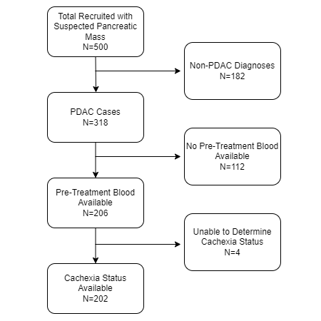
Figure S1: Overview of total patients and patients included in the analytical dataset.
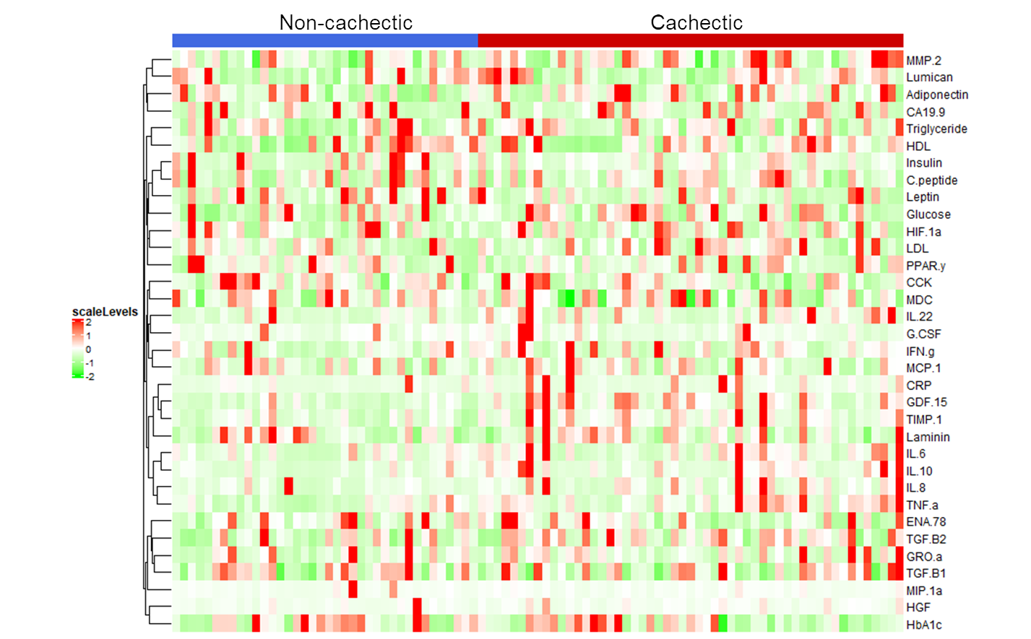
Figure S2: Minimal hierarchical clustering is observed for biomarker levels based on cachexia status. Dendrogram and heatmap of scaled biomarker levels when patients were grouped by cachexia stage (red = cachectic, blue = non cachectic).

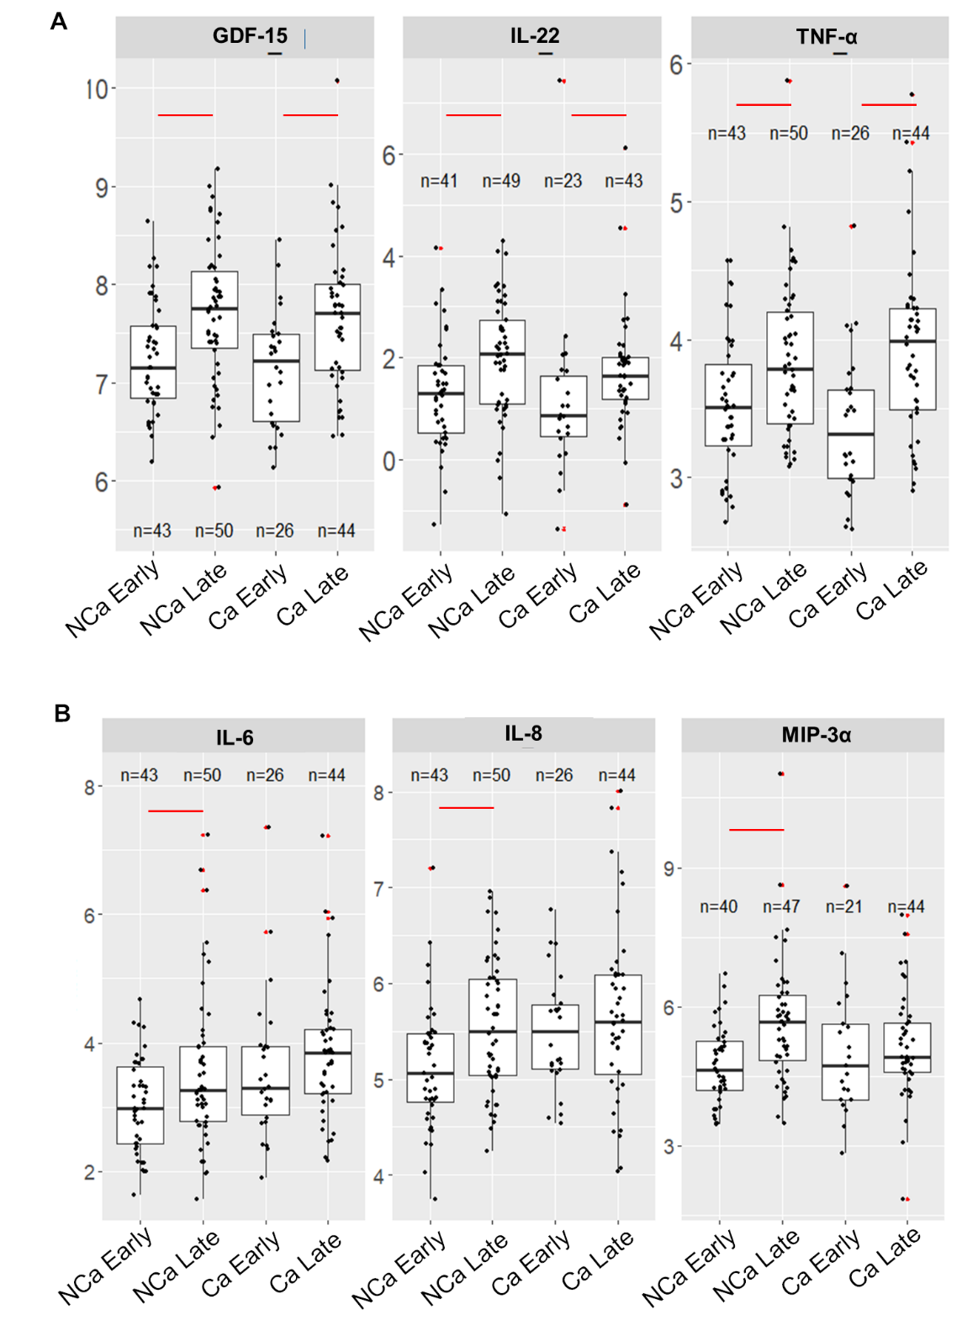

Figure S3: Differences were observed by cancer stage in multiple biomarkers at timepoint 1. Boxplots of significantly different analytes when stratified by cachexia and stage if both stages demonstrate significant differences (A) or if only early stage was calculated to be significantly different (B). NCa = non-cachectic, Ca = cachectic.

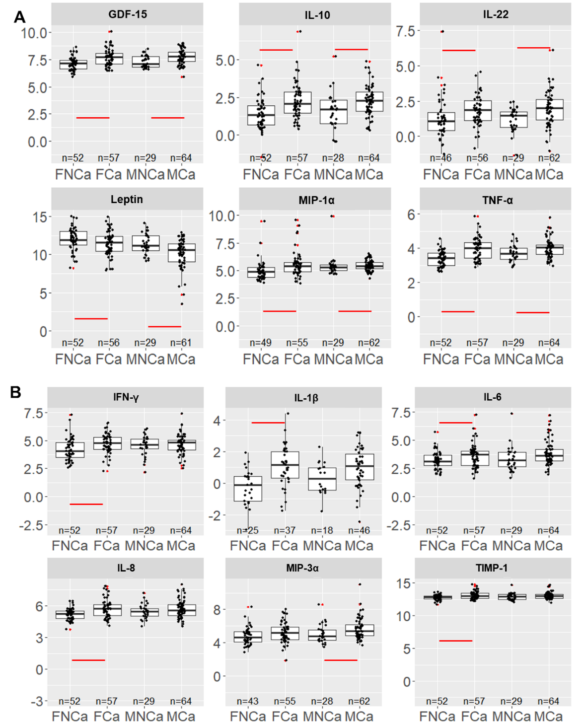

Figure S4: Differences were observed either for both or one sex in multiple biomarkers at baselline. Boxplots of significantly different analytes when stratified by cachexia and sex if both sexes demonstrate significant differences (A) or if only one sex was calculated to be significantly different (B). FNCa=female non cachectic, FCa=female cachectic, MNCa=male non cachectic, MCa=male cachectic.

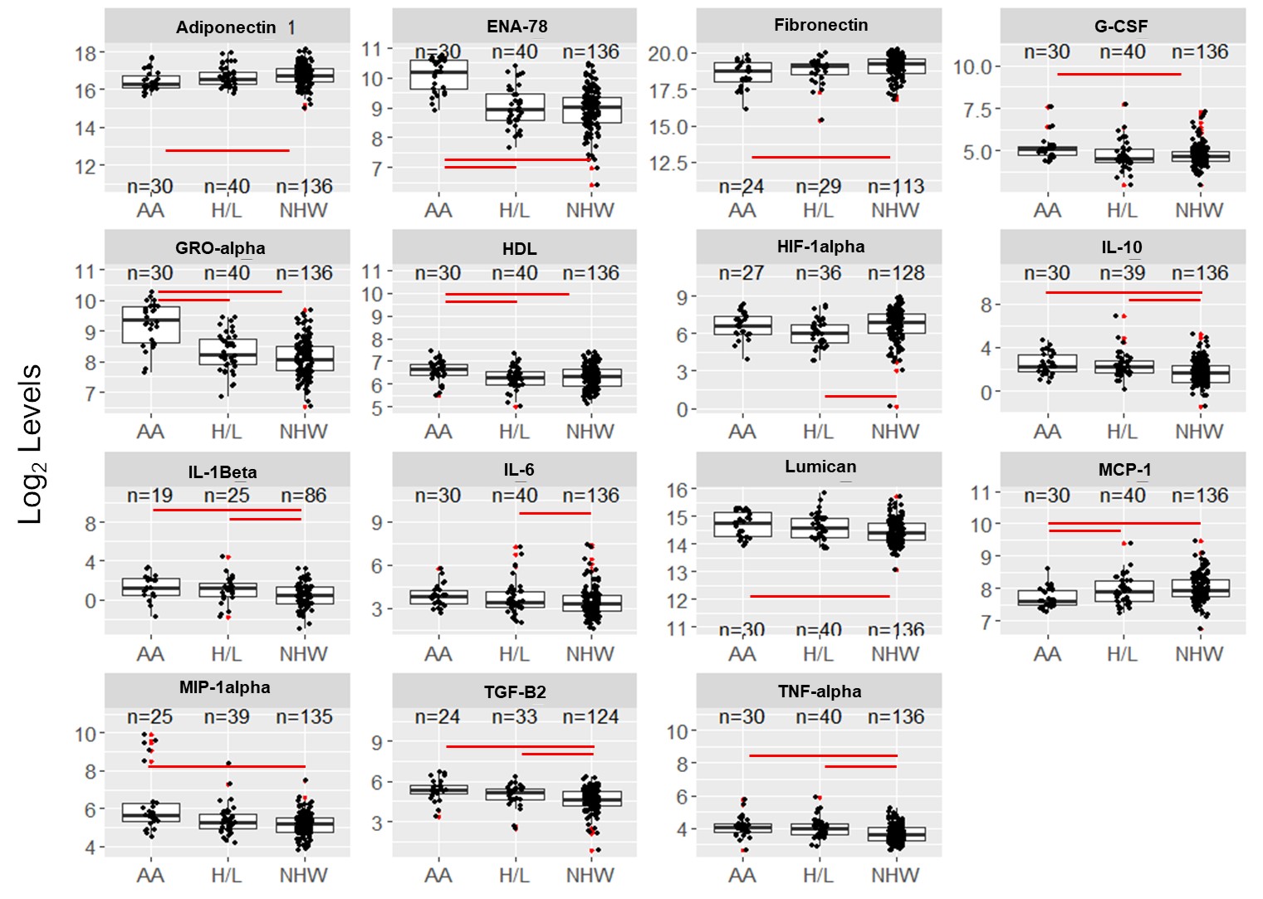
Figure S5: Differences were observed for R&E groups in multiple biomarkers at baseline. Boxplots of significantly different analytes when stratified by race and ethnicity. NHB=Non-Hispanic Black, HL=Hispanic/Latinx, NHW=Non-Hispanic White. Significant differences are indicated with a red line. Outliers are denoted with a red dot.

Table S10: Beta coefficients, CI and p-values for ENA-78 and GRO-alpha (continuous) modeled by R/E, BMI, sex, cachexia stage and cancer stage
Characteristic | ENA-78 |  |  | GRO-alpha
 | Beta | 95% CI¹ | p-value | Beta | 95% CI¹ | p-value
Race/Ethnicity
NHW | — | — |  | — | —
NHB | 1.2 | 0.82, 1.5 | <0.001 | 1.2 | 0.94, 1.5 | <0.001
H/L | 0.08 | -0.25, 0.41 | 0.6 | 0.28 | 0.00, 0.56 | 0.049
BMI Category
normal | — | — |  | — | —
underweight | 0.10 | -0.33, 0.53 | 0.6 | 0.23 | -0.13, 0.60 | 0.2
overweight | 0.15 | -0.14, 0.44 | 0.3 | 0.31 | 0.07, 0.56 | 0.013
obese | 0.11 | -0.22, 0.44 | 0.5 | 0.29 | 0.01, 0.57 | 0.040
Gender
Female | — | — |  | — | —
Male | -0.17 | -0.41, 0.07 | 0.2 | 0.04 | -0.17, 0.24 | 0.7
Cachexia Stage
non cachexia | — | — |  | — | —
cachexia | -0.04 | -0.29, 0.20 | 0.7 | 0.06 | -0.15, 0.26 | 0.6
Stage
1/2 | — | — |  | — | —
3/4 | -0.05 | -0.29, 0.19 | 0.7 | 0.04 | -0.16, 0.24 | 0.7
1 CI = Confidence Interval, p-values of less than 0.05 are in bold.

