Supplementary information
Environmental friendly multi-step processing of efficient mixed-cation mixed halide perovskite solar cells from chemically bath deposited lead sulphide

Sahel Gozalzadeh¹, Farzad Nasirpouri^{1,*}, Sang Il Seok²

¹Faculty of Materials Engineering, Sahand University of Technology, Tabriz 51335-1996, Iran
²School of Energy and Chemical Engineering, Ulsan National Institute of Science and Technology (UNIST), 50 UNIST-gil, Eonyang-eup, Ulju-gun, Ulsan 689-798, Republic of Korea
*-Corresponding author: nasirpouri@sut.ac.ir; f_nasirpouri@yahoo.com

Table S1. Representative of different water-based metal precursors for synthesizing perovskite film and fabricating PSC.
Metal precursor | Processing route | PSC configuration | PCE(%) | Year/Ref
Pb | Magnetron sputtering of Pb film  Spin coating of MAI/IPA solution | FTO/ZnO/MAPbI₃/spiro-OMeTAD/Au | 3.08 | 2016 ¹⁶
PbO | Electrodeposition of PbO  Exposing in iodine vapors  Spin coating MAI | FTO/mp-TiO₂/MAPbI₃/spiro-OMeTAD/Au | 12.5 | 2015 ¹⁷
PbO | Electrodeposition of PbO film  Spin-coating a layer of MAI | FTO/mp-TiO₂/MAPbI₃/spiro-OMeTAD/Au | 14.59 | 2015 ¹⁸
PbO₂ | Anodic ED of PbO₂  Exposing PbO₂ to an excess of HI vapor  Exposing PbI₂ to MAI vapor | - | - | 2016 ¹⁹
PbO₂ | Electrodeposition of PbO₂  Immersing in HI/ethanol solution  Immersing PbI₂ samples in MAI solution | FTO/bl-TiO₂/mp-TiO₂/MAPbI₃/carbon electrode | 10.19 | 2015 ²⁰
Pb(NO₃)₂ | Spin coating  Spin coating MAI solution | FTO/mp-TiO₂/MAPbI₃/spiro-OMeTAD/Au | 13.7 | 2017 ²¹
Pb(NO₃)₂ | Spin coating  Dipping in MAI solution | FTO/mp-TiO₂/MAPbI₃/spiro-OMeTAD/Ag | 13.7 | 2017 ²²
Pb(NO₃)₂ | Spin coating  Dipping in MAI solution | FTO/bl-TiO₂/mp-TiO₂/MAPbI₃/spiro-OMeTAD/Au | 12.58 | 2015 ²³
Pb(NO₃)₂ | Sequential dipping in Pb(NO₃)₂ and MAI solution | FTO/bl-TiO₂/mp-TiO₂/ZnO/ MAPbI₃/spiro-OMeTAD/MoO₃/Ag | 12.41 | 2018 ²⁴
PbSe | Physical vapor deposition of PbSe  Exposing to iodine vapor  In situ closed-space vapor transport for conversion to MAPbI₃ | - | - | 2019 ²⁵
PbS | Atomic layer deposition of PbS  Exposure to iodine gas  Dipping in (MAI) solution | - | - | 2015 ²⁶
PbS | Depositing PbS via rf-sputtering  Exposure to iodide gas (I₂)  Dipping into MAI solution | - | - | 2018 ²⁷
PbS | Chemical bath deposition of PbS  Transforming to CH₃NH₃PbI₃ by CVD process | FTO/C-TiO₂/CH₃NH₃PbI₃/Spiro-MeOTAD/Ag | 4.65 | 2016 ²⁸
PbS | Electrodeposition of PbS  Exposure to iodide gas (I₂)  Dipping into MAI solution | FTO/bl-TiO₂/mp-TiO₂/MAPbI₃/spiro-OMeTAD/Au | 7.72 | 2021 ²⁹

Table S2. Thickness of PbS, PbI₂ and perovskite layer versus immersion duration inside chemical bath.
Immersion time | Thickness (nm)
Immersion time | PbS | PbI₂ | perovskite
30 | 60 | 130 | 320
60 | 158 | 310 | 600
90 | 200 | 400 | 800

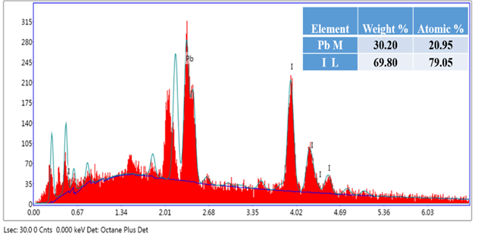
Figure S1. Energy dispersive X-ray analysis (EDAX) of bright regions in perovskite structure. Table in the inset of Figure shows the atomic percentage of the constituent elements present in the sample.

Table S3. Photovoltaic parameters of FTO/bl-TiO₂/mp-TiO₂/FA-based perovskite /spiro-OMeTAD/Au solar cells chemically deposited PbS as the metal precursor by using three step method (i) chemical bath deposition of PbS ii)iodination at 120°C iii) exposing to FAI/MACl/MABr solution)
 | V_{oc} | J_{sc} | FF | PCE
 | 0.857 | 21.24 | 45.04 | 8.20
 | 0.837 | 20.49 | 42.43 | 7.28
 | 0.867 | 21.25 | 43.15 | 7.96
 | 0.837 | 20.76 | 44.45 | 7.73
 | 0.797 | 21.32 | 44.92 | 7.64
 | 0.877 | 21.06 | 43.87 | 8.11
avg. | 0.845333 | 21.02 | 43.97667 | 7.82
stdev. | 0.028577 | 0.329059 | 1.032621 | 0.340646

Table S4. Photovoltaic parameters of FTO/bl-TiO₂/mp-TiO₂/FA-based perovskite /spiro-OMeTAD/Au solar cells chemically deposited PbS as the metal precursor by using three step method (i) chemical bath deposition of PbS ii)iodination at 155°C iii) exposing to FAI/MACl/MABr solution)
 | V_{oc} | J_{sc} | FF | PCE
 | 0.918 | 21.43 | 57.67 | 11.35
 | 0.908 | 21.42 | 58.02 | 11.28
 | 0.877 | 21.44 | 55.67 | 10.48
 | 0.898 | 21.58 | 56.72 | 10.99
 | 0.908 | 21.37 | 57.71 | 11.20
 | 0.918 | 21.61 | 56.57 | 11.23
avg. | 0.9045 | 21.475 | 57.06 | 11.08833
stdev. | 0.015411 | 0.096488 | 0.894874 | 0.321709

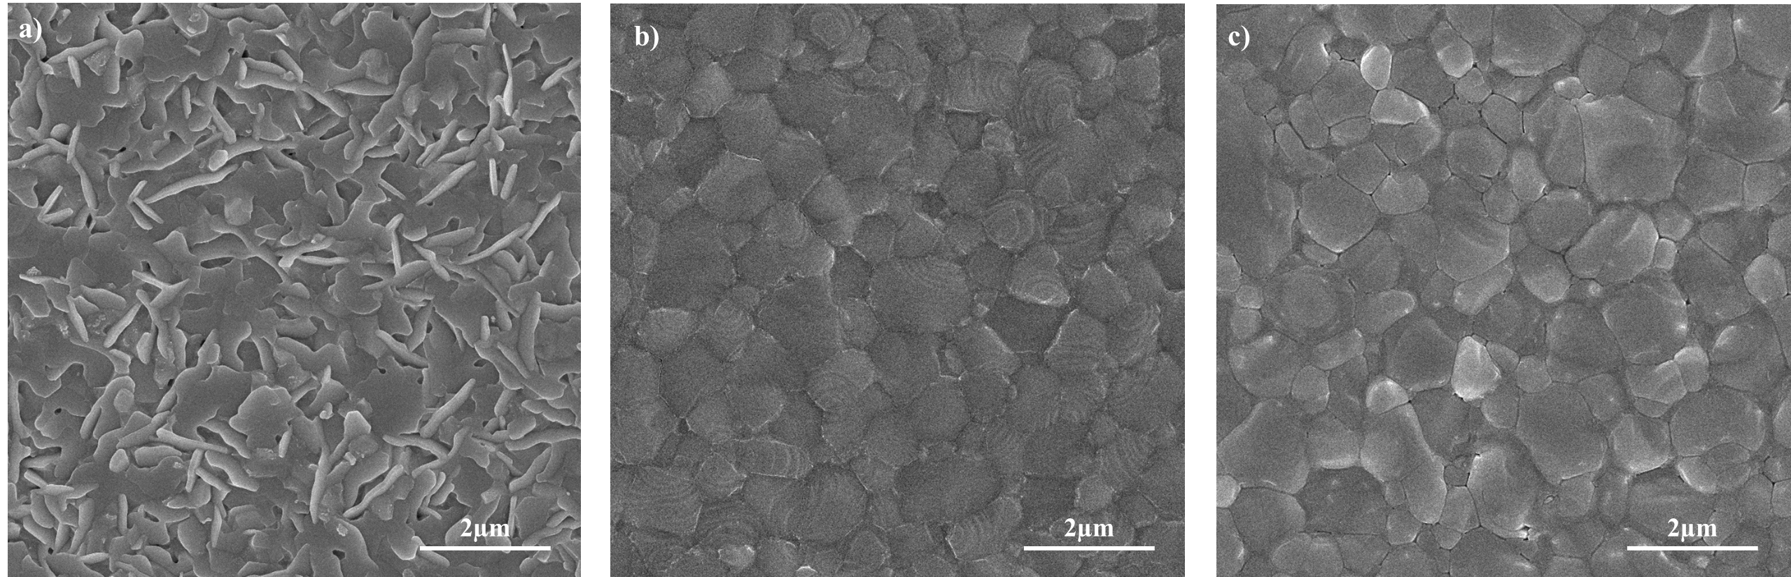
Figure S2. SEM images of perovskite films obtained from spin coating of three different FAI:MACl:MABr solutions including a)70:10:10 mg in 1 ml IPA b)85:10:10 mg in 1 ml IPA and c)100:10:10 mg in 1 ml IPA on PbI₂.

