Table S1. Soil chemical and biological properties and seed cotton yield of different plots in study area
Sample | Location | Geographical coordinates | Yield | EC | pH | TC | TN | TP | AP | OP | Texture（sand，silt, clay） | MBC | MBP | ALP
 |  |  | kg/hm² | μs/cm |  | g/kg |  |  | mg/kg |  | % | mg/kg |  | μmol/d/g soil
Plots1 | 26 in 4 field | 44°51′E，86°42′N | 6966.9 | 521 | 7.9 | 28.20 | 1.47 | 1.53 | 34.30 | 8.25 | 28.61，71.36，0.03 | 431 | 15.7 | 4.34
Plots2 | 26 in 4 field | 44°50′E，86°42′N | 7450.4 | 426 | 7.9 | 20.88 | 1.24 | 1.40 | 60.32 | 10.07 | 16.78，83.19，0.03 | 587 | 59.3 | 3.74
Plots3 | 26 in 4 field | 44°51′E，86°43′N | 6483.5 | 380 | 8.2 | 16.48 | 0.96 | 1.33 | 29.55 | 12.25 | 22.83，77.15，0.02 | 256 | 103.9 | 3.76
Plots4 | 26 in 4 field | 44°49′E，86°43′N | 6000 | 733 | 8.1 | 17.45 | 0.83 | 1.44 | 23.10 | 8.01 | 6.73，93.24，0.03 | 1023 | 26.4 | 2.02
Plots5 | 24 in 4 field | 44°48′E，86°43′N | 6725.2 | 613 | 8.2 | 21.50 | 1.49 | 1.40 | 30.88 | 30.84 | 4.44，95.53，0.04 | 682 | 82.4 | 6.93
Plots6 | 3 in 3 field | 44°52′E，86°40′N） | 5274.9 | 710 | 8.2 | 18.60 | 1.35 | 1.55 | 14.07 | 2.41 | 11.61，88.36，0.03 | 261 | 27.2 | 3.61
Plots7 | 2 in 3 field | 44°51′E，86°37′N | 6241.8 | 307 | 8.4 | 17.23 | 1.25 | 1.84 | 37.53 | 14.00 | 24.48，75.50，0.03 | 346 | 70.9 | 2.81
Plots8 | 4 in 3 field | 44°55′E，86°41′N | 5274.9 | 388 | 8.4 | 6.00 | 0.52 | 0.74 | 18.92 | 13.03 | 77.91，22.08，0.01 | 374 | 17.3 | 2.02
Plots9 | 5 in 3 field | 44°57′E，86°43′N | 6241.8 | 419 | 8.1 | 13.00 | 1.12 | 1.62 | 33.73 | 10.37 | 53.51，46.47，0.02 | 234 | 42.9 | 2.75
Plots10 | 5 in 3 field | 44°57′E，86°43′N | 6241.7 | 468 | 8.1 | 14.43 | 1.31 | 1.45 | 14.83 | 4.64 | 45.47，54.51，0.02 | 347 | 91.5 | 2.60
Plots11 | 7 in 3 field | 44°55′E，86°45′N | 5274.8 | 456 | 8.4 | 7.35 | 1.18 | 1.25 | 13.12 | 7.70 | 8.75，91.23，0.03 | 395 | 30.5 | 2.48
Plots12 | 6 in 3 field | 44°45′E，86°53′N | 6725.2 | 648 | 8.3 | 25.85 | 1.48 | 0.86 | 20.15 | 6.61 | 4.73，95.24，0.03 | 628 | 36.3 | 4.09
Plots13 | 7 in 6 field | 44°44′E，86°49′N | 6000 | 646 | 8.3 | 24.27 | 1.25 | 1.82 | 17.49 | 8.21 | 12.67，87.30，0.03 | 283 | 82.4 | 2.94
Plots14 | 6 in 6 field | 44°41′E，86°48′N | 6000 | 730 | 8.2 | 22.23 | 1.23 | 1.66 | 13.41 | 3.41 | 12.04，87.93，0.03 | 395 | 21.4 | 2.82
Plots15 | 4 in 6 field | 44°40′E，86°42′N | 7208.6 | 838 | 8.2 | 21.45 | 1.23 | 1.46 | 44.56 | 22.43 | 12.16，87.82，0.02 | 446 | 99.7 | 2.96
Plots16 | 1 in 6 field | 44°42′E，86°40′N | 6000 | 406 | 8.2 | 13.31 | 1.56 | 1.39 | 28.79 | 36.43 | 40.45，59.52，0.03 | 244 | 95.6 | 4.94
Plots17 | 5 in 2 field | 44°69′E，86°46′N | 6000 | 435 | 8.0 | 16.09 | 1.34 | 1.75 | 30.79 | 5.46 | 36.99，62.99，0.02 | 512 | 50.3 | 3.95
Plots18 | 8 in 2 field | 44°72′E，86°36′N | 6483.5 | 822 | 8.8 | 18.90 | 0.92 | 1.37 | 2.90 | 19.18 | 33.09，66.89，0.01 | 147 | 69.2 | 3.18
Plots19 | 10 in 2 field | 44°77′E，86°32′N | 6241.7 | 378 | 8.2 | 18.13 | 1.12 | 1.46 | 6.19 | 11.33 | 46.20，53.78，0.02 | 158 | 58.5 | 2.64
Plots20 | 1 in 2 field | 44°75′E，86°41′N | 7208.6 | 345 | 8.3 | 19.45 | 1.24 | 0.84 | 21.58 | 5.95 | 36.53，63.45，0.02 | 581 | 33.8 | 4.05
Plots21 | 2 in 3 field | 44°73′E，86°45′N | 5274.8 | 538 | 8.0 | 14.22 | 1.44 | 0.98 | 26.32 | 12.74 | 23.79，76.18，0.03 | 342 | 61.8 | 3.83
Plots22 | 4 in 1 field | 44°80′E，86°42′N | 6241.7 | 472 | 8.0 | 15.90 | 1.31 | 1.70 | 30.50 | 11.50 | 30.73，69.25，0.03 | 165 | 80.0 | 4.07
Plots23 | 7 in 1 field | 44°87′E，86°46′N | 6483.5 | 566 | 8.0 | 16.35 | 1.43 | 1.80 | 24.14 | 5.44 | 18.43，81.53，0.03 | 360 | 29.7 | 4.26
Plots24 | 6 in 1 field | 44°87′E，86°41′N | 7208.6 | 398 | 8.1 | 23.53 | 1.53 | 1.83 | 35.73 | 8.71 | 19.21，80.76，0.03 | 524 | 74.2 | 3.13
Plots25 | 9 in 1 field | 44°83′E，86°39′N | 6967 | 364 | 8.1 | 23.75 | 1.35 | 1.10 | 15.97 | 11.57 | 38.05，61.93，0.02 | 359 | 108 | 4.07
Plots26 | 2 in 1 field | 44°78′E，86°38′N | 6967 | 394 | 8.2 | 13.67 | 1.13 | 1.42 | 17.49 | 4.76 | 40.72，59.25，0.03 | 541 | 108 | 2.71
Average |  |  | 6353.3 | 515 | 8.2 | 18.01 | 1.24 | 1.42 | 24.86 | 11.36 | 27.19，72.79，0.03 | 373 | 60.7 | 3.49
CV% |  |  | 10.1* | 30.0* | 2.3 | 29.1* | 20.1* | 21.9* | 49.7** | 70.7** | 64.3**，24.0*，19.3* | 57.4** | 50.1** | 29.7*
EC: electrical conductivity; TC: total carbon; TN: total nitrogen; TP: total phosphorus; AP: available phosphorus; OP: organic phosphorus; MBC: microbial carbon; MBP: microbial phosphorus; SALP: soil alkaline phosphatase.

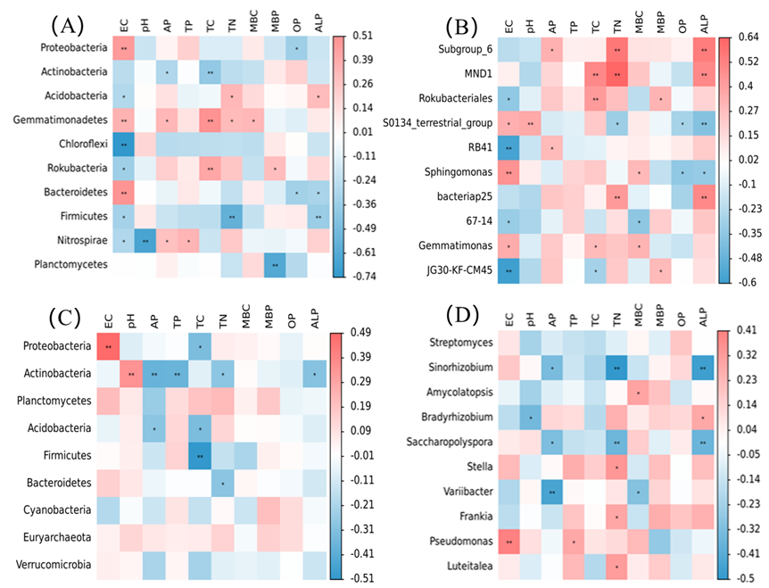
Figure S1. Relationships between environmental variables and bacterial and phoD communities. Phylum-level composition of (A) bacterial and (C) phoD communities. Genus-level composition of (B) bacterial and (D) phoD communities. EC: electrical conductivity; TC: total carbon; TN: total nitrogen; TP: total phosphorus; AP: available phosphorus; OP: organic phosphorus; MBC: microbial carbon; MBP: microbial phosphorus; SALP: soil alkaline phosphatase.

