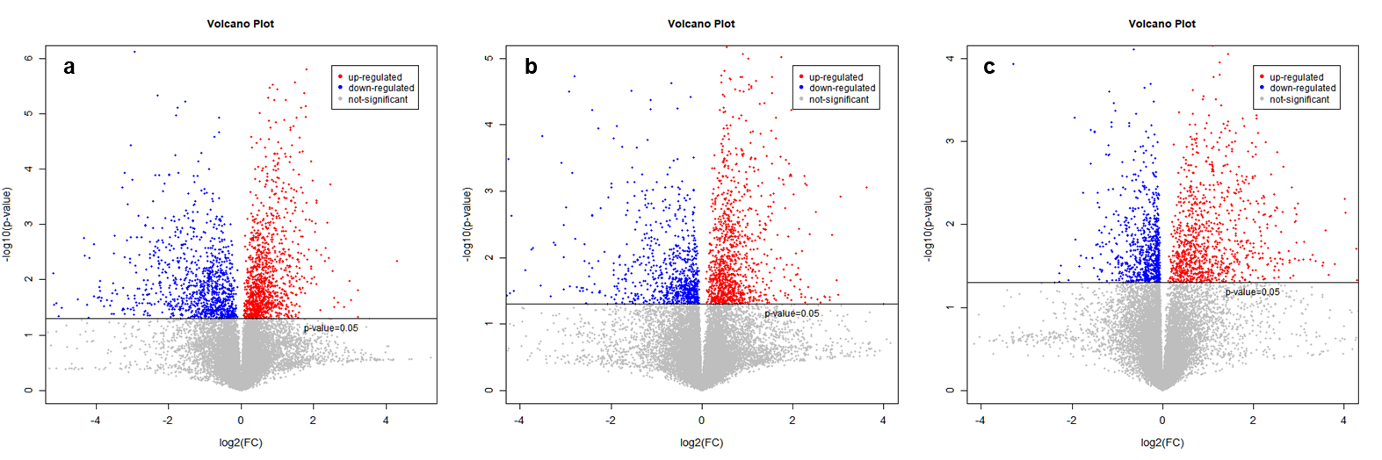
Figure. S1 Volcano graph for screening differential metabolites. a: NC vs OPD, b: NC vs OPD’, c: OPD vs OPD’

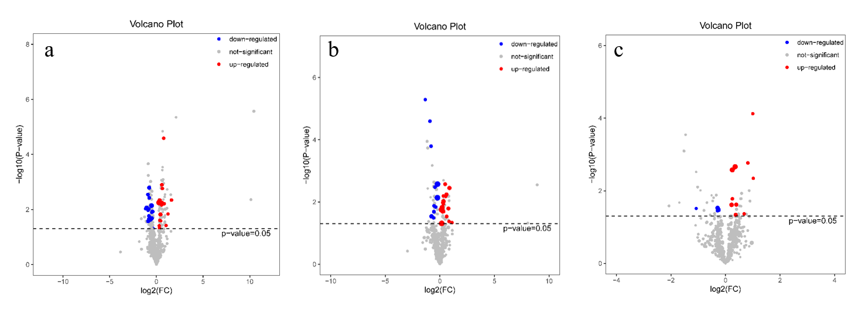
Figure. S2 Volcano graph for screening differential lipids. a: NC vs OPD, b: NC vs OPD’, c: OPD vs OPD’

