Online Resource 1 Comparison of the protocols for extraction and yield of PM_{2.5} from quartz and Teflon filters
Parameters | Quartz filter | Teflon filter
Sonication duration | 30 min with ethanol  15 min (thrice) with water | 5 min with 9:1 (methanol: water)
Solvent required for sonication | 10 ml | 3 ml
Centrifugation duration | 60 mins | 15 mins
Yield of pollutant | 300 μg/filter | 1000 μg/filter

Online Resource 2 Primer used for qRT-PCR
Genes | Primer sequences
tgs1 | F: ATTCCGTGTCAATCCAAGCG  R: AGCGACGCAAATCACTGATC
icl | F: CATCGCCAAGTTCCAGAAGG  R: CATACGCGCTCATCTGGTTC
hspX | F: CAAATGGCCACCACCCTTCC  R: CTCGTCTTCCAGCCGCATCA
rpfB | F: CGACGCTAAGCAGGTGTGGACGAC  R: CACTCAGCAGCCCCGCGACATTGG
16s rRNA | F: TCCCGGGCCTTGTACACA  R: CCACTGGCTTCGGGTGTTA

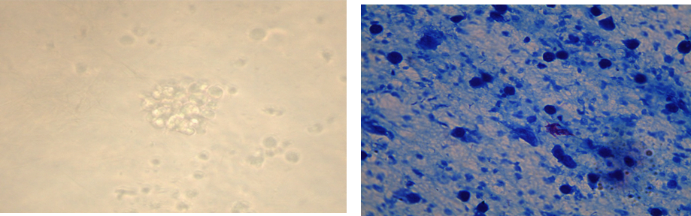
40X magnification
40X magnification
(b)
(a)
Online Resource 3 Microscopic examination of PBMCs granuloma formed with M. bovis BCG. a) Inverted phase-contrast microscopic images showing granuloma like cellular aggregates after 10 days incubation of PBMCs with M. bovis BCG. b) Acid-fast (ZN) staining of human PBMCs granuloma formed in the presence of 0.1 MOI of M. bovis BCG

