Supplementary Information

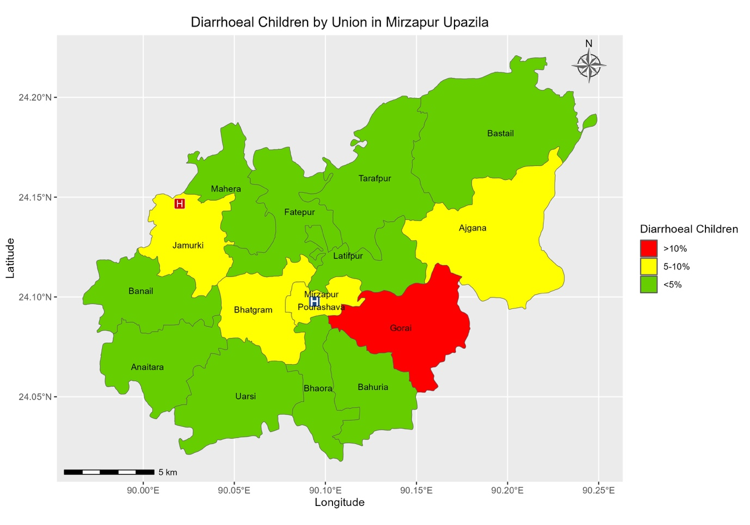

Figure S1a. Union-wise distribution of the under-5 diarrheal children visited Kumudini Hospital
The proportion of children with diarrhea per union was calculated with diarrhea from a union / total children with diarrhea

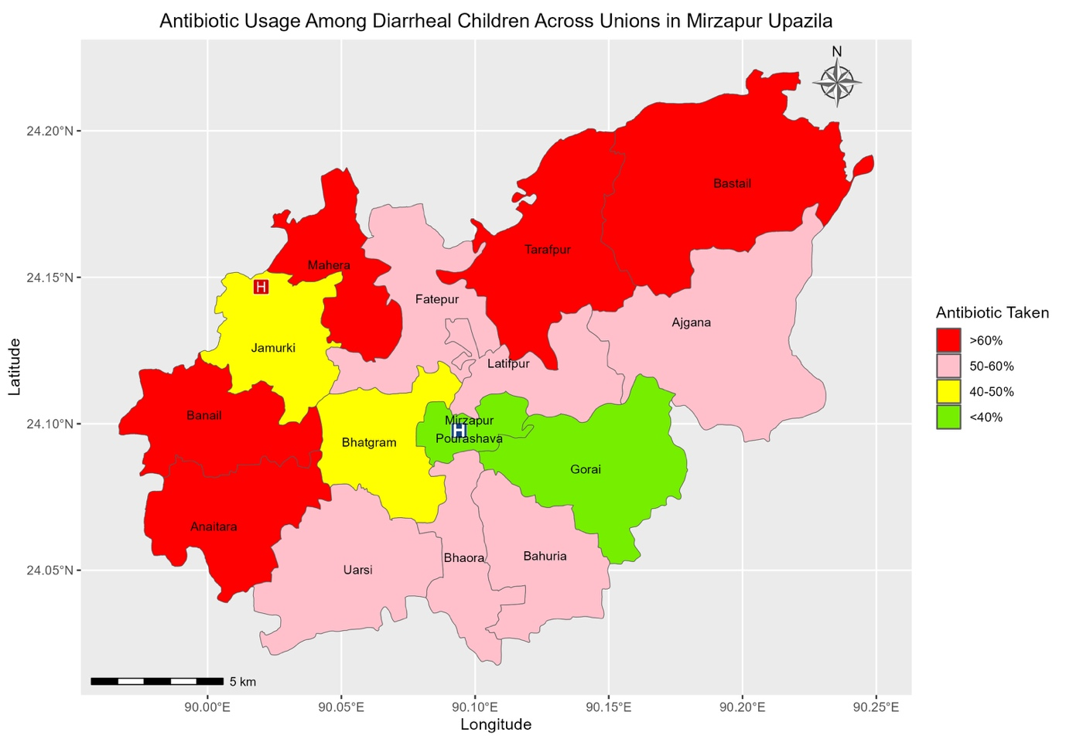
Figure S 1b. Union-wise distribution of the proportion of children received antibiotics before visiting Kumudini Hospital
Proportion of children received antibiotic from each union were calculated by the number of children received antibiotic from that union / the total number of diarrhoeal children visited Kumudini Hospital from that union.

