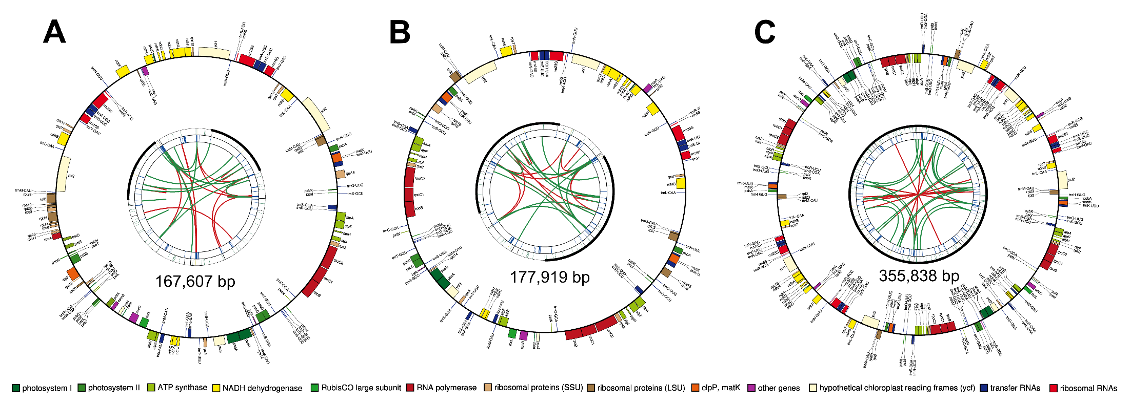
Figure S1. Chloroplast genomes with wrong circularization of F. mixta, demonstrating: the 167,607 bp plastome obtained when using k-mer 23 and matK gene (FR832766) as seed (A); the 177,919 bp assembly obtained when using k-mer 39 and atpF-atpH intergenic region (MH644211) as seed (B); and the 355,838 bp assembly when using k-mer 39 and trnL-trnF intergenic region (KU727627) as seed (C). Four concentric rings represent chloroplast features. Starting from the innermost ring, the first circle illustrates forward (red arc) and reverse (green arc) repeats. The second circle highlights tandem repeats with short bars. The third ring features microsatellite sequences. The outermost ring depicts the gene structure of the plastome, with genes color-coded according to their functional categories.

