Additional File 3
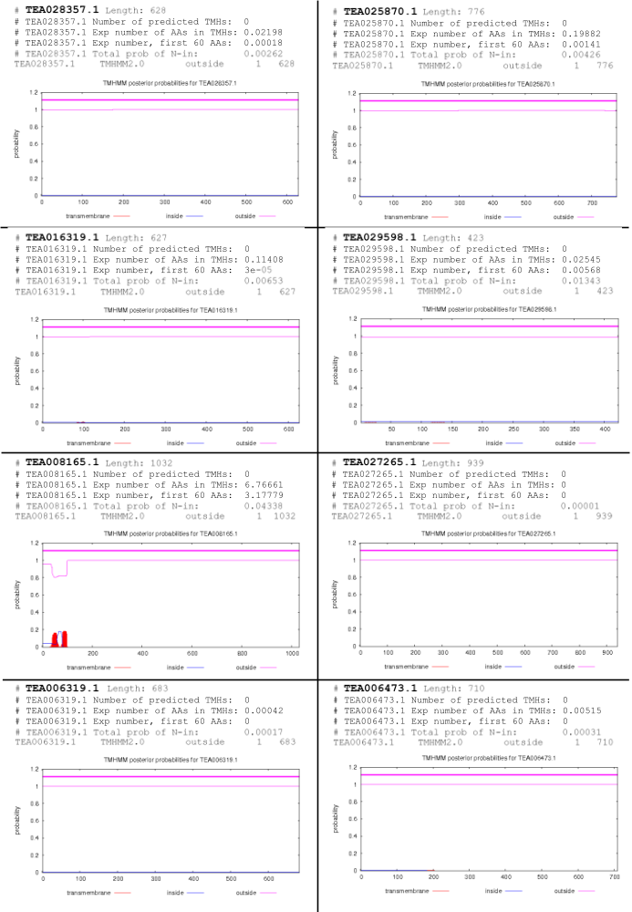
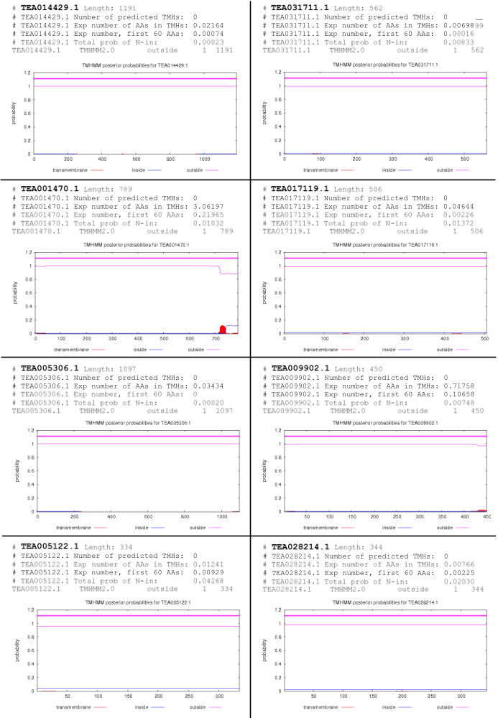

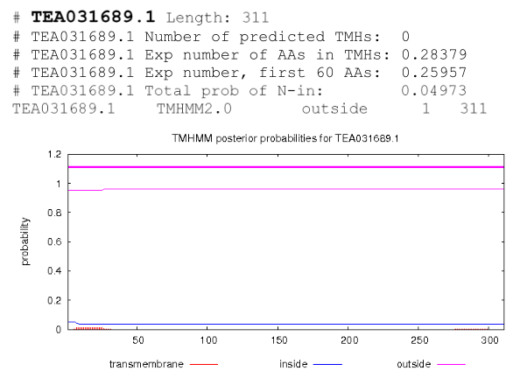

Supplementary Fig. S1 Transmembrane helices of MAPKKKs of MEKK subfamily in C. sinensis. TMHMM Server, v.2.0 (http://www.cbs.dtu.dk/services/TMHMM/), was used to generate the transmembrane helices.

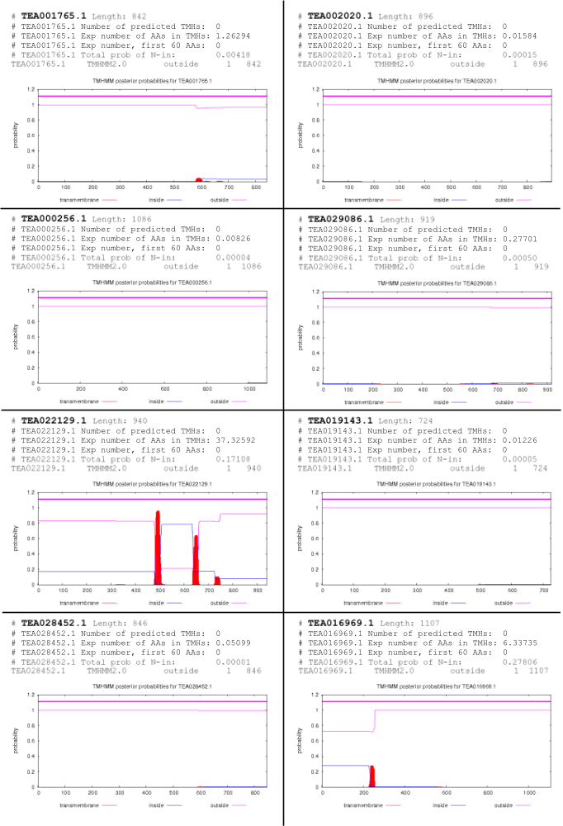

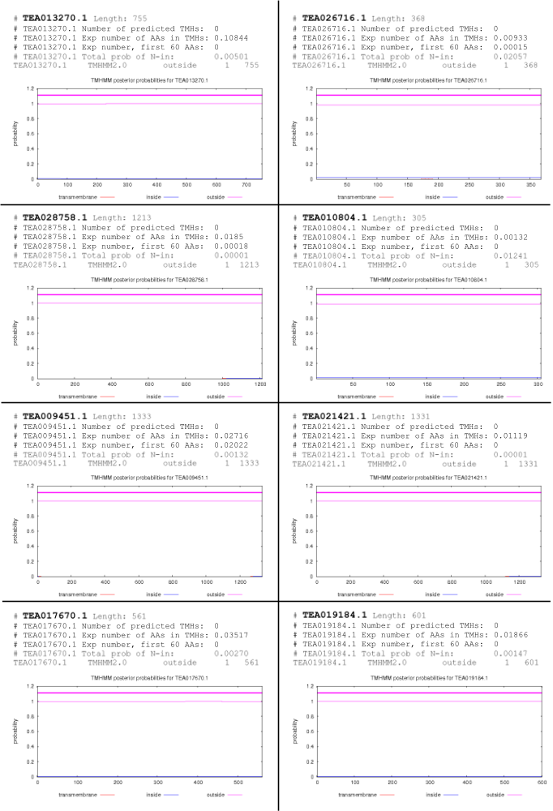
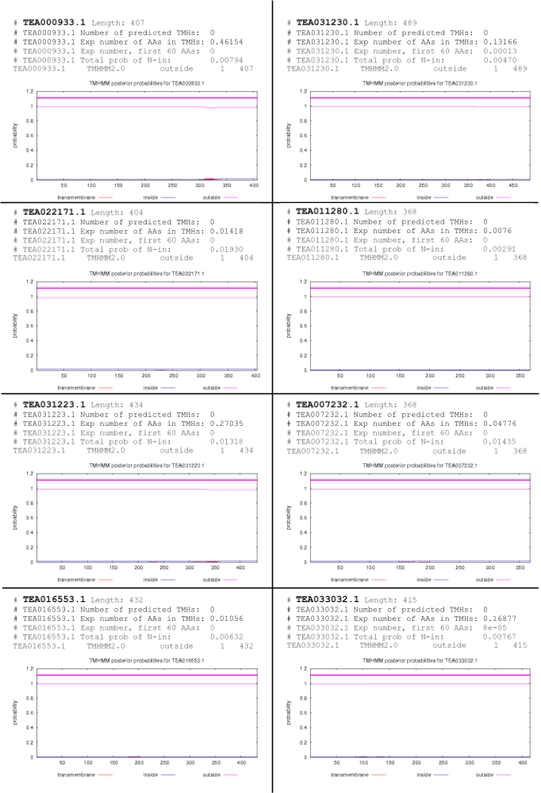

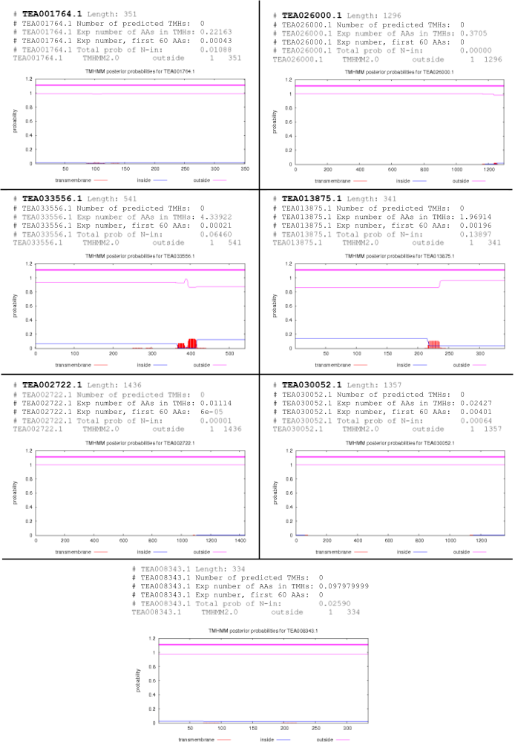
Supplementary Fig. S2 Transmembrane helices of MAPKKKs of Raf subfamily in C. sinensis. TMHMM Server, v.2.0 (http://www.cbs.dtu.dk/services/TMHMM/), was used to generate the transmembrane helices.
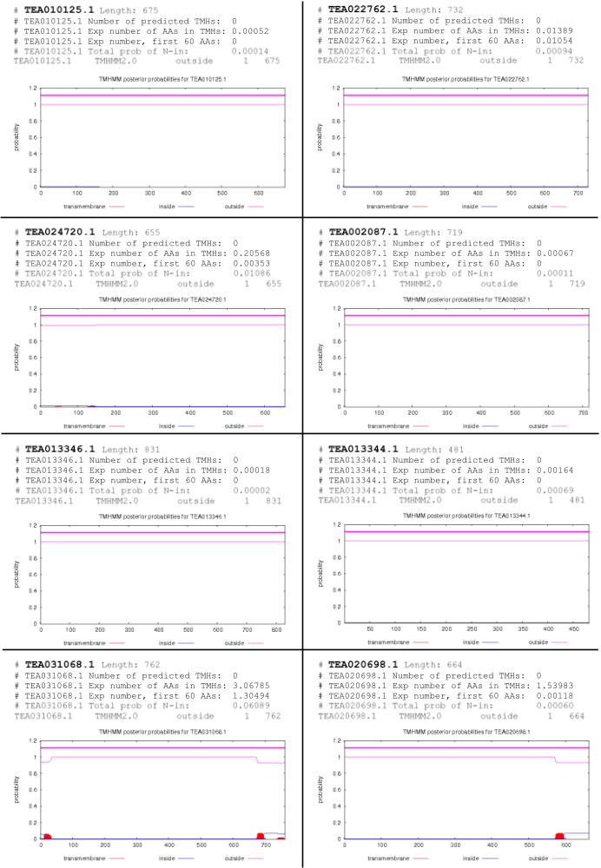
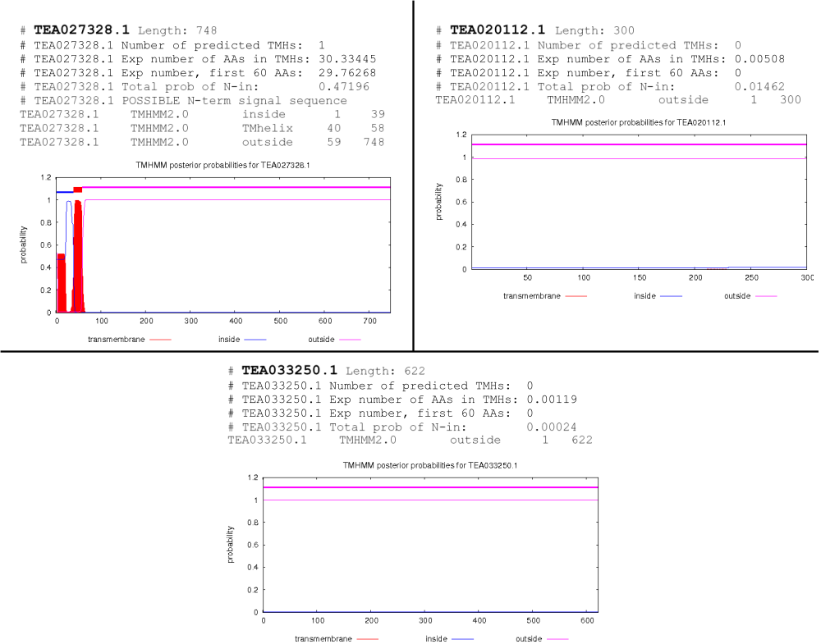
Supplementary Fig. S3 Transmembrane helices of MAPKKKs of ZIK subfamily in C. sinensis. TMHMM Server, v.2.0 (http://www.cbs.dtu.dk/services/TMHMM/), was used to generate the transmembrane helices.

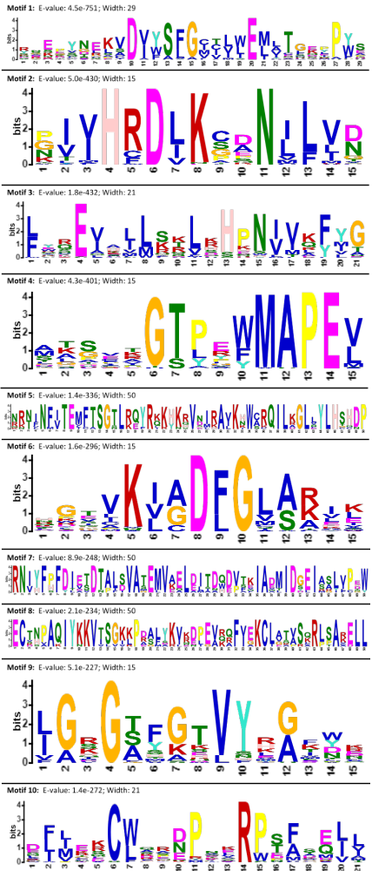

Supplementary Fig. S4 Motif logos of the 10 identified motifs in 59 MAPKKKs in C. sinensis. The motif logos were generated by MEME suite.
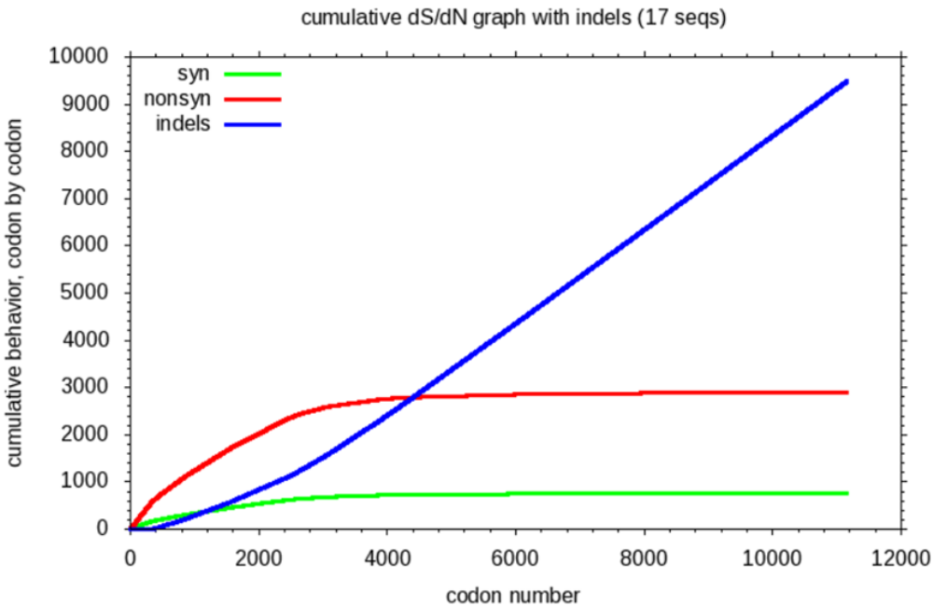
Supplementary Fig. S5 The ds/dn cumulative graph of MAPKKKs of MEKK subfamily in C. sinensis. SNAP server (https://www.hiv.lanl.gov/content/sequence/SNAP/SNAP.html) has been used to generate the graph.

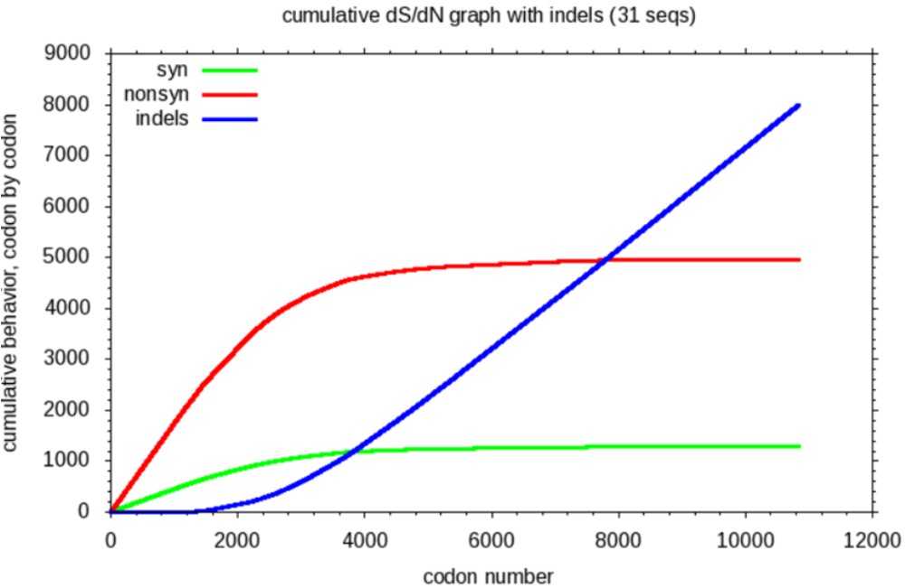
Supplementary Fig. S6 The ds/dn cumulative graph of MAPKKKs of Raf subfamily in C. sinensis. SNAP server (https://www.hiv.lanl.gov/content/sequence/SNAP/SNAP.html) has been used to generate the graph.

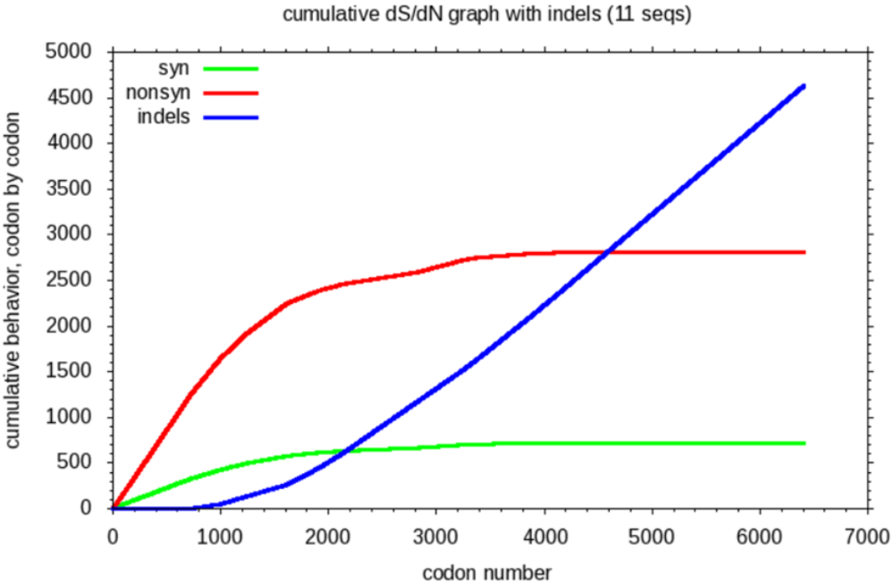
Supplementary Fig. S7 The ds/dn cumulative graph of MAPKKKs of ZIK subfamily in
C. sinensis. SNAP server (https://www.hiv.lanl.gov/content/sequence/SNAP/SNAP.html) has been used to generate the graph.

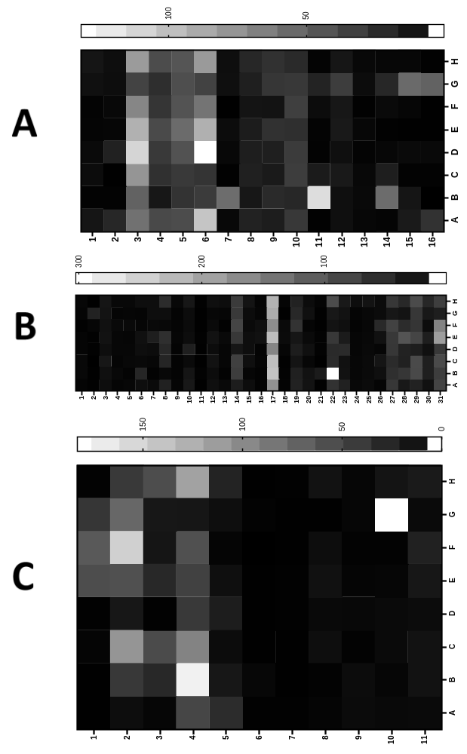

Supplementary Fig. S8 Heat maps for tissue-specific expression patterns of A) MEKK; B) Raf and; C) ZIK genes in C. sinensis. The relative expression of these genes was analysed in different developmental stages, by using GraphPad Prism 8 software. The level of expression was in transcript per million (TPM).

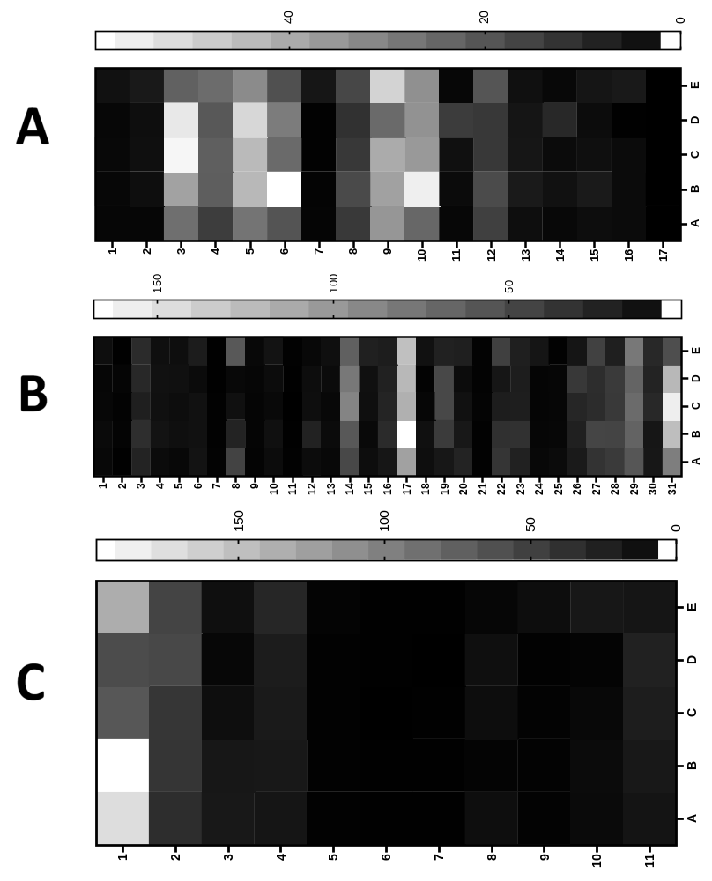

Supplementary Fig. S9 Heat maps for cold stress expression patterns of A) MEKK; B) Raf and; C) ZIK genes in C. sinensis. The relative expression of these genes was analysed in different developmental stages, by using GraphPad Prism 8 software. The level of expression was in transcript per million (TPM).

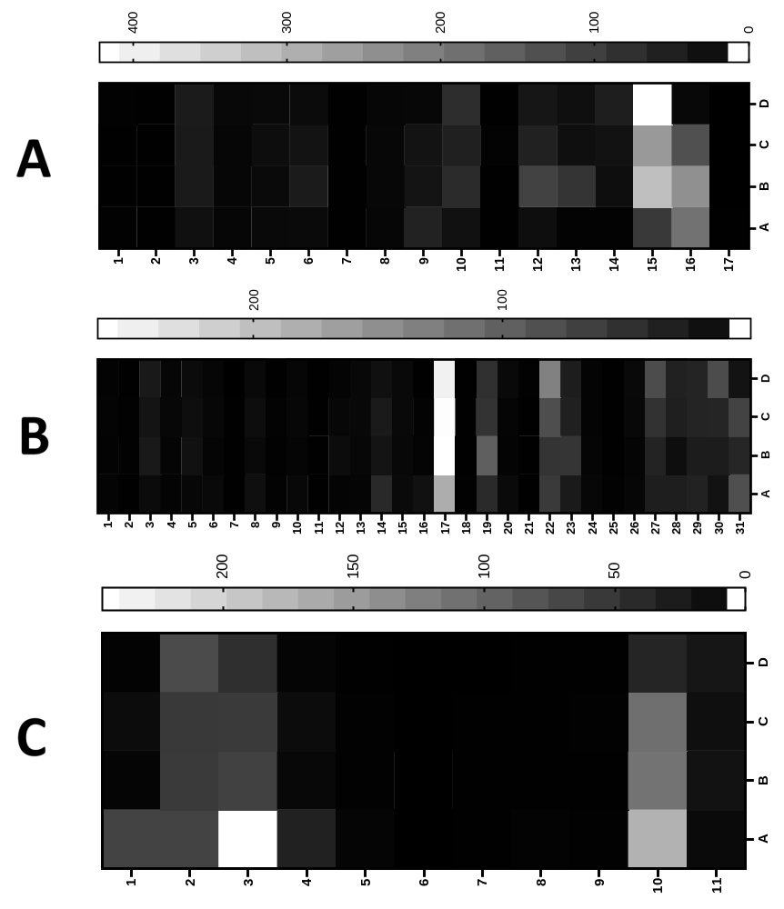

Supplementary Fig. S10 Heat maps for drought stress expression patterns of A) MEKK; B) Raf and; C) ZIK genes in C. sinensis. The relative expression of these genes was analysed in different developmental stages, by using GraphPad Prism 8 software. The level of expression was in transcript per million (TPM).

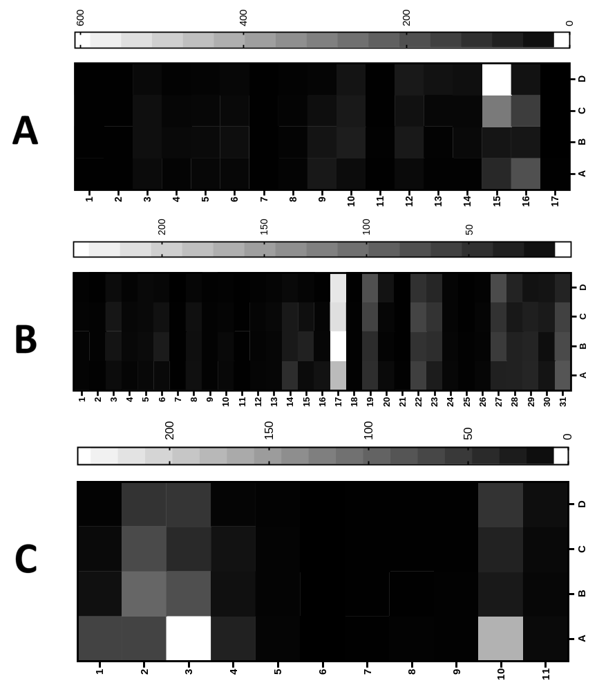

Supplementary Fig. S11 Heat maps for salt stress expression patterns of A) MEKK; B) Raf and; C) ZIK genes in C. sinensis. The relative expression of these genes was analysed in different developmental stages, by using GraphPad Prism 8 software. The level of expression was in transcript per million (TPM).

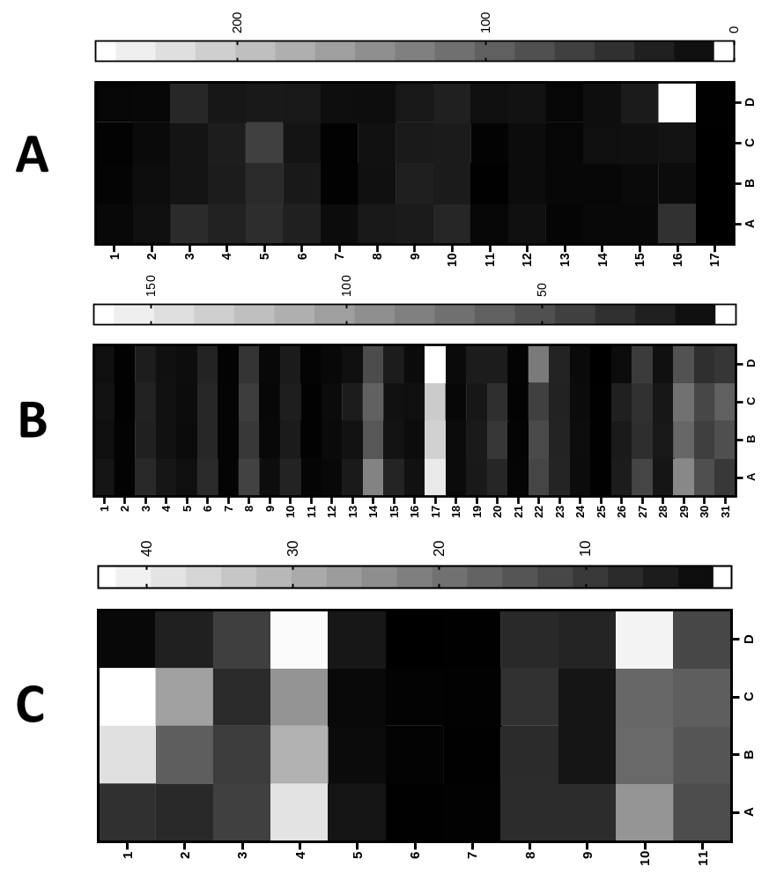

Supplementary Fig. S12 Heat maps for MeJA treatment expression patterns of A) MEKK;
B) Raf and; C) ZIK genes in C. sinensis. The relative expression of these genes was analysed in different developmental stages, by using GraphPad Prism 8 software. The level of expression was in transcript per million (TPM).

