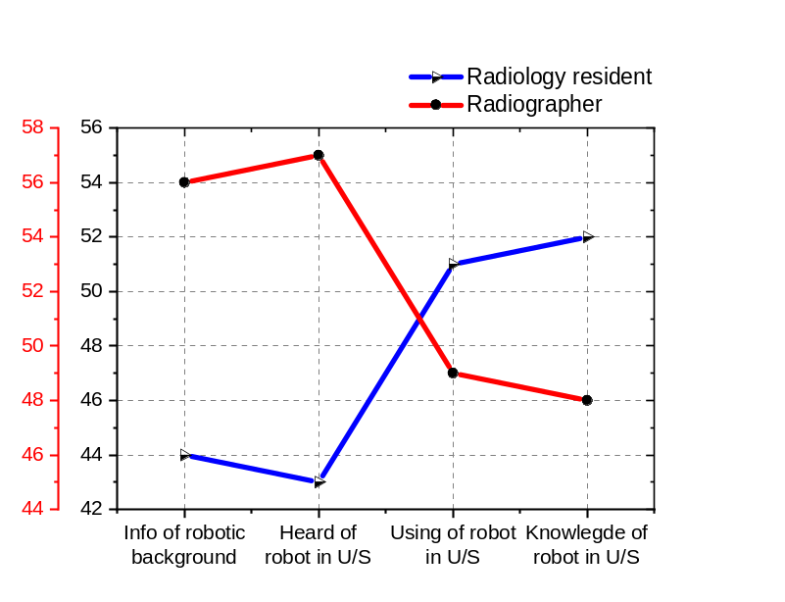
Info of robotic background 44 56
Heard of robot in U/S 43 57
Using of robot in U/S 51 49
Knowlegde of robot in U/S 52 48

Disease detection by robotic U/S 41 59
Auto diagnosis of robotic U/S 36 64
Benefits of robotic U/S 42 58
Altering radiologist+ sonographers 45 55
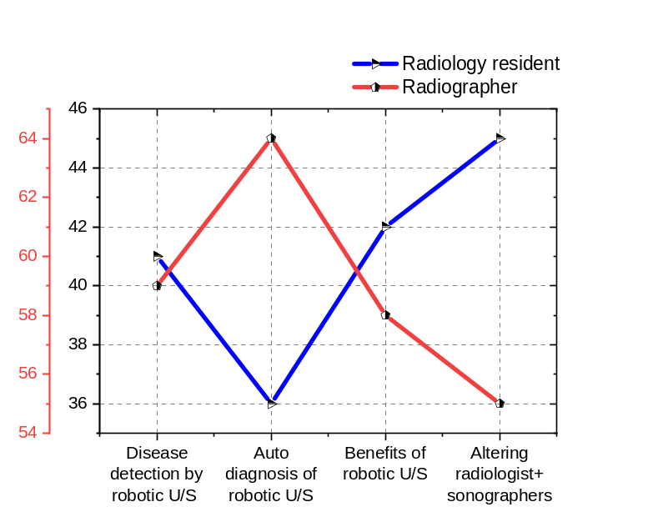

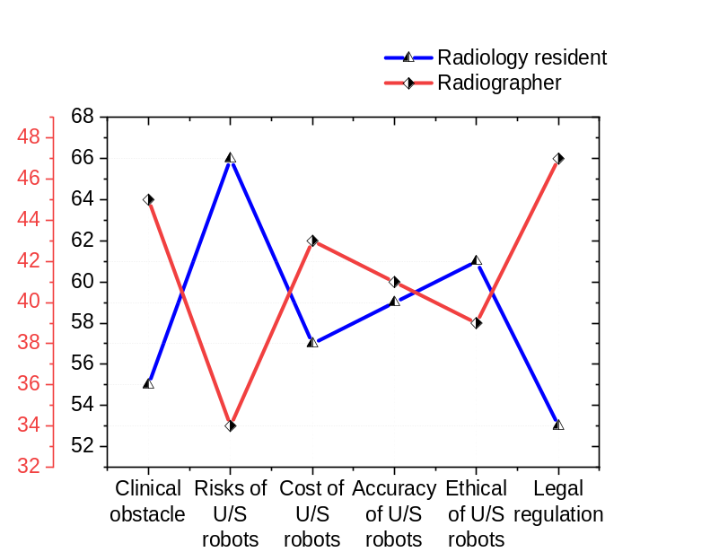
Clinical obstacle 55 45
Risks of U/S robots 66 34
Cost of U/S robots 57 43
Accuracy of U/S robots 59 41
Ethical of U/S robots 61 39
Legal regulation 53 47

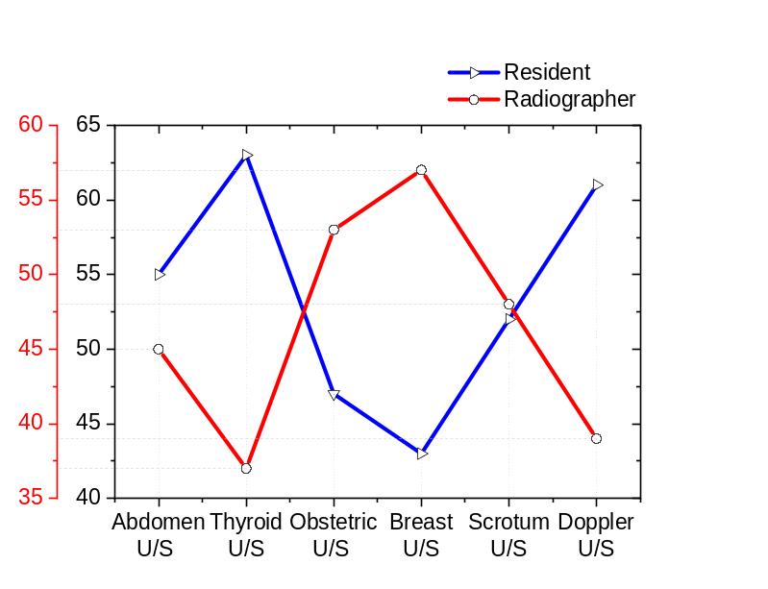

Abdomen U/S 55 45
Thyroid U/S 63 37
Obstetric U/S 47 53
Breast U/S 43 57
Scrotum U/S 52 48
Doppler U/S 61 39

Variable |  | Frequency | Percent %
- Category of professional | Radiology resident | 25 | 50
- Category of professional | Radiographer | 25 | 50
- Category of professional | total | 50
- Years of Experience | Less than 5 years | 16 | 32
- Years of Experience | 5-10 years | 24 | 48
- Years of Experience | More than 10 years | 10 | 20
- Years of Experience | total | 50
- Gender | Male | 27 | 54
- Gender | Female | 23 | 46
a)
b)

