S1: Proteomics measurements and quality control
Circulating proteins were measured using the Olink Proteomics multiplex platform (Uppsala, Sweden). The technology is based on a proximity extension assay (PEA) technique that is highly sensitive and avoids cross-reactivity with high reproducibility. The full protocol of the PEA has been reported previously.¹ All sample plates included eight internal control samples to monitor the quality of assay performance, as well as the quality of individual samples. The quality control (QC) was performed in two steps:
- Protein values per participant where average matched count between PEA measurements and NGS reads was less than 500 counts were removed as per Olink guidelines.
- Protein values per participant where deviation from the median value of the controls for each participant was greater than 0.3 NPX from the median were excluded.
Less than 2% of all protein measurements were excluded from analyses after QC steps.
For protein measurements, pairs of case-control samples were plated together, with the pairs randomly allocated over 88-well plates. Protein concentrations were measured by next-gen sequencing (qPCR) to quantify relative protein concentrations expressed as normalized protein expression (NPX) values on the log2 scale. Measurements below the lower limit of detection (LOD) were replaced with the Lower limit of detection (LOD) divided by the square-root of 2. A summary of proportion of protein measurements with values below LOD is presented in Table S1.

S2: Supplementary figures for identified risk proteins in relation to prostate cancer 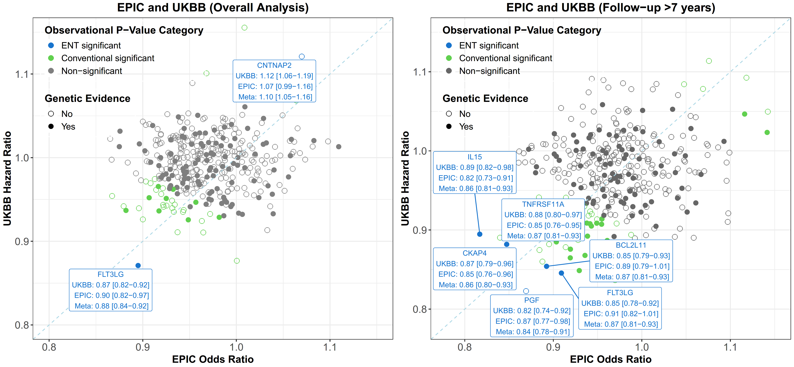
Figure S1: Scatterplot of inflammatory proteins and prostate from EPIC, UKBB and meta-analyses
The scatter plot illustrates the consistency of evidence between two observational studies (EPIC and UKBB). The labelled proteins are prostate cancer risk proteins identified in the main and long lag-time meta-analysis. The colours represent the degree of evidence from the meta-analysis: blue indicates ENT significance (P-value < 0.05/189), green represents conventional significance, and grey denotes non-significance. Filled circles indicate the presence of genetic evidence, which could originate from either exome analysis or MR analysis.

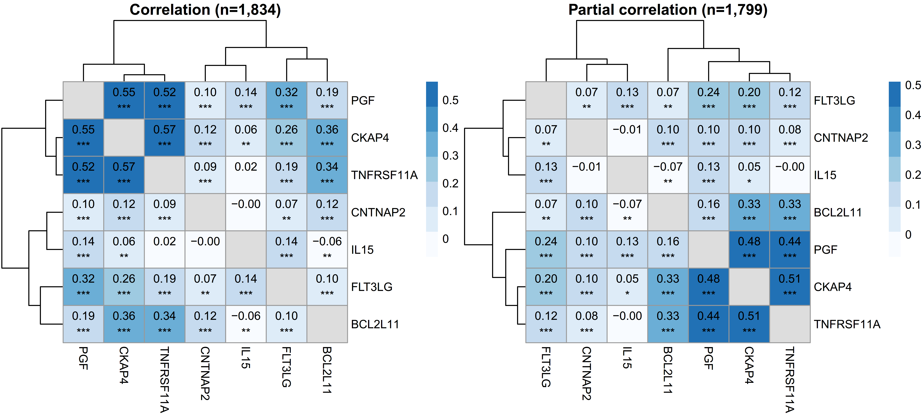
Figure S2: Pearson correlation coefficients among candidate risk proteins related to prostate cancer prostate cancer among EPIC matched case-control pairs diagnosed more than seven years after recruitment.
Significance levels: *, p < 0.05; **, p < 0.01; ***, p < 0.001.
Partial correlations are adjusted based on age at blood collection and BMI. The sample size is reduced by 35 due to missing BMI values.

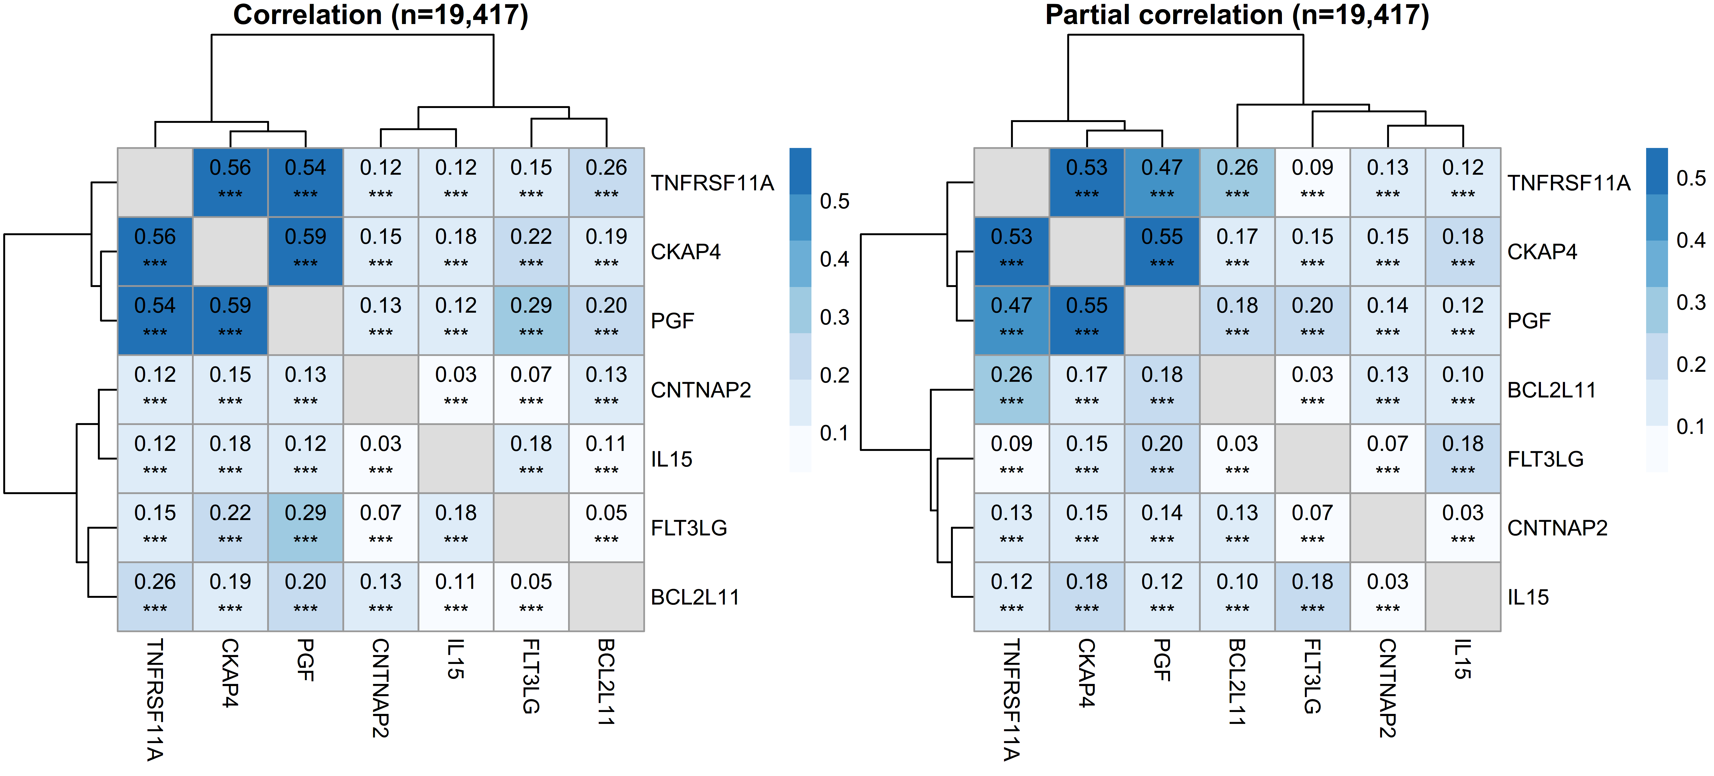
Figure S3: Pearson correlation coefficients among candidate risk proteins related to prostate cancer in the UKBB cohort diagnosed more than seven years after recruitment.
Significance levels: *, p < 0.05; **, p < 0.01; ***, p < 0.001.
Partial correlations are adjusted based on age at blood collection and BMI.

Figure S4: Relative risk (95% CI) for identified risk proteins in relation to prostate cancer diagnosed more than seven years from recruitment after pairwise and mutual adjustment, and percent change in the magnitude of the associations.
The analysis is based on data from EPIC, UKBB, and the combined EPIC+UKBB meta-analysis, assessing the association of risk proteins with prostate cancer diagnosed more than seven years from recruitment. Percent changes are calculated by comparing the magnitude of the association of each individual protein with risk to that after pairwise or mutual adjustment for all selected inflammatory risk proteins identified in the long lag time analyses (FLT3LG, IL15, PGF, TNFRSF11A, BCL2L11, and CKAP4) based on EPIC+UKBB meta-analysis. All models are additionally adjusted for smoking, alcohol intake, BMI, education, and diabetes status. The base model includes only the single protein in the model and adjusts for the above covariates.

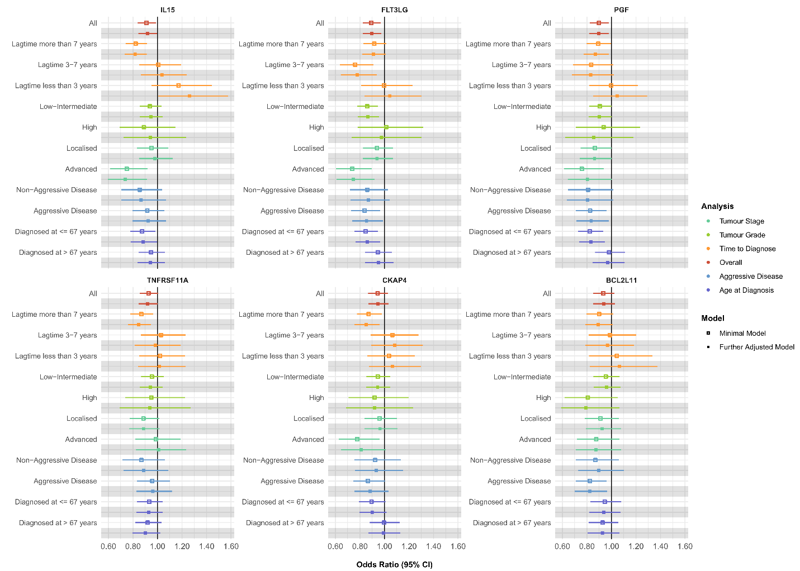
Figure S5: Model comparison for the association of selected inflammatory proteins and prostate cancer risk in EPIC study
Minimally Adjusted Model: Adjustment for exact age at blood collection.
Fully Adjusted Model: Additional adjustment for smoking, alcohol intake, attained education level, and diabetes status.

S3: Protein-protein interaction network
Bayesian network analysis was used to explore the inter-relationships among proteins associated with prostate cancer. This approach relies on a probabilistic graphical model, where proteins were represented as nodes and their interdependencies as directed edges.² We selected a set of proteins significantly associated with prostate cancer (p ≤ 0.01) from the EPIC+UK Biobank meta-analysis in sub-group analysis with more than 7 years of follow-up (25 proteins). Using hill-climbing learning method, the algorithm starts with an initial network structure and iteratively modifies the structure (by adding, removing, or reversing edges), aiming to optimize the fit of the model using Bayesian Information Criterion (BIC), which balances model fit and the complexity of the network. The learning process iterated until convergence, in which no modification to the network structure improves the fit of the model. Analyses were conducted using data from cases and their matched controls with more than seven years of follow-up.
To emphasize the most important interactions, edges displaying weaker associations (strength below the 40th quantile) were excluded. Additionally, proteins not directly related to the target proteins (IL15, FLT3LG, CKAP4, PGF, TNFRSF11A, and BCL2L11) were omitted from the network result (only 15 proteins remained in the final analysis).
The protein-protein networks among cases and separately among controls with more than 7 years of follow-up are presented in Supplementary Figure S6 & Supplementary Figure S7, respectively. To compare the interconnection among cases and controls, we conducted a differential analysis based on nodes’ degree of protein-protein interaction network between cases and controls (cases-controls) presented in Supplementary Figure S8.

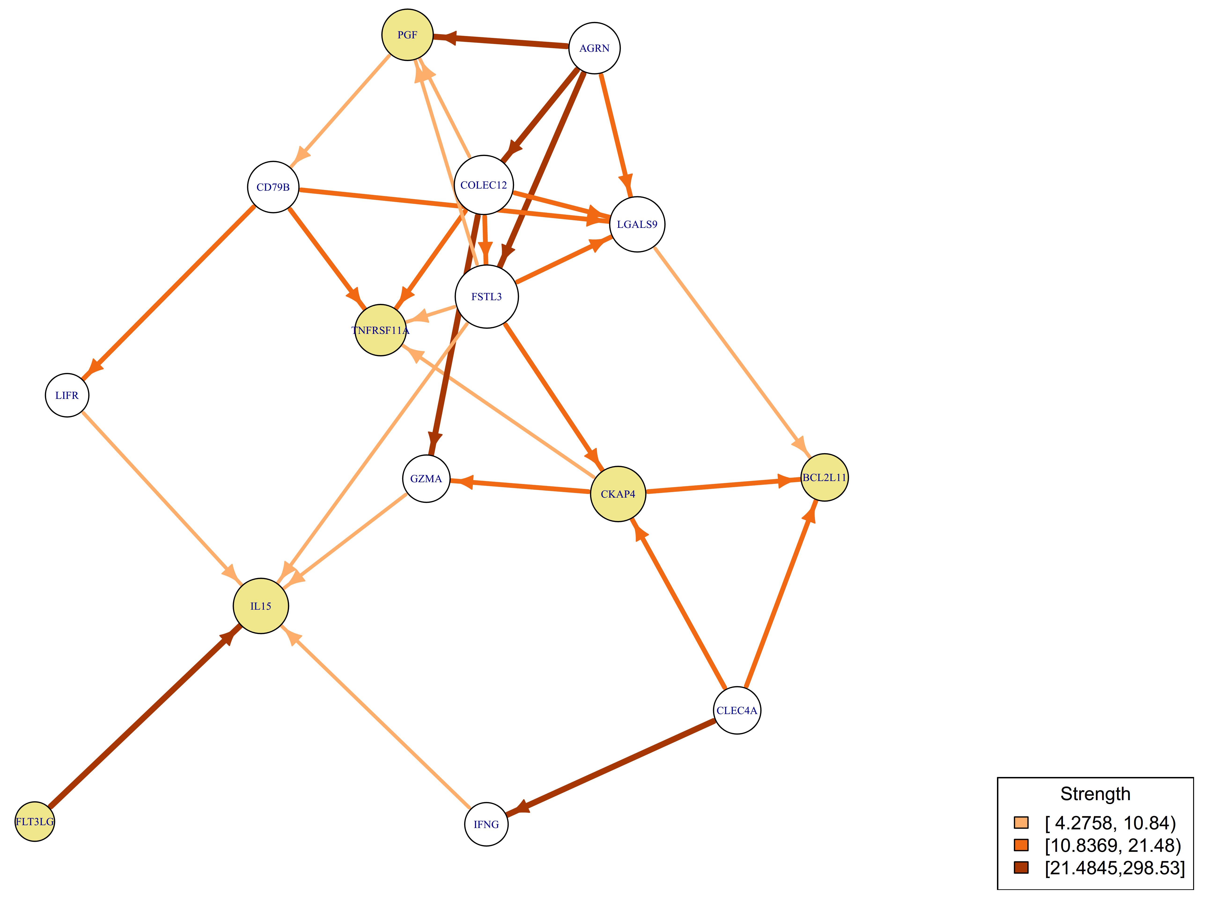

Figure S6: Network analysis of proteins associated with prostate cancer risk in cases with more than 7 years of follow-up (p < 0.01) in EPIC participants with prostate cancer.
Nodes in yellow refer to those prostate cancer risk proteins identified in the long lag-time meta-analysis.

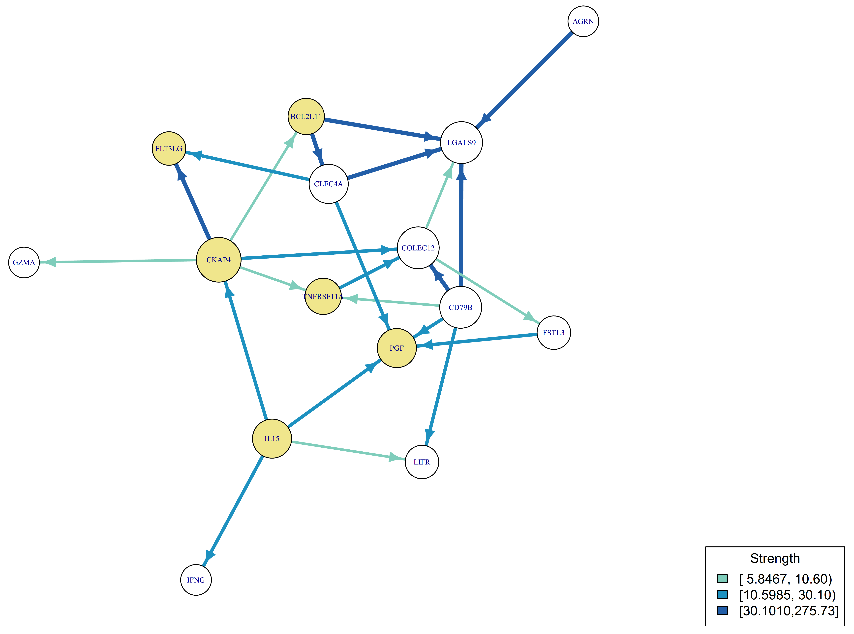
Figure S7: Network analysis of proteins associated with prostate cancer risk in cases with more than 7 years of follow-up (p < 0.01) in EPIC participants without prostate cancer.
Nodes in yellow refer to those prostate cancer risk proteins identified in the long lag-time meta-analysis.

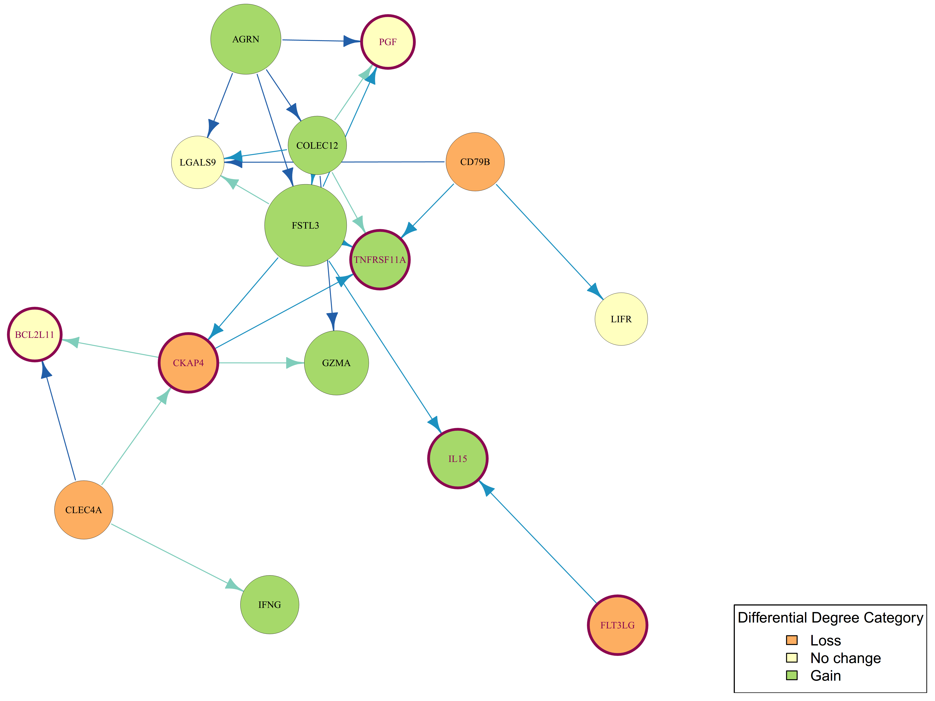

Figure S8: Differential analysis of network of proteins associated with prostate cancer risk in cases with more than 7 years of follow-up (p < 0.01) based on the nodes’ degree between cases and controls (case –control) in EPIC participants.
Nodes with a red ring refer to those prostate cancer risk proteins identified in the long lag-time meta-analysis.
Loss: Less connected among cases, No Change: Similar connections in cases and controls, Gain: More connected among cases

S4: Cross cancer analysis of candidate prostate cancer risk proteins

S4.1 Cross cancer analysis in the UK Biobank cohort study
UK Biobank endpoints definition for the observational analyses
For associations with prostate cancer identified in both observational and genetic analyses, we examined the relationship of these proteins with other cancer outcomes using UK Biobank (UKBB) data. Cancer outcomes were defined based on the 10th revision of the World Health Organization’s International Statistical Classification of Diseases (ICD-10), including head and neck (C00–C14, C32), oesophagus (C15), stomach (C16), colorectum (C18–C20), liver (C22), pancreas (C25), lung (C34), malignant melanoma (C43), breast in women (C50), uterine (C54), ovary (C56), prostate (C61), kidney (C64–C65), bladder (C67), brain (C71), thyroid (C73), and blood cancers, including non-Hodgkin lymphoma (NHL; C82–C85), multiple myeloma (C90), and leukaemia (C91–C95). The following sub-classifications of these cancer groupings were also considered: oral (C00–14) and lip and oral cavity (C00–06) within head and neck cancers (C00–14, C32); adenocarcinoma of the oesophagus (C15, morphology codes ICD-O-3 8140–8573) within oesophageal cancer (C15); colon (C18) and rectum (including rectosigmoid junction, C19–20) within colorectal cancer (C18–20); adenocarcinoma of the lung (C34, morphology codes ICD-O-3 8140, 8211, 8250–8260, 8310, 8323, 8480–8490 and 8550), squamous cell carcinoma (C34, morphology codes ICD-O-3 8070-8072), small cell carcinoma (C34, morphology codes ICD-O-3 8041-8042) within lung cancer (C34); and diffuse lymphoma (C83) within NHL (C82–85).

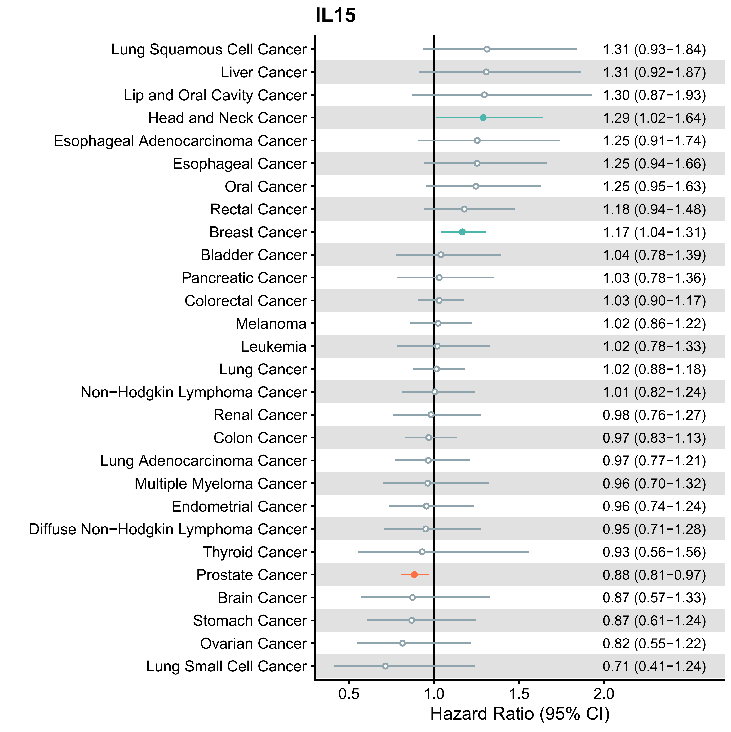
Figure S9: Observational analysis of IL15 in relation to risk for prostate cancer and other cancers diagnosed more than seven years after recruitment in the UK Biobank cohort study.
Results in red refer to those for risk of prostate cancer, while those in blue indicate an association with p < 0.05. Hollow points indicate p > 0.05.
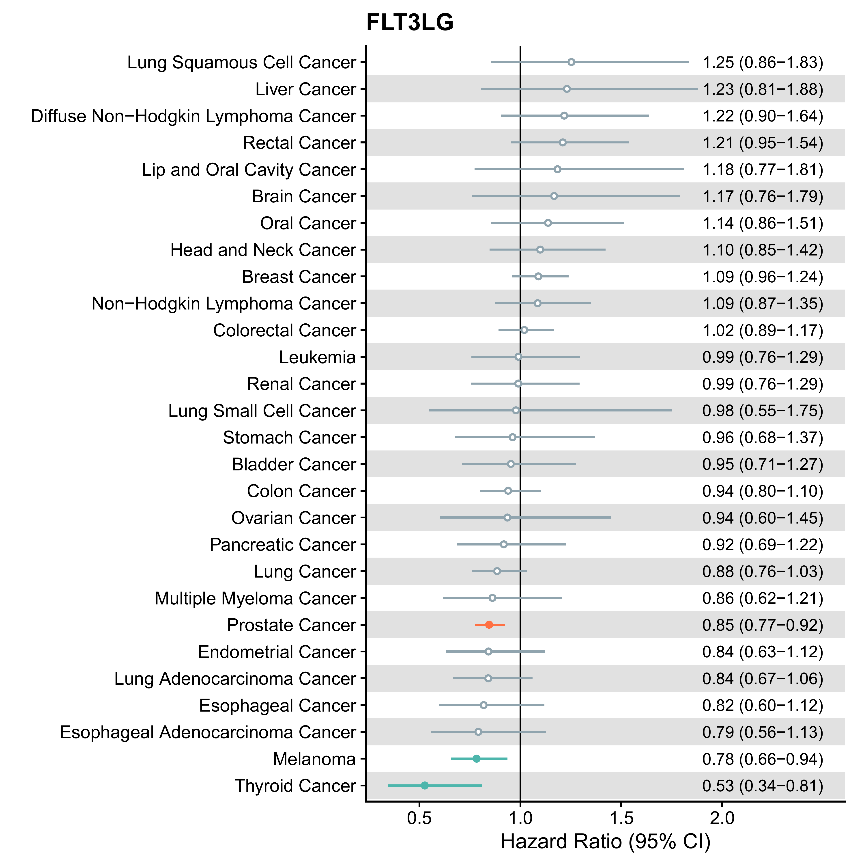
Figure S10: Observational analysis of FLT3LG in relation to risk for prostate cancer and other cancers diagnosed more than seven years after recruitment in the UK Biobank cohort study.
Results in red refer to those for risk of prostate cancer, while those in blue indicate an association with p < 0.05. Hollow points indicate p > 0.05.

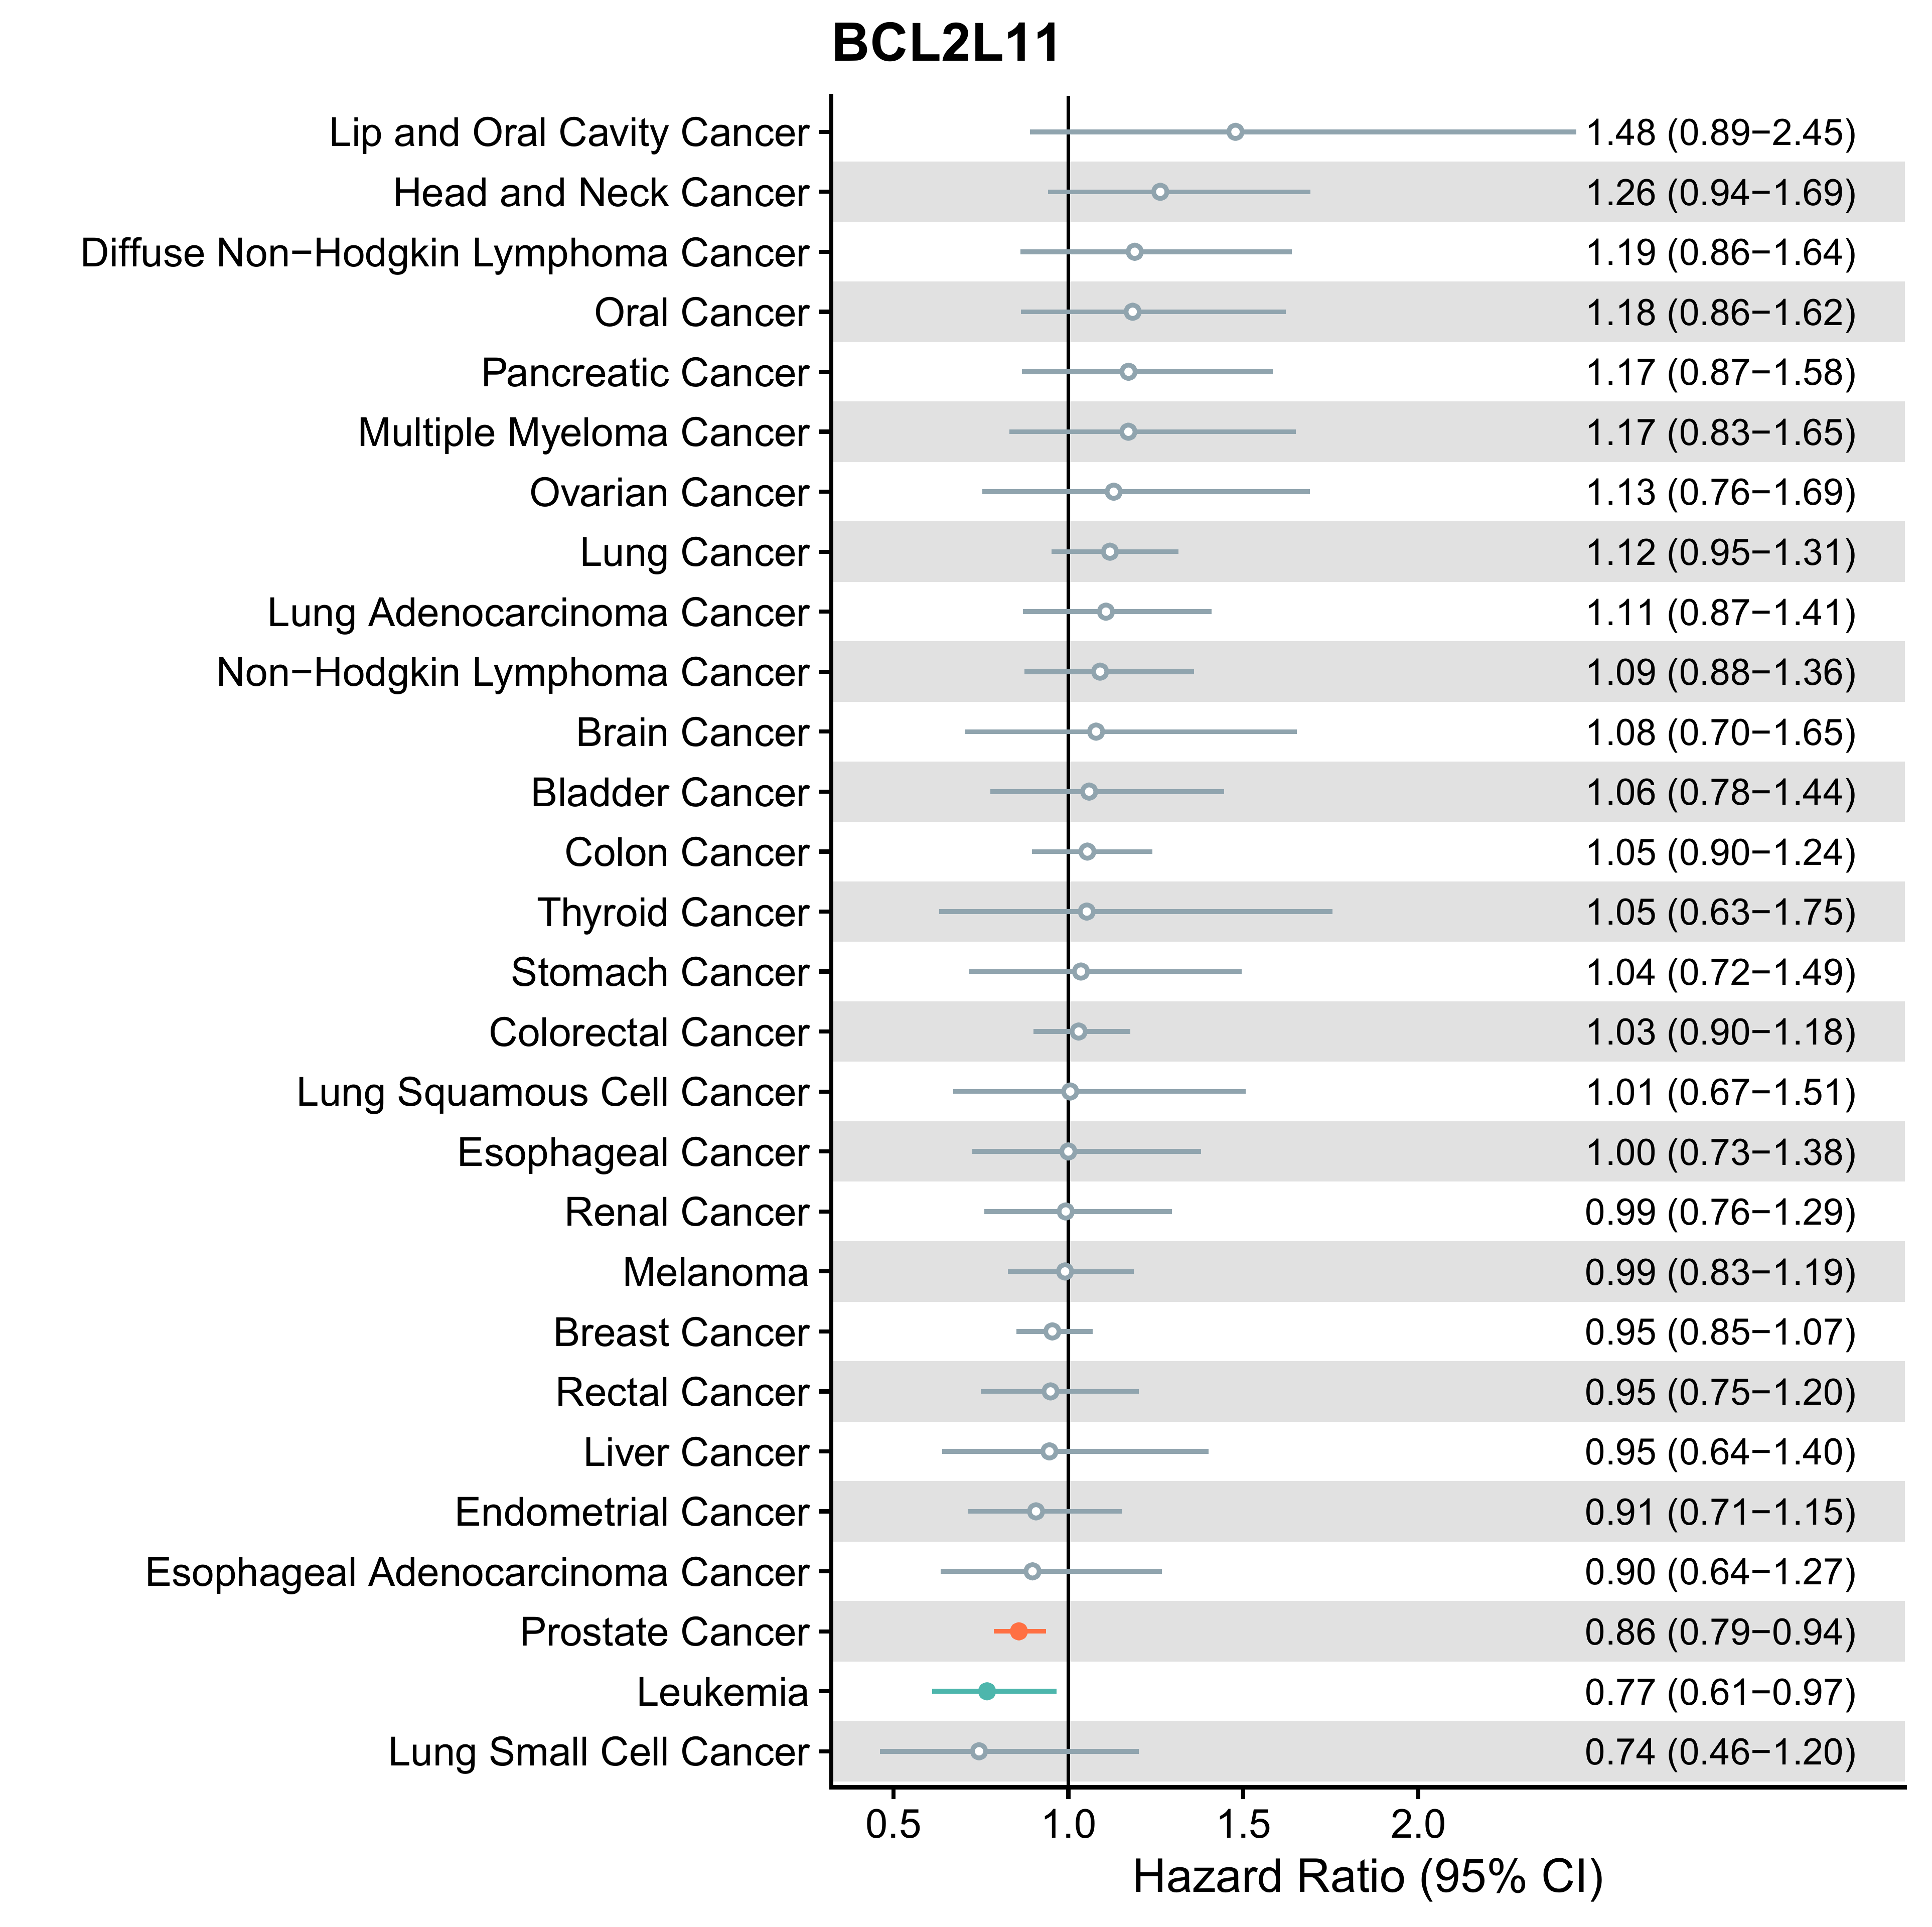
Figure S11: Observational analysis of BCL2L11 in relation to risk for prostate cancer and other cancers diagnosed more than seven years after recruitment in the UK Biobank cohort study.
Results in red refer to those for risk of prostate cancer, while those in blue indicate an association with p < 0.05. Hollow points indicate p > 0.05.

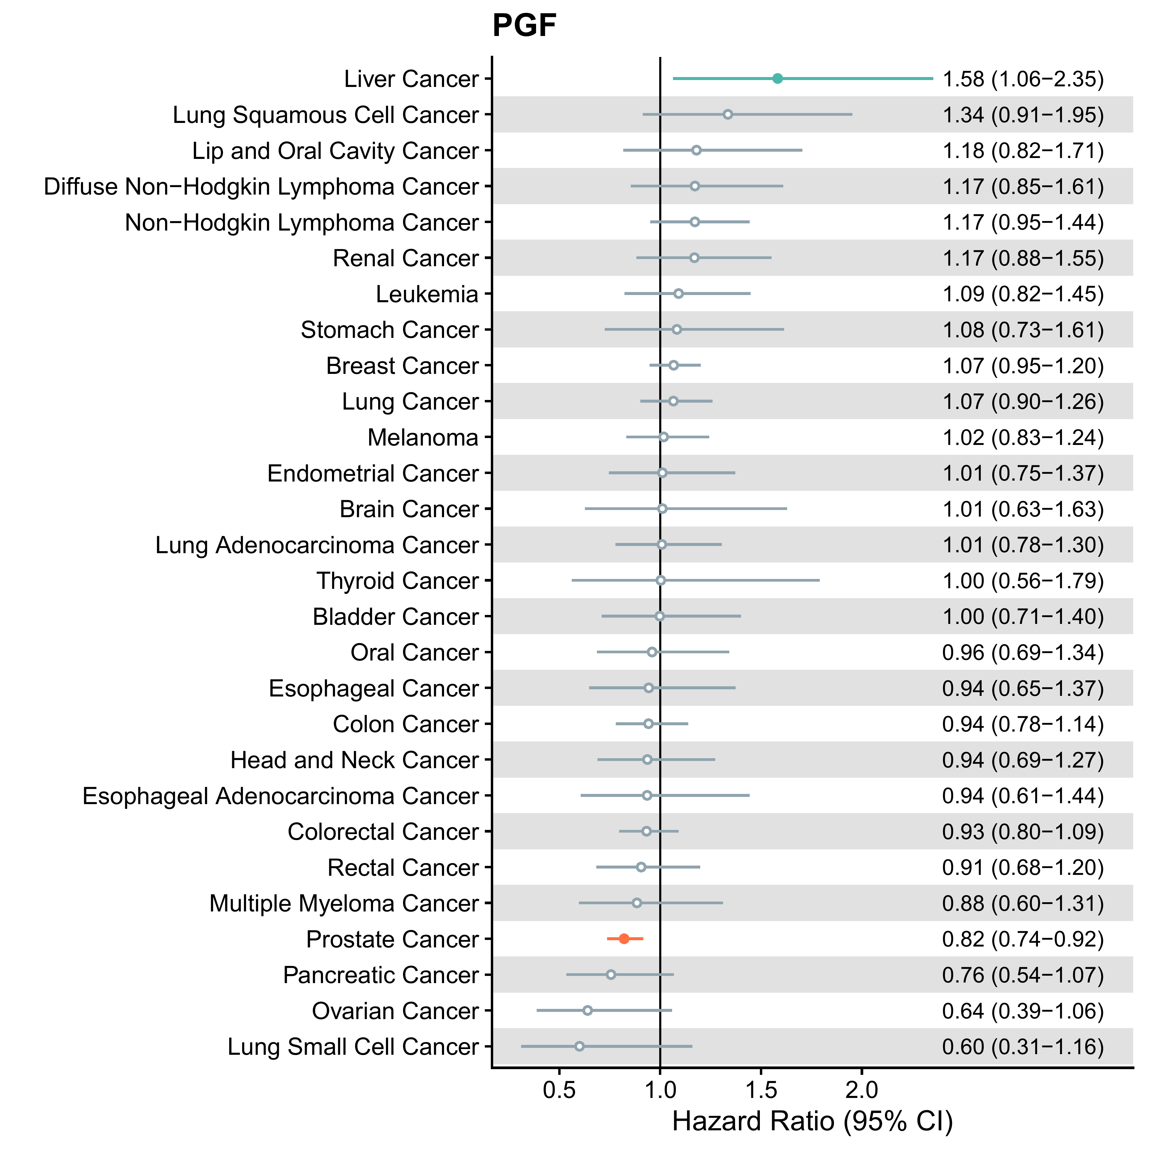
Figure S12: Observational analysis of PGF in relation to risk for prostate cancer and other cancers diagnosed more than seven years after recruitment in the UK Biobank cohort study.
Results in red refer to those for risk of prostate cancer, while those in blue indicate an association with p < 0.05. Hollow points indicate p > 0.05.
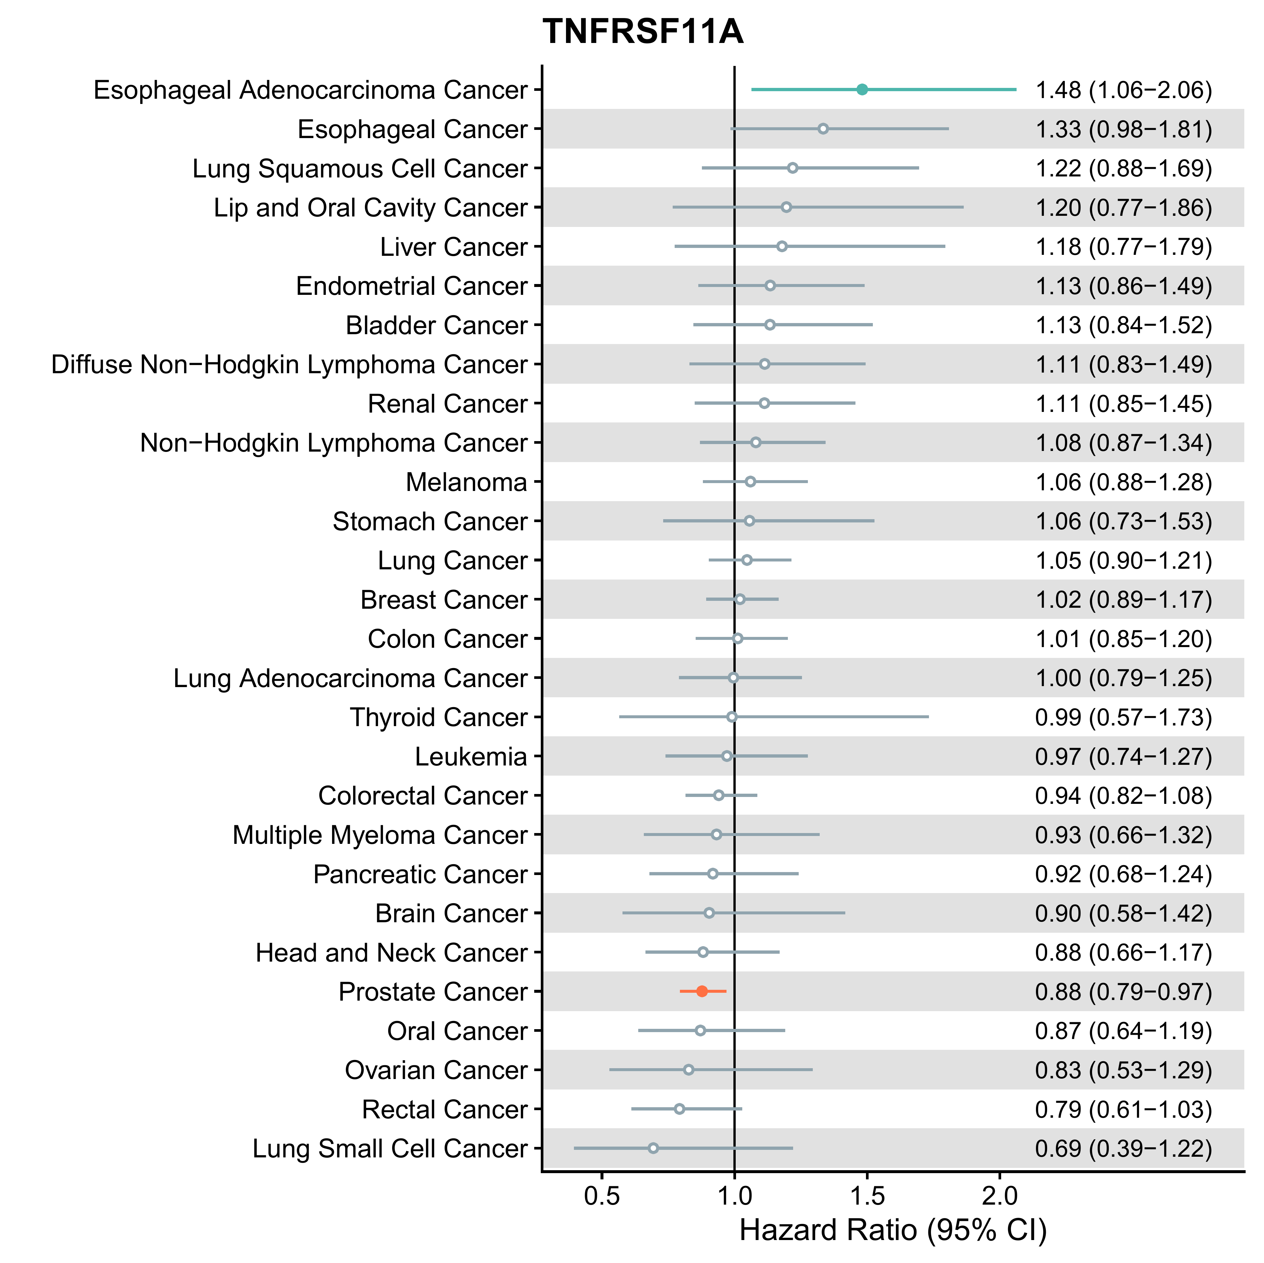
Figure S13: Observational analysis of TNFRSF11A in relation to risk for prostate cancer and other cancers diagnosed more than seven years after recruitment in the UK Biobank cohort study.
Results in red refer to those for risk of prostate cancer, while those in blue indicate an association with p < 0.05. Hollow points indicate p > 0.05.

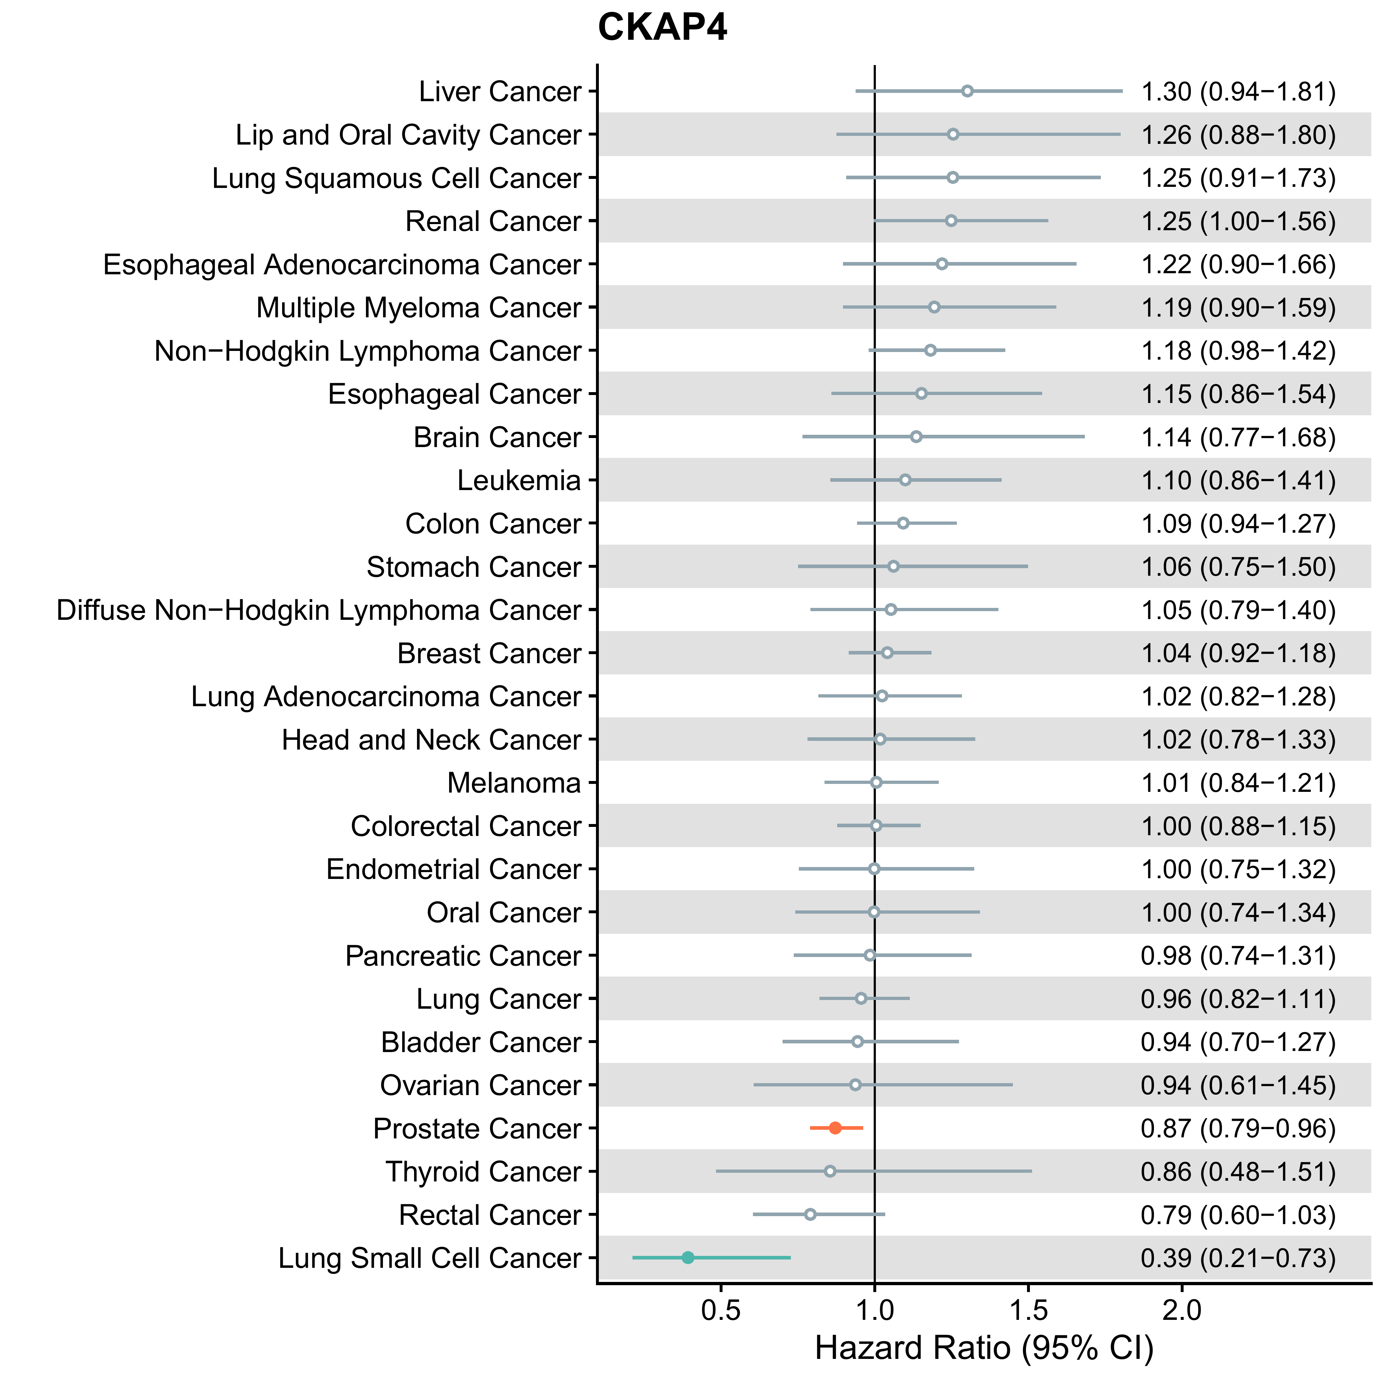
Figure S14: Observational analysis of CKAP4 in relation to risk for prostate cancer and other cancers diagnosed more than seven years after recruitment in the UK Biobank cohort study.
Results in red refer to those for risk of prostate cancer, while those in blue indicate an association with p < 0.05. Hollow points indicate p > 0.05.
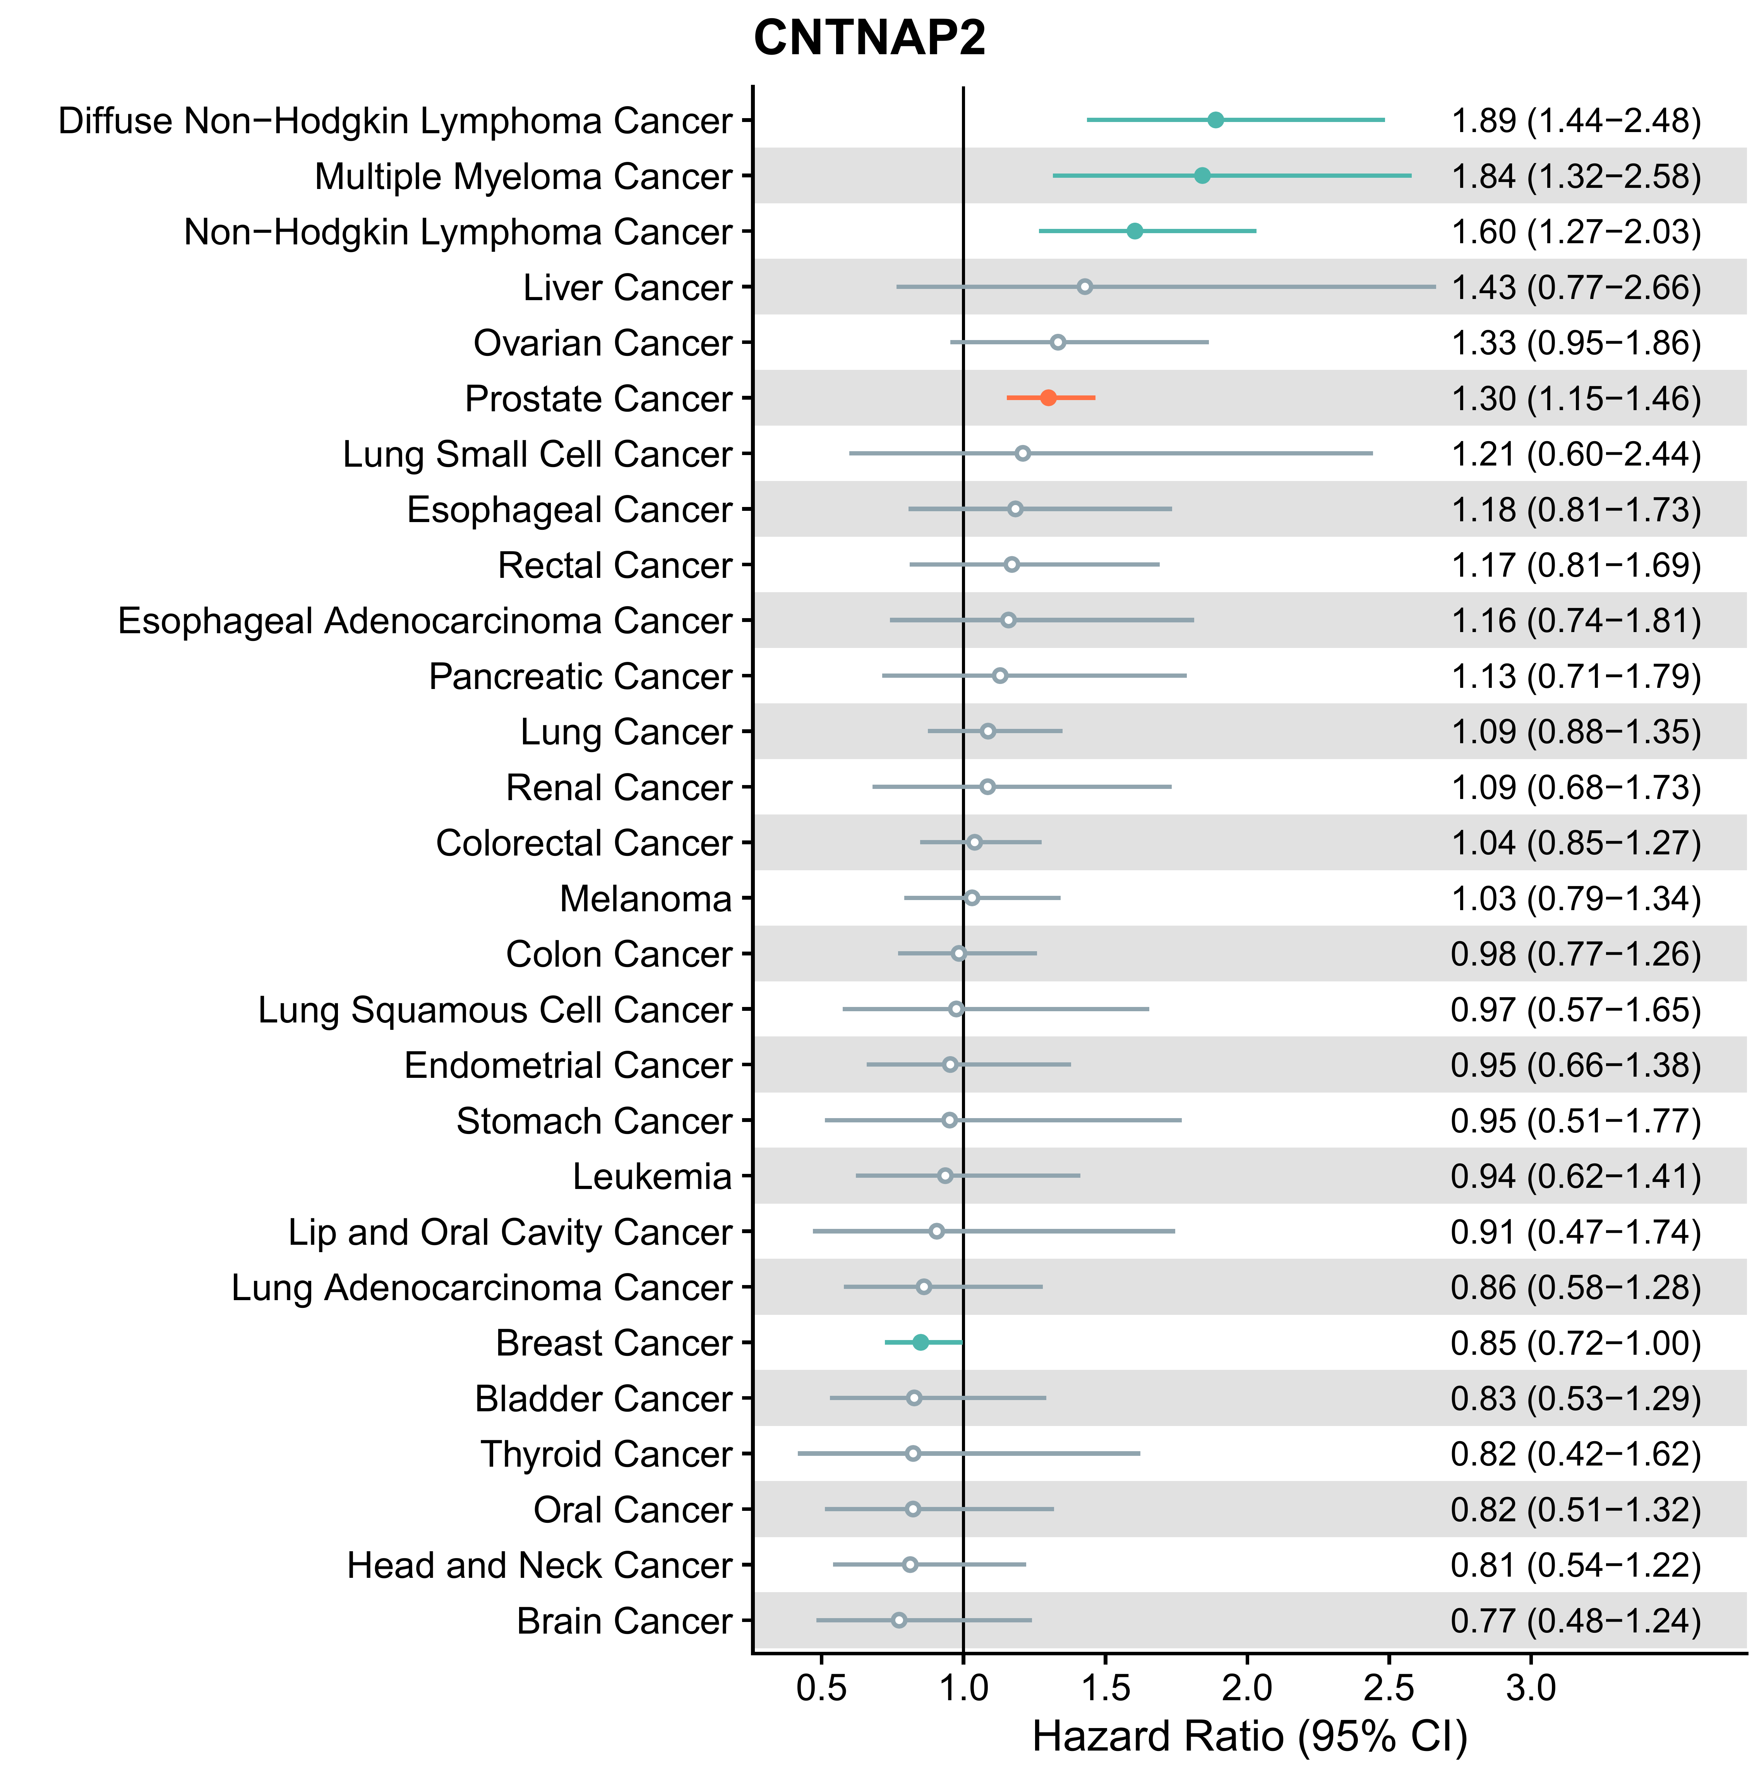
Figure S15: Observational analysis of CNTNAP2 in relation to risk for prostate cancer and other cancers diagnosed less than three years after recruitment in the UK Biobank cohort study.
Results in red refer to those for risk of prostate cancer, while those in blue indicate an association with p < 0.05. Hollow points indicate p > 0.05.

S4.2 Cross cancer analysis based on MR results
Summary of GWAS used in MR analyses
Bladder (ICD-10: C67). GWAS summary statistics were obtained from a meta-analysis involving 8,988 cases and 11,978 controls of European ancestry.³ Breast (ICD-10: C50). GWAS summary statistics were obtained for overall breast cancer (133,384 cases and 113,789 controls) and for breast cancer stratified by oestrogen receptor status (ER-positive: 69,501 cases and 105,974 controls; ER-negative: 21,468 cases and 105,974 controls) and by molecular subtypes (luminal B-like, luminal A-like, luminal /HER2-negative-like, HER2-enrichedlike, and triple negative).⁴ All analyses were in participants of European ancestry. Colorectum (ICD-10: C18-C20). GWAS summary statistics were taken from a meta-analysis involving 78,473 cases and 107,143 controls of European ancestry.⁵ Endometrium (ICD-10: C54.1). GWAS summary statistics came from the Endometrial Cancer Association Consortium, with 121,885 participants of European ancestry (12,906 cases and 108,979 controls).⁶ Head and Neck. GWAS summary statistics for head and neck cancer (6,034 cases and 6,585 controls) based on ICD-10 codes: oral cavity (2,641 cases) (C02.0–C02.9, C03.0–C03.9, C04.0–C04.9 and C05.0–C06.9) and oropharynx (2,990 cases) (C01.9, C02.4 and C09.0–C10.9). The study population included individuals from Europe (45.3%), North America (43.9%) and South America (10.8%).⁷ Kidney (ICD-10: C64). GWAS summary statistics for kidney cancer was obtained from a meta-analysis involving 25,890 cases and 743,585 controls of European ancestry.⁸ Lung (ICD-10: C34). GWAS summary statistics for overall lung cancer came from a meta-analysis of a case-control GWAS for lung cancer (29,266 cases and 56,450 controls) and a GWAS of family history of lung cancer in the UK Biobank (48,843 proxy cases and 195,387 controls), with a total effective sample size of 41,477 cases and 105,297 controls.⁹ We also obtained summary data by smoking status (never: 2,355 cases and 7,504 controls; ever: 23,223 cases and 16,964 controls), and by histological subtypes from the INTEGRAL-ILCCO cohort (adenocarcinoma: 11,273 cases and 55,483 controls; squamous cell carcinoma: 7,426 cases and 55,627 controls; small cell carcinoma: 2,664 cases and 21,444 controls).¹⁰ All analyses were in participants of European descent. Ovary (ICD-10: C56). GWAS summary statistics were obtained from the Ovarian Cancer Association Consortium (OCAC), for invasive epithelial ovarian cancer (25,509 cases and 40,941 controls) and for histological subtypes: high-grade serous carcinoma (13,037 cases), endometrioid carcinoma (2,810 cases), invasive mucinous ovarian cancer (1,417 cases), clear cell carcinoma (1,366 cases), and high/low grade serous carcinoma (14,049 cases), with 40,941 controls for all subtypes.¹¹ All analyses were in European descents. Pancreas (ICD-10: C25). GWAS data were extracted from the PanScan and PanC4 consortia (with 7,638 cases and 7,364 controls of European ancestry) via the National Center for Biotechnology Information database of Genotypes and Phenotypes (dbGaP; Study Accession: phs000206.v3.p2 and phs000648.v1.p1; project reference #9314).¹² Additional cancer endpoints. GWAS summary statistics were obtained from meta-analyses of European descents from FinnGen (412,181 participants) and UKB (42,0531 participants) for the following cancers: oesophageal (ICD-10: C15, 1594 cases), stomach (C16, 2187 cases), thyroid (C73, 2334 cases), uterine (C54, 4454 cases), brain (C71, 1486 cases), melanoma of skin (C43, 5792 cases), and blood cancers including follicular (C82, 1717 cases), non-follicular (C83, 3903 cases), diffuse B-cell (C83, 1811 cases), and mature T/NK lymphoma (C84, 514 cases), multiple myeloma (C90, 2097 cases), lymphoid leukaemia (C91, 2419 cases), and myeloid leukaemia (C92, 1301 cases).¹³⁻¹⁵

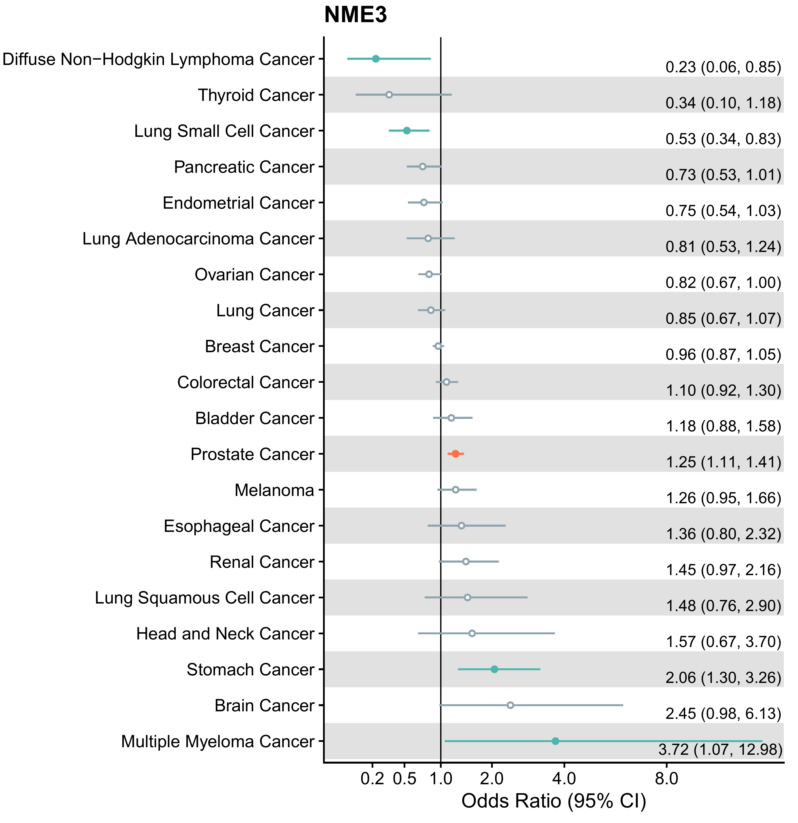
Figure S16: MR analysis of NME3 in relation to risk for prostate cancer and other cancers.
Results in red refer to those for risk of prostate cancer, while those in blue indicate an association with p < 0.05. Hollow points indicate p > 0.05.

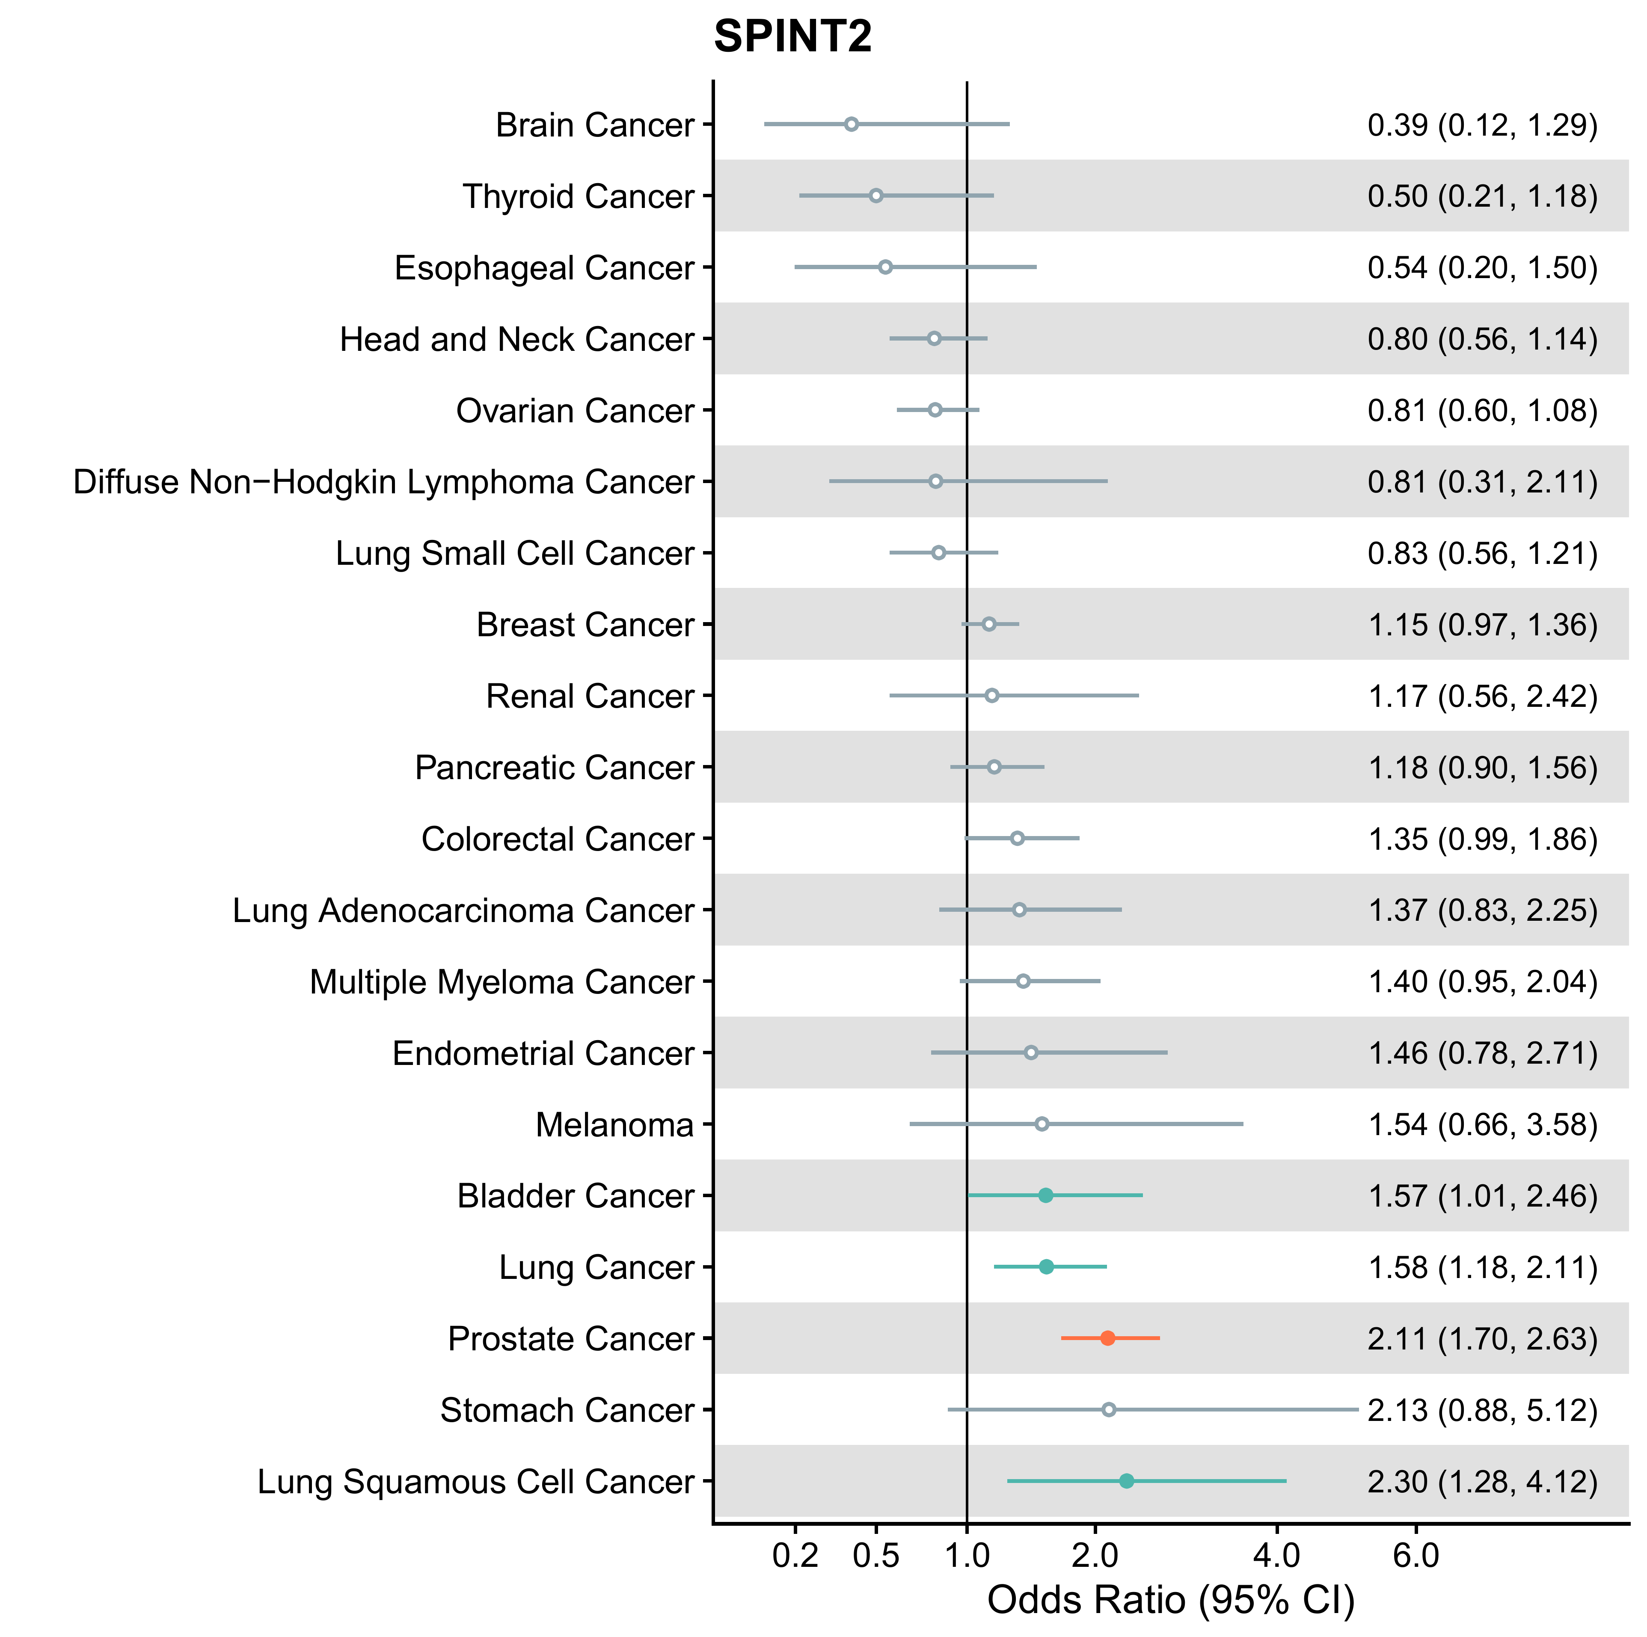
Figure S17: MR analysis of SPINT2 in relation to risk for prostate cancer and other cancers.
Results in red refer to those for risk of prostate cancer, while those in blue indicate an association with p < 0.05. Hollow points indicate p > 0.05.

References
1. PEA – a high-multiplex immunoassay technology with qPCR or NGS readout2020. https://www.olink.com/content/uploads/2021/09/olink-white-paper-pea-a-high-multiplex-immunoassay-technology-with-qpcr-or-ngs-readout-v1.0.pdf (accessed.
2. Scutari M, Denis J-B. Bayesian networks: with examples in R: Chapman and Hall/CRC; 2021.
3. Rothman N, Garcia-Closas M, Chatterjee N, et al. A multi-stage genome-wide association study of bladder cancer identifies multiple susceptibility loci. Nat Genet 2010; 42(11): 978-84.
4. Michailidou K, Lindström S, Dennis J, et al. Association analysis identifies 65 new breast cancer risk loci. Nature 2017; 551(7678): 92-4.
5. Fernandez-Rozadilla C, Timofeeva M, Chen Z, et al. Deciphering colorectal cancer genetics through multi-omic analysis of 100,204 cases and 154,587 controls of European and east Asian ancestries. Nat Genet 2023; 55(1): 89-99.
6. O'Mara TA, Glubb DM, Amant F, et al. Identification of nine new susceptibility loci for endometrial cancer. Nat Commun 2018; 9(1): 3166.
7. Lesseur C, Ferreiro-Iglesias A, McKay JD, et al. Genome-wide association meta-analysis identifies pleiotropic risk loci for aerodigestive squamous cell cancers. PLoS Genet 2021; 17(3): e1009254.
8. Purdue MP, Dutta D, Machiela MJ, et al. Multi-ancestry genome-wide association study of kidney cancer identifies 63 susceptibility regions. Nat Genet 2024; 56(5): 809-18.
9. Gabriel AAG, Atkins JR, Penha RCC, et al. Genetic Analysis of Lung Cancer and the Germline Impact on Somatic Mutation Burden. J Natl Cancer Inst 2022; 114(8): 1159-66.
10. McKay JD, Hung RJ, Han Y, et al. Large-scale association analysis identifies new lung cancer susceptibility loci and heterogeneity in genetic susceptibility across histological subtypes. Nat Genet 2017; 49(7): 1126-32.
11. Phelan CM, Kuchenbaecker KB, Tyrer JP, et al. Identification of 12 new susceptibility loci for different histotypes of epithelial ovarian cancer. Nat Genet 2017; 49(5): 680-91.
12. Klein AP, Wolpin BM, Risch HA, et al. Genome-wide meta-analysis identifies five new susceptibility loci for pancreatic cancer. Nat Commun 2018; 9(1): 556.
13. Kurki MI, Karjalainen J, Palta P, et al. FinnGen provides genetic insights from a well-phenotyped isolated population. Nature 2023; 613(7944): 508-18.
14. Karczewski KJ, Gupta R, Kanai M, et al. Pan-UK Biobank GWAS improves discovery, analysis of genetic architecture, and resolution into ancestry-enriched effects. medRxiv 2024: 2024.03.13.24303864.
15. FinnGen. Documentation of R10 release. 2023. https://finngen.gitbook.io/documentation/ (accessed 13/12/2024.

