Nicking Enzyme Assisted Amplification Combined with CRISPR-Cas12a System for One-Pot Sensitive Detection of APE1
Wei Dai^{1,2, #}, Han Wang^{3, #}, Xian Xiao¹, Yiyuan Li¹, Jiahui Zhou¹, Dayang Jiang⁴, Yangkang Luo¹, Xianjin Xiao⁵, Longjie Li¹, Jie Yu^{1, *}, Bei Yan^{2, *},

¹ School of Life Science and Technology, Wuhan Polytechnic University, Wuhan 430023, China
² Human Sperm Bank, Institute of Medical Sciences, General Hospital of Ningxia Medical University, Yinchuan, 750004, China
³ Union Hospital, Tongji Medical College, Huazhong University of Science and Technology, Wuhan 430022, China
⁴ Department of Nephrology, Xiangya Hospital of Central South University, Changsha, Hunan, 410008，China
⁵ State Key Laboratory of Chemo/Biosensing and Chemometrics, Hunan University, Changsha 410082, China
# These authors contributed equally.
Corresponding author: yujie0326@163.com, d202081630@hust.edu.cn

Table S1. Sequences used in the study
Name | Sequence（5’— >3’） | Role in the study
crRNA | UAAUUUCUACUAAGUGUAGAUCUAUAAUUUUUCGUGCAGUG | Figure 1-5
Primer-1 | AAATGACCTAG/AP/ACTGACCTCAAAC | Figure 1-3
Template-1 | CTATAATTTTTCGTGCAGTGTTAGTTCTAGGTCATTT | Figure 1-3
Reporter Probe | BHQ-TTATTATT-FAM | Figure 1-5
Primer-2 | AAATGACCTAG/AP/ACTGACCTTATA | Figure 3
Primer-3 | ACGACCAAATGACCTAG/AP/ACTGACCTTATA-P | Figure 3
Template-2 | CTATAATTTTTCGTGCAGTGTTAGTTCTAGGTCATTTGGTCGT | Figure 3
Primer-4 | ACGACCAAATGACCTAG/AP/ACTGACCTTAT-ddATP | Figure 3
Template- Primer | CTATAATTTTTCGTGCAGTGTTAGTTCTAGGTCATTTGGTCGTAAAAAAACGACCAAATGACCTAG/AP/ACTGACCTTAT-ddATP | Figure 3-5
The modifications on probes were highlighted with bold font.
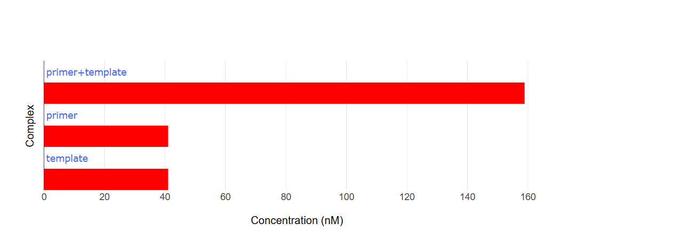
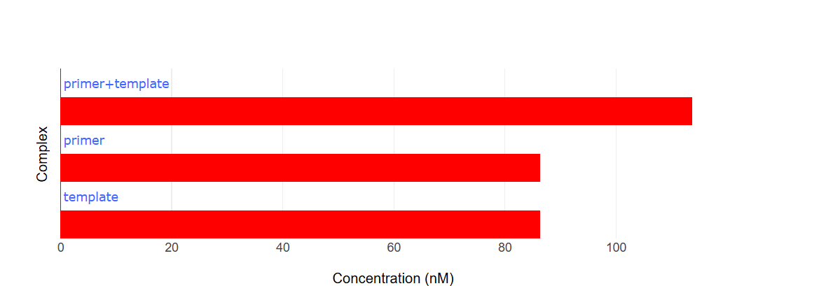
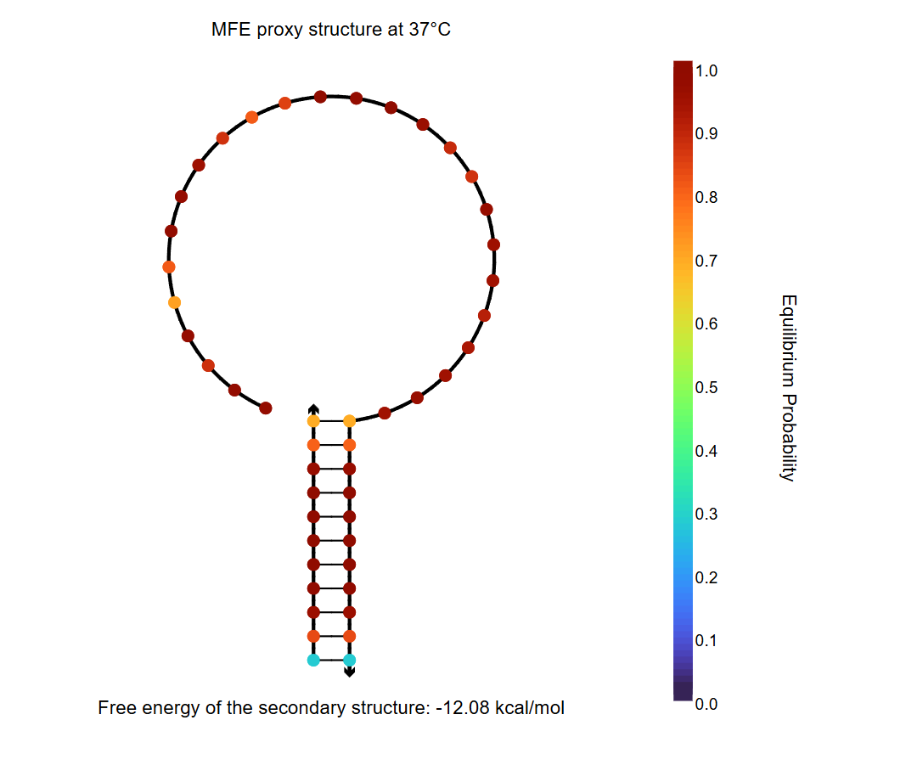
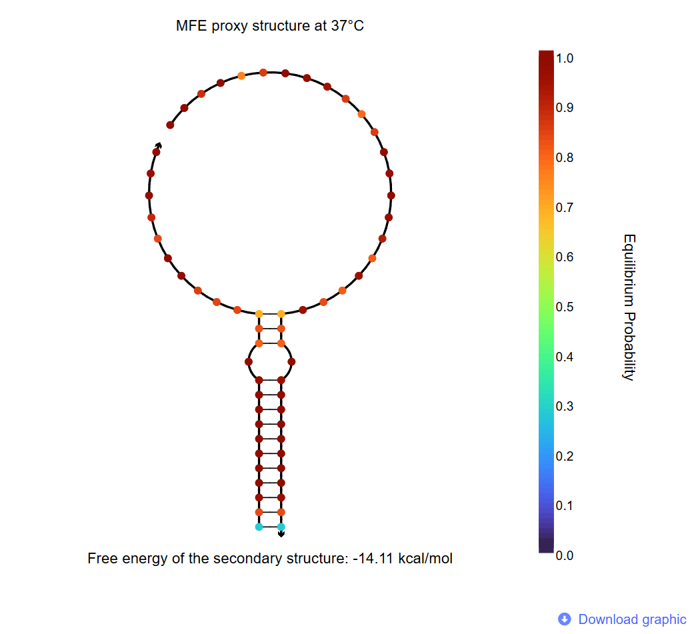
B. Detection Probe after cleavage （Primer-1 and Pemplate-1）.
A. Detection Probe（Primer-1 and Pemplate-1）.
Figure S1. The structure and concentration distribution of the detection probe and the cleaved detection probe in the system.
Table S2. Comparison of the analytical performance of some reported methods in APE1 detection
Method strategy | Signal | Sensitivity | Operation complexity | Time | Assay temperature | Ref
A sensitive sensing system enables rapid activation of gated HRCA upon intelligent recognition of APE1. | fluorescence | 0.0001U/mL | Simple | 90min | 37℃ | [1]
Host-guest interaction between b-CDP and pyrene | fluorescence | 0.05 U/mL | moderate | 40 min | 37 °C | [2]
An integrated electrochemical biosensing system that gives consideration to both immunoassay and enzyme activity analysis | Electrochemical signal | 0.00518 U/mL | complex | ＞3h | 37℃ | [3]
closed cycle circuit (CCC) | fluorescence | 7.8×10⁻⁵ U /mL | complex | 1h | ？ | [4]
primer exchange reaction (PER) cascade rolling circle amplification (RCA)/ dimeric G-quadruplex | fluorescence | 0.001U/mL | Simple | 2h | 37℃ | [5]

References
- Kang Q, Yang X, Du Y, Qi Y, He Z, Xiang H (2023) A molecular gated HRCA quick sensing system intelligently controlled by APE1. Microchemical Journal 191:108880
- Zhou M, Qin S, Feng Z, Song C, Zhang H, Li W, Wang Q, Liu J, Huang J, Yang X (2018) A simple and sensitive assay for apurinic/apyrimidinic endonuclease 1 activity based on host-guest interaction of β-cyclodextrin polymer and pyrene. Chinese Chemical Letters 29 (6):973-976
- Zhou M, Feng C, Mao D, Yang S, Ren L, Chen G, Zhu X (2019) An electrochemical biosensor integrating immunoassay and enzyme activity analysis for accurate detection of active human apurinic/apyrimidinic endonuclease 1. Biosensors and Bioelectronics 142:111558
- Chai Q, Chen J, Zeng S, Zhu T, Chen J, Qi C, Mao G, Liu Y (2023) Closed cyclic DNA machine for sensitive logic operation and APE1 detection. Small 19 (23):2207736
- Qi Y, Du Y, Kang Q, Yang X, Xiang H (2023) A novel self-feedback biosensor for label-free detection of APE1 by primer exchange reaction and rolling circle amplification/dimeric G-quadruplex. Microchemical Journal 193:109246

