Supplementary information
Characterisation of between-cluster heterogeneity in malaria cluster randomised trials to inform future sample size calculations

Contents
Supplementary Table 1: List of trials that provided data in this meta analysis. 2
Supplementary Table 2: Overall characteristics of the trials that provided cluster-level data in this meta- analysis. 3
Supplementary table 3: Characteristics of the cluster-level prevalence data for malaria CRTs provided in this meta-analysis 4
Supplementary table 4: Characteristics of the cluster-level incidence data for malaria CRTs provided in this meta-analysis 5
Supplementary Figure 1: The agreement between the methods of moments and random effects model approaches for estimating prevalence k (coefficient of variation) 6
Supplementary Figure 2: Longitudinal patterns in prevalence k estimates for each intervention survey arm (A) and incidence k estimates for each intervention study year arm (B). 7
Supplementary Table 5: Factors associated with elevated active-case detection k estimates (k>0.5) for all trial study year arms. 8
Supplementary Table 6: Factors associated with elevated passive-case detection k estimates (k>0.5) for all trial study year arms. 9
Supplementary Figure 3: Survey-level k values in the control arm and effect size (prevalence ratios) estimations by months since intervention introduction among eight trials that conducted surveys in both malaria and non-malaria seasons. 10
Supplementary Table 7: Dummy tables used to obtain prevalence data from malaria CRTs 11
Supplementary Table 8: Dummy tables used to obtain active case detection (ACD) incidence data from malaria CRTs 12
Supplementary Table 9: Dummy tables used to obtain passive case detection (PCD) incidence data from malaria CRTs 13

Supplementary Table 1: List of trials that provided data in this meta analysis.

Supplementary Table 2: Overall characteristics of the trials that provided cluster-level data in this meta- analysis.

Supplementary table 3: Characteristics of the cluster-level prevalence data for malaria CRTs provided in this meta-analysis. Trial endemicity categorised according to the overall control-arm prevalence reported throughout the trial.

Supplementary table 4: Characteristics of the cluster-level incidence data for malaria CRTs provided in this meta-analysis Trial endemicity categorised according to the overall control-arm incidence reported throughout the trial.

Supplementary Figure 1: The agreement between the methods of moments and random effects model approaches for estimating prevalence k (coefficient of variation) (green) and incidence k (red) for each survey-arm and study year-arm, respectively.
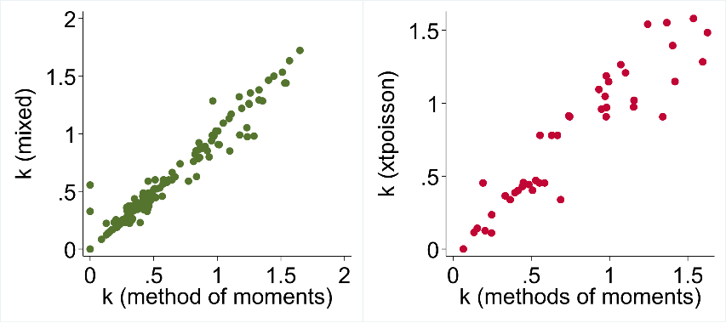

Supplementary Figure 2: Longitudinal patterns in prevalence k estimates for each intervention survey arm (A) and incidence k estimates for each intervention study year arm (B). Green: Prevalence, Blue: PCD incidence, Orange: ACD incidence. Error bars: 95%CIs
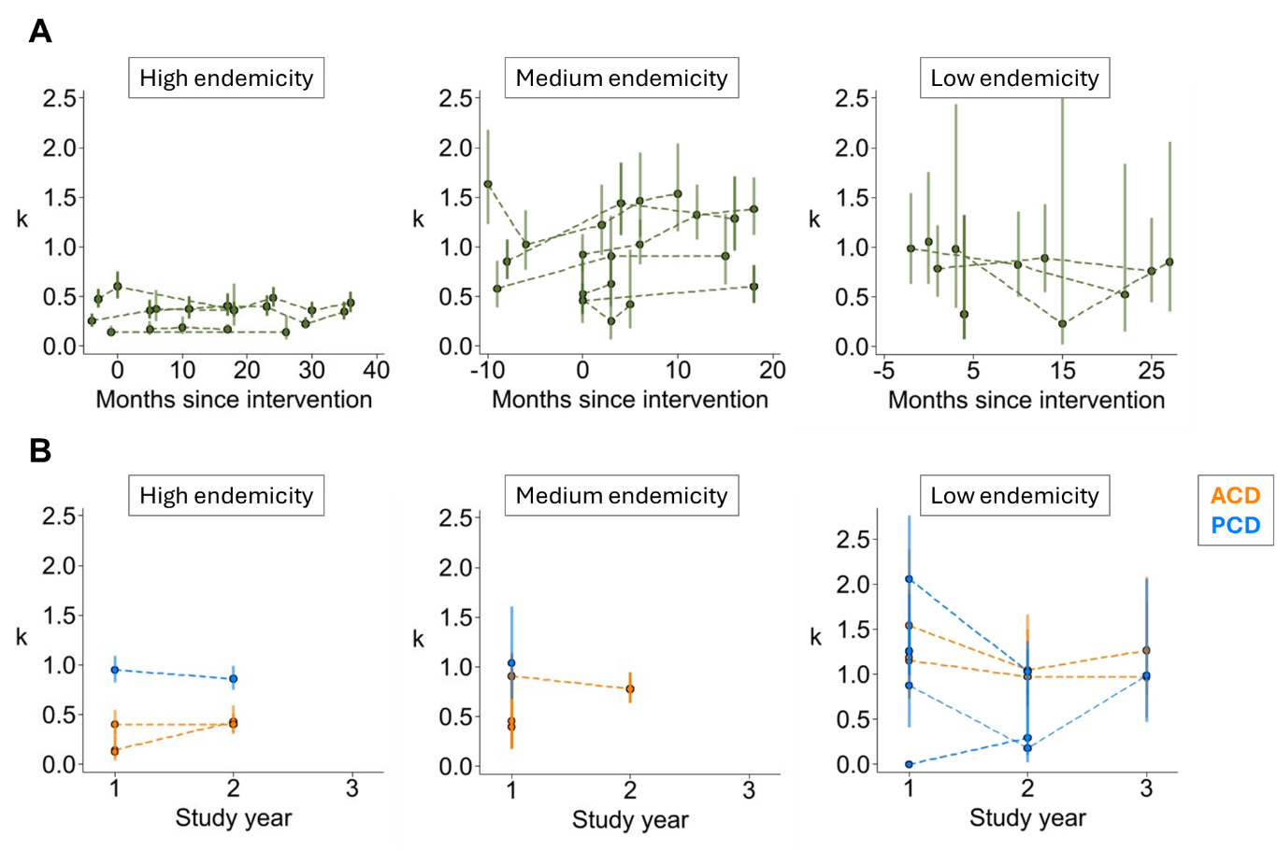

Supplementary Table 5: Factors associated with elevated active-case detection k estimates (k>0.5) for all trial study year arms.

Supplementary Table 6: Factors associated with elevated passive-case detection k estimates (k>0.5) for all trial study year arms.

Supplementary Figure 3: Survey-level k values in the control arm and effect size (prevalence ratios) estimations by months since intervention introduction among eight trials that conducted surveys in both malaria and non-malaria seasons. Trials 12, 39 and 47 experienced larger effect sizes (lower prevalence ratios) in the malaria seasons when k was higher.
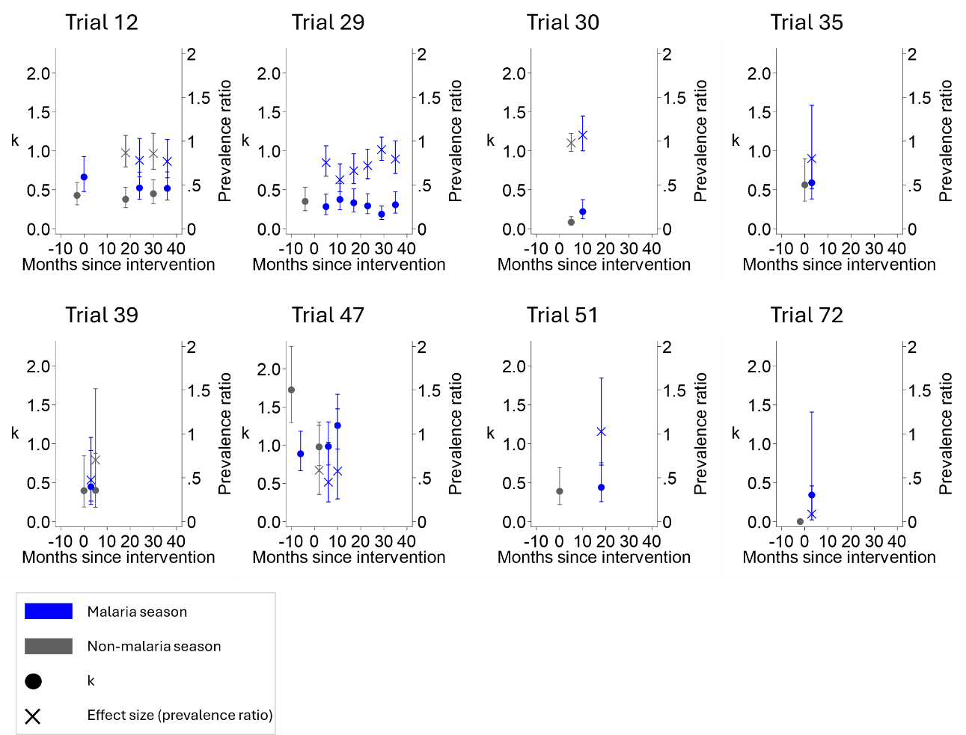

Supplementary Table 7: Dummy tables used to obtain prevalence data from malaria CRTs

Supplementary Table 8: Dummy tables used to obtain active case detection (ACD) incidence data from malaria CRTs

Supplementary Table 9: Dummy tables used to obtain passive case detection (PCD) incidence data from malaria CRTs

