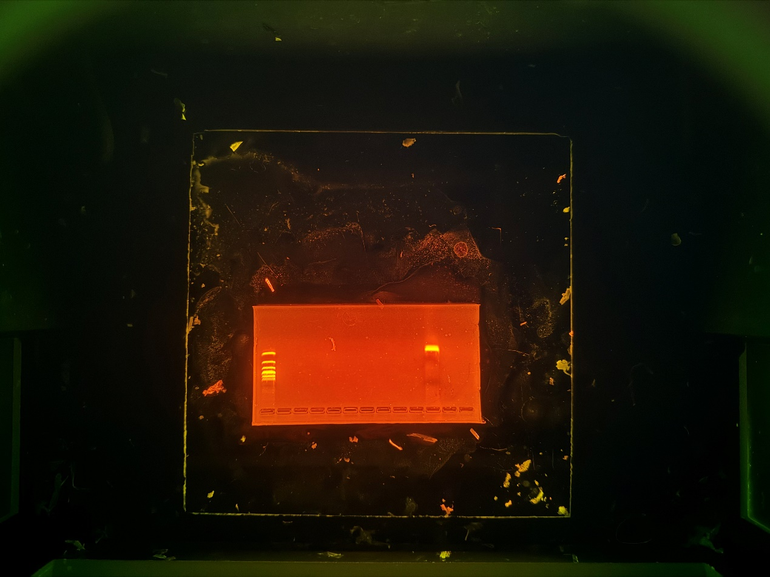
PCR specific gel electrophoresis pattern.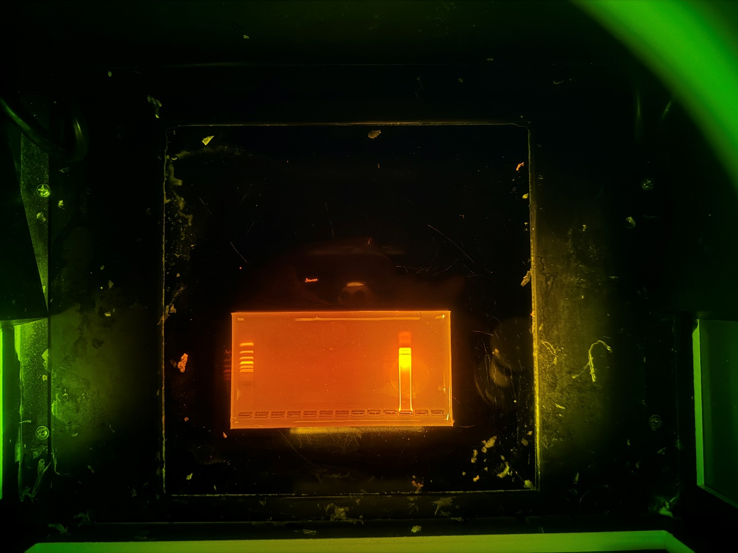
LAMP specific gel electrophoresis pattern.

