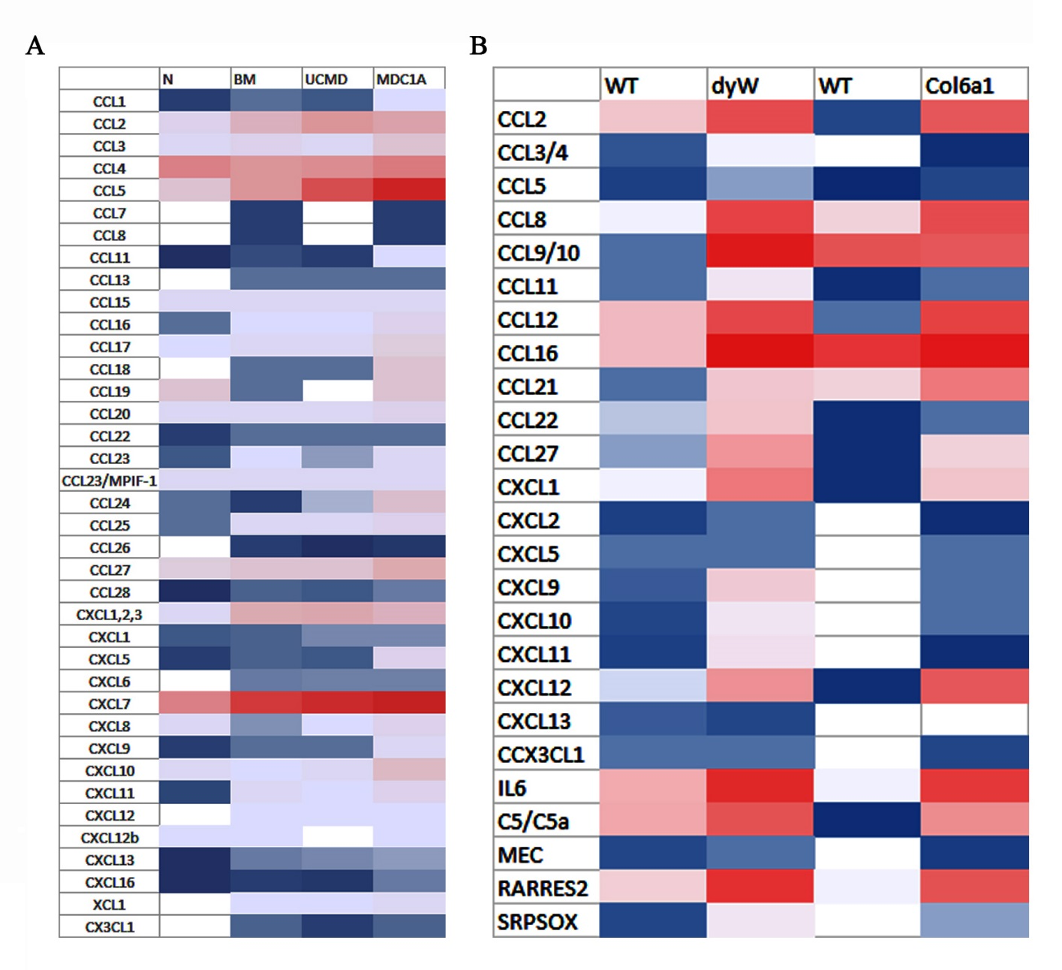
Figure S1. Heat map generated from proteome analysis of human and mouse chemokines reflecting protein expression values in human (A) and mouse (B) muscle biopsies. BM, Bethlem myopathy; UCMD, Ulrich congenital muscular dystrophy; MDC1A, Merosin-deficient congenital muscular dystrophy type 1A.

