Supplementary Figure S1:Comparison of Induction Success Rate Between Two Groups (Sensitivity Analysis)

Supplementary Figure S2:Comparison of Induction Time Between Two Groups (Sensitivity Analysis)

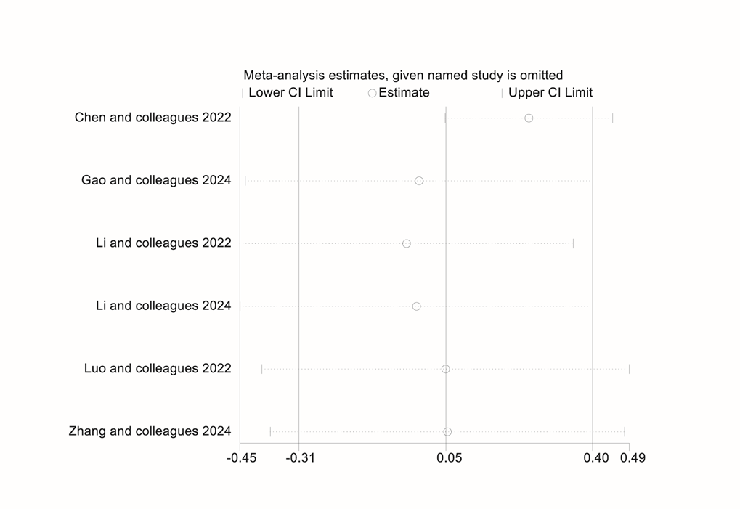
Supplementary Figure S3:Comparison of Time to Full Awakening Between Two Groups (Sensitivity Analysis)

Supplementary Figure S4:Comparison of Adverse Reaction: Injection Pain Between Two Groups (Sensitivity Analysis)

Supplementary Figure S5:Comparison of Patient Satisfaction Between Two Groups (Sensitivity Analysis)

