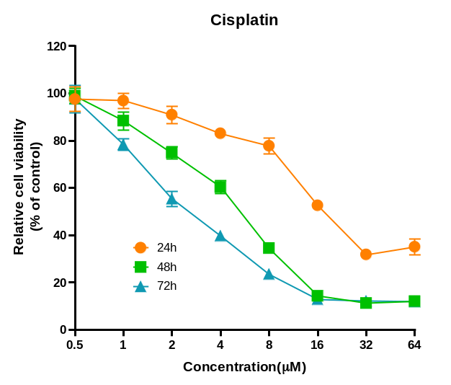

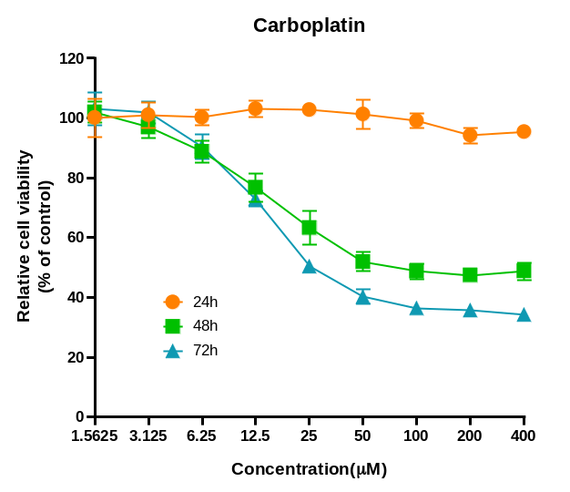

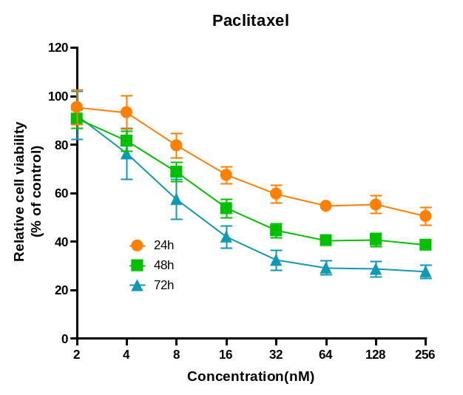

Figure S1 | Cisplatin, Carboplatin and Paclitaxel. inhibits growth of ZOC54. Graph showing the inhibitory effects of olaparib on the proliferation of ZOC254. Average results from three independent experiments are presented. SD signifies standard deviation (n=3).

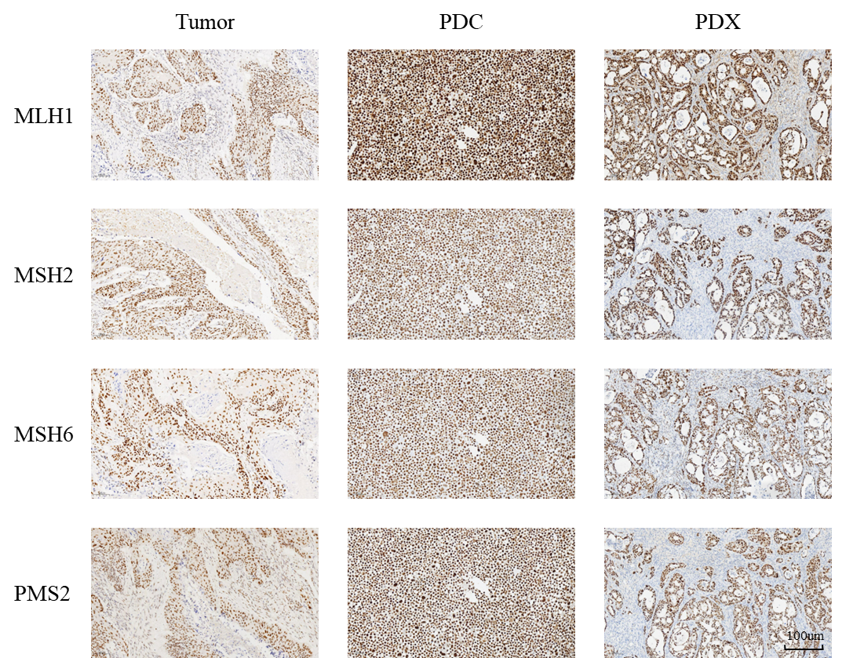

Figure S2 | Immunohistochemical staining of Tumor(patient tissues),PDC(patient-derived cells),PDX(patient-derived xenografts) with MLH1、MSH2、MSH6 and PMS2. The scale bar corresponds to 100 µm.

