Supplementary information

Mucosal administration of lipid nanoparticles containing self-amplifying mRNA induces local uptake and expression in a pig model as a potential vaccination platform against STIs
Ibe Van de Casteele^{1,2}, Magalie Plovyt¹, Magdalena Stuchlíková ¹, Michiel Lanssens¹, Ben Verschueren¹, Quenten Denon³, Paul Van der Meeren³, Sean McCafferty^{1,4}, Arlieke Gitsels ², Pieter Cornillie⁵, Niek N. Sanders⁴, Aster Vandierendonck¹, Katrien C. K. Poelaert^{1*}, Daisy Vanrompay^{2*}
¹ Ziphius NV, B-9052 Zwijnaarde, Belgium
² Laboratory for Immunology and Animal Biotechnology, Department of Animal Sciences and Aquatic Ecology, Faculty of Bioscience Engineering, Ghent University, B-9000 Ghent, Belgium
³ Particle and Interfacial Technology group (PainT), Department of Green Chemistry and Technology, Faculty of Bioscience Engineering, Ghent University, B-9000 Ghent, Belgium
⁴ Laboratory of Gene Therapy, Department of Veterinary and Biosciences, Faculty of Veterinary Medicine, Ghent University, B-9820 Merelbeke, Belgium
⁵ Department of Morphology, Imaging, Orthopedics, Rehabilitation and Nutrition, Faculty of Veterinary Medicine, Ghent University, B-9820 Merelbeke, Belgium
* Shared senior authors and corresponding authors: katrien.poelaert@ziphus.org & daisy.vanrompay@ugent.be

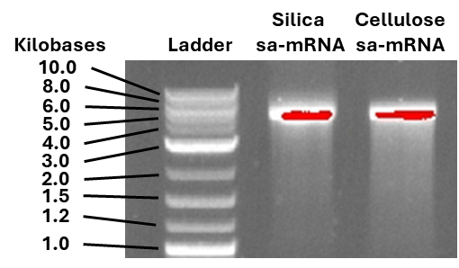
Fig. S1 Bleach gel of the sa-mRNA used during the in vitro trials. The quality of both silica purified and cellulose purified sa-mRNA was analyzed using the bleach gel. The 1kB plus DNA ladder was used to check the size of the sa-mRNA

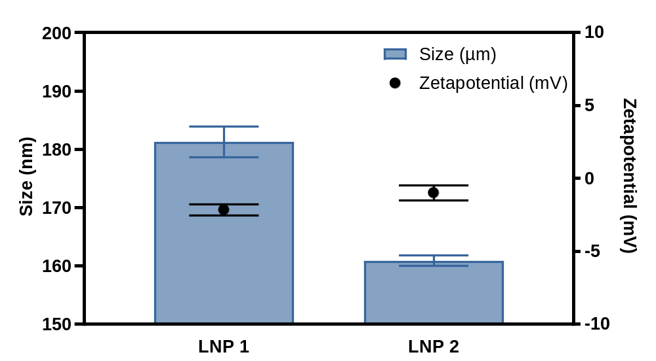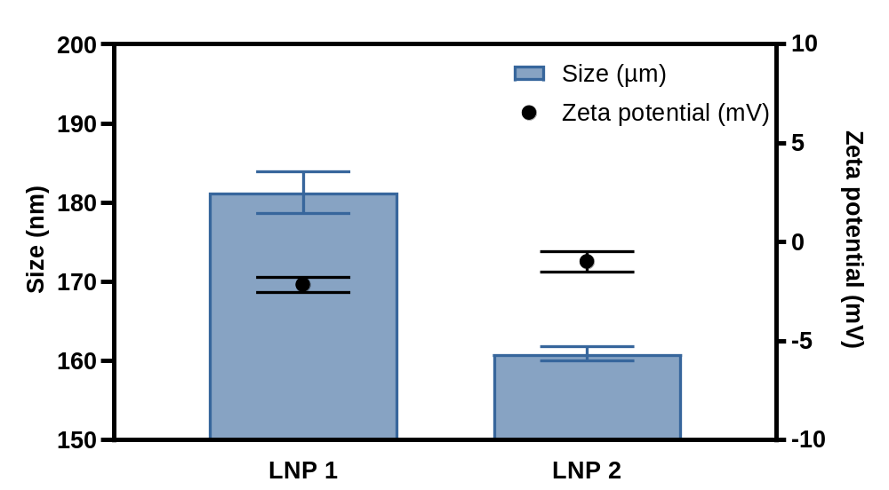
Fig. S2 Physicochemical characteristics of LNP 1 and LNP 2 used during the in vitro trials. The average of three repeated measurements is given together with the standard deviation. The left y-axis presents the size of the particles, depicted by the blue columns and corresponding blue error bars. On the right y-axis, the zetapotential of the particles can be found, depicted by the black dots and black error bars

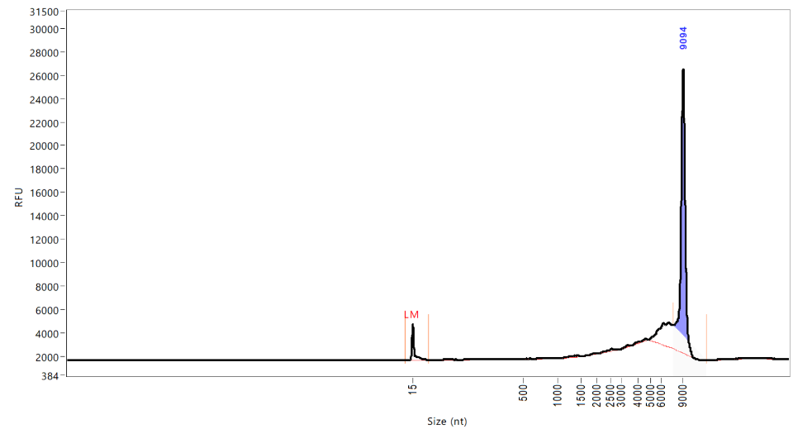
Fig. S3 Fragment analyzer of the sa-mRNA used during the in vivo trials. A fragment analyzer was used to assess the quality of the cellulose purified sa-mRNA used during the in vivo trial. On the X-axis, the size of the sa-mRNA is indicated based on a Lonza RNA ladder. The exact size of the sa-mRNA is given on top of the peak. The y-axis gives the signal intensity in relative fluorescent units (RFU). Smear analysis revealed a purity of 74.8% when comparing the signal in a 15% range from the peak to the total signal

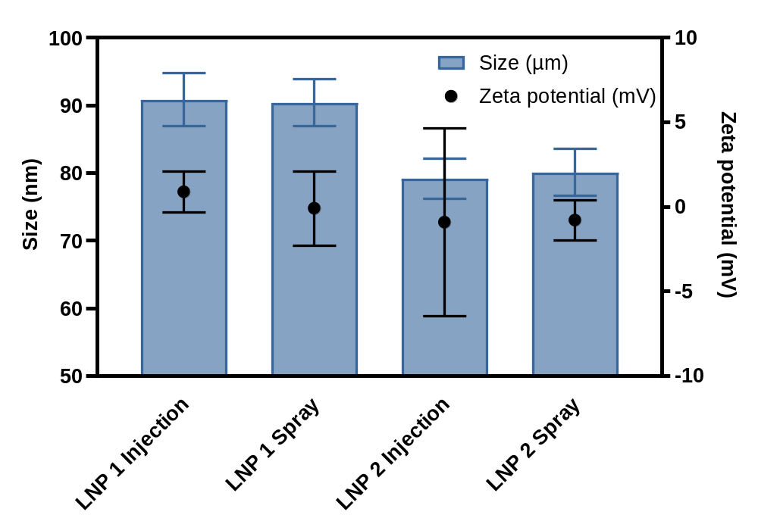
Fig. S4 Physicochemical characteristics of the LNPs used during the in vivo trials. For each LNP, three repeated measurements were included. The average of these three measurements is given together with the standard deviation. On the left y-axis, the size of the particles can be found, depicted by the blue columns and the blue error bars. On the right y-axis, the zeta potential of the particles can be found, depicted by the black dots and the black error bars

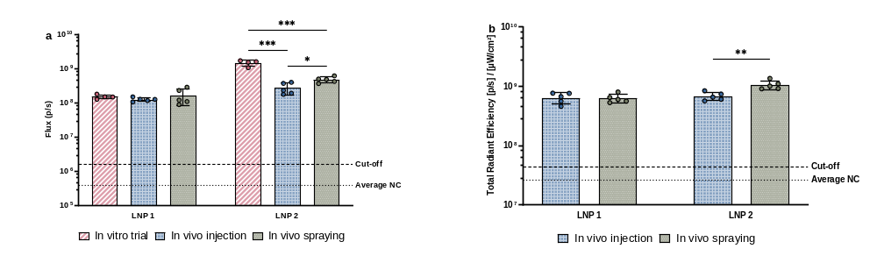
Fig. S5 In vitro transfection performed with the LNPs of the in vitro and two in vivo trials. HeLa cells were transfected with sa-mRNA encapsulated in LNP 1 or LNP 2. After 24 hours, bioluminescent (a) and fluorescent signals (b) were measured. For the in vitro trial, four replicates were included in comparison to five replicates for the in vivo trial. These replicates are visualized together with the mean signal and the standard deviation. The average signal of the negative control is depicted with a dotted line. A cut-off for positive signals was established by adding two times the standard deviation and is depicted by a second dashed line. Significance is indicated by P<0.01 ** and P<0.001***

Fig. S6 Plate layout and IVIS lumina III images from pig samples. Two DiD fluorescently labelled LNP formulations were administered through mucosal injection or spraying at a dose of 15 µg sa-mRNA. a) The order of the tissues on the image can be found in the set-up depicted on top of the figure. b) Representative fluorescent images for each LNP and administration method are given. c) Representative bioluminescent images for each LNP and administration method are given

