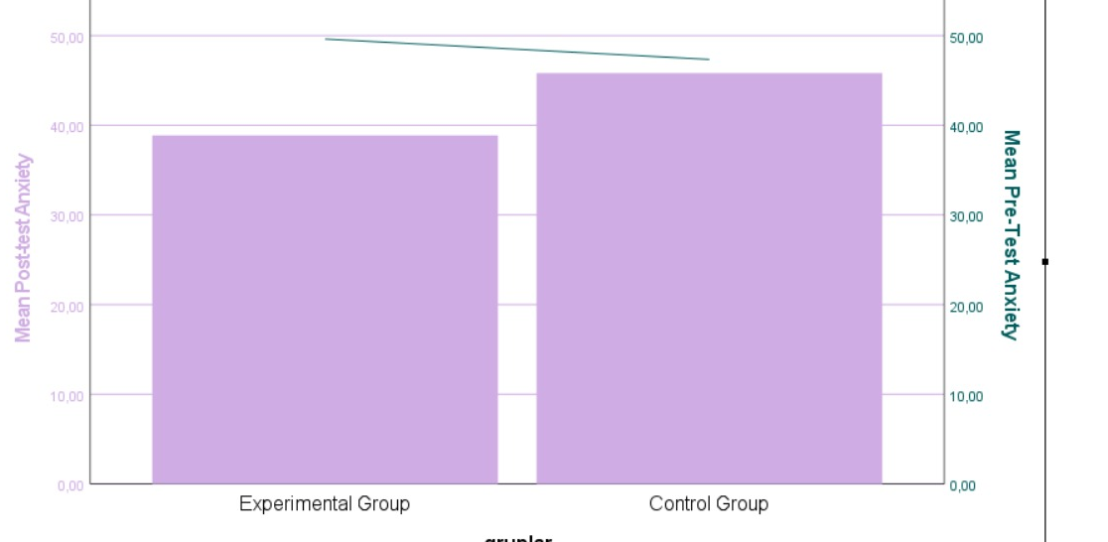
Grafik

Graph 1 Comparison of pre-test and post-test anxiety scores of the groups

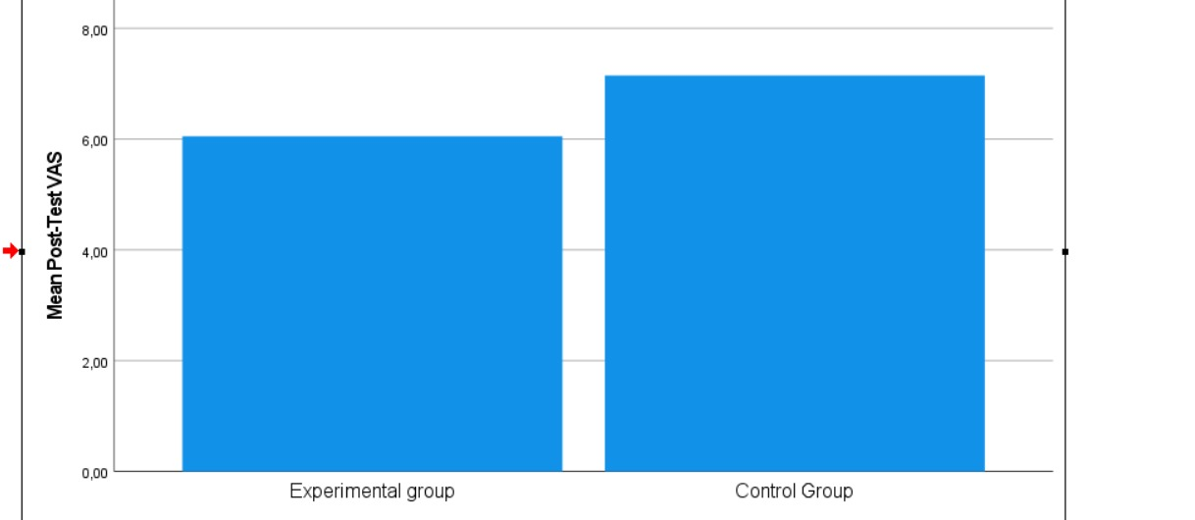
Graph 2 Comparison of post-test VAS scores of the groups

