Supplementary Information

Hexacyanometallate aqueous flow battery

Ji-Eun Jang¹*, Ryeong-ah Kim¹*, Chanhee Lee¹, Sujin Kang¹, Jaechan Ryu¹, S. Jayasubramaniyan¹, Jaephil Cho¹, Wonyoung Choe², Dong-Hwa Seo^{1†}, Hyun-Wook Lee^{1†}

Correspondence to: hyunwooklee@unist.ac.kr (H.W.L); dseo@unist.ac.kr (D.H.S.)

This PDF file includes:

Supplementary Note 1
Supplementary Figs. 1 to 4
Supplementary Tables 1 to 5
Supplementary References 1 to 10

Other Supplementary Materials for this manuscript include the following:

Supplementary Movie 1

Supplementary Note 1 | Kinetic calculation
Diffusion coefficient (D₀)
The diffusion coefficient and reduction rate constant for [Cr(CN)₆]^{4-/3-} at NaCN supporting electrolyte was obtained from cyclic voltammetry data (Fig. 4 and Supplementary Table 1), using the followed Randles-Sevcik equation at the quasi-reversible process.
$$i_{p}=0.4958nFAC_{0}D_{0}^{1/2}v^{1/2}{\left[\frac{αn_{a}F}{RT}\right]}^{1/2}$$
Where n = the number of electrons, F is Faraday’s constant, A is the electrode area (0.071 cm²) for 3 mm diameters glassy carbon electrode. C₀ is the bulk concentration of K₃[Cr(CN)₆] solution (5 mM), v is the scan rate (20, 30 50, 100, 200, and 500 mV s⁻¹), D₀ is the diffusion coefficient of [Cr(CN)₆]^{4-/3-}, α is the charge transfer coefficient (0.5), and n_{a} is the number of electrons involved in the rate-determining step (1). The slopes of the cathodic and anodic sides are ±0.0002, and the calculated D₀ is 7.16 ×10⁻⁶ cm² s⁻¹.
Charge transfer rate (k⁰)
k⁰ was calculated from ΔE_{p} and D₀ which was obtained at the previous process using simple Nicholson method ¹. The followed equation shows the relationship between ΔE_{p} and k_{0.}
$$ψ= π^{-1/2}=\frac{k^{0}}{{(πD_{O}^{1-α}D_{R}^{α}\frac{F}{RT}v)}^{1/2}}$$
Where ψ is the term related to ΔE_{p,} k⁰ is charge transfer rate, D_{o} and D_{R} are diffusion coefficient of oxidation and reduction process each (D_{O} = D_{R} = 7.16 ×10⁻⁴ cm² s⁻¹), F is Faraday’s constant, v is scan rate and T is temperature (= 25 C⁰). The relationships between ψ and ΔE_{p} are in Supplementary Table 2. We assumed ψ = 0.288 when ΔE_{p,} = 134 mV, which is interpolated value. The corresponding at v is 500 mV sec⁻¹ (0.5 V sec⁻¹), giving k⁰ = 6.03 × 10⁻³ cm s⁻¹.
Supplementary Figure 1 | XRD patterns of K₃[Fe(CN)₆] produced by Sigma Aldrich and as-synthesized K₃[Cr(CN)₆]

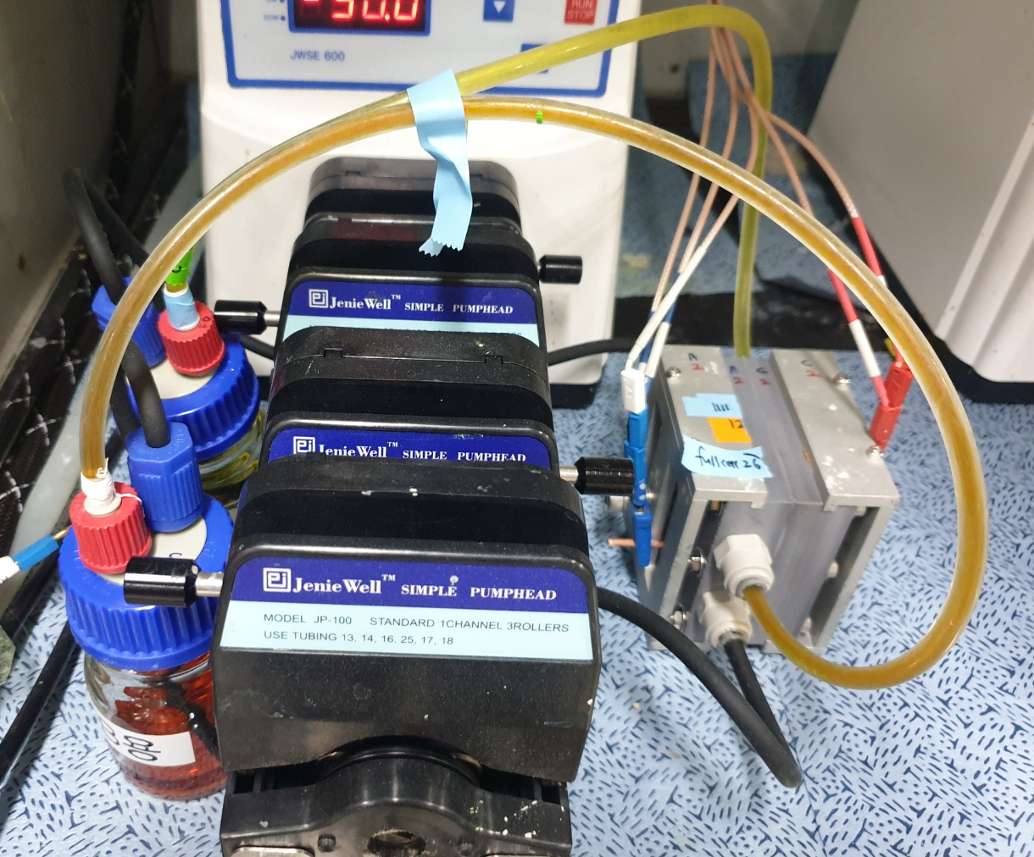

Supplementary Figure 2 | The full-cell configurations used in this work

Supplementary Figure 3 | Full cell cycling data at 0.1 A cm⁻² a) Cell potential as a function of time and cycle number, and b) corresponding single charging and discharging plot. The negolyte is 0.4 M of K₃[Cr(CN)₆] with 2 M NaCN, and the posolyte is 0.3 M of K₄[Fe(CN)₆] and K₃[Fe(CN)₆]

Supplementary Figure 4 | UV-vis spectrum of the negolytes a) UV-vis spectrum of the discharged negolytes – pristine (navy line) and after 10 days from starting cell operation (pink line) without shielding the ambient light. Increasing shoulder peak at 430 nm of pink line means some ligands of [Cr(CN)₆]³⁻ are exchanged to others ([Cr(CN)₄(H₂O)₂]⁻) during cell operation under the ambient light. b) UV-vis spectrum of negolytes before the cycling test and after 1st cycle. Before cycling test, the peaks are displayed at 380 and 430 nm, which is matched with [Cr(CN)₄(H₂O)₂]⁻. In contrast, the dominant peaks at 307 nm and 377 nm are observed, corresponding to [Cr(CN)₆]³⁻. This indicates that the ligand exchange process, from H₂O to CN⁻ ligand occurs during the first cycle ^{2–4}.

Supplementary Figure 5 | Negolyte replacement and capacity recovering. The cell capacity depending on cycle number. At 140th cycle, the cell was damaged on purpose and the capacity is recovered after replacement of the negolyte.
Concentration  (M) | Peak intensity | Wavelength  (nm)
0.05 | 0.05359 | 429.5
0.1 | 0.11681 | 432
0.2 | 0.23244 | 431.5
0.3 | 0.36481 | 432
0.4 | 0.45393 | 431.5
Unknown | 1.28014 | 432

Supplementary Figure 6 | Solubility test through UV-vis spectroscopy. a) Whole UV-vis spectrum of each synthesized K₃[Cr(CN)₆] concentrations (0.05, 0.1, 0.3, 0.4 M, and saturated solution(unknown). b) Zoom in the specific range (400 – 500 nm) determining the relationship between absorbance and concentration. c) The linear relationship between concentration peak intensity corresponding to (b). (y = 1.1626x + 0.0002, R² = 0.9964) Table indicates the specific the position and intensity of peaks.

Scan rate (mV sec⁻¹) | ΔE_{p} (mV)
20 | 81
30 | 83
50 | 87
100 | 94
200 | 111
500 | 134

Supplementary Table 1 | Peak to peak difference at the various scan rates of 5 mM K₃[Cr(CN)₆] in 1 M NaCN supporting electrolyte

ψ | n(E_{pa}-E_{pc})/mV | ψ | n(E_{pa}-E_{pc})/mV
20 | 61 | 0.38 | 117
7 | 63 | 0.35 | 121
6 | 64 | 0.26 | 140
5 | 65 | 0.25 | 141
3 | 68 | 0.16 | 176
2 | 72 | 0.14 | 188
1 | 84 | 0.12 | 200
0.91 | 86 | 0.11 | 204
0.80 | 89 | 0.10 | 212
0.75 | 92 | 0.077 | 240
0.61 | 96 | 0.074 | 244
0.54 | 104 | 0.048 | 290
0.50 | 105

Supplementary Table 2 | The relationship between ψ and ΔE_{p} at Nicholson’s method to calculate k⁰.

Material | Reduction  potential  (V vs SHE) | D₀  (cm² s⁻¹) | k₀  (cm s⁻¹) | Reference
K₃[Cr(CN)₆] | -1.13 | 7.16 × 10⁻⁶ | 6.03 × 10⁻³ | This work
Cr(III)-EDTA | -0.99 | 8.1 × 10⁻⁶ | - | ⁵
Cr(III)-PDTA | -1.113 | 6.2 × 10⁻⁶ | 1.7 × 10⁻⁴ | ⁶
CrCl₃ | -0.41 | - | < 10⁻⁶ | ⁷
CrCl₃  (with Bi catalyst) | -0.41 | 6.2 × 10⁻⁶ | 1.35 × 10⁻³ | ⁸
[Cr( f-DPA)₂]Br | -0.71 | - | 10⁻³ | ⁷

Supplementary Table 3 | The electrochemical properties of Cr-based active materials

Energy (eV) | [CrCl₆]⁴⁻ | [Cr(H₂O)₆]²⁺ | [Cr(NH₃)₆]²⁺ | [Cr(CN)₆]⁴⁻
Triplet (t_{2g}⁴) | -103576.613 | -40889.198 | -37648.147 | -43591.718
Quintet (t_{2g}³e_{g}¹) | -103578.625 | -40890.245 | -37648.874 | -43591.365

Supplementary Table 4 | DFT energies of Cr^{II}-based compounds with different spin states.

Negolyte / Posolyte | Supporting  Electrolyte | Current density  (mA cm⁻²) | Cell voltage  (V) | Concentration  (M) | Energy density  (Wh L⁻¹) | Cycles | Reference
[Cr(CN)₆]^{4-/3-} / [Fe(CN)₆]^{4-/3-} | NaCN, NaCl | 100 | 1.5 | 0.4 | 11.19 | 250 | This work
Cr(III/II)-EDTA / Fe(II/III)-EDTA | Sodium acetate  buffer | 0.13 | 2.12 | 0.1 | 0.55 | - | ⁵
Cr(II/III)-EDTA / Cr(III/V)-EDTA | Sodium acetate  buffer | 0.13 | 2.11 | 0.05 | 0.53 | - | ⁵
Cr(II/III)-EDTA / Cr(III/V)-EDTA | Sodium acetate  buffer | Charge : 15, 30  Discharge : 2.5 | 2.17 | 0.1 , 0.2 | - | - | ⁹
Cr(II/III)-PDTA / [Fe(CN)₆]^{4-/3-} | K₂B₄O₇ | 100 | 1.53 | 0.4 | 12.5 | 75 | ⁶
Cr(II/III)-PDTA / Br₂ | K₂B₄O_{7,} KBr | 100 | 2.2 | 0.4 | - | 10 | ⁶
Cr( f-DPA)₂]Br / [Fe(CN)₆]^{4-/3-} | KCl | 10 | 1.2 | 0.13 | 3 | 120 | ⁷
Cr(II/III)-PDTA / Fe(II/III)-DTPA | K₂B₄O₇ | 100 | 0.9 | 1.0 | 21~22 | 40 | ¹⁰

Supplementary Table 5 | Previoulsy reported Cr-based RFB

Supplementary Movie 1.
The discharge process of [Cr(CN)₆]^{4-/3-} negolyte, from SOC 100 % to SOC 0 %

Supplementary Reference
1. Nicholson, R. S. Theory and Application of Cyclic Voltammetry for Measurement of Electrode Reaction Kinetics. Anal. Chem. 37, 1351–1355 (1965).
2. Adin, A., Sykes, A. G., Gates, H. S. & Kin, E. L. The Chromium(II)-catalysed Dissociation of Monochlorochromium(III). J. Chem. Soc. A 80, 1518–1521 (1966).
3. Chiang, A. & Adamson, A. W. Photochemistry of Aqueous Cr(CN)₆ ³⁻. J. Phys. Chem. 72, 3827–3831 (1968).
4. Wakefield, D. K., Schaap, W. B. & Wakefield2, D. K. Cyanoaquochromium(III) Complexes. Separation and Identification of the Neutral and Cationic Cyanoaquo Complexes of Chromium(III) and Aquation Kinetics of the Monocyanopentaaquochromium(III) Ion1. Inorg. Chem. 8, 512–519 (1968).
5. Bae, C.-H., Roberts, E. P. L. & Dryfe, R. A. W. Chromium redox couples for application to redox flow batteries. Electrochim. Acta 48, 279–287 (2002).
6. Robb, B. H., Farrell, J. M. & Marshak, M. P. Chelated Chromium Electrolyte Enabling High-Voltage Aqueous Flow Batteries. Joule 3, 2503–2512 (2019).
7. Ruan, W. et al. Designing Cr complexes for a neutral Fe-Cr redox flow battery. Chem. Commun. 56, 3171–3174 (2020).
8. C. D. Wu, D. A. Scherson,* E. J. Calvo, and E. B. Y. A Bismuth-Based Electrocatalyst for the Chromous-Chromic Couple in Acid Electrolytes. J. Electrochem. Soc. 133, 2109–2112 (1986).
9. Bae, C., Roberts, E. P. L., Chakrabarti, M. H. & Saleem, M. All-chromium redox flow battery for renewable energy storage. Int. J. Green Energy 8, 248–264 (2011).
10. Waters, S. E., Robb, B. H., Marshak, M. P. & Marshak, M. P. Effect of Chelation on Iron-Chromium Redox Flow Batteries. ACS Energy Lett. 5, 1758–1762 (2020).

