Table: A Parameter estimates and standard errors for the separate models of the Pr, Rr, and Wh
 | P-value | <.0001 | <.0001 | <.0001 |  | 0.0019 |  | <.0001 | <.0001 |  | 0.0002 |  | <.0001 | <.0001 | <.0001 | 0.0006 | 0.0308 | <.0001 | <.0001 | <.0001 | 0.0002 | 0.0001
Pulse Rate | Estimate  (SE) | 1.8902  (0.02265 ) | -0.04484 (0.001815) | 0.000968 (0.000219) |  | -0.02184 (0.007002) |  | -0.1142  (0.02228) | -0.1341  (0.02140) |  | -0.07104  (0.01911) |  | 0.001020 (0.000114) | 0.000741  (0.000168) | 0.03382 (0.008587) | 0.02953 (0.008551) | 0.01636  (0.007562) | 0.002022  (0.000159) | 0.3453  (0.04972) | 0.004939  (0.001123) | -0.00159  (0.000427) | 0.000670 (0.000181)
 | Effects | Inter(${\hat{α}}_{10}$) | Ti(${\hat{α}}_{11}$) | Age(${\hat{α}}_{13}$) |  | Sex(${\hat{α}}_{14}$) |  | I(${\hat{α}}_{15}$) | II(${\hat{α}}_{16}$) |  | III(${\hat{α}}_{17}$) |  | Sys(${\hat{α}}_{18}$) | Dias(${\hat{α}}_{19}$) | I*Ti(${\hat{α}}_{110}$) | II*Ti(${\hat{α}}_{111}$) | III*T(${\hat{α}}_{112}$) | Sigma1($σ_{1}$) | $$ε_{1}$$ | $${{\hat{σ}}^{2}}_{b10}$$ | $$σ_{b10,b11}$$ | $${{\hat{σ}}^{2}}_{b11}$$
 |  |  |  |  |  |  |  | NYHAC |  |  |  |  |  | Dias(${\hat{α}}_{19}$) | NYH*Ti
 | P-value | <.0001 | <.0001 | 0.0069 | 0.0017 |  | <.0001 | <.0001 | <.0001 | <.0001 |  |  | 0.0003 | 0.0073 | <.0001 | <.0001 | <.0001 | <.0001 | <.0001 | <.0001 | <.0001 | <.0001
Respiratory rate | Estimate  (SE) | 1.4401  (0.03207) | -0.1161  (0.007169 ) | 0.000918 (0.000339) | -0.03344  (0.01062 ) |  | -0.2038  (0.03356) | -0.2028  (0.03151) | -0.1785  (0.02646) | 0.000921  (0.000123) |  |  | 0.000647  (0.000179) | 0.03854  (0.01434) | 0.07713  (0.01149 ) | 0.06895  (0.01163 ) | 0.05666  (0.009849 ) | 0.002422  (0.000231) | 0.4217  (0.05425) | 0.01305 (0.002235) | -0.00418 (0.000832) | 0.001745 (0.000351)
 | Effects | Inter(${\hat{α}}_{20}$) | Ti(${\hat{α}}_{21}$) | Age(${\hat{α}}_{23}$) | Sex(${\hat{α}}_{24}$) |  | I(${\hat{α}}_{25}$) | II(${\hat{α}}_{26}$) | III(${\hat{α}}_{27}$) | Sys(${\hat{α}}_{28}$) |  |  | Dias(${\hat{α}}_{29}$) | Vhds$( {\hat{α}}_{210}$) | I*Ti(${\hat{α}}_{211}$) | II*Ti(${\hat{α}}_{212}$) | III*Ti(${\hat{α}}_{213}$) | Sigma1($σ_{2}$) | $$ε_{2}$$ | $${{\hat{σ}}^{2}}_{b20}$$ | $$σ_{b20,b21}$$ | $${{\hat{σ}}^{2}}_{b21}$$
 |  |  |  |  |  |  | NYHAC |  |  |  |  |  |  |  | NYHAC*Ti
Weight | P-value | <.0001 | <.0001 | <.0001 | 0.0004 | 0.7206 | 0.0208 | 0.4478 | <.0001 | 0.0003 | 0.0022 | 0.0231 | 0.0999 | 0.0074 | <.0001 | <.0001 | <.0001
Weight | Estimate  (SE) | 1.6873  (0.01726) | -0.00465 (0.001130) | 0.001406  (.000294) | 0.03561  (0.009957) | -0.00322  (0.008995) | -0.02164  (0.009347) | 0.004438 (0.005844) | 0.000191  (0.000034) | 0.000198 (0.000050) | 0.07656  (0.02494) | 0.002734 (0.001202) | 0.001959 (0.00119) | 0.003152 (0.001175) | 0.000329 (0.000036) | 0.6535  (0.03944) | 0.003383 (0.00041)
Weight | Effects | Inter(${\hat{α}}_{30}$) | Ti(${\hat{α}}_{31}$) | Age(${\hat{α}}_{31}$) | Sex(${\hat{α}}_{32}$) | I(${\hat{α}}_{33}$) | II(${\hat{α}}_{34}$) | III(${\hat{α}}_{35}$) | Sys(${\hat{α}}_{36}$) | Dias(${\hat{α}}_{37}$) | Smok(${\hat{α}}_{38}$) | Other*Ti(${\hat{α}}_{39}$) | Sev.*Ti(${\hat{α}}_{310}$) | CHD*Ti(${\hat{α}}_{311}$) | Sigma1($σ_{3}$) | $$ε_{3}$$ | $${{\hat{σ}}^{2}}_{b30}$$
 |  |  |  |  |  | NYHAC |  |  | Sys(${\hat{α}}_{36}$) | Dias(${\hat{α}}_{37}$) | Smok(${\hat{α}}_{38}$) | DIG HIS*T |  |  | Sigma1($σ_{3}$) | $$ε_{3}$$ | $${{\hat{σ}}^{2}}_{b30}$$

Table: B Parameter estimates and standard errors for the bivariate models of the Pr, Rr and Wh.
Joint(Pr andRr) |  | Pulse rate(Pr) |  | Respiratory rate(Rr)
Effects |  | Estimate(SE) | P-value | effects |  |  | Estimate(SE) |  | P-value
Inter(${\hat{α}}_{10}$) |  | 1.9089( 0.02247) | <.0001 | Inter(${\hat{α}}_{20}$) |  |  | 1.4674(0.03046) |  | <.0001
Time(${\hat{α}}_{11}$) |  | -0.05208(0.005436) | <.0001 | Time(${\hat{α}}_{21}$) |  |  | -0.1180(0.007196) |  | <.0001
Age(${\hat{α}}_{12}$) |  | 0.000997(0.000221) | <.0001 | Age(${\hat{α}}_{22}$) |  |  | 0.001157(0.000336) |  | 0.0006
Sex(${\hat{α}}_{13}$) |  | -0.02185(0.007057) | 0.0020 | Sex(${\hat{α}}_{23}$) |  |  | -0.03396(0.01078) |  | 0.0017
NYHAC | I(${\hat{α}}_{14}$) | -0.1239(0.02246) | <.0001 | NYHAC |  | I(${\hat{α}}_{24}$) | -0.2351(0.03190) |  | <.0001
NYHAC | II(${\hat{α}}_{15}$) | -0.1409(0.02169) | <.0001 |  |  | II(${\hat{α}}_{25}$) | -0.2170(0.03060) |  | <.0001
NYHAC | III(${\hat{α}}_{16}$) | -0.08153(0.01887) | <.0001 |  |  | III(${\hat{α}}_{26}$) | -0.1845(0.02629) |  | <.0001
Sys(${\hat{α}}_{17}$) |  | 0.000981(0.000110) | <.0001 | Sys(${\hat{α}}_{27}$) |  |  | 0.000911(0.000120) |  | <.0001
Dias(${\hat{α}}_{18}$) |  | 0.000693(0.000163) | <.0001 | Dias(${\hat{α}}_{28}$) |  |  | 0.000645(0.000175) |  | 0.0002
NYHAC*Ti | I*T(${\hat{α}}_{19}$) | 0.03838(0.008594) | <.0001
NYHAC*Ti | II*T(${\hat{α}}_{110}$) | 0.03451(0.008733) | <.0001 | NYHAC*Ti | I*T(${\hat{α}}_{29}$ |  |  | 0.08186(0.01151) |  | <.0001
NYHAC*Ti | III*T(${\hat{α}}_{111}$) | 0.02232(0.007433) | 0.0027 | NYHAC*Ti | II*T(${\hat{α}}_{210}$) |  |  | 0.06576(0.01176) |  | <.0001
Sigma1($σ_{1}$) |  | 0.001911(0.000134) | <.0001 | NYHAC*Ti | III*T(${\hat{α}}_{211}$) |  |  | 0.06012(0.009725) |  | <.0001
$$ε_{1}$$ |  | 0.3179(0.04645) | <.0001 | Sigma1($σ_{2}$) |  |  |  | 0.002310(0.000200) |  |  | <.0001
$${{\hat{σ}}^{2}}_{b10}$$ |  | 0.005767(0.001154) | <.0001 | $$ε_{2}$$ |  |  |  | 0.4015(0.05129) |  |  | <.0001
$$σ_{b10,b11}$$ |  | -0.00198(0.000448) | <.0001 | $${{\hat{σ}}^{2}}_{b20}$$ |  |  |  | 0.01411(0.002278) |  |  | <.0001
$${{\hat{σ}}^{2}}_{b11}$$ |  | 0.000872(0.000193) | <.0001 | $$σ_{b20,b21}$$ |  |  |  | -0.00460(0.000850) |  |  | <.0001
 |  |  |  | $${{\hat{σ}}^{2}}_{b21}$$ |  |  |  | 0.001958(0.000360) |  |  | <.0001
Common parameters |  | $$σ_{b10,b20}$$ |  |  |  |  |  | 0.006891(0.001264) |  |  | <.0001
 |  | $$σ_{b10,b21}$$ |  |  |  |  |  | -0.00261(0.000499) |  |  | <.0001
 |  | $$σ_{b20,b11}$$ |  |  |  |  |  | -0.00237(0.000514) |  |  | <.0001
 |  | $${ σ}_{b11,b21}$$ |  |  |  |  |  | 0.001114(0.000210) |  |  | <.0001

Joint(Pr and Wh)
Log of pulse rate |  |  |  |  |  |  |  | Log of weight
Effects |  |  | Estimate(SE) |  | P-value |  |  | effects |  |  | Estimate(SE) | P-value
Inter(${\hat{α}}_{10}$) |  |  | 1.8948(0.02259) |  | <.0001 |  |  | Inter(${\hat{α}}_{30}$) |  |  | 1.6789(0.01570) | <.0001
Time(${\hat{α}}_{11}$) |  |  | -0.04553(0.005390) |  | <.0001 |  |  | Time(${\hat{α}}_{31}$) |  |  | -0.00432(0.001127) | 0.0001
Age(${\hat{α}}_{12}$) |  |  | 0.000963(0.000218) |  | <.0001 |  |  | Age(${\hat{α}}_{32}$) |  |  | 0.001532(0.000285) | <.0001
Sex(${\hat{α}}_{13}$) |  |  | -0.02167(0.006980) |  | 0.0019 |  |  | Sex(${\hat{α}}_{33}$) |  |  | 0.03368(0.009926) | 0.0007
NYHAC | I(${\hat{α}}_{14}$) |  | -0.1187(0.02241) |  | <.0001 |  |  | Sys(${\hat{α}}_{34}$) |  |  | 0.000188(0.000034) | <.0001
NYHAC | II(${\hat{α}}_{15}$) |  | -0.1365(0.02141) |  | <.0001 |  |  | Dias(${\hat{α}}_{35}$) |  |  | 0.000191(0.000050) | 0.0001
NYHAC | III(${\hat{α}}_{16}$) |  | -0.07217(0.01900) |  | 0.0001 |  |  | Smok(${\hat{α}}_{36}$) |  |  | 0.07510(0.02464) | 0.0023
Sys(${\hat{α}}_{17}$) |  |  | 0.001007(0.000113) |  | <.0001 |  |  | Diag*Ti |  | I*T(${\hat{α}}_{37}$) | 0.002462(0.001199) |  | 0.0403
Dias(${\hat{α}}_{18}$) |  |  | 0.000723(0.000166) |  | <.0001 |  |  |  |  | II*T(${\hat{α}}_{38}$) | 0.001522(0.001183) |  | 0.1983
NYHAC*Ti NYHAC*Ti |  | I*T(${\hat{α}}_{19}$) | 0.03553(0.008611) |  | <.0001 |  |  |  |  | III*T(${\hat{α}}_{39}$) | 0.002798(0.001171) |  | 0.0170
 |  | II*T(${\hat{α}}_{110}$) | 0.03055(0.008532) |  | 0.0004 |  |  | Sigma1($σ_{3}$) |  |  | 0.000331(0.000036) |  | <.0001
 |  | III*T(${\hat{α}}_{111}$) | 0.01677(0.007523) |  | 0.0259 |  |  | $$ε_{3}$$ |  |  | 0.6533(0.03924) |  | <.0001
Sigma1($σ_{1}$) |  |  | 0.002030(0.000164) |  | <.0001 |  |  | $${{\hat{σ}}^{2}}_{b30}$$ |  |  | 0.003389(0.000409) |  | <.0001
$$ε_{1}$$ |  |  | 0.3513(0.05056) |  | <.0001
$${{\hat{σ}}^{2}}_{b10}$$ |  |  | 0.004952(0.001139) |  | <.0001
$$σ_{b10,b11}$$ |  |  | -0.00160(0.000434) |  | 0.0002
$${{\hat{σ}}^{2}}_{b11}$$ |  |  | 0.000668(0.000185) |  | 0.0001
 |  |  | Common parameters |  |  | $$σ_{b10,b30}$$ |  |  |  |  | -0.00033(0.000471) | 0.4812
 |  |  | Common parameters |  |  | $$σ_{b30,b11}$$ |  |  |  |  | 0.000173(0.000198) | 0.3826

Joint(Rr and Wh)
Log of respiratory rate |  |  |  |  |  | Log of weight
Effects |  |  | Estimate(SE) | P-value |  | effects | Estimate(SE) | P-value
Inter(${\hat{α}}_{20}$) |  |  | 1.4424 (0.03154) | <.0001 |  | Inter(${\hat{α}}_{30}$) | 1.6790 (0.01549) | <.0001
Time(${\hat{α}}_{21}$) |  |  | -0.1163 (0.007063) | <.0001 |  | Time(${\hat{α}}_{31}$) | -0.00208(0.000233) | <.0001
Age(${\hat{α}}_{22}$) |  |  | 0.000900 (0.000328) | 0.0062 |  | Age(${\hat{α}}_{32}$) | 0.001505(0.000281) | <.0001
Sex(${\hat{α}}_{23}$) |  |  | -0.03313 (0.01030) | 0.0013 |  | Sex(${\hat{α}}_{33}$) | 0.03485(0.009763) | 0.0004
NYHAC |  | I(${\hat{α}}_{24}$) | -0.2056 (0.03335) | <.0001 |  | Sys(${\hat{α}}_{34}$) | 0.000189(0.000034) | <.0001
 |  | II(${\hat{α}}_{25}$) | -0.2059 (0.03096) | <.0001 |  | Dias(${\hat{α}}_{35}$) | 0.000196(0.000050) | <.0001
 |  | III(${\hat{α}}_{26}$) | -0.1804 (0.02571) | <.0001 |  | Smok(${\hat{α}}_{36}$) | 0.07155(0.02424) | 0.0032
Sys(${\hat{α}}_{27}$) |  |  | 0.000913(0.000121) | <.0001 |  | Sigma1($σ_{3}$) | 0.000350(0.000040) | <.0001
Dias(${\hat{α}}_{28}$) |  |  | 0.000644(0.000177) | 0.0003 |  | $$ε_{3}$$ | 0.6728(0.03860) | <.0001
Vhds(${\hat{α}}_{29}$) |  |  | 0.03979(0.01444) | 0.0059 |  | $${{\hat{σ}}^{2}}_{b30}$$ | 0.003277(0.000393) | <.0001
 |  |  | 0.03979(0.01444) | 0.0059 |  |  | Common parameters
NYHAC*Ti | I*T(${\hat{α}}_{210}$) |  | 0.07791(0.01139) | <.0001 |  | $$σ_{b20,b30}$$ | -0.00082(0.000646) | 0.2060  0.3180
NYHAC*Ti | II*T(${\hat{α}}_{211}$) |  | 0.06973 (0.01142) | <.0001 |  | $$σ_{b20,b30}$$ | -0.00082(0.000646) | 0.2060  0.3180
NYHAC*Ti | III*T(${\hat{α}}_{212}$) |  | 0.05675(0.009663) | <.0001 |  | $$σ_{b30,b31}$$ | 0.000258(0.000258) | 0.2060  0.3180
Sigma1($σ_{2}$) |  |  | 0.002456 (0.000245) | <.0001 |  | $$σ_{b30,b31}$$ | 0.000258(0.000258) | 0.2060  0.3180
$$ε_{2}$$ |  |  | 0.4342 (0.05536) | <.0001 |  | $$σ_{b30,b31}$$ | 0.000258(0.000258) | 0.2060  0.3180
$${{\hat{σ}}^{2}}_{b20}$$ |  |  | 0.01237(0.002149) | <.0001 |  | $$σ_{b30,b31}$$ | 0.000258(0.000258) | 0.2060  0.3180
$$σ_{b20,b21}$$ |  |  | -0.00397(0.000802) | <.0001 |  | $$σ_{b30,b31}$$ | 0.000258(0.000258) | 0.2060  0.3180
$${{\hat{σ}}^{2}}_{b21}$$ |  |  | 0.001647(0.000339) | <.0001 |  | $$σ_{b30,b31}$$ | 0.000258(0.000258) | 0.2060  0.3180

Table: C Parameter estimates and standard errors for multivariate linear mixed effects model
Multivariate |  |  | LogPr |  | LogRr |  |  |  |  |  |  |  | LogWh
Effect |  |  | Estimate(s.e) | p-value | Effects |  |  |  | Estimate(s.e) |  | p-value |  | Effects |  |  |  | Estimate(s.e) |  | p-value
Inter(${\hat{α}}_{10}$) |  |  | 1.9094(0.02248) | <.0001 | Inter(${\hat{α}}_{20}$) |  |  |  | 1.4438(0.03161) |  | <.0001 |  | Inter(${\hat{α}}_{30}$) |  |  |  | 1.6785(0.01565) |  | <.0001
T(${\hat{α}}_{11}$) |  |  | -0.05257(0.005444) | <.0001 | T(${\hat{α}}_{21}$) |  |  |  | -0.1175(0.007202) |  | <.0001 |  | T(${\hat{α}}_{31}$) |  |  |  | -0.00209(0.000234) |  | <.0001
Age(${\hat{α}}_{13}$) |  |  | 0.000998(0.000221) | <.0001 | Age(${\hat{α}}_{23}$) |  |  |  | 0.000982(0.000335) |  | 0.0033 |  | Age(${\hat{α}}_{31}$) |  |  |  | 0.001515(0.000283) |  | <.0001
Sex(${\hat{α}}_{14}$) |  |  | -0.02216(0.007066) | 0.0017 | Sex(${\hat{α}}_{24}$) |  |  |  | -0.03449(0.01056) |  | 0.0011 |  | Sex(${\hat{α}}_{32}$) |  |  |  | 0.03430(0.009868) |  | 0.0005
NYHAC | I(${\hat{α}}_{15}$) |  | -0.1245(0.02244) | <.0001 | NYHAC |  | I(${\hat{α}}_{25}$) |  | -0.2099(0.03350) |  | <.0001 |  | Sys(${\hat{α}}_{38}$) |  |  |  | 0.000189(0.000034) |  | <.0001
NYHAC | II(${\hat{α}}_{16}$) |  | -0.1430(0.02167) | <.0001 |  |  | II(${\hat{α}}_{26}$) |  | -0.2008(0.03134) |  | <.0001 |  | Dias(${\hat{α}}_{37}$) |  |  |  | 0.000196(0.000050) |  | <.0001
NYHAC | III(${\hat{α}}_{17}$) |  | -0.08198(0.01885) | <.0001 |  |  | III(${\hat{α}}_{27}$) |  | -0.1821(0.02606) |  | <.0001 |  | Smok(${\hat{α}}_{38}$) |  |  |  | 0.07749(0.02445) |  | 0.0015
Sys(${\hat{α}}_{18}$) |  |  | 0.000984(0.000110) | <.0001 | Sys(${\hat{α}}_{28}$) |  |  |  | 0.000906(0.000120) |  | <.0001 |  | Sigma1($σ_{3}$) |  |  |  | 0.000352(0.000040) |  | <.0001
Dias(${\hat{α}}_{19}$) |  |  | 0.000693(0.000163) | <.0001 | Dias(${\hat{α}}_{29}$) |  |  |  | 0.000659(0.000175) |  | 0.0002 |  | $$ε_{3}$$ |  |  |  | 0.6743(0.03869) |  | <.0001
NYHAC*T |  | I*T(${\hat{α}}_{110}$) | 0.03897(0.008600) | <.0001 |  | Vhds (${\hat{α}}_{210}$) |  |  |  | 0.03390 (0.01280) |  |  |  | $${{\hat{σ}}^{2}}_{b30}$$ |  |  |  | 0.003368(0.000408) | <.0001
 |  | II*T(${\hat{α}}_{111}$) | 0.03545(0.008736) | <.0001 |  |  |  |  |  |  |  |  |  | Common parameters
 |  | III*T(${\hat{α}}_{112}$) | 0.02255(0.007431) | 0.0024 |  |  |  | I*T(${\hat{α}}_{211}$) |  | 0.08043 (0.01153) |  | <.0001 |  | Effects |  | Estimate(s.e) |  |  | P_value
Sigma1($σ_{1}$) |  |  | 0.001901(0.000132) | <.0001 | NYHAC *T |  |  | II*T(${\hat{α}}_{212}$) | 0.06630 (0.01173) |  | <.0001 |  | $$σ_{b10,b20}$$ |  | 0.006873(0.001260) |  |  |  | <.0001
$$ε_{1}$$ |  |  | 0.3135(0.04615) | <.0001 |  |  |  | III*T(${\hat{α}}_{213}$) | 0.05916(0.009703) |  | <.0001 |  | $$σ_{b10,b30}$$ |  | -0.00039(0.000481) |  |  |  | 0.4123
$${{\hat{σ}}^{2}}_{b10}$$ |  |  | 0.005817(0.001153) | <.0001 | Sigma1($σ_{2}$) |  |  |  | 0.002288(0.000194) |  | <.0001 |  | $$σ_{b10,b21}$$ |  | -0.00263(0.000500) |  |  |  | <.0001
$$σ_{b10,b11}$$ |  |  | -0.00201(0.000450) | <.0001 | $$ε_{2}$$ |  |  |  | 0.3956(0.05097) |  | <.0001 |  | $$σ_{b20,b30}$$ |  | -0.00092(0.000679) |  |  |  | 0.1765
$${{\hat{σ}}^{2}}_{b11}$$ |  |  | 0.000889(0.000195) | <.0001 | $${{\hat{σ}}^{2}}_{b20}$$ |  |  |  | 0.01402(0.002260) |  | <.0001 |  | $$σ_{b20,b11}$$ |  | -0.00237(0.000515) |  |  |  | <.0001
 |  |  |  |  | $$σ_{b20,b21}$$ |  |  |  | -0.00464(0.000851) |  | <.0001 |  | $$σ_{b30,b11}$$ |  | 0.000215(0.000205) |  |  |  | 0.2952
 |  |  |  |  | $${{\hat{σ}}^{2}}_{b21}$$ |  |  |  | 0.001984(0.000361) |  | <.0001 |  | $$σ_{b30,b21}$$ |  | 0.000336(0.000274) |  |  |  | 0.2195
 |  |  |  |  |  |  |  |  |  |  |  |  | $$σ_{b11,b21}$$ |  | 0.001120(0.000212) |  |  |  | <.0001
Where, inter=intercept, T=Time, Sys=systolic blood pressure, Dys= diastolic blood pressure and smok=smoking status

A) B)
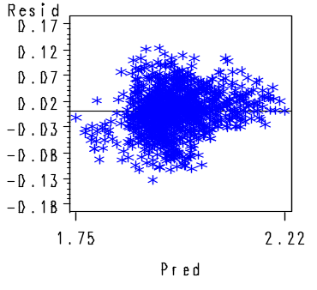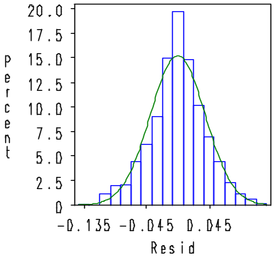
C) D)
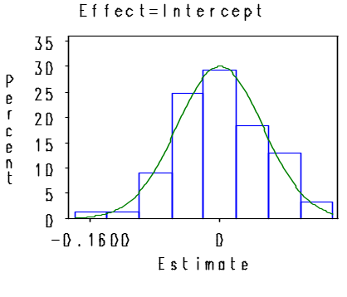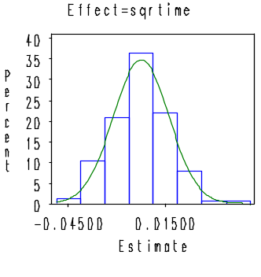
Figure 1: Model checking for log of pulse rate
A) B)
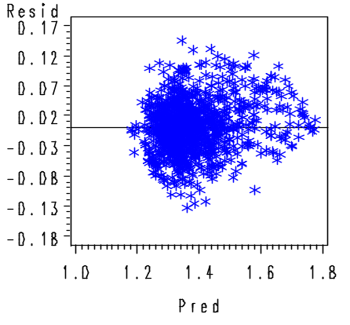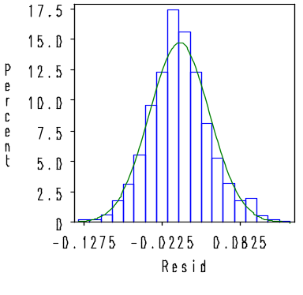

D) C)
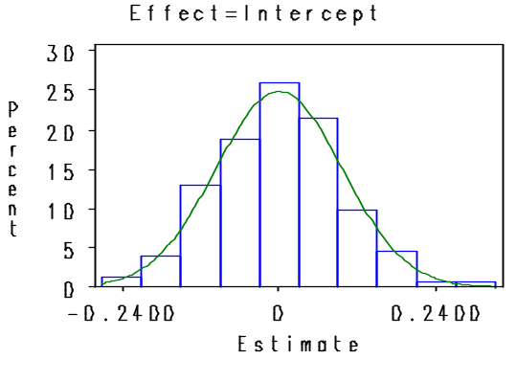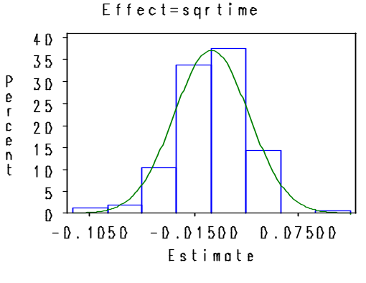
Figure 2: Model checking for log of respiratory rate
A) B)
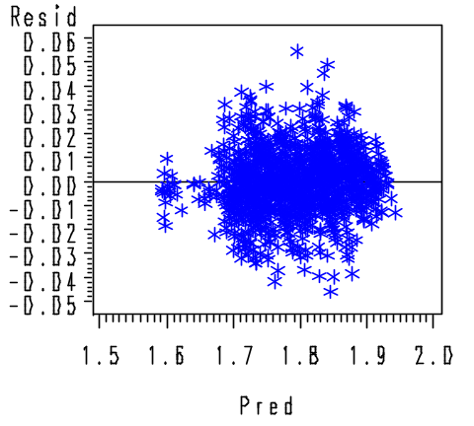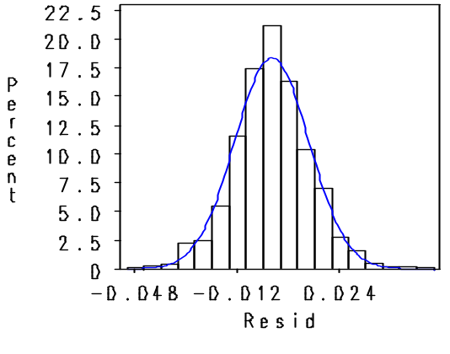

C)

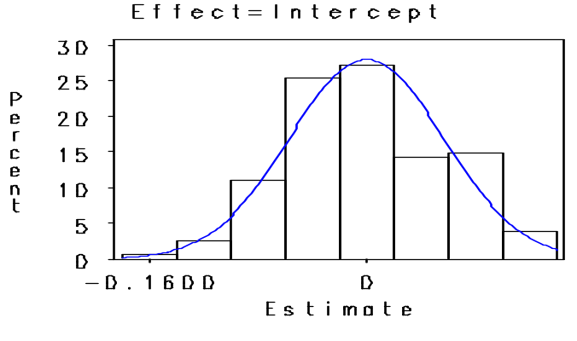

Figure 3: Model checking for log of weight

