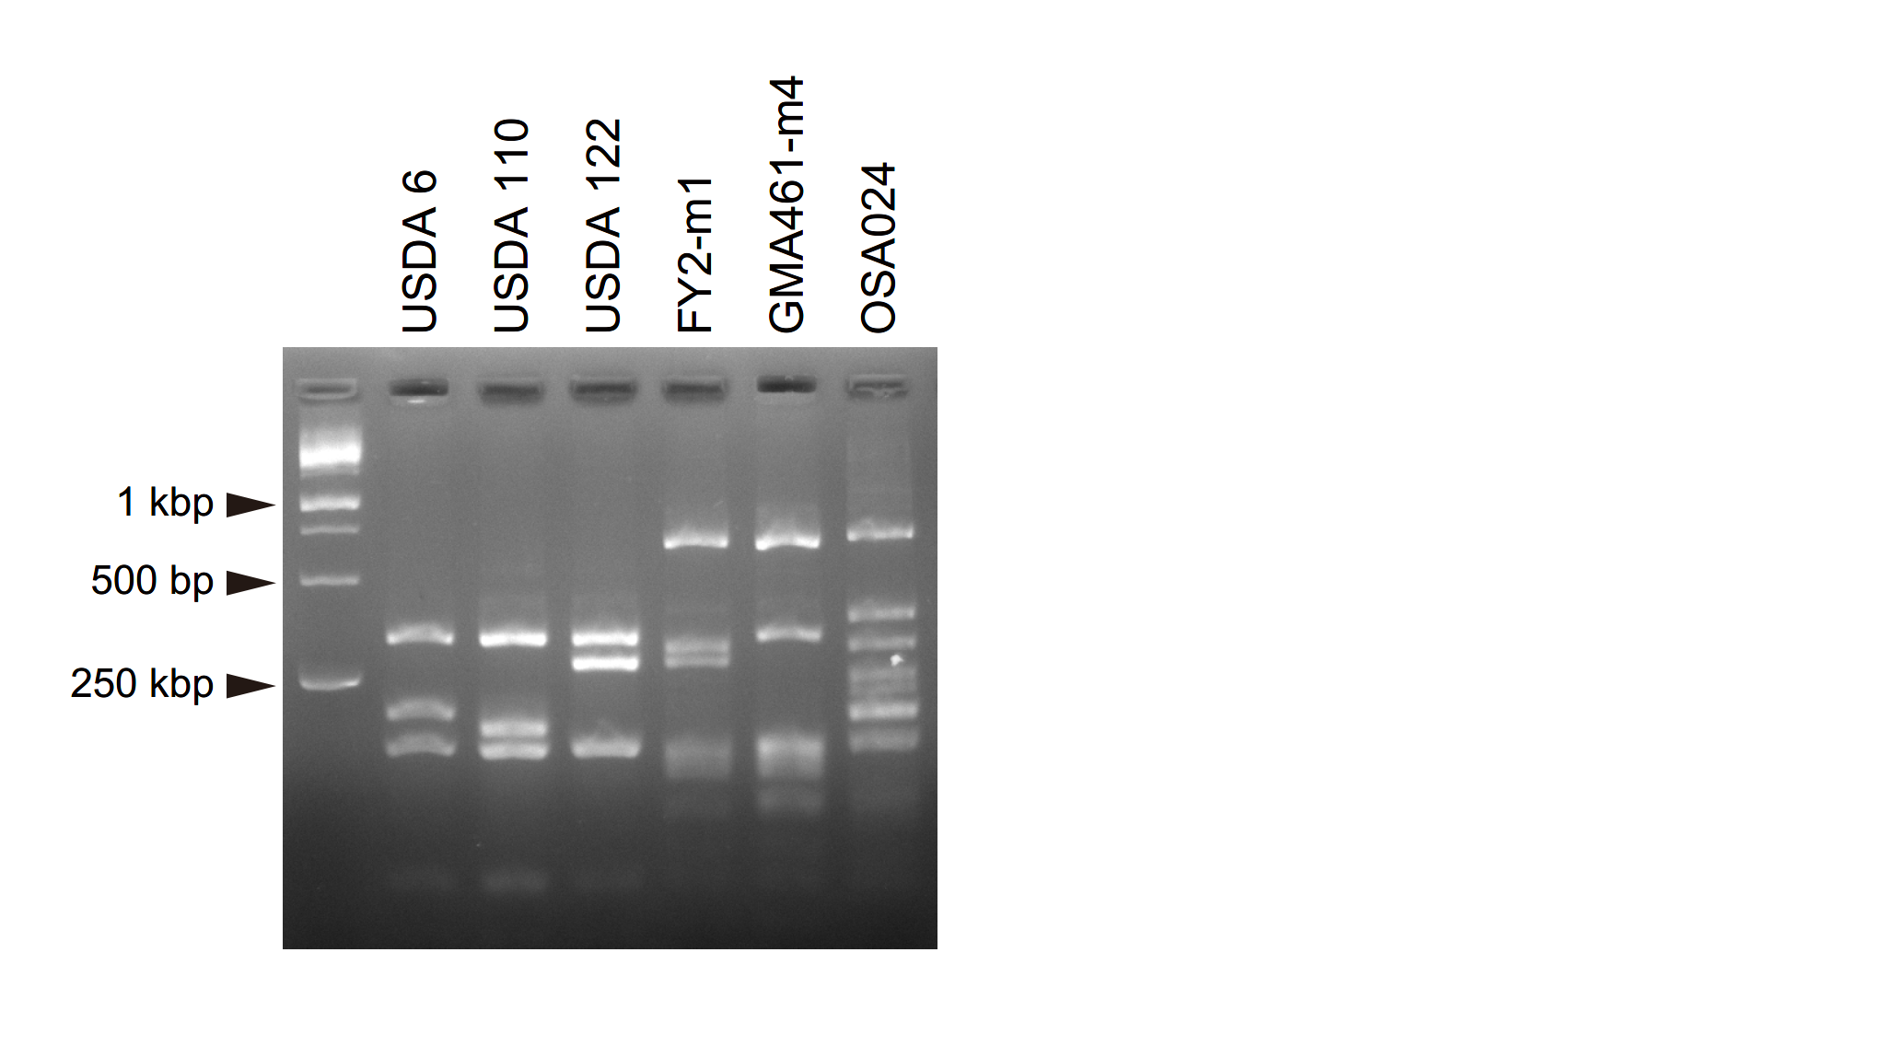
Supplemental Figure 1. PCR-RFLP analysis of the nopP regions in the bradyrhizobia strains inoculated.

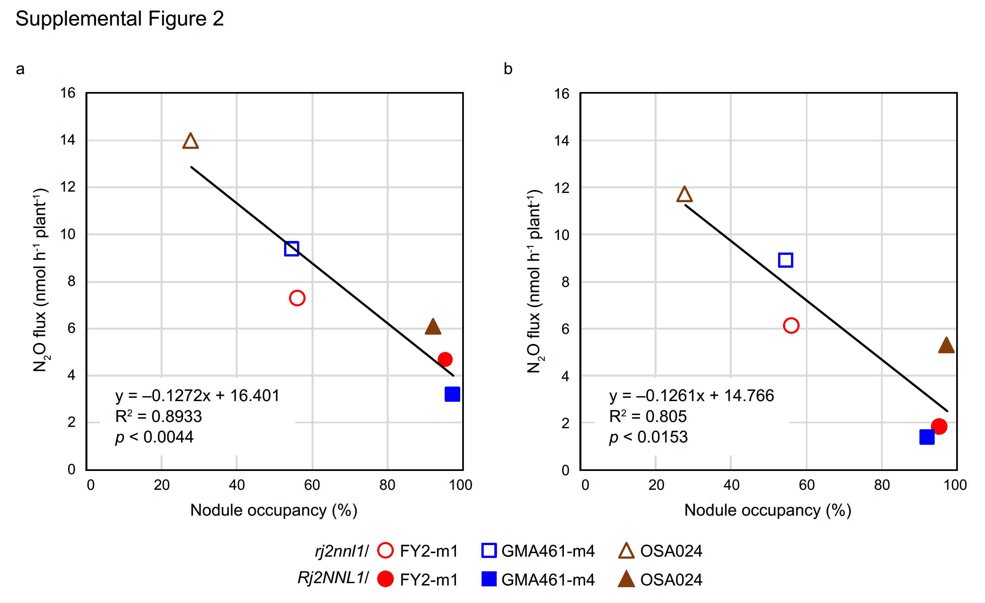
Supplemental Figure 2. Relationship between nodule occupancy of incompatibility-avoiding N₂O-reducing bradyrhizobia strains and N₂O flux.
a. Two weeks after decapitation. b. Three weeks after decapitation. Lines and equations represent linear regression results.

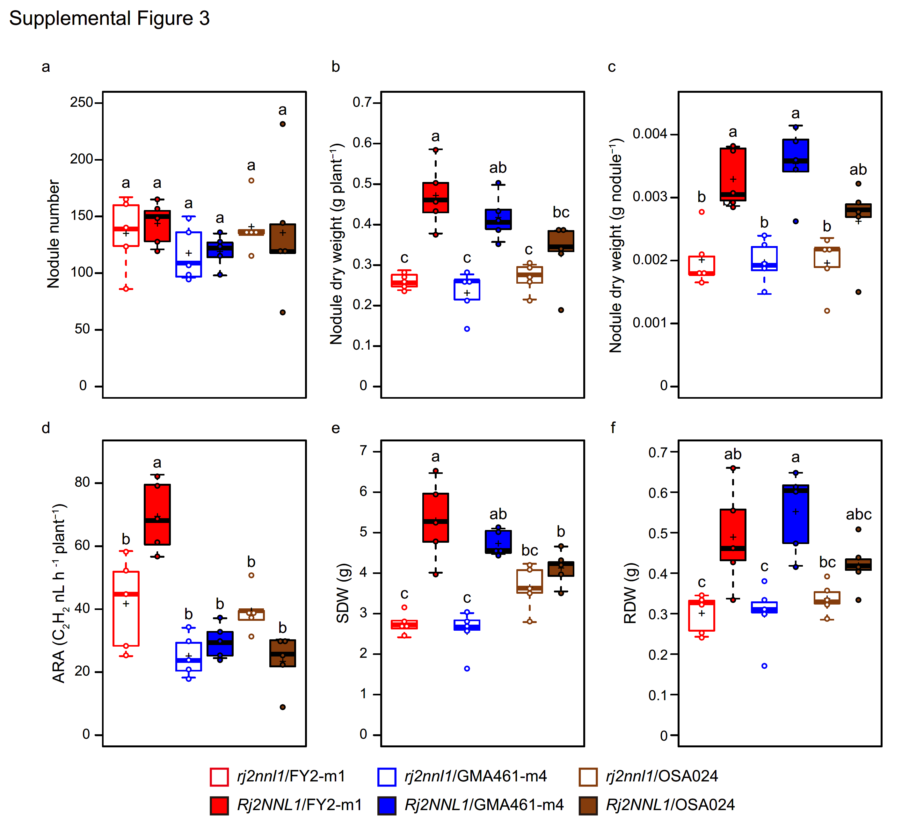
Supplemental Figure 3. Nodulation phenotypes from simultaneous inoculation of Nos⁺⁺ incompatibility-avoiding bradyrhizobia strains with USDA6, USDA110, and USDA122.
a. Nodule number per plant (Nod No). b. Nodule dry weight per plant (Nod DW). c. Nod DW per nodule (NodDW/Nod). d. N₂ fixation activity per plant (ARA/plant). e. Shoot dry weight (SDW). f. Root dry weight (RDW). n=4.

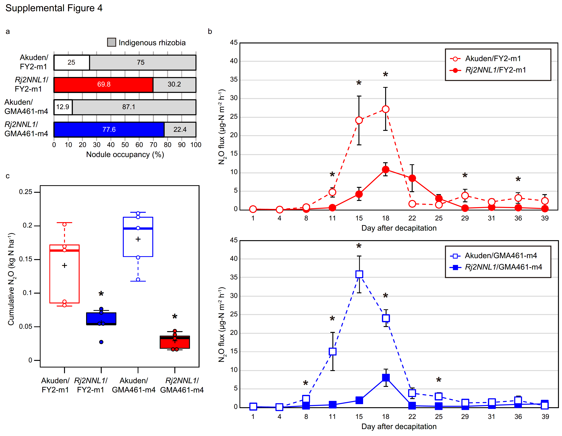
Supplemental Figure 4. Mitigation of N₂O emissions through predominant infection by incompatibility-avoiding Nos⁺⁺ bradyrhizobia strains in Rj2/GmNNL1 soybean under competition with indigenous soil rhizobia.
a. Nodule occupancy. b. Trends in N₂O emission over time following plant decapitation. c. Cumulative N₂O emission. n=5.

