Supplementary Materials

Supplementary material 1. Examples of good and poor synchronisations determined by visual inspection
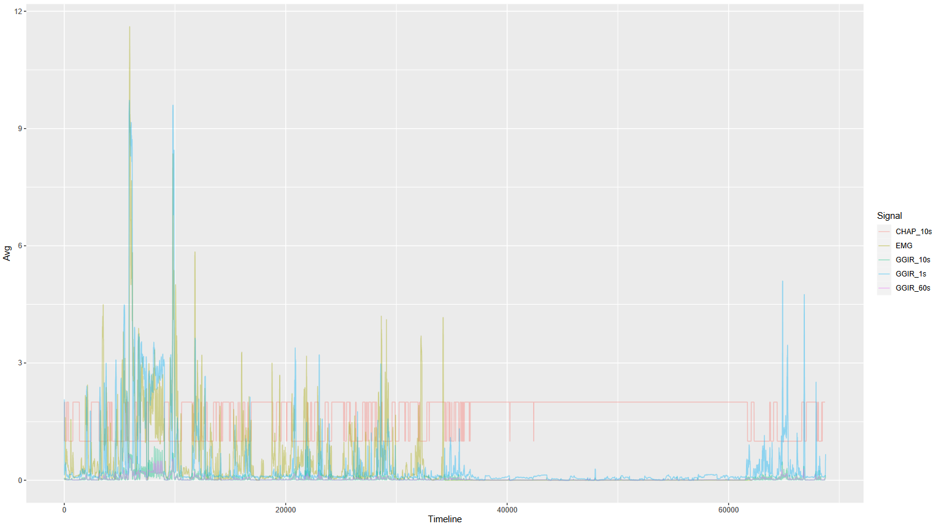
Example of ‘good’ synchronisation. Following best alignment, peaks of acceleration (denoted by the GGIR signal epochs with MAD values), match up with peaks of EMG amplitude. EMG shorts are removed (due to sleep) at halfway into the timeline, but with the accelerometer still being worn. The CHAP signal indicates with binary category where participants are sitting or not-sitting.

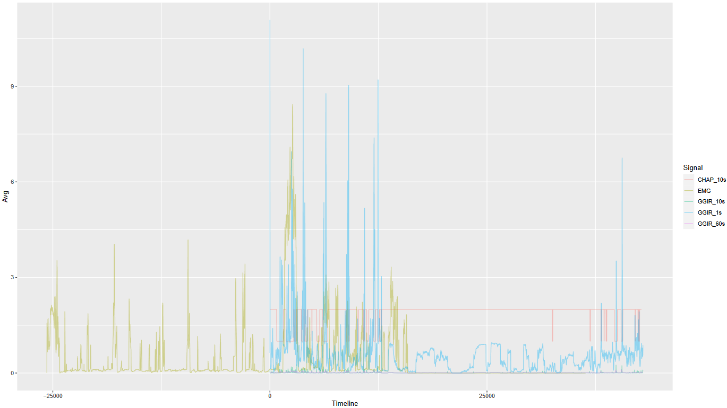
Example of ‘bad’ synchronisation. Following best alignment, peaks of acceleration (denoted by the GGIR signal epochs with MAD values), decidedly did not match up with peaks of EMG amplitude.

Supplementary material 2. Comparison between power law and exponential decay model fit by sample

Study sample | BIC for power law fit  EMG activity % (min) = a * t^{-b} | BIC for exponential decay fit  EMG activity % (min) = a * exp(-b * t) + c
Overall | 709 | 826
EMG24 | 5347 | 38240
BREAK | 1153 | 1118
OPTIMUS | 605 | 797
Term ‘t’ refers to sitting bout duration in minutes.

