Supplementary Information for
Negligible Contribution from Aerosols to Recent Trends in Earth’s Energy Imbalance

This file includes:

Supplementary Figures 1 to 6

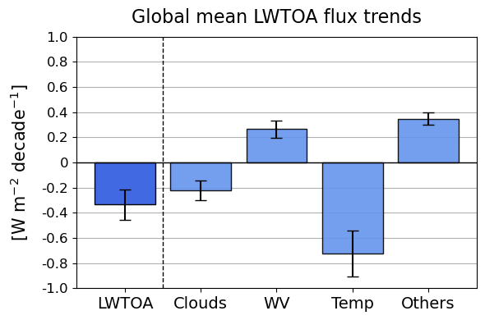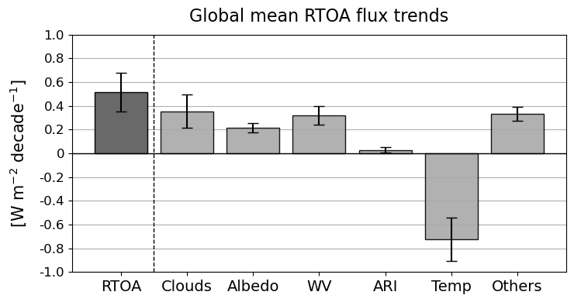
(a)
(b)
Supplementary Fig. 1. Decomposition of global mean top-of-atmosphere (TOA) flux trends, focusing on net TOA radiation (RTOA) and longwave TOA radiation (LWTOA). (a) Global mean RTOA flux trends and their contributions from clouds, surface albedo, water vapor (WV), aerosol-radiation interactions (ARI), temperature, and other factors (labeled as “Others”, such as trace gases and solar irradiance). (b) Global mean LWTOA flux trends, with contributions from the same components, excluding surface albedo and ARI. Error bars represent the 5–95% confidence intervals determined using the methodology in Santer et al. (2000). Positive anomalies indicate Earth absorbing more energy, while negative anomalies represent energy loss.

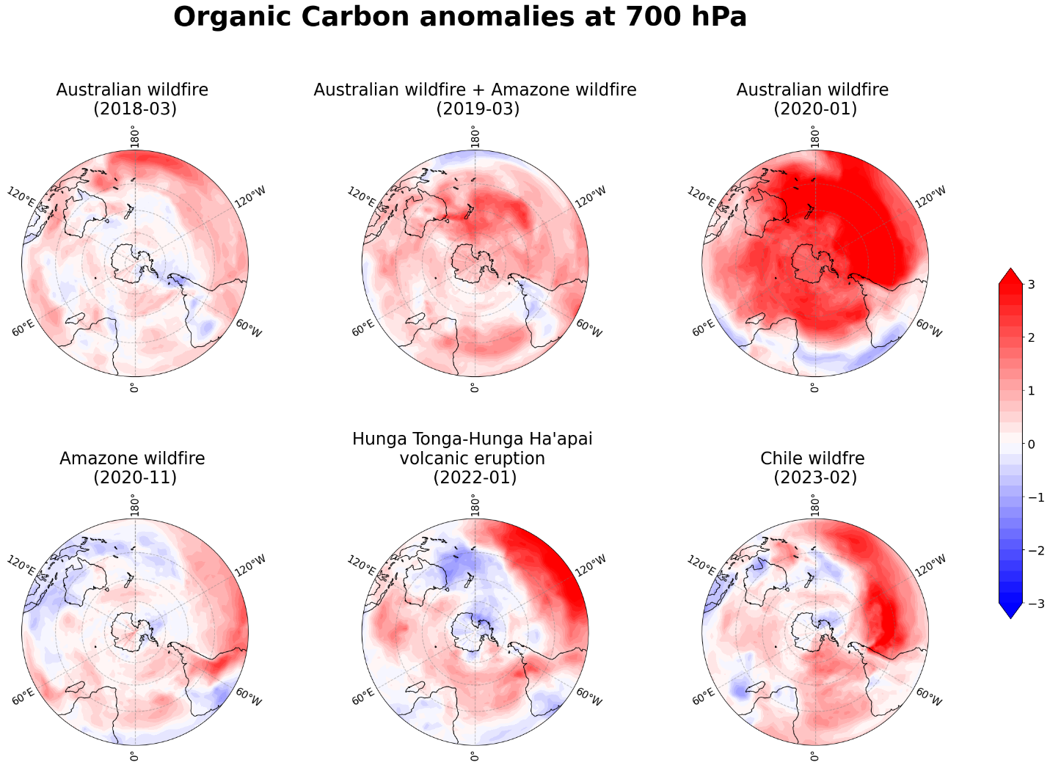
Supplementary Fig. 2. Natural logarithm of hydrophilic organic carbon anomalies at 700 hPa during multiple wildfire and volcanic events. Each panel represents a major aerosol emission event in a specific month in the Southern Hemisphere (SH) and the corresponding anomaly: (a) Australian wildfire (March 2018), (b) combined Australian and Amazon wildfires (March 2019), (c) Australian wildfire (January 2020), (d) Amazon wildfire (November 2020), (e) Hunga Tonga-Hunga Ha’apai volcanic eruption (January 2022), and (f) Chile wildfire (February 2023). The anomalies illustrate the impact of these events on atmospheric organic carbon concentrations at 700 hPa. Organic carbon is used in this analysis because it is a primary component of aerosols emitted from biomass burning and can also be influenced indirectly by volcanic activity through interactions with organic precursors, making it a useful tracer for these events.

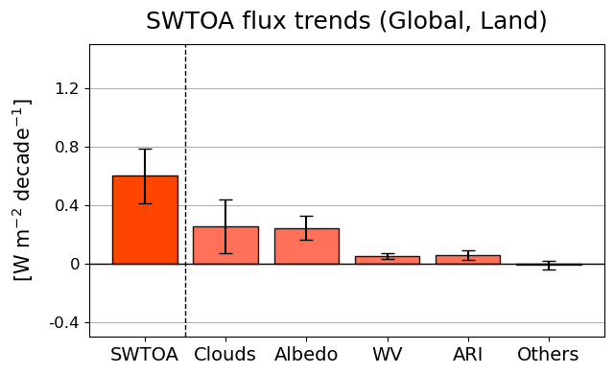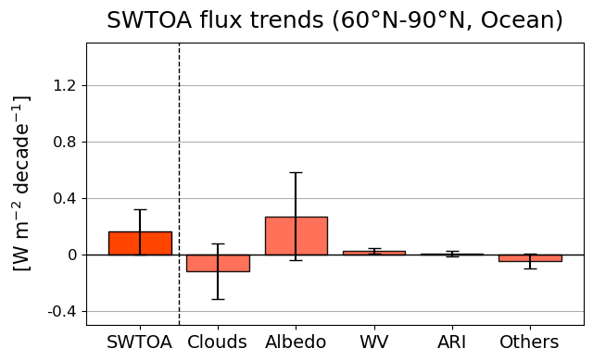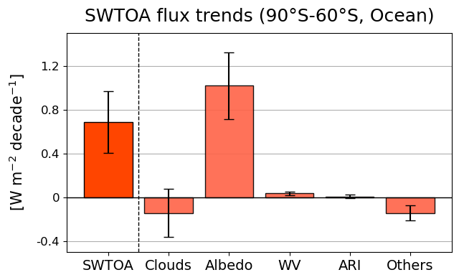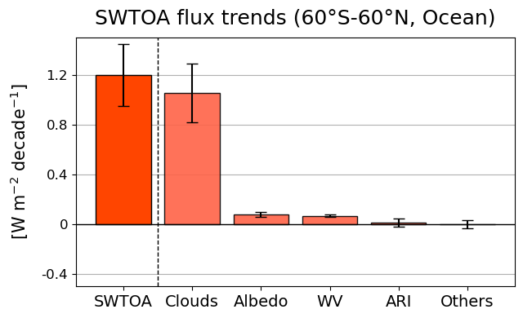
(a)
(b)
(c)
(d)
Supplementary Fig. 3. Decomposition of SWTOA trends by region, illustrating their contributions from clouds, surface albedo, water vapor (WV), aerosol-radiation interactions (ARI), and other factors (labeled as “Others”, such as trace gases and solar irradiance). Regions include (a) near-global (60°S–60°N over ocean), (b) global land, (c) Northern Hemisphere (NH) polar (60°N–90°N, over ocean), and (d) Southern Hemisphere (SH) polar (90°S–60°S, over ocean). Error bars represent 5–95% confidence intervals, determined using the methodology in Santer et al. (2000). Positive anomalies indicate increased energy absorption by Earth, while negative anomalies indicate energy loss.

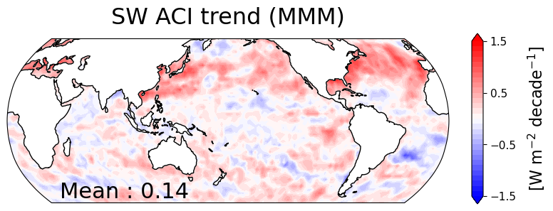
Supplementary Fig. 4. Spatial distribution of the decadal trend in shortwave (SW) effective radiative forcing from aerosol-cloud interactions (ACI) for the period 2003–2023. The multi-model mean (MMM) is derived from five models participating in the Radiative Forcing Model Intercomparison Project (RFMIP; Pincus et al., 2016) single-forcing (aerosol-only) experiments. For this analysis, all models and their realizations, as presented in Fig. 4, are averaged. The domain-averaged (60°S–60°N, ocean) SW ACI value is displayed in the lower-left corner.

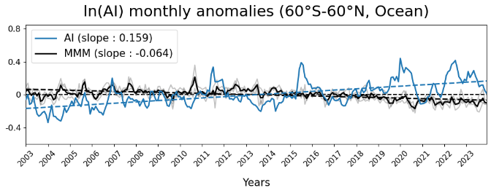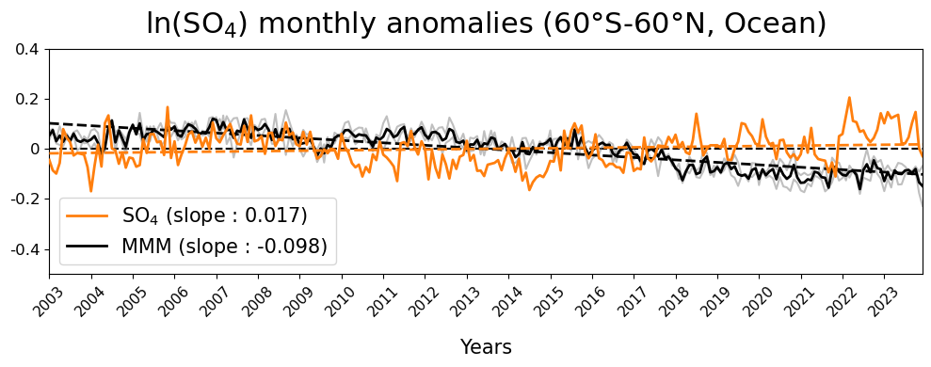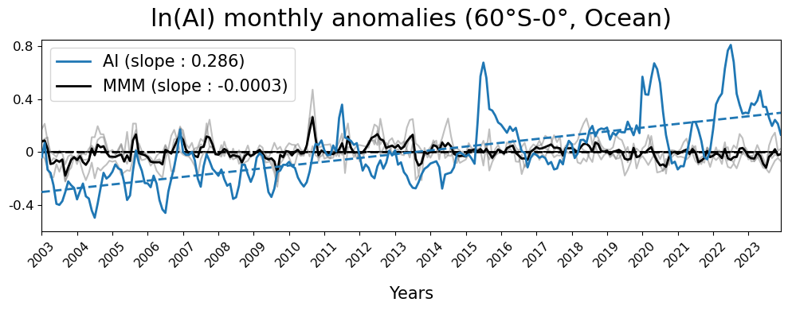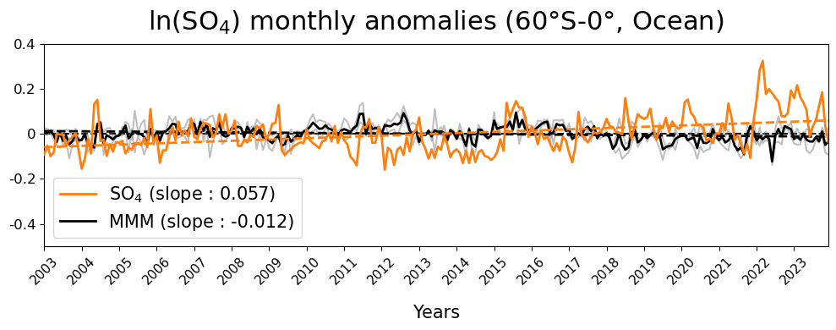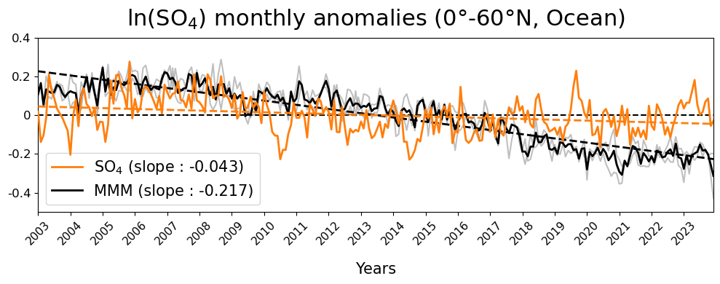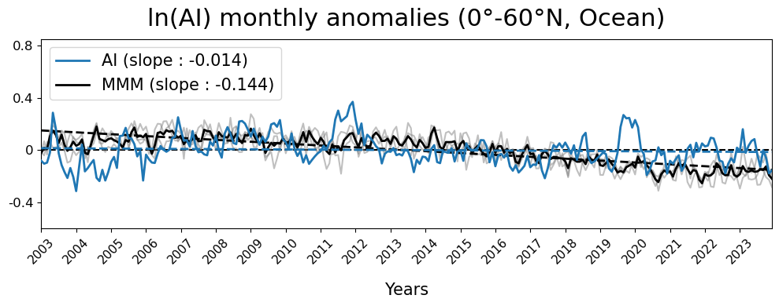
(a)
(b)
(c)
(d)
(e)
(f)
Supplementary Fig. 5. Monthly anomalies in the natural logarithm of aerosol index (AI) and sulfate mass concentrations (SO₄) at 925 hPa from observations, reanalysis and CMIP6 models (MMM in black, individual models in grey) over oceans across three different domains from 2003 to 2023. (a,b) The top row shows anomalies for near-global (60°S–60°N), (c,d) the middle row for the Northern Hemisphere (NH; 0°–60°N), and (e,f) the bottom row for the Southern Hemisphere (SH; 60°S–0°). The left panels display AI anomalies, and the right panels display SO₄ anomalies on a natural logarithmic scale. The MMM and individual models are derived from historical experiments up to 2014, followed by the SSP2-4.5 scenario through 2023. Only models among the five shown in Fig. 4 that provide aerosol proxies, along with their first realization (r1), are included in this analysis: ‘HadGEM3-GC31-LL’, ‘IPSL-CM6A-LR’, and ‘MIROC6’ for AI, and ‘GFDL-CM4’ and ‘MIROC6’ for SO₄. Dashed lines represent the linear trends for each component, with their slopes indicated in the upper or lower left corners of each panel.

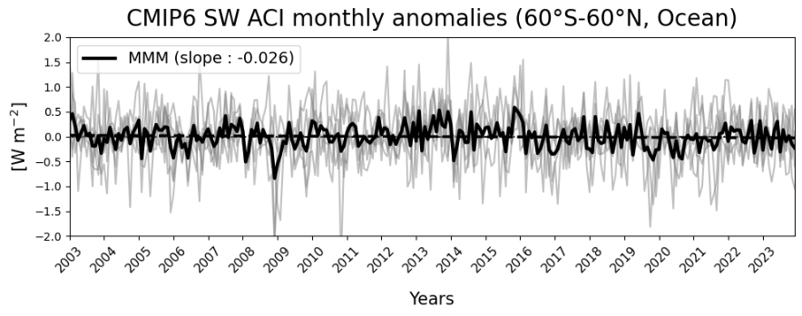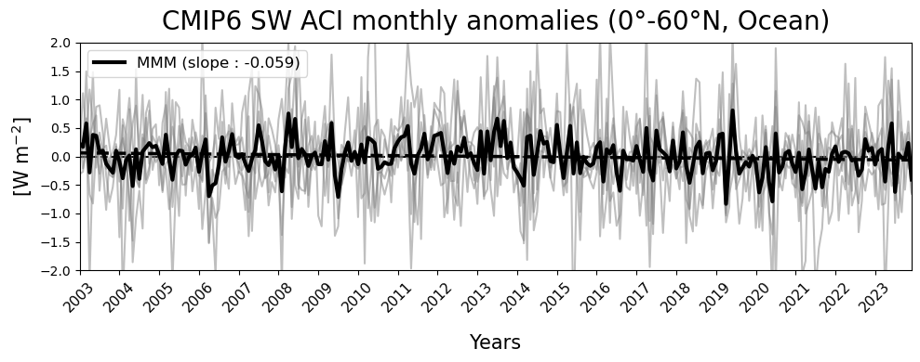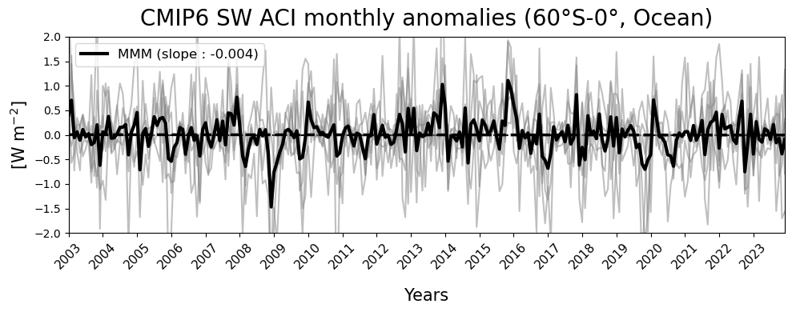
Supplementary Fig. 6. Monthly anomalies of SW ACI from CMIP6 RFMIP single-forcing (natural-forcing-only; piClim-histnat) experiment models (MMM in black, individual models in grey) over oceans across three different domains from 2003 to 2023. The top row shows anomalies for the near-global domain (60°S–60°N), the middle row for the Northern Hemisphere (NH; 0°–60°N), and the bottom row for the Southern Hemisphere (SH; 60°S–0°). The analysis includes five models shown in Fig. 4, each using the first realization (r1). Dashed lines represent the linear trends, with the slopes noted in the upper left corners of each panel.

References
- Santer, B. D. et al. Statistical significance of trends and trend differences in layer-average atmospheric temperature time series. Journal of Geophysical Research: Atmospheres 105, 7337–7356 (2000).
- Pincus, R., Forster, P. M. & Stevens, B. The Radiative Forcing Model Intercomparison Project (RFMIP): experimental protocol for CMIP6. Geoscientific Model Development 9, 3447–3460 (2016).

