Supplementary Table 1. Location of volcanoes and measurements of the volcano-trench-water divide distances.
Name Volcano | Long. °W | Lat. °S | dvt (km) | dvw (km) | dtw (km) | Zone
Tupungato | 69.77 | 33.36 | 285 | 10 | 274 | 1
Tupungatito | 69.80 | 33.43 | 282 | 9 | 275 | 1
Nevado de los Piuquenes | 69.83 | 33.52 | 285 | 12 | 271 | 1
San Jose | 69.90 | 33.79 | 286 | 9 | 277 | 1
Maipo | 69.83 | 34.16 | 306 | 0 | 306 | 1
Palomo | 79.29 | 34.61 | 282 | -11 | 294 | 1
Caldera del Atuel | 70.05 | 34.65 | 305 | 10 | 296 | 1
Northern Mendoza Volcanic Field | 69 | 34.67 | 400* | 93 | 305 | 1
Tinguiririca | 70.35 | 34.81 | 286 | -8 | 293 | 1
Risco Plateado | 70.46 | 34.99 | 323 | 28 | 293 | 1
Sordo Lucas | 70.46 | 34.99 | 283 | -13 | 295 | 1
Infiernillo | 69.9 | 35.12 | 335 | 40 | 295 | 1
Planchon-Peteroa | 70.57 | 35.22 | 281 | -13 | 291 | 1
Calabozos | 70.50 | 35.56 | 302 | -10 | 308 | 1
Cerro Nevado | 68.49 | 35.58 | 472* | 175* | 297 | 1
Descabezado Grande | 70.75 | 35.58 | 282 | -31 | 302 | 1
Cerro Azul | 70.76 | 35.65 | 285 | -35 | 302 | 1
Llancanelo Volcanic Field | 69.25 | 35.75 | 415* | 99 | 316 | 1
Puelche Volcanic Field | 70.48 | 35.78 | 313 | -12 | 326 | 1
San Pedro Pellado | 70.85 | 35.99 | 293 | -40 | 332 | 1
Laguna del Maule | 70.49 | 36.06 | 324 | -8 | 333 | 1
Nevado del Longavi | 71.16 | 36.19 | 272 | -44 | 315 | 1
Lomas Blancas | 71.01 | 36.29 | 288 | -28 | 315 | 1
Payun Matru | 69.24 | 36.42 | 446* | 114* | 329 | 1
Volcan Resago | 70.92 | 36.45 | 303 | -9 | 311 | 1
Domuyo | 70.43 | 36.64 | 353 | 40 | 312 | 1
Cochiquito Volcanic Group | 69.83 | 36.74 | 405* | 90 | 315 | 1
Nevados de Chillan | 71.38 | 36.87 | 293 | -14 | 305 | 1
Tromen | 70.03 | 37.14 | 414* | 104* | 304 | 2
Antuco | 71.35 | 37.41 | 313 | -11 | 319 | 2
Auca Mahuida Volcanic Field | 68.92 | 37.74 | 530* | 212* | 316 | 2
Trolon | 70.91 | 37.74 | 355 | 17 | 338 | 2
Copahue | 71.18 | 37.86 | 335 | -11 | 344 | 2
Callaqui | 71.45 | 37.92 | 312 | -38 | 349 | 2
Laguna Mariñaqui | 71.17 | 38.26 | 344 | -11 | 356 | 2
Tolhuaca | 71.65 | 38.31 | 304 | -52 | 357 | 2
Lonquimay | 71.59 | 38.38 | 311 | -48 | 359 | 2
Tralihue | 70.90 | 38.51 | 373 | 5 | 364 | 2
Sierra Nevada | 71.58 | 38.58 | 314 | -56 | 369 | 2
Pino Hachado | 70.81 | 38.68 | 381 | 12 | 369 | 2
Llaima | 71.73 | 38.69 | 300 | -42 | 341 | 2
Sollipulli | 71.52 | 38.97 | 323 | -21 | 343 | 2
Laguna Blanca | 70.37 | 39.02 | 422* | 80 | 340 | 2
Nevados de Caburga | 70.53 | 39.17 | 410* | 67* | 344 | 2
Cerro Trautren | 71.4 | 30.17 | 337 | -9 | 345 | 2
Caburgua-Huelemolle | 71.75 | 39.25 | 308 | -35 | 343 | 2
Cerro Maichin | 71.55 | 39.35 | 329 | -13 | 342 | 2
Villarrica | 71.93 | 39.42 | 298 | -43 | 340 | 2
Quetrupillan | 71.7 | 39.5 | 317 | -26 | 343 | 2
Lanin | 71.50 | 39.64 | 337 | -3 | 339 | 2
Quinchilca | 72.01 | 39.68 | 294 | -40 | 333 | 2
Huanquihue Group | 71.58 | 39.89 | 333 | -1 | 333 | 2
Mocho-Choshuenco | 72.03 | 39.93 | 294 | -41 | 335 | 2
Carran-Los Venados | 72.07 | 40.35 | 291 | -30 | 312 | 2
Puyehue-Cordon Caulle | 72.12 | 40.59 | 288 | -22 | 307 | 2
Cerro Pantoja | 71.94 | 40.77 | 304 | -5 | 308 | 2
Antillanca Volcanic Complex | 72.15 | 40.78 | 287 | -23 | 309 | 2
Puntiagudo-Cordon Cenizos | 72.26 | 40.97 | 280 | -32 | 311 | 2
Osorno | 72.50 | 41.11 | 265 | -53 | 311 | 2
Tronador | 71.89 | 41.16 | 316 | -10 | 322 | 2
Cayutue-La Vigueria | 72.27 | 41.25 | 288 | -43 | 323 | 2
Calbuco | 72.62 | 41.33 | 260 | -73 | 324 | 2
Cuernos del Diablo | 72.01 | 41.36 | 311 | -34 | 336 | 2
Yate | 72.40 | 41.76 | 282 | -87 | 347 | 2
Hornopiren | 72.43 | 41.87 | 280 | -98 | 357 | 2
Apagado | 72.58 | 41.88 | 268 | (-107)* | 352 | 2
Crater Basalt Volcanic Field | 70.19 | 42.02 | 467* | 70 | 385 | 3
Huequi | 72.58 | 42.38 | 273 | -110 | 380 | 3
Michinmahuida | 72.45 | 42.80 | 287 | -94 | 379 | 3
Chaiten | 72.65 | 42.83 | 271 | -110 | 380 | 3
Corcovado | 72.79 | 43.19 | 261 | -119 | 376 | 3
Yanteles | 72.81 | 43.50 | 263 | -115 | 378 | 3
Melimoyu | 72.88 | 44.08 | 266 | -129 | 395 | 3
Puyuhuapi | 72.53 | 44.3 | 297 | -101 | 395 | 3
Mentolat | 73.08 | 44.7 | 255 | -122 | 377 | 3
Cay | 72.98 | 45.06 | 250 | -114 | 359 | 3
Maca | 73.17 | 45.1 | 235 | -129 | 359 | 3
Meullin | 73.05 | 45.22 | 238 | -111 | 335 | 3
Cerro Hudson | 72.97 | 45.9 | 214 | -94 | 298* | 3
Rio Murta | 72.71 | 46.17 | 219 | -70 | 287* | 3
dvt: distance volcano – subduction trench; dvw: distance volcano – topographic water divide; dtw: distance subduction trench – topographic water divide. *Outliers shown in the box plots of Fig. 1. Negative values of dvw indicate volcanoes to the west of the topographic water divide.
Supplementary Table 2. Material properties used in the numerical experiments.
 | ρ₀^{s} and ρ₀^{l} | E_{a} | V_{a} | n | C | Vis-cous | sin | c | µ | C_{p} | Hr | H_{l} | α | β | T_{solidus} | T_{liquidus}
 | (km/  m³) | (kJ/mol) | (m³/mol) |  | (Mpa) | flow law | (ϕ_{eff}) | (W/m/K) | (GPa) | (J/kg/K) | (µW/m³) | (kJ/kg) | (1/k) | (1/Pa) | (K) | (K)
Crust | 2800  (solid) 2400 (liquid) | 154 | 0 | 2.3 | 10 | Wet Qz. | 0.2 | 0.64+807/  (T+77) | 10 | 1000 | 1 | 300 | 3x10⁻⁵ | 1x10⁻¹¹ | 889 + 17900 /(P+54)+ 20200/  (P+54)²  at P <1200 MPa;  831 + 0.06 P  at P > 1200 MPa | 1262 + 0.09 P
Lithos-pheirc Mantle | 3250  (solid)  2200 (liquid) | 532 | 10 | 3.5 | 10 | Dry  Ol. | 0.6 | 0.73+1293/ (T+77) | 67 | 1000 | 0.022 | 400 | 3x10⁻⁵ | 1x10⁻¹¹ | 1394 + 0.132899 P-0.000005104P²  at P < 1000 MPa,  2212 + 0.030819 (P-10000)  at P >1000 MPa | 2073 + 0.114 P
Asthenos-pheric Mantle | 3250 (solid) 2200 (liquid) | 532 | 10 | 3.5 | 10 | Dry  Ol. | 0.6 | 0.73+1293/ (T+77) | 67 | 1000 | 0.022 | 400 | 3x10⁻⁵ | 1x10⁻¹¹ | 1394 + 0.132899 P-0.000005104 P²  at P < 1000 MPa,  2212 + 0.030819 (P-1000)  at P>10000 MPa | 2073 + 0.114 P
MMZ and 75% of the magma  channel | 3250 (solid)  2200 (liquid)  *1800 (liquid) | 471 | 0 | 4.0 | 10 | Wet Ol. | 0 | 0.73+1293/ (T+77) | 67 | 1000 | 0.022 | 400 | 3x10⁻⁵ | 1x10⁻¹¹ | 1240 + 49800/(P+323)  at P<2400 MPa,  1266 + 0.114 P + 0.000005 P²  at P>2400 MPa | 2073 + 0.114 P
Basalt 25% of the magma channel | 3100 (solid), 2300 (liquid)  *1800 (liquid) | 154 | 0 | 2.3 | 10 | Wet Qz. | 0 | 1.18+474/ (T+77) | 25 | 1000 | 0.25 | 380 | 3x10⁻⁵ | 1x10⁻¹¹ | 973-70400/(P+354)+77800000  at P<1600  935+0.0035 P + 0.0000062 P²  at P>1600 | 1423 + 0.105 P
$ρ_{l}^{0}$ and $ρ_{s}^{0}$ are the standard densities of solid and molten rocks, respectively; $E_{a}$ is the activation energy; $V_{a}$ is the activation volume; n is the stress exponent; C is cohesion; $φ$ is the effective internal friction angle; C_{p} is the specific heat capacity; c is thermal conductivity; $μ$ is the shear modulus; H_{r} and H_{l} are the radiogenic and latent heat productions, respectively; $α$ is thermal expansion; $β$ is compressibility; $T_{s}$ and $T_{l}$ are the solidus and liquidus temperatures, respectively. Qz and Ol are quartzite and olivine, respectively. *Lighter $ρ_{l}^{0}$ was used on MMZ and magmatic channel with the simulations with thick crust (Ch = 45 km) to allow the partially molten rocks to rise through the crust. All rheological and partial melting laws/parameters are based on experimental rock mechanics and petrology^{51–54}.

Supplementary Table 3. Results of the parametric study.
Ch | Lh | Dmc | Topography | dl | dr | δd=|dr|-|dl|
35 | 90 | 15 | central | -63 | 54 | -9
35 | 90 | 20 | central | -75 | 70 | -5
35 | 90 | 25 | central | -17.5 | 17.5 | 0
35 | 90 | 15 | lateral | -50 | 12.5 | -37.5
35 | 90 | 20 | lateral | -55 | 3 | -52
35 | 90 | 25 | lateral | -67 | 67 | 0
45 | 90 | 15 | central | -7.5 | 12.5 | 5
45 | 90 | 20 | central | -2.5 | 12.5 | 10
45 | 90 | 25 | central | 0 | 0 | 0
45 | 90 | 15 | lateral | -15 | 10 | -5
45 | 90 | 20 | lateral | -22.5 | 2.5 | -20
45 | 90 | 25 | lateral | -22.5 | 2.5 | -20
35 | 100 | 15 | central | -15 | 15 | 0
35 | 100 | 20 | central | -62.5 | 62.5 | 0
35 | 100 | 25 | central | -65 | 65 | 0
35 | 100 | 15 | lateral | -15 | 5 | -10
35 | 100 | 20 | lateral | -42.5 | 0 | -42.5
35 | 100 | 25 | lateral | -57.5 | 57.5 | 0
45 | 100 | 15 | central | -7.5 | 15 | 7.5
45 | 100 | 20 | central | -12.5 | 10 | -2.5
45 | 100 | 25 | central | 0 | 0 | 0
45 | 100 | 15 | lateral | -20 | 10 | -10
45 | 100 | 20 | lateral | -20 | 0 | -20
45 | 100 | 25 | lateral | -30 | 2.5 | -27.5
Ch: crustal thickness, Lh: lithospheric thickness; Dmc: initial depth of the magmatic channel upper tip; dl and dr: maximum horizontal distances between the center of the model domain and the surface fault tips in surface to the left and to the right, respectively; $δd=\left|dr\right|-\left|dl\right|$ is the degree of the asymmetry of the accumulated bulk strain, (negative values show asymmetry to the left).

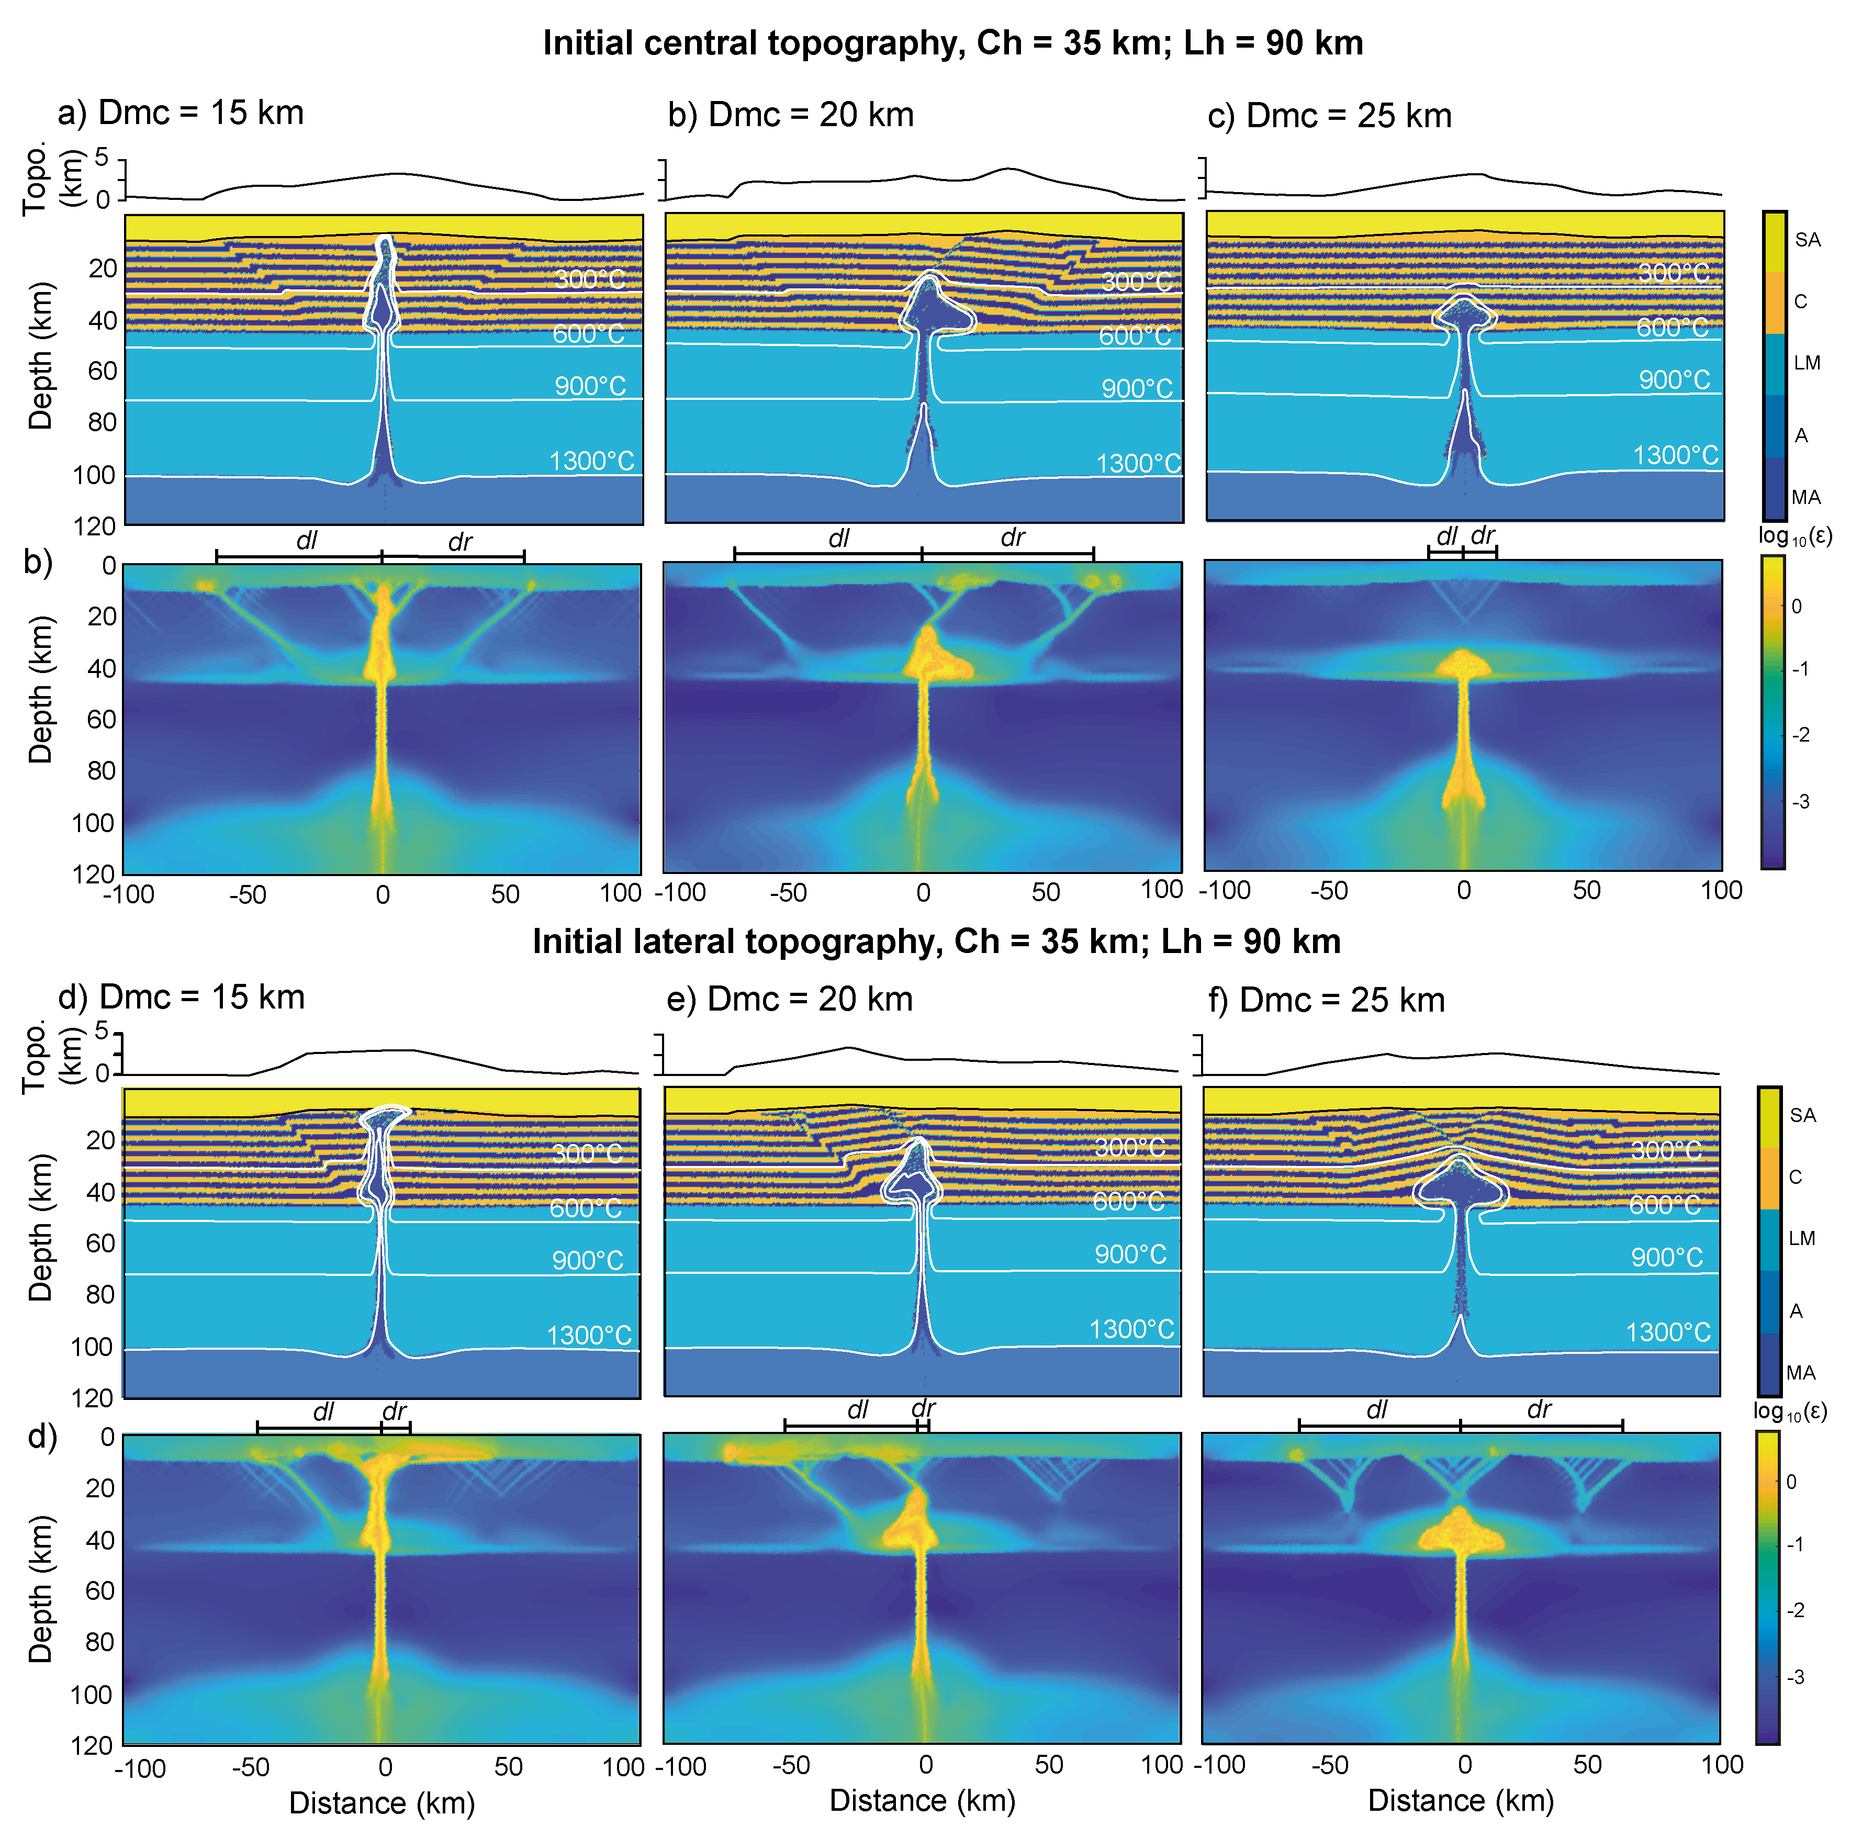
Supplementary Fig. 1. Final steps of simulations accounting for Ch = 35 km and Lh = 90 km. Symbols and definitions are the same of Fig. 2. a-c) The initial topography is centered above the MMZ. d-f) The initial topography is laterally shifted (rightward) respect to the MMZ.
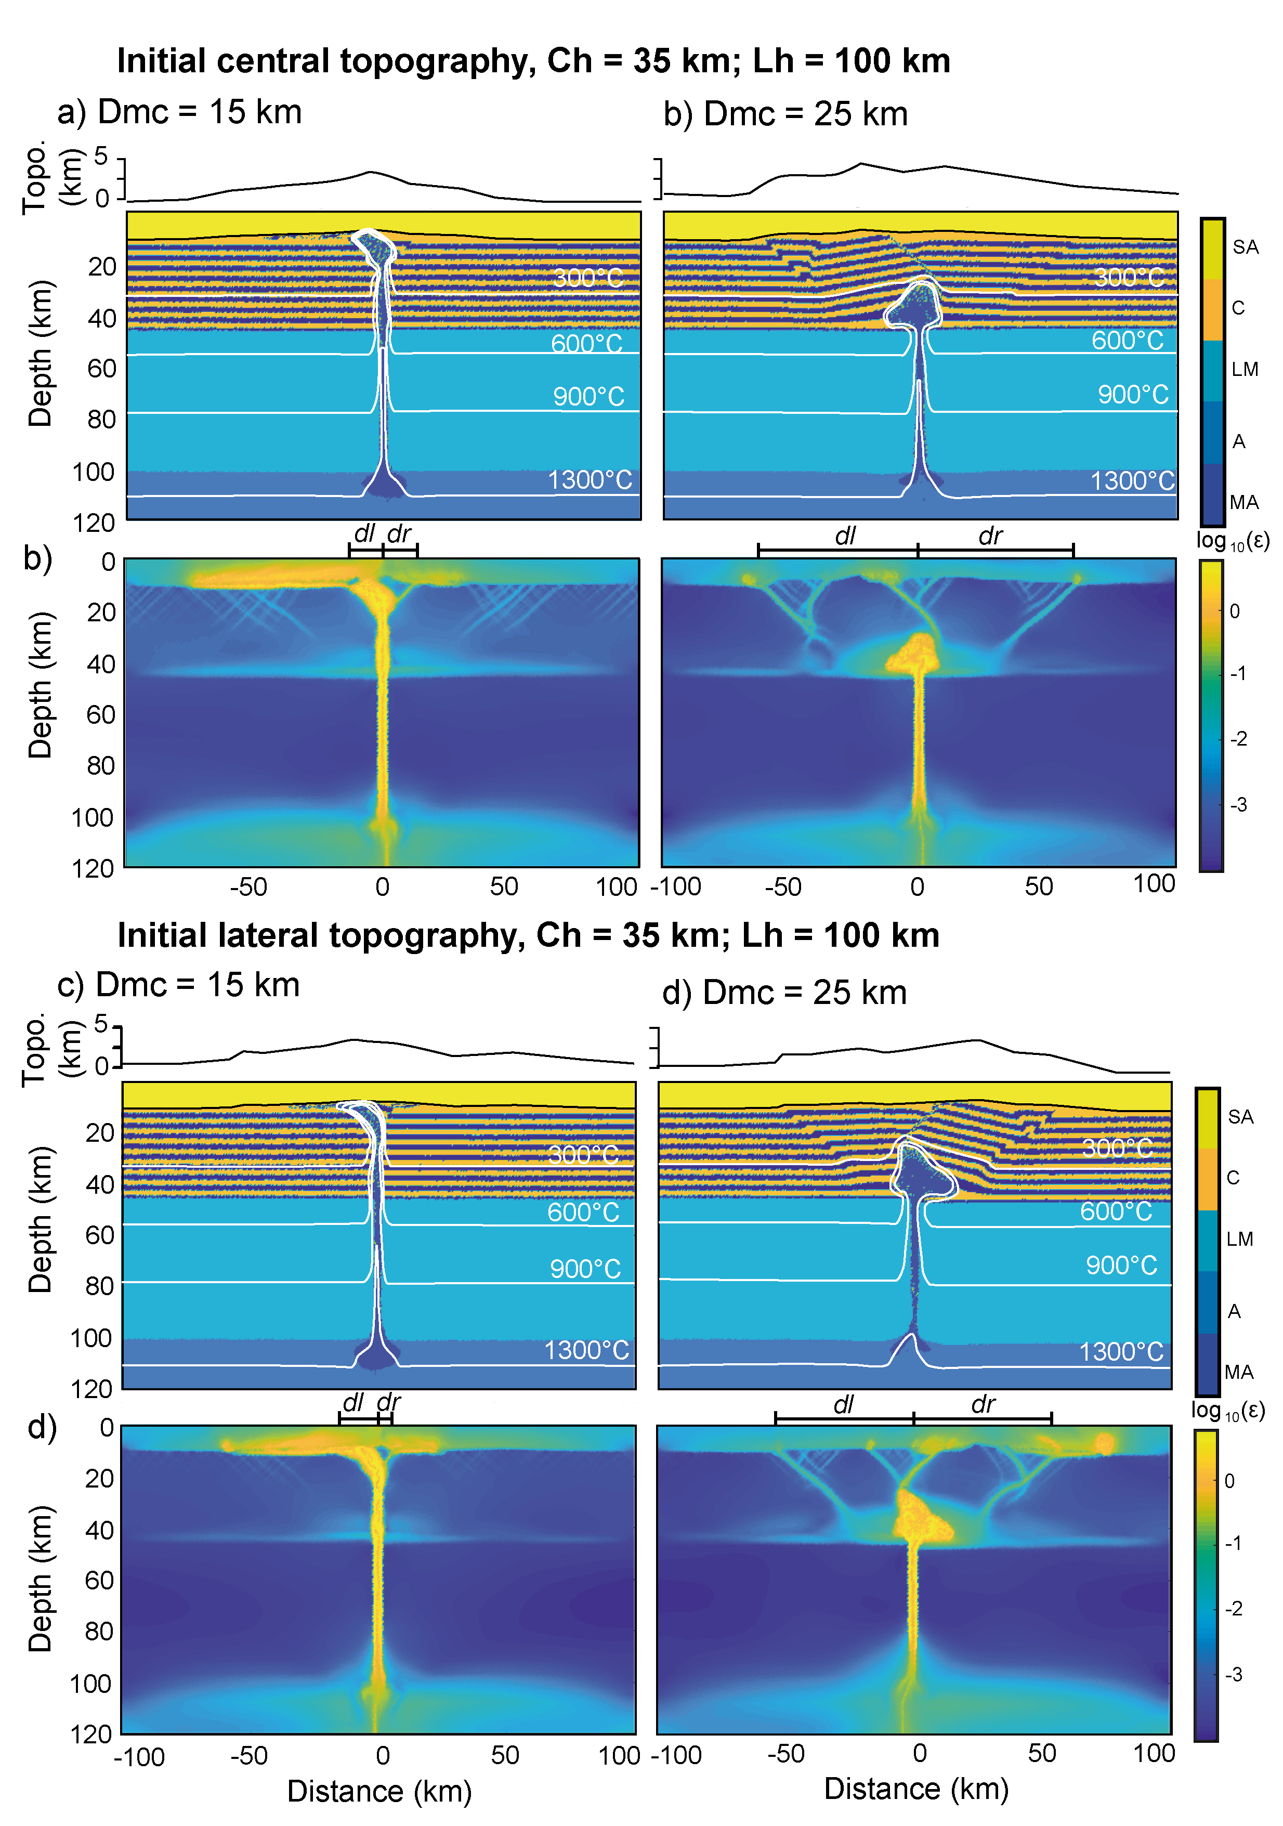 | Supplementary Data Fig. 2. Final steps of simulations accounting for Ch = 35 km and Lh = 100 km. Symbols and definitions are the same of Fig. 2. a, b) The initial topography is centered above the MMZ. c, d) The initial topography is laterally shifted (rightward) respect to the MMZ.

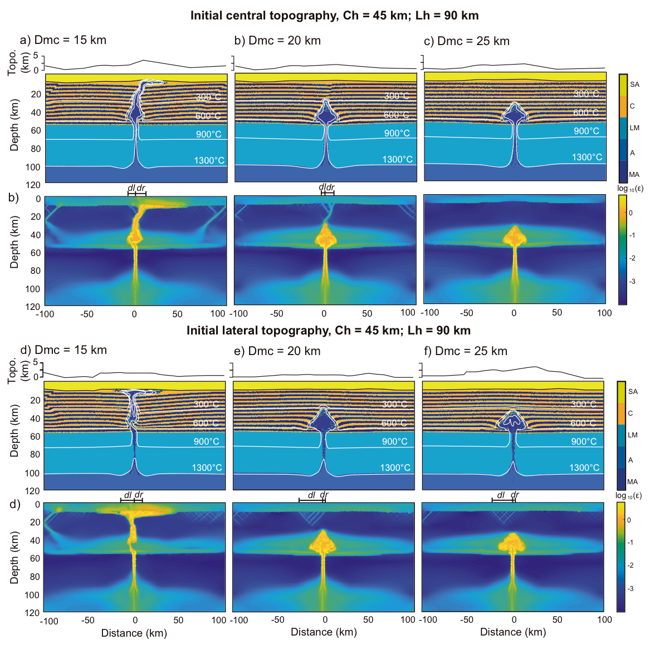
Supplementary Data Fig. 3. Final steps of simulations accounting for Ch = 45 km and Lh = 90 km. Symbols and definitions are the same of Fig. 2. a-c) The initial topography is centered above the MMZ. d-f) The initial topography is laterally shifted (rightward) respect to the MMZ.
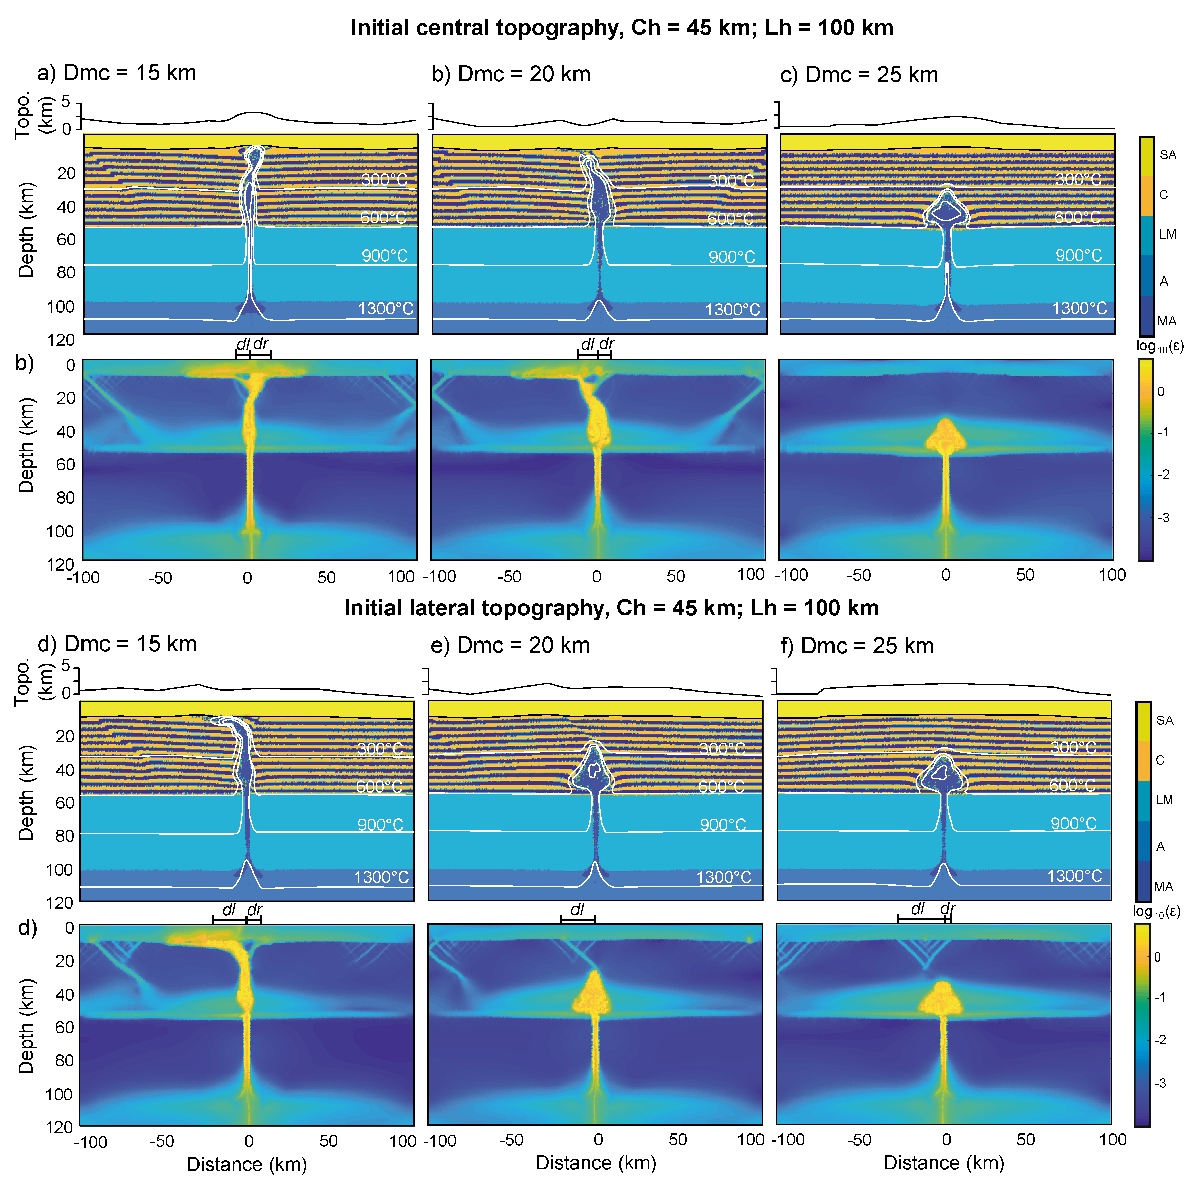
Supplementary Data Fig. 4. Final steps of simulations accounting for Ch = 45 km and Lh = 100 km. Symbols and definitions are the same of Fig. 2. a-c) The initial topography is centered above the MMZ. d-f) The initial topography is laterally shifted (rightward) respect to the MMZ.

