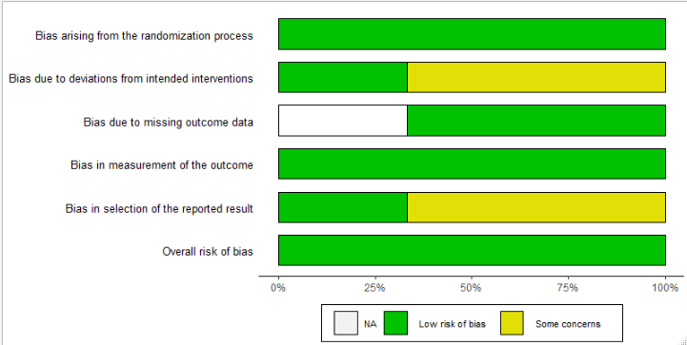
Risk of bias graph: review authors’ judgements about each risk of bias item presented as percentages across all included cluster randomised studies

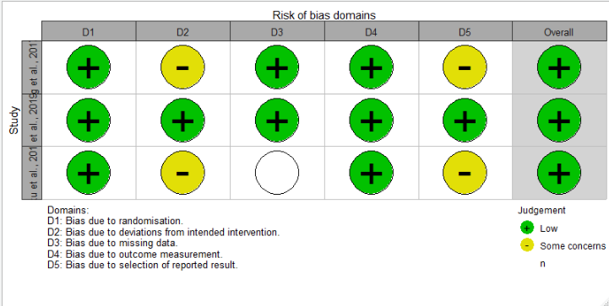
Risk of bias summary: review authors’ judgements about each risk of bias item for each included cluster randomised study

