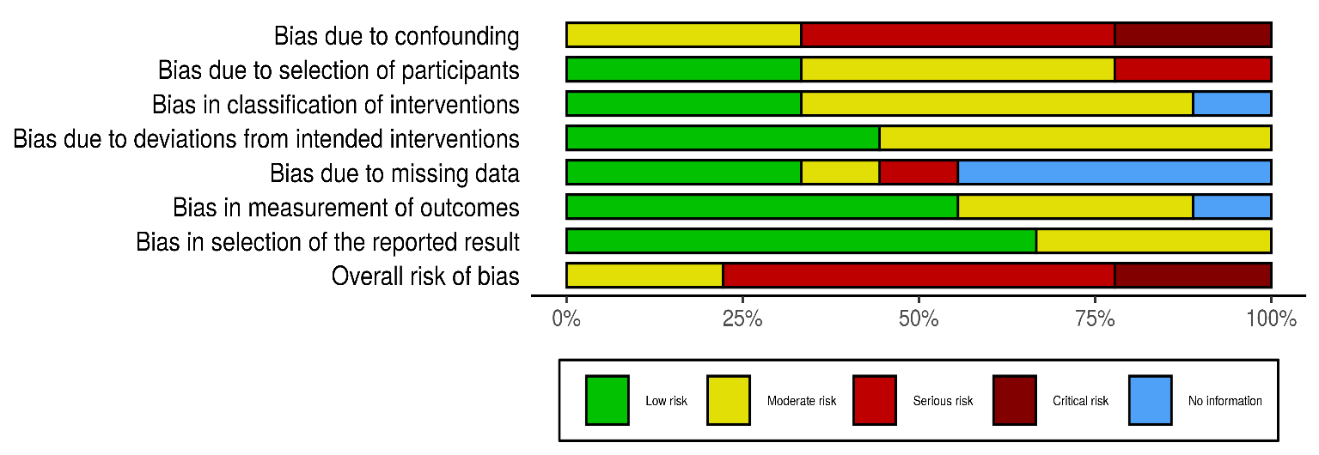
Risk of bias graph: review authors’ judgements about each risk of bias item presented as percentages across all included quasi-experimental studies

Risk of bias summary: review authors’ judgements about each risk of bias item for each included quasi-experimental study

