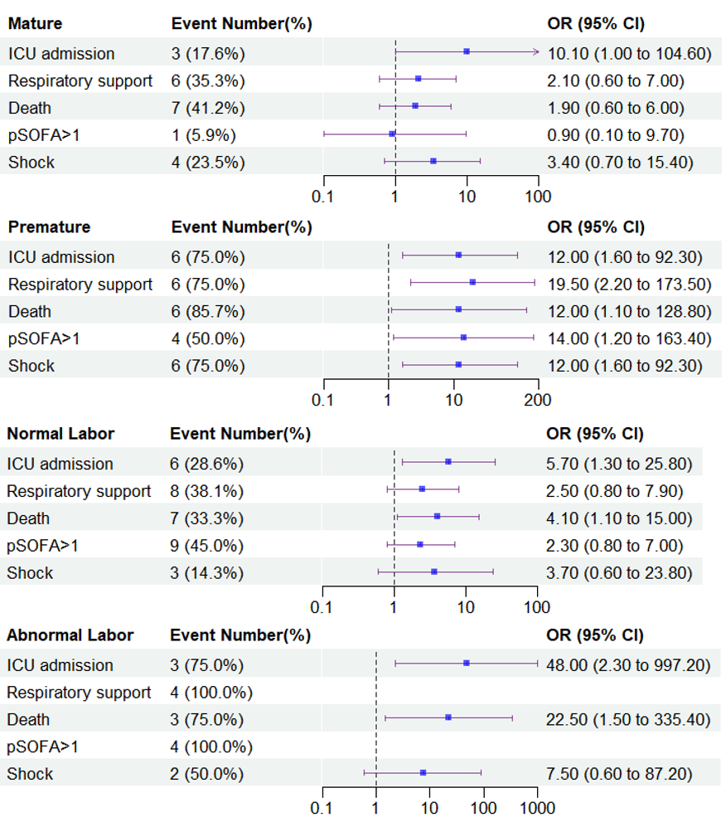
Supplementary Fig 1. Premature and abnormal labor for predicting adverse outcomes in pediatric patients with E.coli meningitis. Abbreviation: CI, confidence interval; OR, odds ratio; pSOFA, pediatric sequential organ failure assessment; ICU, intensive care unit.

Supplementary Table 1 Risk factor for intracerebral hemorrhage of E. coli Meningitis by univariate analysis.
 | Total | Event Number(%) | OR (95%CI) | P
CSF examination
WBC (×10⁶/L)
≤100 | 23 | 3 (13.0) | Reference | -
100-5000 | 44 | 12 (27.3) | 2.5 (0.6, 10.0) | 0.19
>5000 | 21 | 10 (47.6) | 6.1 (1.4, 26.8) | 0.02
Protein (mg/L)
≤1000 | 24 | 3 (12.5) | Reference | -
1000-5000 | 48 | 16 (33.3) | 3.5 (0.9, 13.5) | 0.07
>5000 | 16 | 6 (37.5) | 4.2 (0.9, 20.3) | 0.08
Glucose (mmol/L)
>2.8 | 23 | 3 (13.0) | Reference | -
1.0-2.8 | 24 | 5 (20.8) | 1.8 (0.4, 8.4) | 0.48
≤1.0 | 41 | 17 (41.5) | 4.7 (1.2, 18.5) | 0.03
Chloride (mmol/L)
≤120 | 59 | 18 (30.5) | Reference | -
>120 | 29 | 7 (24.1) | 0.7 (0.3, 2.0) | 0.53
LDH (U/L)
≤100 | 41 | 5 (12.2) | Reference | -
100-300 | 25 | 9 (36.0) | 4.0 (1.2, 14.0) | 0.03
>300 | 22 | 11 (50.0) | 7.2 (2.1, 25.2) | 0.01
Blood laboratory indicators
WBC (×10⁹/L)
4-10 | 29 | 5 (17.2) | Reference | -
≤4 | 9 | 6 (66.7) | 9.6 (1.8, 51.9) | 0.01
10-15 | 25 | 3 (12.0) | 0.7 (0.1, 3.1) | 0.59
>15 | 25 | 11 (44.0) | 3.8 (1.1, 13.1) | 0.04
CRP (mg/mL)
≤20 | 17 | 5 (29.4) | Reference | -
20-100 | 48 | 15 (31.2) | 1.1 (0.3, 3.7) | 0.89
>100 | 23 | 5 (21.7) | 0.7 (0.2, 2.8) | 0.58
PCT (ng/mL)
≤0.5 | 14 | 3 (21.4) | Reference | -
0.5-5 | 38 | 11 (28.9) | 1.5 (0.3, 6.4) | 0.59
>5 | 36 | 11 (30.6) | 1.6 (0.4, 6.9) | 0.52
IL-6 (pg/mL)
≤500 | 47 | 10 (21.3) | Reference | -
500-1500 | 20 | 4 (20.0) | 0.9 (0.3, 3.4) | 0.91
>1500 | 21 | 11 (52.4) | 4.1 (1.3, 12.3) | 0.01
Abbreviation: CSF, cerebrospinal fluid; WBC, white blood count; LDH, lactate dehydrogenase; CRP, C-reactive protein; PCT, procalcitonin; IL-6, interleukin-6; CI, confidence interval; OR, odds ratio;

Fig. 2 (A)Data source

 | Survive  (n=71) | Death  (n=17) | P
MRI abnormal amount |  |  | 0.101
0 | 34 (47.9%) | 5 (29.4%)
1 | 21 (29.6%) | 3 (17.6%)
2 | 8 (11.3%) | 4 (23.5%)
3 | 5 (7.0%) | 2 (11.8%)
4 | 2 (2.8%) | 3 (17.6%)
5 | 1 (1.4%) | 0 (0.0%)
Cerebralhemorrhage | 15 (21.1%) | 10 (58.8%) | 0.002
Intraventricular hemorrhage | 11 (15.5%) | 9 (52.9%) | <0.001
Subdural hemorrhage | 5 (7.0%) | 5 (29.4%) | 0.009
Subarachnoid hemorrhage | 1 (1.4%) | 2 (11.8%) | 0.094
Hydrocephalus | 4 (5.6%) | 4 (23.5%) | 0.042
Ependymitis | 4 (5.6%) | 1 (5.9%) | 1.000
Ventriculomegaly | 6 (8.5%) | 2 (11.8%) | 0.648
Meningealenhancement | 11 (15.5%) | 1 (5.9%) | 0.300
Subduraleffusion | 14 (19.7%) | 2 (11.8%) | 0.445
Brainabscess | 5 (7.0%) | 1 (5.9%) | 1.000
Cerebraledema | 1 (1.4%) | 1 (5.9%) | 0.351
Cerebralparenchymalischemia | 2 (2.8%) | 1 (5.9%) | 0.479
Cerebralatrophy | 1 (1.4%) | 0 (0.0%) | 1.000

Fig. 2 (B)Data source
 | Non-Hemorrhage (n=63) | Hemorrhage (n=25) | P
pSOFA Score ≥ 2 (n, %) | 18 (28.6) | 13 (54.2) | 0.03
ICU admission (n, %) | 4 (6.3) | 9 (36.0) | <0.01
Sepsis (n, %) | 37 (58.7) | 12 (48.0) | 0.36
Respiratory support (n, %) | 12 (19.0) | 12 (48.0) | 0.01
Positive CSF culture (n, %) | 41 (65.1) | 22 (88.0) | 0.03
Positive blood culture (n, %) | 37 (58.7) | 12 (48.0) | 0.36
Dexamethasone use (n, %) | 21 (33.3) | 9 (36.0) | 0.81
Prognosis (n, %) |  |  | 0.01
Death | 7 (11.1) | 10 (40.0)
Abbreviation: pSOFA, pediatric sequential organ failure assessment; ICU, intensive care unit

Fig. 3 Data source
 |  |  |  |  |  |  |  |  |  | ICU admission
 |  |  |  |  | TOTAL number |  |  |  |  | Event number (%) |  |  |  |  | OR (95%CI) |  |  |  |  | P
Cerebral hemorrhage
No |  |  |  |  | 63 |  |  |  |  | 4 (6.3%) |  |  |  |  | 1
Yes |  |  |  |  | 25 |  |  |  |  | 9 (36.0%) |  |  |  |  | 8.3 (2.3, 30.5) |  |  |  |  | 0.001
Subdural hemorrhage
No |  |  |  |  | 78 |  |  |  |  | 9 (11.5%) |  |  |  |  | 1
Yes |  |  |  |  | 10 |  |  |  |  | 4 (40.0%) |  |  |  |  | 5.1 (1.2, 21.6) |  |  |  |  | 0.027
Subarachnoid hemorrhage
No |  |  |  |  | 85 |  |  |  |  | 11 (12.9%) |  |  |  |  | 1
Yes |  |  |  |  | 3 |  |  |  |  | 2 (66.7%) |  |  |  |  | 13.5 (1.1, 161.1) |  |  |  |  | 0.04
Intraventricular hemorrhage
No |  |  |  |  | 68 |  |  |  |  | 5 (7.4%) |  |  |  |  | 1
Yes |  |  |  |  | 20 |  |  |  |  | 8 (40.0%) |  |  |  |  | 8.4 (2.3, 30.1) |  |  |  |  | 0.001
Hemorrhage number
0 |  |  |  |  | 63 |  |  |  |  | 4 (6.3%) |  |  |  |  | 1
1 |  |  |  |  | 18 |  |  |  |  | 5 (27.8%) |  |  |  |  | 5.7 (1.3, 24.1) |  |  |  |  | 0.019
≥2 |  |  |  |  | 7 |  |  |  |  | 4 (57.1%) |  |  |  |  | 19.7 (3.2, 119.9) |  |  |  |  | 0.001
 |  |  |  |  |  |  |  |  | Respiratory support
 |  |  |  | TOTAL number |  |  |  |  | Event number (%) |  |  |  |  | OR (95%CI) |  |  |  |  | P
Cerebral hemorrhage
No |  |  |  | 63 |  |  |  |  | 12 (19.0%) |  |  |  |  | 1
Yes |  |  |  | 25 |  |  |  |  | 12 (48.0%) |  |  |  |  | 3.9 (1.4, 10.7) |  |  |  |  | 0.008
Subdural hemorrhage
No |  |  |  | 78 |  |  |  |  | 16 (20.5%) |  |  |  |  | 1
Yes |  |  |  | 10 |  |  |  |  | 8 (80.0%) |  |  |  |  | 15.5 (3.0, 80.2) |  |  |  |  | 0.001
Subarachnoid hemorrhage
No |  |  |  | 85 |  |  |  |  | 22 (25.9%) |  |  |  |  | 1
Yes |  |  |  | 3 |  |  |  |  | 2 (66.7%) |  |  |  |  | 5.7 (0.5, 66.3) |  |  |  |  | 0.162
Intraventricular hemorrhage
No |  |  |  | 68 |  |  |  |  | 15 (22.1%) |  |  |  |  | 1
Yes |  |  |  | 20 |  |  |  |  | 9 (45.0%) |  |  |  |  | 2.9 (1.0, 8.3) |  |  |  |  | 0.048
Hemorrhage number
0 |  |  |  | 63 |  |  |  |  | 12 (19.0%) |  |  |  |  | 1
1 |  |  |  | 18 |  |  |  |  | 6 (33.3%) |  |  |  |  | 2.1 (0.7, 6.8) |  |  |  |  | 0.205
≥2 |  |  |  | 7 |  |  |  |  | 6 (85.7%) |  |  |  |  | 25.5 (2.8, 232.1) |  |  |  |  | 0.004
 |  |  |  |  |  |  |  | Death
 |  |  | TOTAL number |  |  |  |  | Event number (%) |  |  |  |  | OR (95%CI) |  |  |  |  | P
Cerebral hemorrhage
No |  |  | 63 |  |  |  |  | 7 (11.1%) |  |  |  |  | 1
Yes |  |  | 25 |  |  |  |  | 10 (40.0%) |  |  |  |  | 5.3 (1.7, 16.4) |  |  |  |  | 0.003
Subdural hemorrhage
No |  |  | 78 |  |  |  |  | 12 (15.4%) |  |  |  |  | 1
Yes |  |  | 10 |  |  |  |  | 5 (50.0%) |  |  |  |  | 5.5 (1.4, 21.9) |  |  |  |  | 0.016
Subarachnoid hemorrhage
No |  |  | 85 |  |  |  |  | 15 (17.6%) |  |  |  |  | 1
Yes |  |  | 3 |  |  |  |  | 2 (66.7%) |  |  |  |  | 9.3 (0.8, 109.7) |  |  |  |  | 0.076
Intraventricular hemorrhage
No |  |  | 68 |  |  |  |  | 8 (11.8%) |  |  |  |  | 1
Yes |  |  | 20 |  |  |  |  | 9 (45.0%) |  |  |  |  | 6.1 (1.9, 19.4) |  |  |  |  | 0.002
Hemorrhage number
0 |  |  | 63 |  |  |  |  | 7 (11.1%) |  |  |  |  | 1
1 |  |  | 18 |  |  |  |  | 5 (27.8%) |  |  |  |  | 3.1 (0.8, 11.3) |  |  |  |  | 0.089
≥2 |  |  | 7 |  |  |  |  | 5 (71.4%) |  |  |  |  | 20.0 (3.2, 123.2) |  |  |  |  | 0.001
 |  |  |  |  |  |  | PSOFA>1
 |  | TOTAL number |  |  |  |  | Event number (%) |  |  |  |  | OR (95%CI) |  |  |  |  | P
Cerebral hemorrhage
No |  | 63 |  |  |  |  | 18 (28.6%) |  |  |  |  | 1
Yes |  | 25 |  |  |  |  | 13 (54.2%) |  |  |  |  | 5.3 (1.7, 16.4) |  |  |  |  | 0.003
Subdural hemorrhage
No |  | 78 |  |  |  |  | 24 (30.8%) |  |  |  |  | 1
Yes |  | 10 |  |  |  |  | 7 (77.8%) |  |  |  |  | 5.5 (1.4, 21.9) |  |  |  |  | 0.016
Subarachnoid hemorrhage
No |  | 85 |  |  |  |  | 30 (35.3%) |  |  |  |  | 1
Yes |  | 3 |  |  |  |  | 1 (50.0%) |  |  |  |  | 9.3 (0.8, 109.7) |  |  |  |  | 0.076
Intraventricular hemorrhage
No |  | 68 |  |  |  |  | 20 (29.9%) |  |  |  |  | 1
Yes |  | 20 |  |  |  |  | 11 (55.0%) |  |  |  |  | 6.1 (1.9, 19.4) |  |  |  |  | 0.002
Hemorrhage number
0 |  | 63 |  |  |  |  | 18 (28.6%) |  |  |  |  | 1
1 |  | 18 |  |  |  |  | 8 (44.4%) |  |  |  |  | 3.1 (0.8, 11.3) |  |  |  |  | 0.089
≥2 |  | 7 |  |  |  |  | 5 (83.3%) |  |  |  |  | 20.0 (3.2, 123.2) |  |  |  |  | 0.001
 |  |  |  |  |  | Shock
 | TOTAL number |  |  |  |  | Event number (%) |  |  |  |  | OR (95%CI) |  |  |  |  | P
Cerebral hemorrhage
No | 63 |  |  |  |  | 4 (6.3%) |  |  |  |  | 1
Yes | 25 |  |  |  |  | 5 (20.0%) |  |  |  |  | 3.7 (0.9, 15.1) |  |  |  |  | 0.07
Subdural hemorrhage
No | 78 |  |  |  |  | 7 (9.0%) |  |  |  |  | 1
Yes | 10 |  |  |  |  | 2 (20.0%) |  |  |  |  | 2.5 (0.4, 14.3) |  |  |  |  | 0.293
Subarachnoid hemorrhage
No | 85 |  |  |  |  | 8 (9.4%) |  |  |  |  | 1
Yes | 3 |  |  |  |  | 1 (33.3%) |  |  |  |  | 4.8 (0.4, 59.1) |  |  |  |  | 0.22
Intraventricular hemorrhage
No | 68 |  |  |  |  | 5 (7.4%) |  |  |  |  | 1
Yes | 20 |  |  |  |  | 4 (20.0%) |  |  |  |  | 3.1 (0.8, 13.1) |  |  |  |  | 0.114
Hemorrhage number
0 | 63 |  |  |  |  | 4 (6.3%) |  |  |  |  | 1
1 | 18 |  |  |  |  | 3 (16.7%) |  |  |  |  | 2.9 (0.6, 14.6) |  |  |  |  | 0.185
≥2 | 7 |  |  |  |  | 2 (28.6% |  |  |  |  | 5.9 (0.9, 40.5) |  |  |  |  | 0.071

Abbreviation: pSOFA, pediatric sequential organ failure assessment; ICU, intensive care unit; OR, odd ratios.

Supplementary Fig. 1 Data source
 |  | Mature
 | Cerebral hemorrage number | Event number (%) | OR (95%CI) | P
ICU admission | 17 | 3 (17.6%) | 10.1 (1.0, 104.6) | 0.053
Respiratory support | 17 | 6 (35.3%) | 2.1 (0.6, 7.0) | 0.239
PSOFA>1 | 17 | 7 (41.2%) | 1.9 (0.6, 6.0) | 0.283
Shock | 17 | 1 (5.9%) | 0.9 (0.1, 9.7) | 0.957
Death | 17 | 4 (23.5%) | 3.4 (0.7, 15.4) | 0.115
 |  | Premature
 | Cerebral hemorrage number | Event number (%) | OR (95%CI) | P
ICU admission | 8 | 6 (75.0%) | 12.0 (1.6, 92.3) | 0.017
Respiratory support | 8 | 6 (75.0%) | 19.5 (2.2, 173.5) | 0.008
PSOFA>1 | 8 | 6 (85.7%) | 12.0 (1.1, 128.8) | 0.040
Shock | 8 | 4 (50.0%) | 14.0 (1.2, 163.4) | 0.035
Death | 8 | 6 (75.0%) | 12.0 (1.6, 92.3) | 0.017
Abbreviation: pSOFA, pediatric sequential organ failure assessment; ICU, intensive care unit; OR, odd ratios.

 |  | Normal labor
 | Cerebral hemorrage number | Event number (%) | OR (95%CI) | P
ICU admission | 21 | 6 (28.6%) | 5.7 (1.3, 25.8) | 0.023
Respiratory support | 21 | 8 (38.1%) | 2.5 (0.8, 7.9) | 0.111
PSOFA>1 | 21 | 7 (33.3%) | 4.1 (1.1, 15.0) | 0.033
Shock | 21 | 9 (45.0%) | 2.3 (0.8, 7.0) | 0.134
Death | 21 | 4 (23.5%) | 3.4 (0.7, 15.4) | 0.115
 |  | Abnormal labor
 | Cerebral hemorrage number | Event number (%) | OR (95%CI) | P
ICU admission | 4 | 3 (75.0%) | 48.0 (2.3, 997.2) | 0.012
Respiratory support | 4 | 4 (100.0%) | - | -
PSOFA>1 | 4 | 3 (75.0%) | 22.5 (1.5, 335.4) | 0.024
Shock | 4 | 4 (100.0%) | - | -
Death | 4 | 2 (50.0%) | 7.5 (0.6, 87.2) | 0.107
Abbreviation: pSOFA, pediatric sequential organ failure assessment; ICU, intensive care unit; OR, odd ratios.

