The optimal cutoff value of Post-treatment ADCmean for PFS
Standardized Log−Rank Statistic Density

Distribution
60  40  20  0 |  | 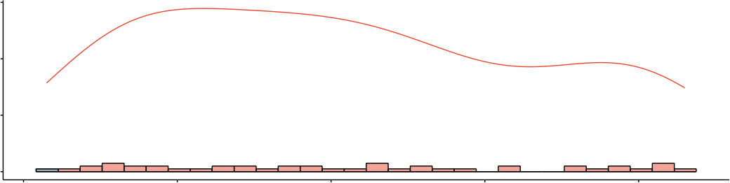  1.2 1.4 1.6 1.8 2.0
Maximally Selected Rank Statistics
4  3  2  1  0 | Cutpoint: 1.23  ●  ●  ●  ●  ●  ●  ●  ●  ●  ● ●  ●  ● ●  ●  ●  ●  ●  ●  ●  ●  ●  ●  ●  ●  ●  ●  ●  ●  ●  ●  ●  ●  ●  ●  ●  ● ●  ●  ● ●  ●  ●  ●  ● |  | groups  ● high  ● low
4  3  2  1  0 | 1.2 1.4 1.6 1.8 2.0  Post-treatment ADCmean |  | groups  ● high  ● low

