The optimal cutoff value of Post-treatment ADCmean for OS
Standardized Log−Rank Statistic Density

Distribution
Density | 80  60  40  20  0 |  | 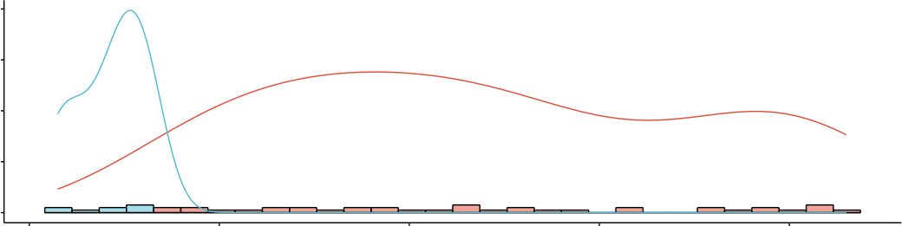  1.2 1.4 1.6 1.8 2.0
Maximally Selected Rank Statistics
2  1  0 |  | Cutpoint: 1.33  1.2 1.4 1.6 1.8 2.0  ●  ●  ●  ●  ●  ●  ●  ●  ●  ●  ●  ●  ●  ●  ●  ●  ●  ●  ●  ●  ●  ●  ●  ●  ●  ●  ●  ●  ●  ●  ●  ●  ●  ●  ●  ●  ●  ●  ●  ●  ●  ●  ●  ●  ●  Post-treatment ADCmean |  | groups  ● high  ● low

