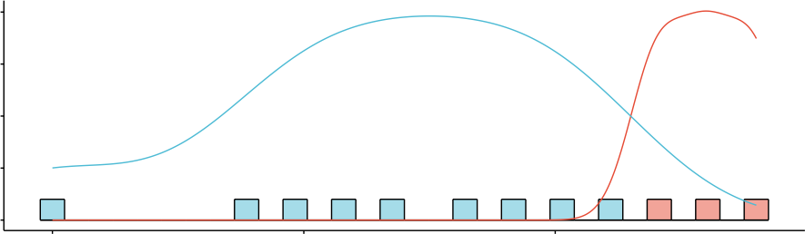  Standardized Log−Rank Statistic Density  10.0  7.5  5.0  2.5  0.0 | Distribution  The optimal cutoff value of residual disease for OS  0.0 0.5 1.0
Maximally Selected Rank Statistics  3  ●  ●  2  1  0 |  | ● |  | groups  ● high  ● low
 |  | ●  ● | ● | groups  ● high  ● low
 |  | ●  ●  ● | ● | groups  ● high  ● low
 |  | Cutpoint: 1.1  ●  ● |  | groups  ● high  ● low
0.0 0.5 1.0
Residual disease size

