The optimal cutoff value of SCC for OS

Distribution
Density  7.5  5.0  2.5  0.0 |  |  | 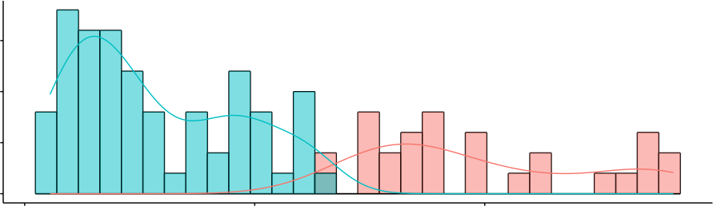  0 10 20
Maximally Selected Rank Statistics
Standardized Log−Rank Statistic | 4  3  2  1  0 | ●  ●  ●  ●  ●●  ●  ●  ●  ●  ●  ●  ●  ●●  ●  ●  ●●  ●  ●● ●●  ●  ●  ●  ●  ●  ●  ●  ●  ●  ●  ●  ●  ●  ●  ●  ●  ●  ●  ●  ●  ●  ●  ●  ●  ●  ●  ●  ●  ●  ●  ● ●●  ●  ●  ●  ●●  ●  ●  ●  ●  ●  ●●  ●  ●  ●  ●  ●  ●  ●  ●  ●  ●  ●  ●  ●  ●  ●  ●  ●  ●  ●  ●  ●  ●  Cutpoint: 12.8  0 10 20  SCC |  | grps  ● high ● low

