The optimal cutoff value of SCC for PFS

Distribution
Density | 10.0  7.5  5.0  2.5  0.0 |  | 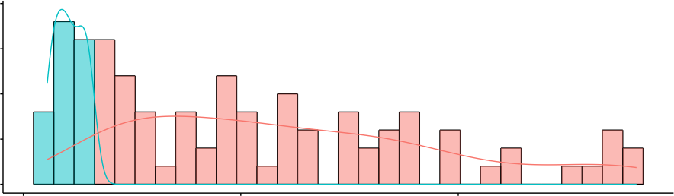  0 10 20
Maximally Selected Rank Statistics
4  Standardized Log−Rank Statistic  3  2  1  0 |  | ●  ●  ●  ●  ●  ●  ●  ●  ●  ●  ●  ●  ●  ●  ●  ●  ●  ●  ●  ●  ●  ●  ●  ●  ●  ●  ●  ●  ●  ●  ●  ●  ●  ●  ●  ●  ●  ●  ●  ●  ●  ●  ●  ●  ●  ●  ●  ●  ●  ●  ●  ●  ●  ●  ● ●  ●  ●  ●  ●  ●  ●  ●  ●  ●  ●  ●  ●  ●  ●  ●  ●  ●  ● ●  ●  ●  ●  ●  ●  ●  ● ●  ●  ●  ●  ●●  ●  ●  ●  Cutpoint: 3.2  0 10 20  SCC |  | grps  ● high ● low

