Supplementary Information
Manuscript Title
A five-stage protocol for systematic measuring and monitoring soil carbon and greenhouse gas fluxes in complex estates
Caio F. Zani^{1,2*}, Arlete S. Barneze^{1,2}, David A. C. Manning¹
¹ School of Natural and Environmental Sciences, Newcastle University, Kings Road, Newcastle upon Tyne, England, NE1 7RU, United Kingdom
² UK Centre for Ecology & Hydrology, Lancaster Environment Centre, Library Avenue, Bailrigg, Lancaster, England LA1 4AP, United Kingdom.
* Corresponding author: Caio Fernandes Zani, School of Natural and Environmental Sciences, Newcastle University, Kings Road, Newcastle upon Tyne, England, NE1 7RU, United Kingdom
E-mail address: caiofzani@gmail.com
Mobile: +44 07866177844
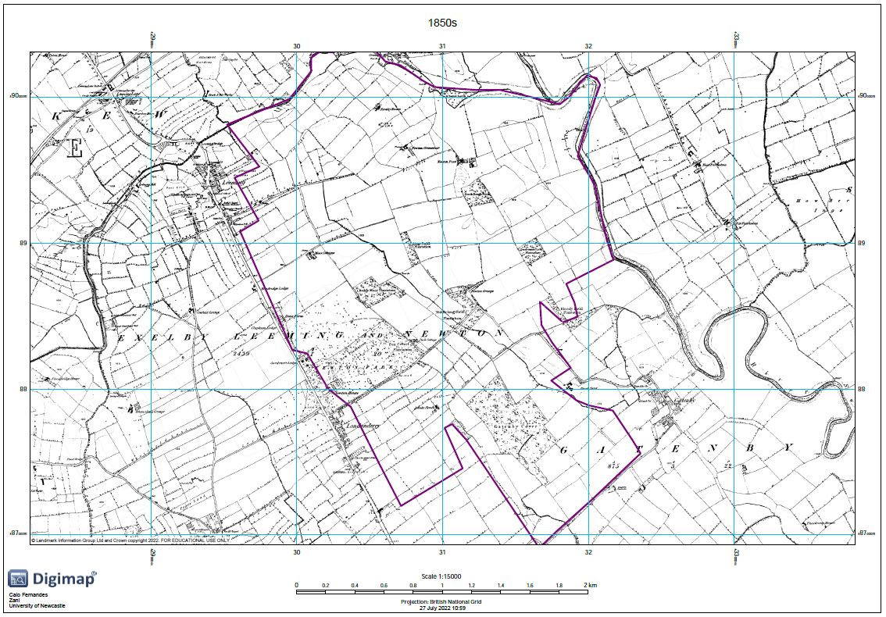
Figure A1. Historic 1850s land use at the RAF Leeming base.
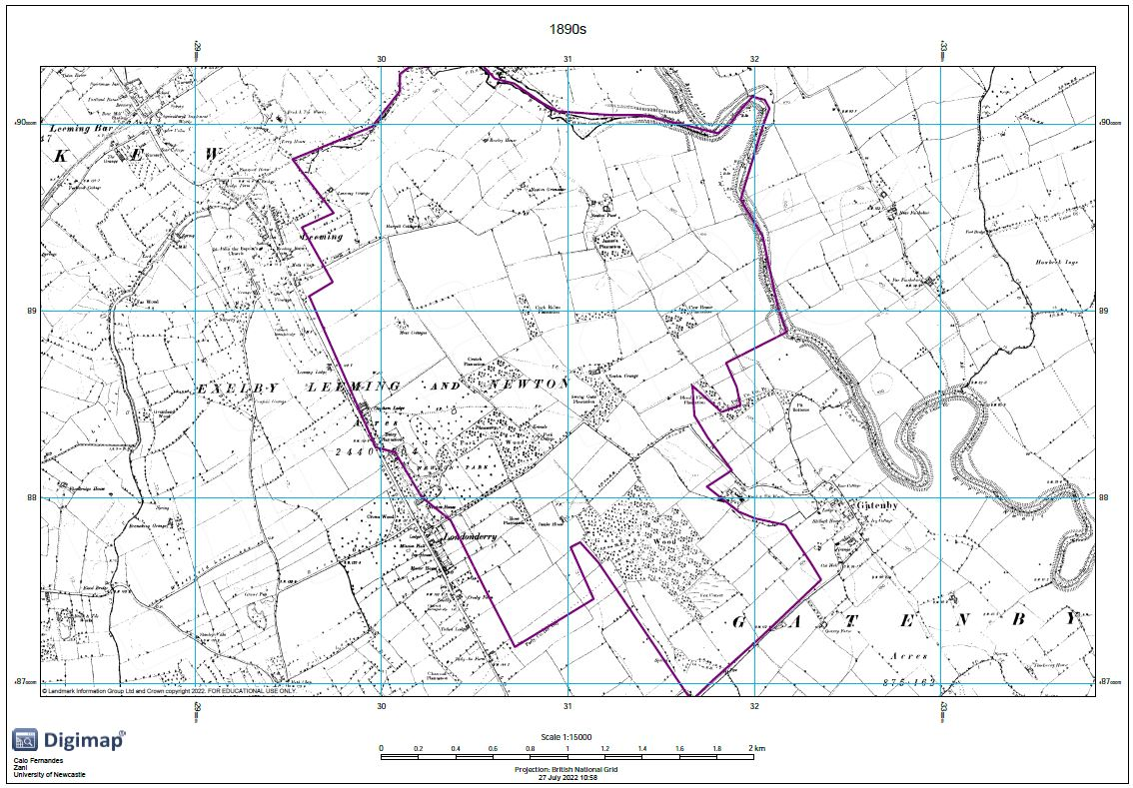
Figure A2. Historic 1890s land use at the RAF Leeming base.
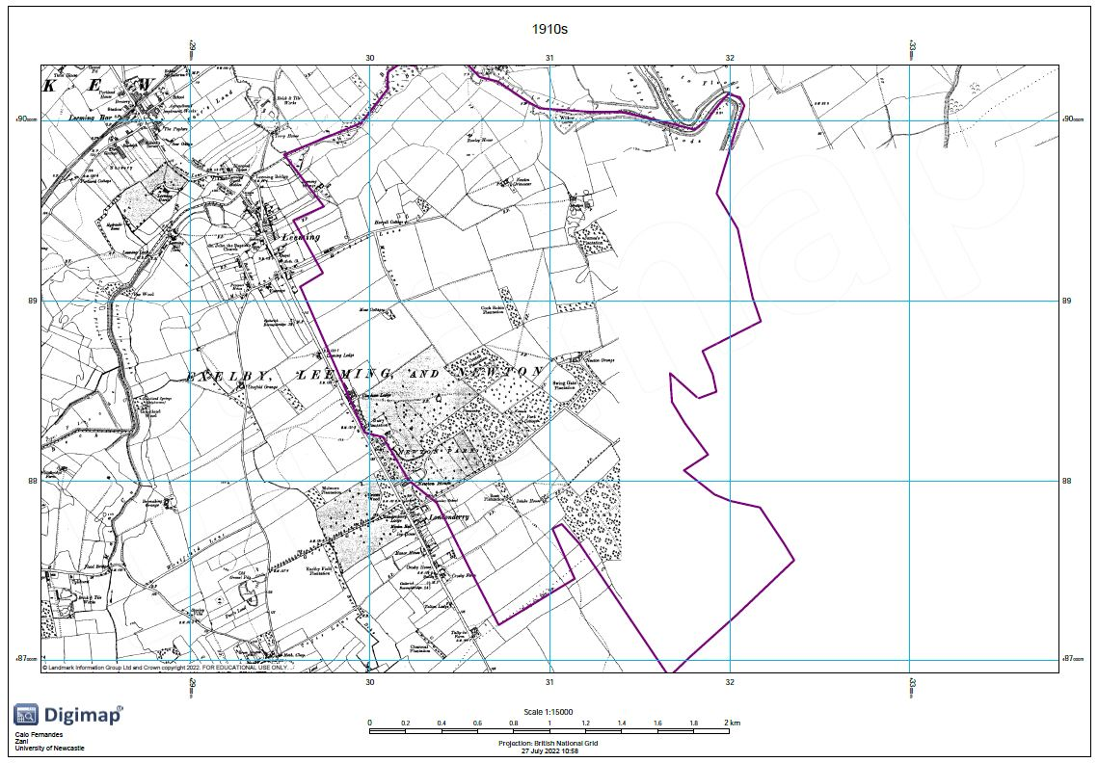
Figure A3. Historic 1910s land use at the RAF Leeming base No information available at this date for the area left blank.
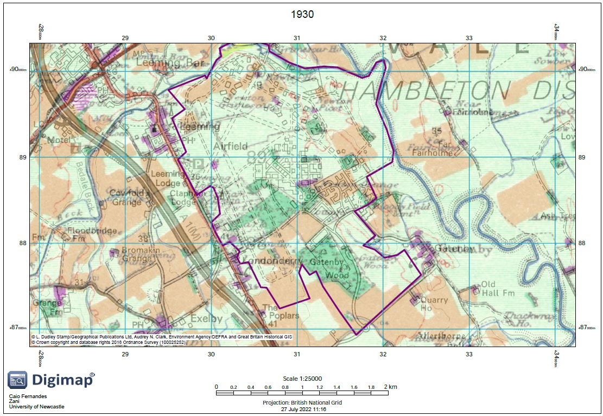
Figure A4. Historic 1930 land use at the RAF Leeming base.
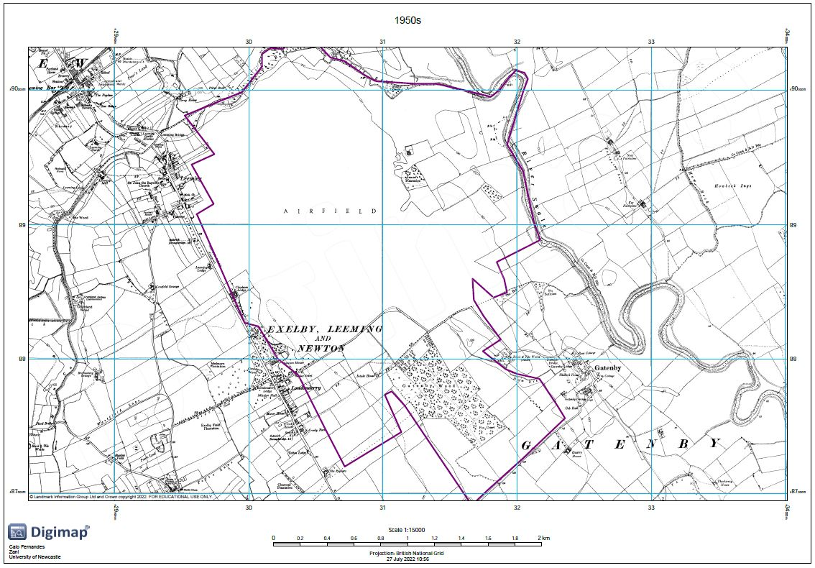
Figure A5. Historic 1950s land use at the RAF Leeming base.
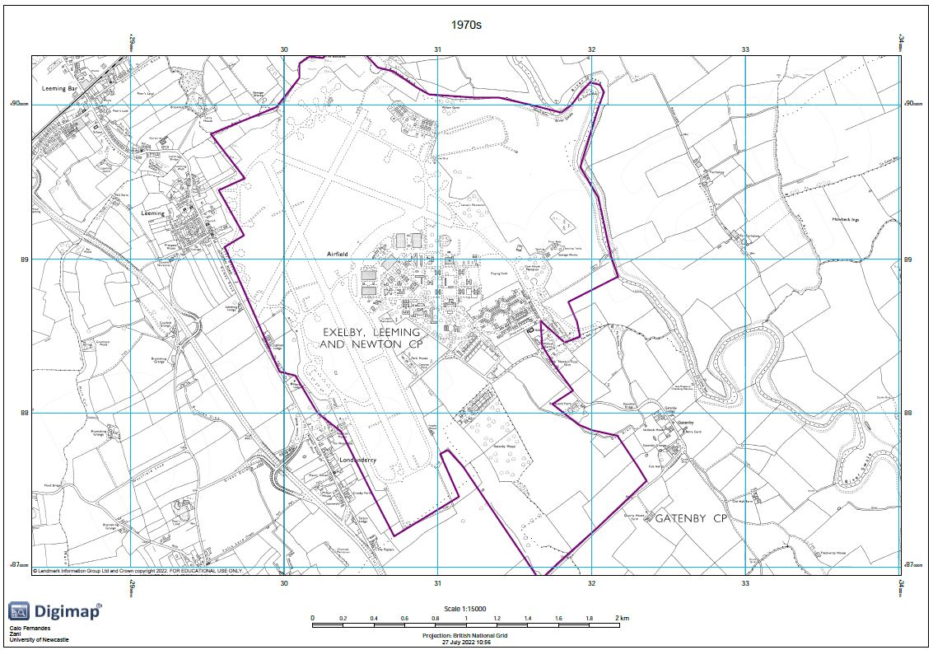
Figure A6. Historic 1970s land use at the RAF Leeming base.
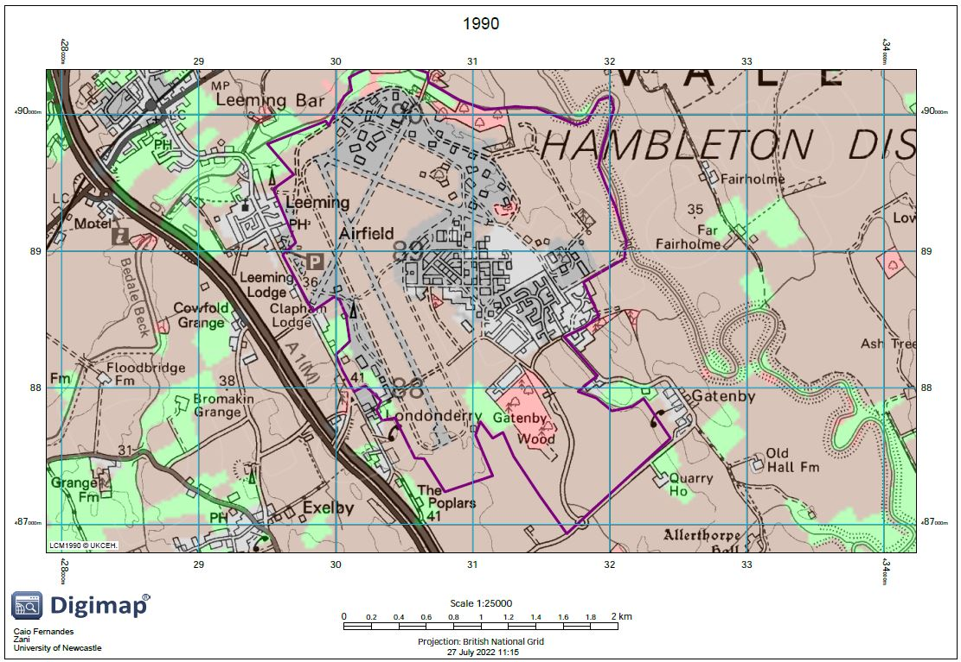
Figure A7. Historic 1990 land use at the RAF Leeming base. Roads from contrmporary data.
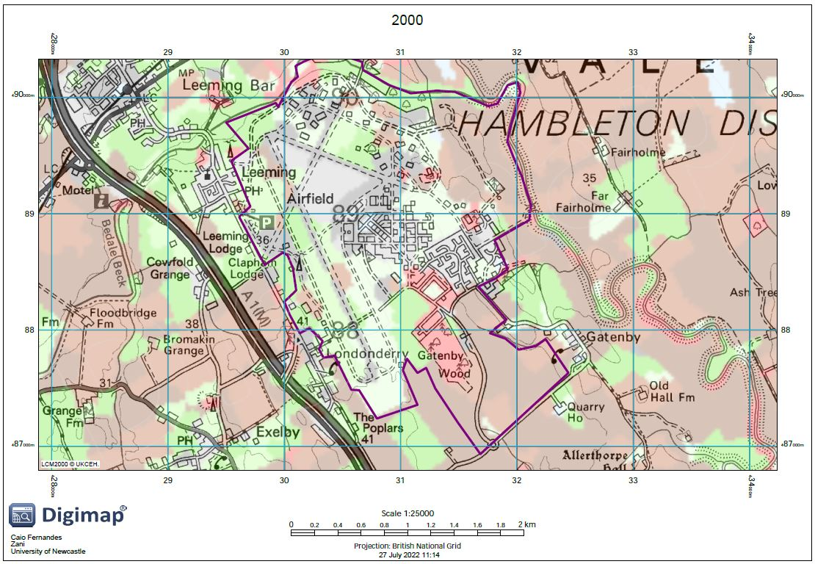
Figure A8. Historic 2000 land use at the RAF Leeming base. Roads from contemporary data.
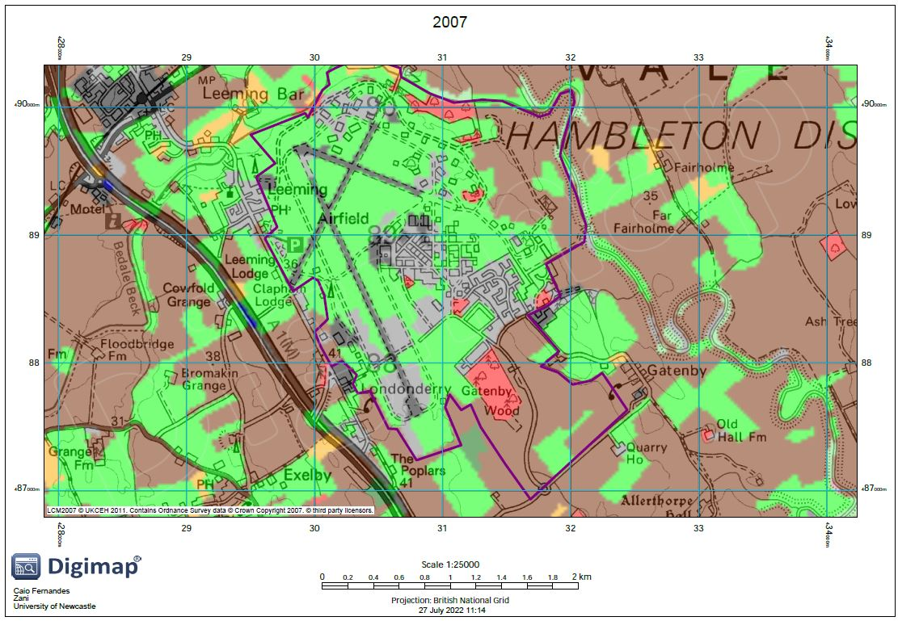
Figure A9. Historic 2007 land use at the RAF Leeming base. Roads from contemporary data.
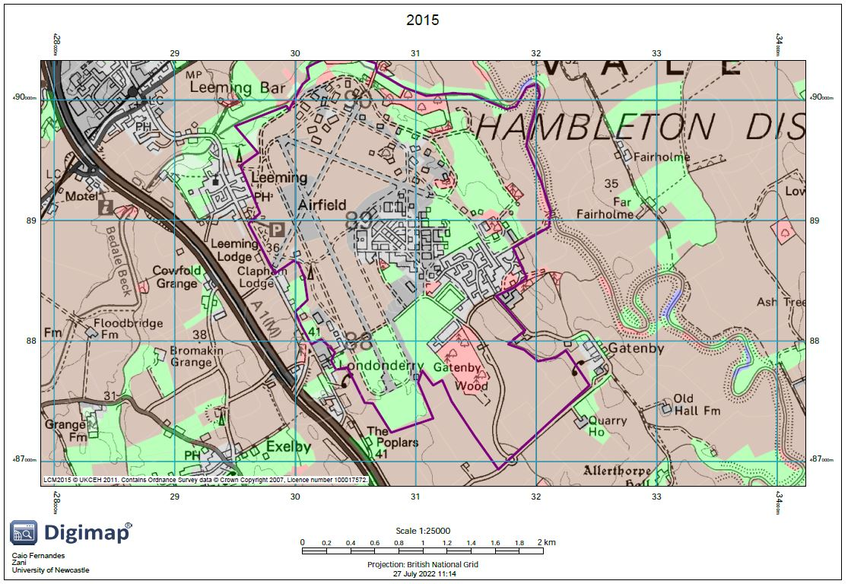
Figure A10. Historic 2015 land use at the RAF Leeming base. Roads from contemporary data.
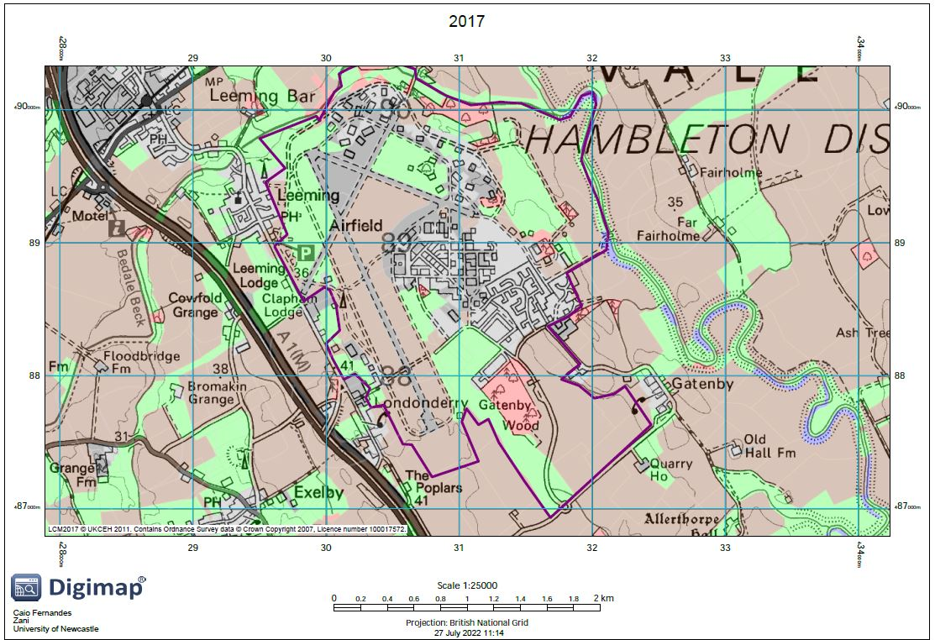
Figure A11. Historic 2017 land use at the RAF Leeming base. Roads from contemporary data.
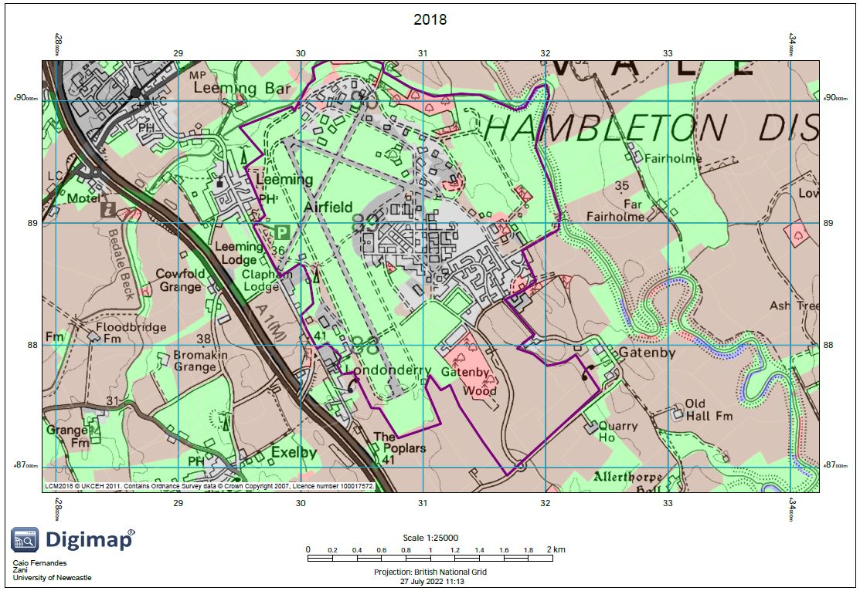
Figure A12. Historic 2018 land use at the RAF Leeming base. Roads from contemporary data.
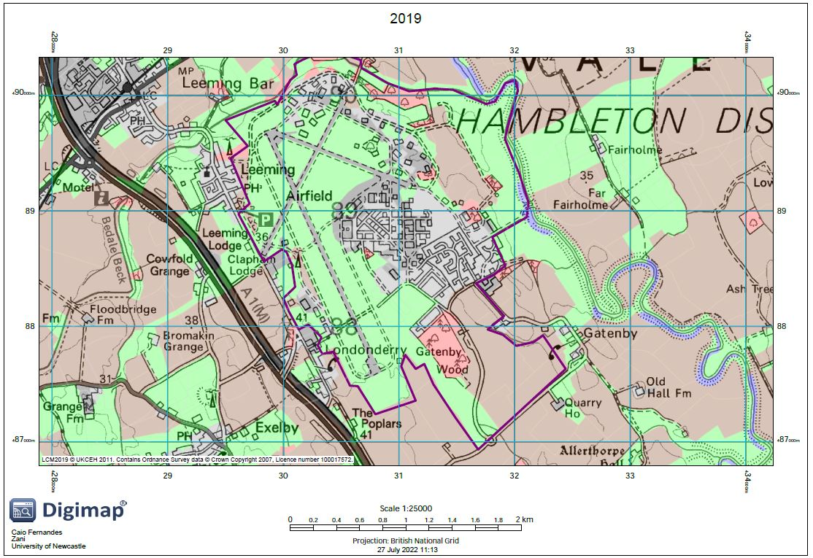
Figure A13. Historic 2019 land use at the RAF Leeming base. Roads from contemporary data.
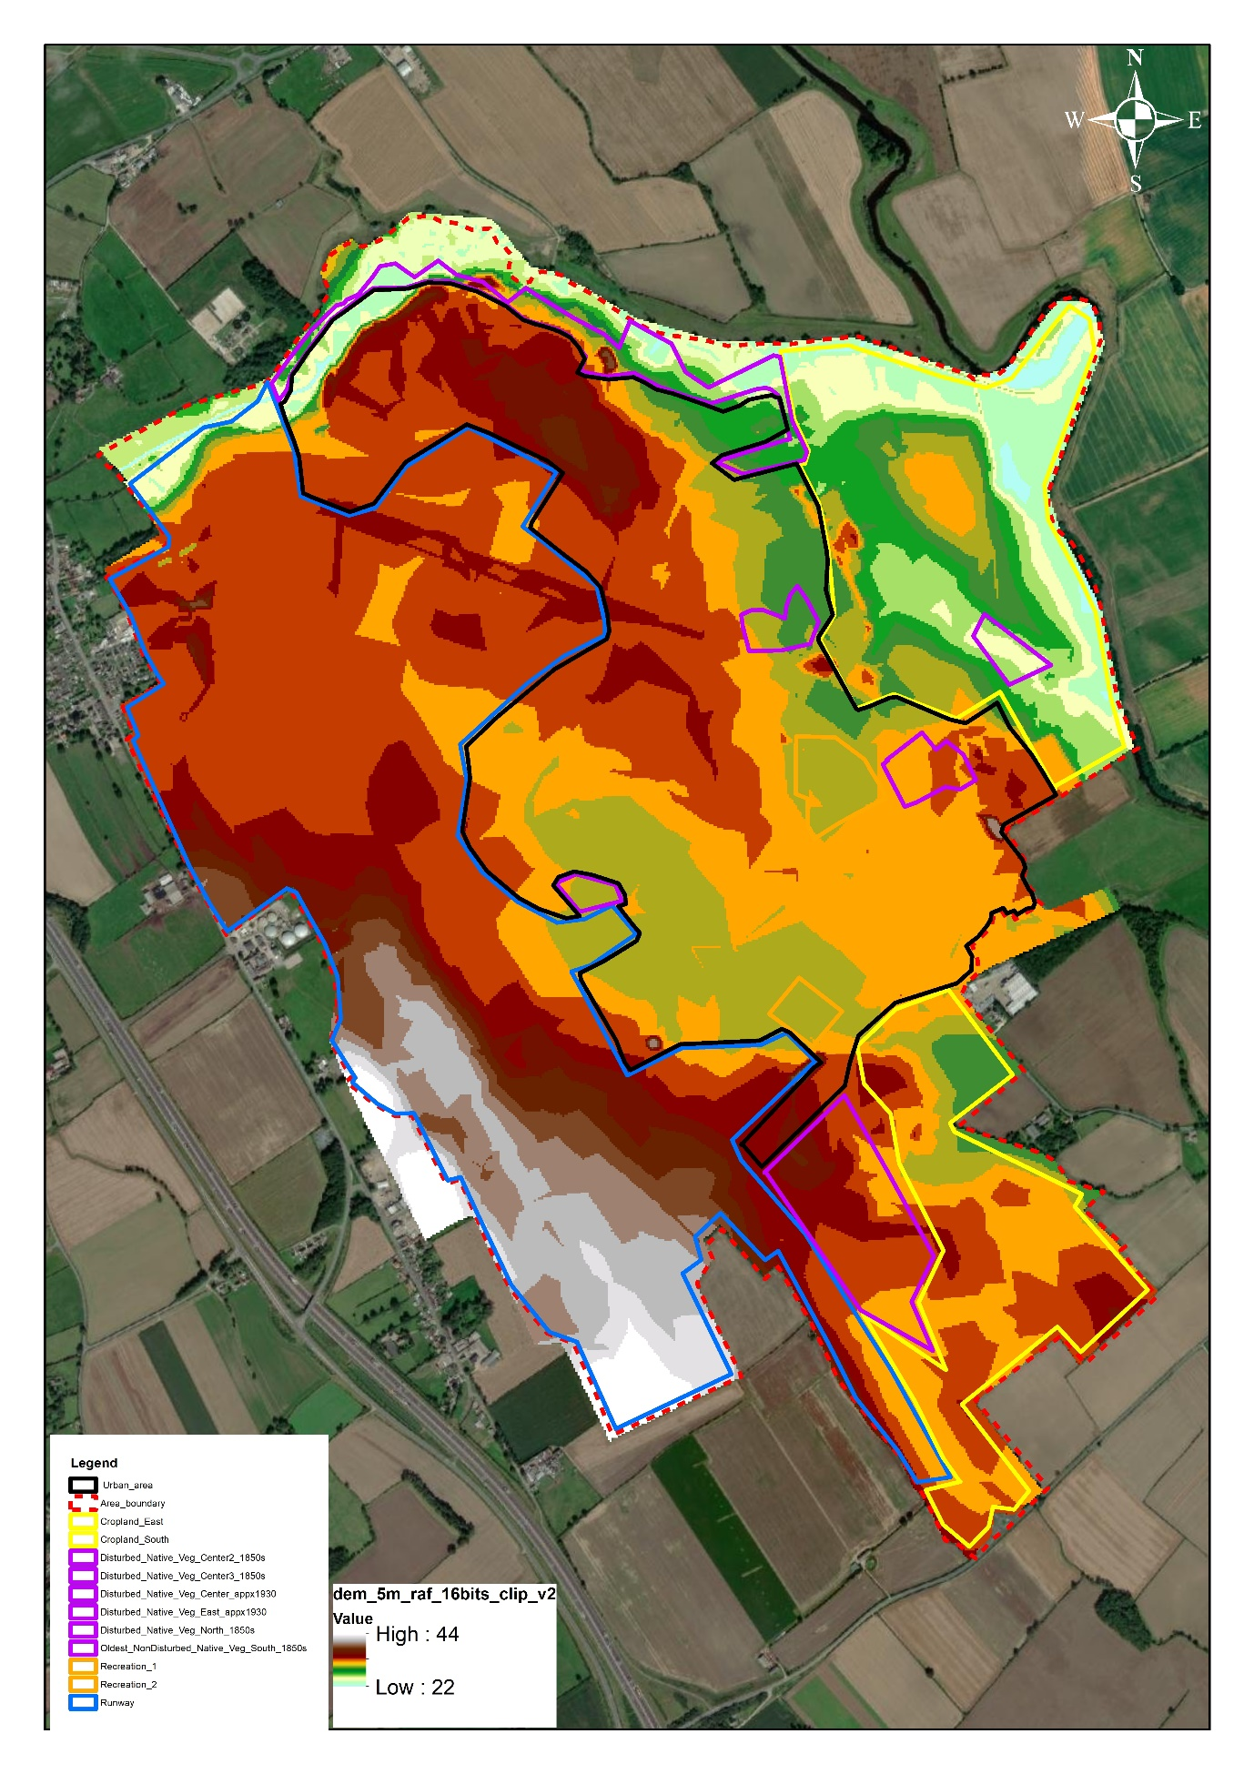
Figure A14. Elevation map across the RAF Leeming base.
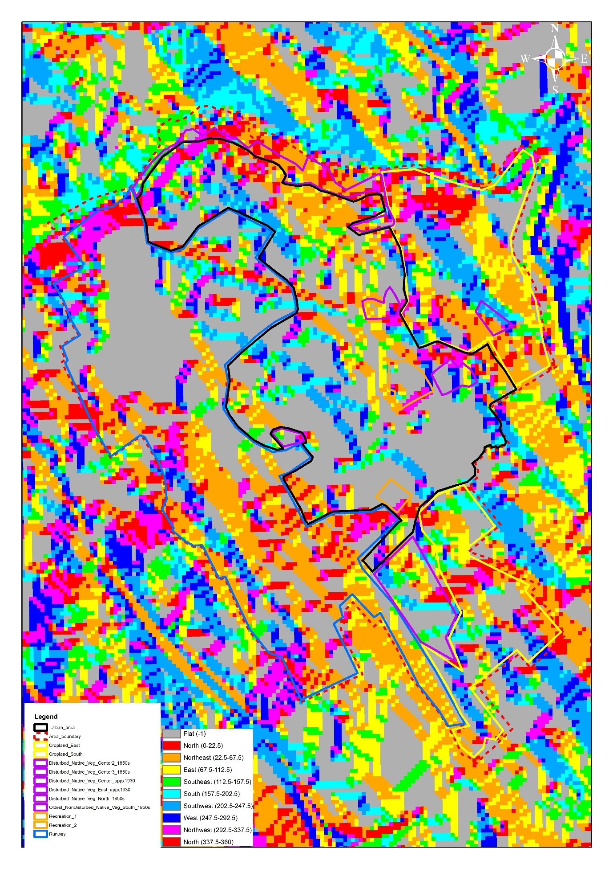
Figure A15. Flow direction map across the RAF Leeming base.
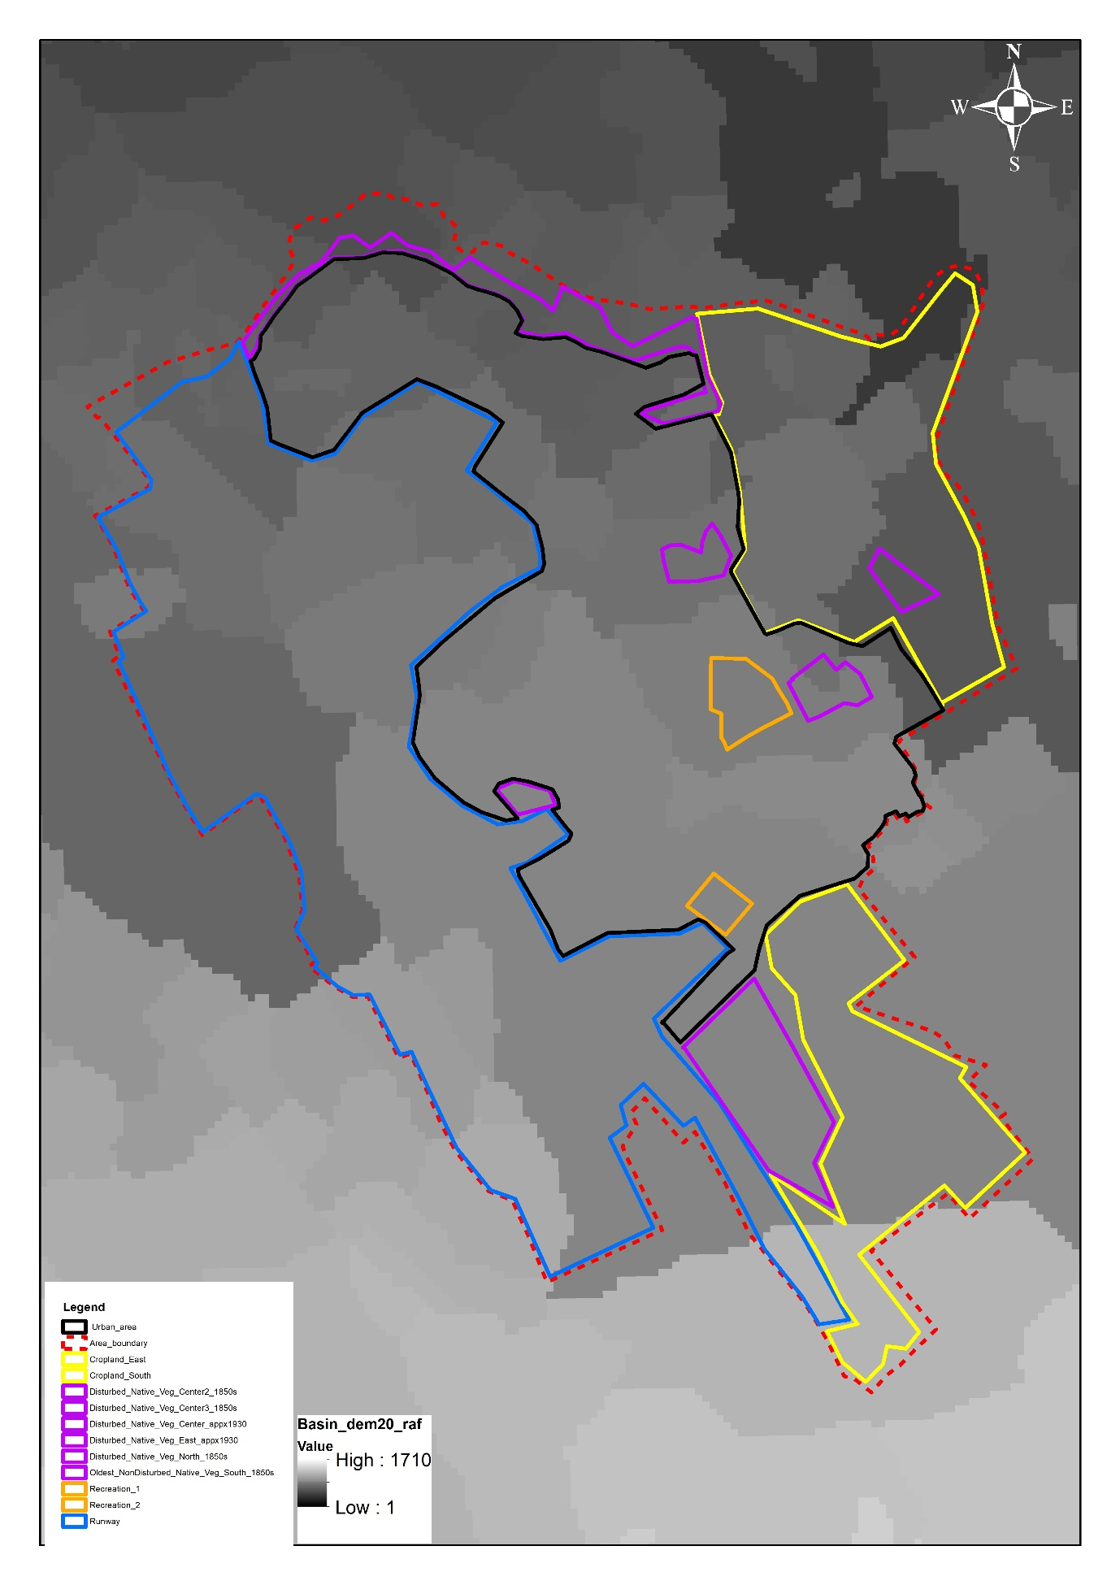
Figure A16. Basin map across the RAF Leeming base.
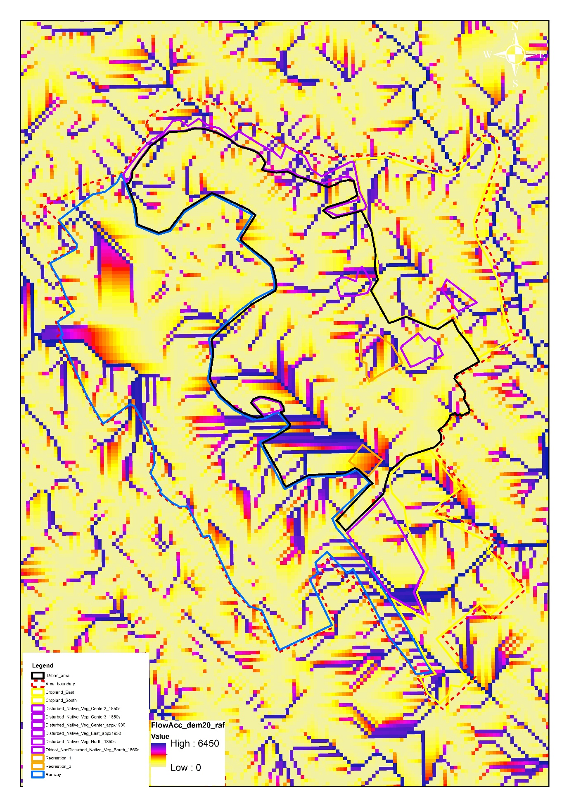
Figure A17. Flow accumulation map across the RAF Leeming base.
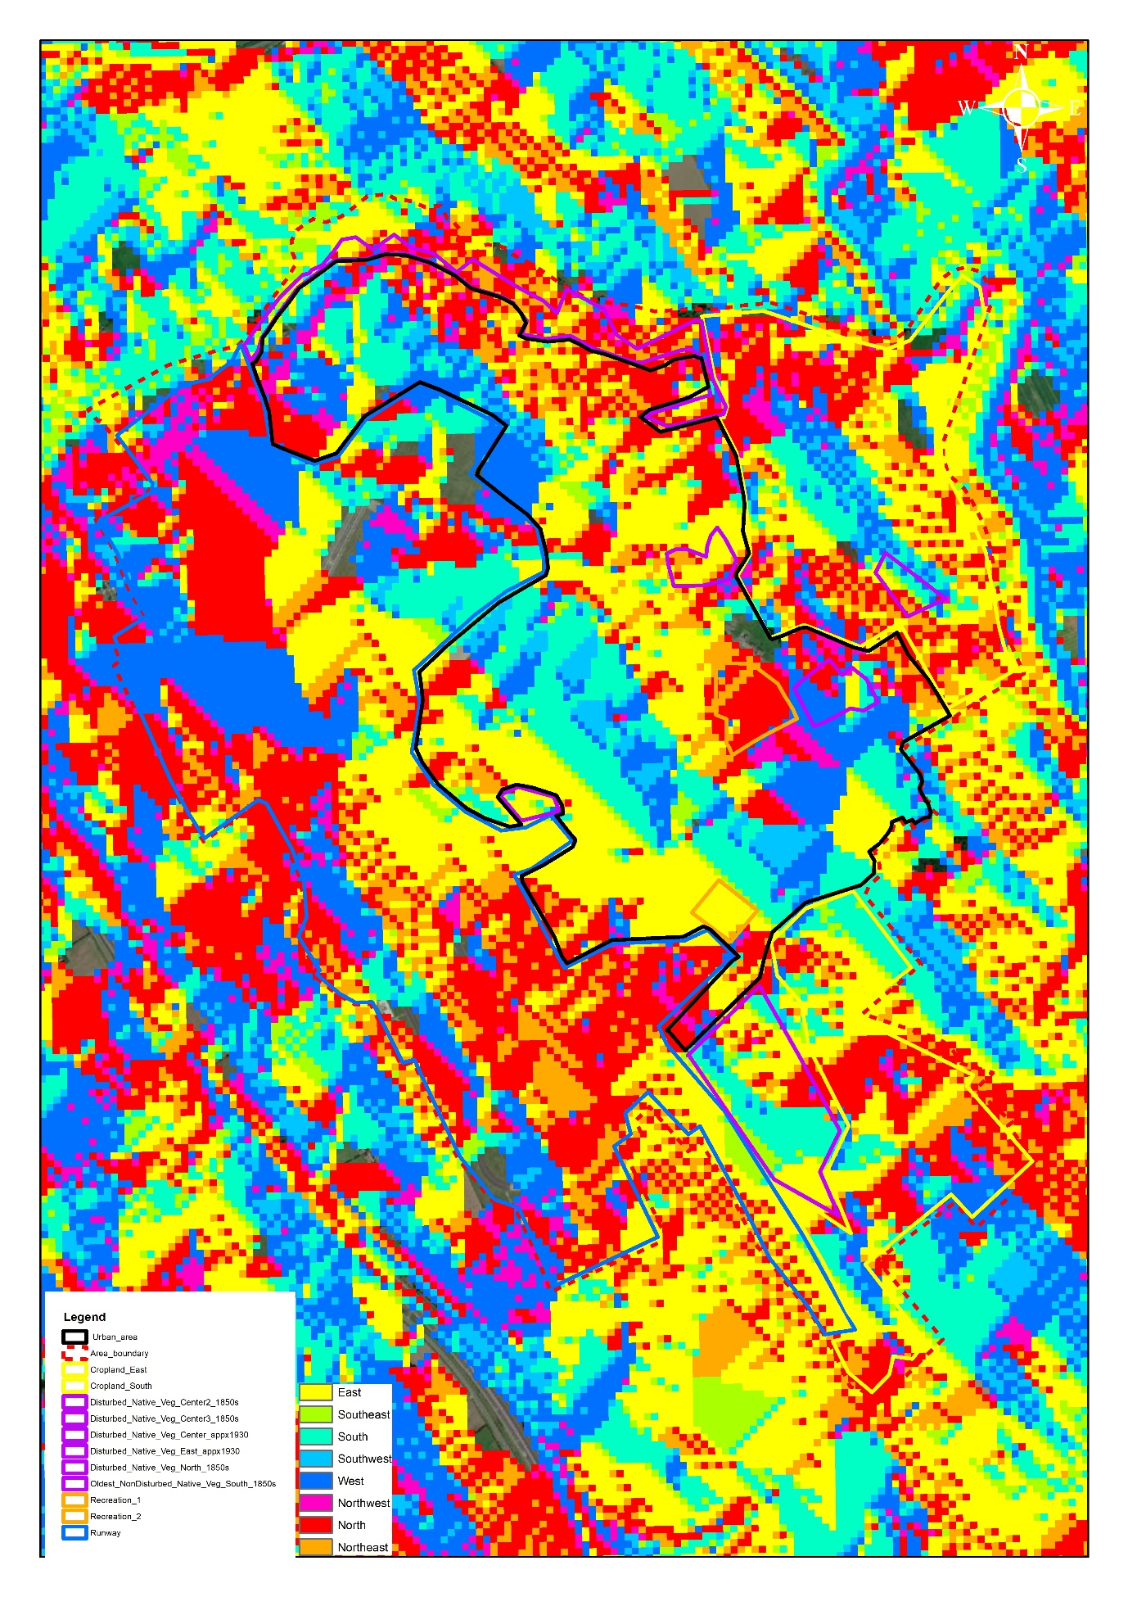
Figure A18. Flow direction map across the RAF Leeming base.
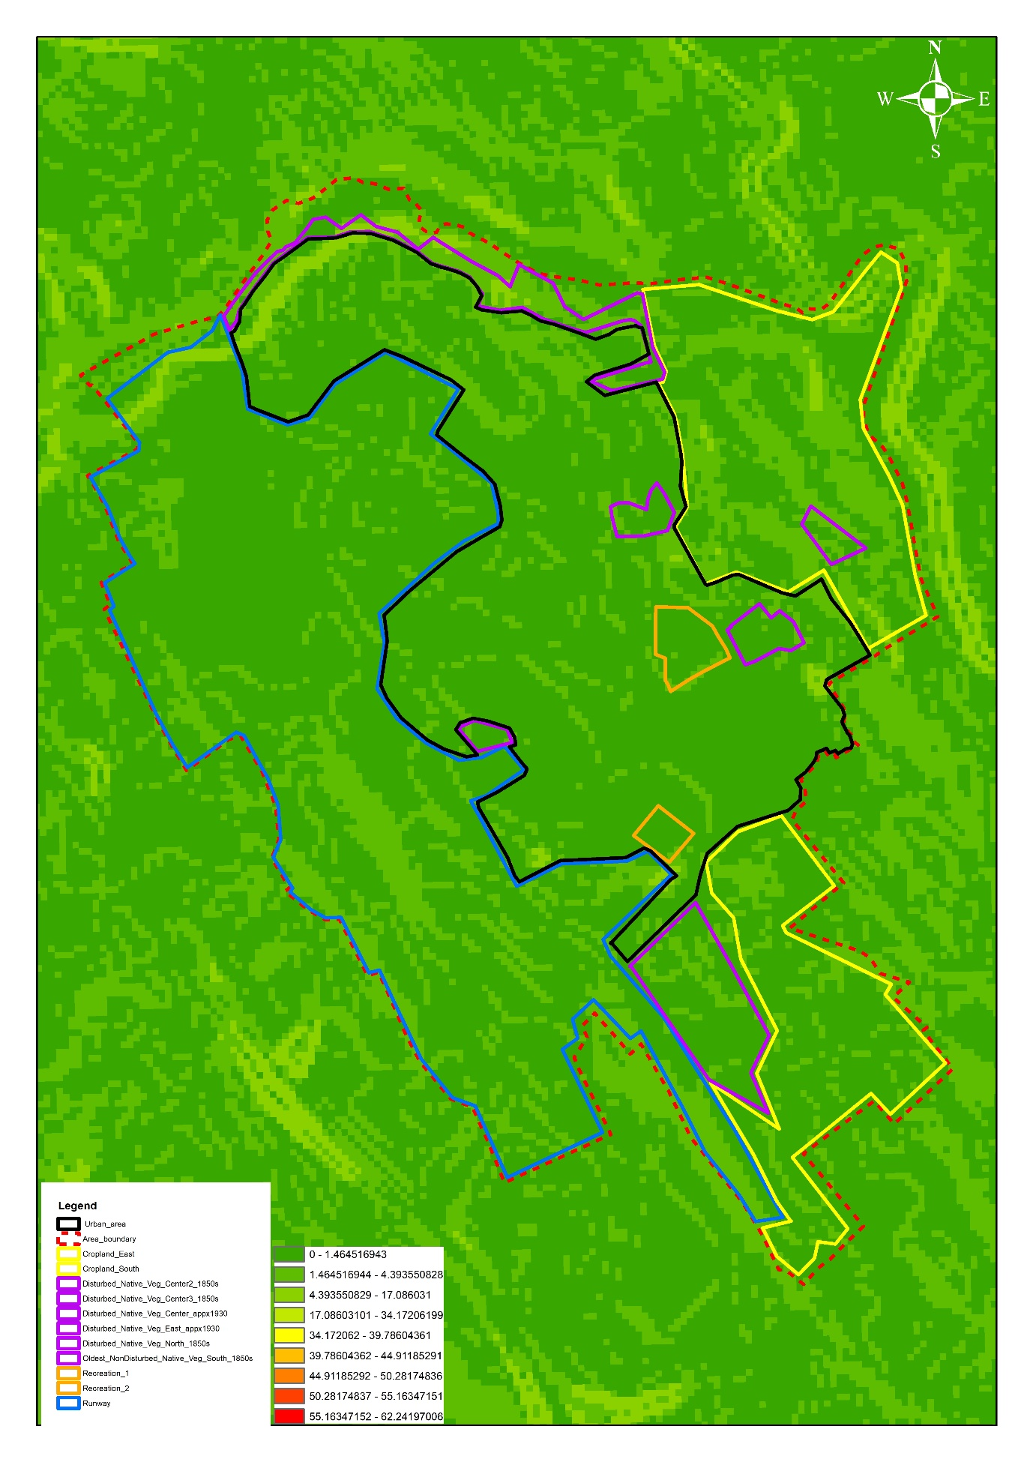
Figure A19. Slope map across the RAF Leeming base.
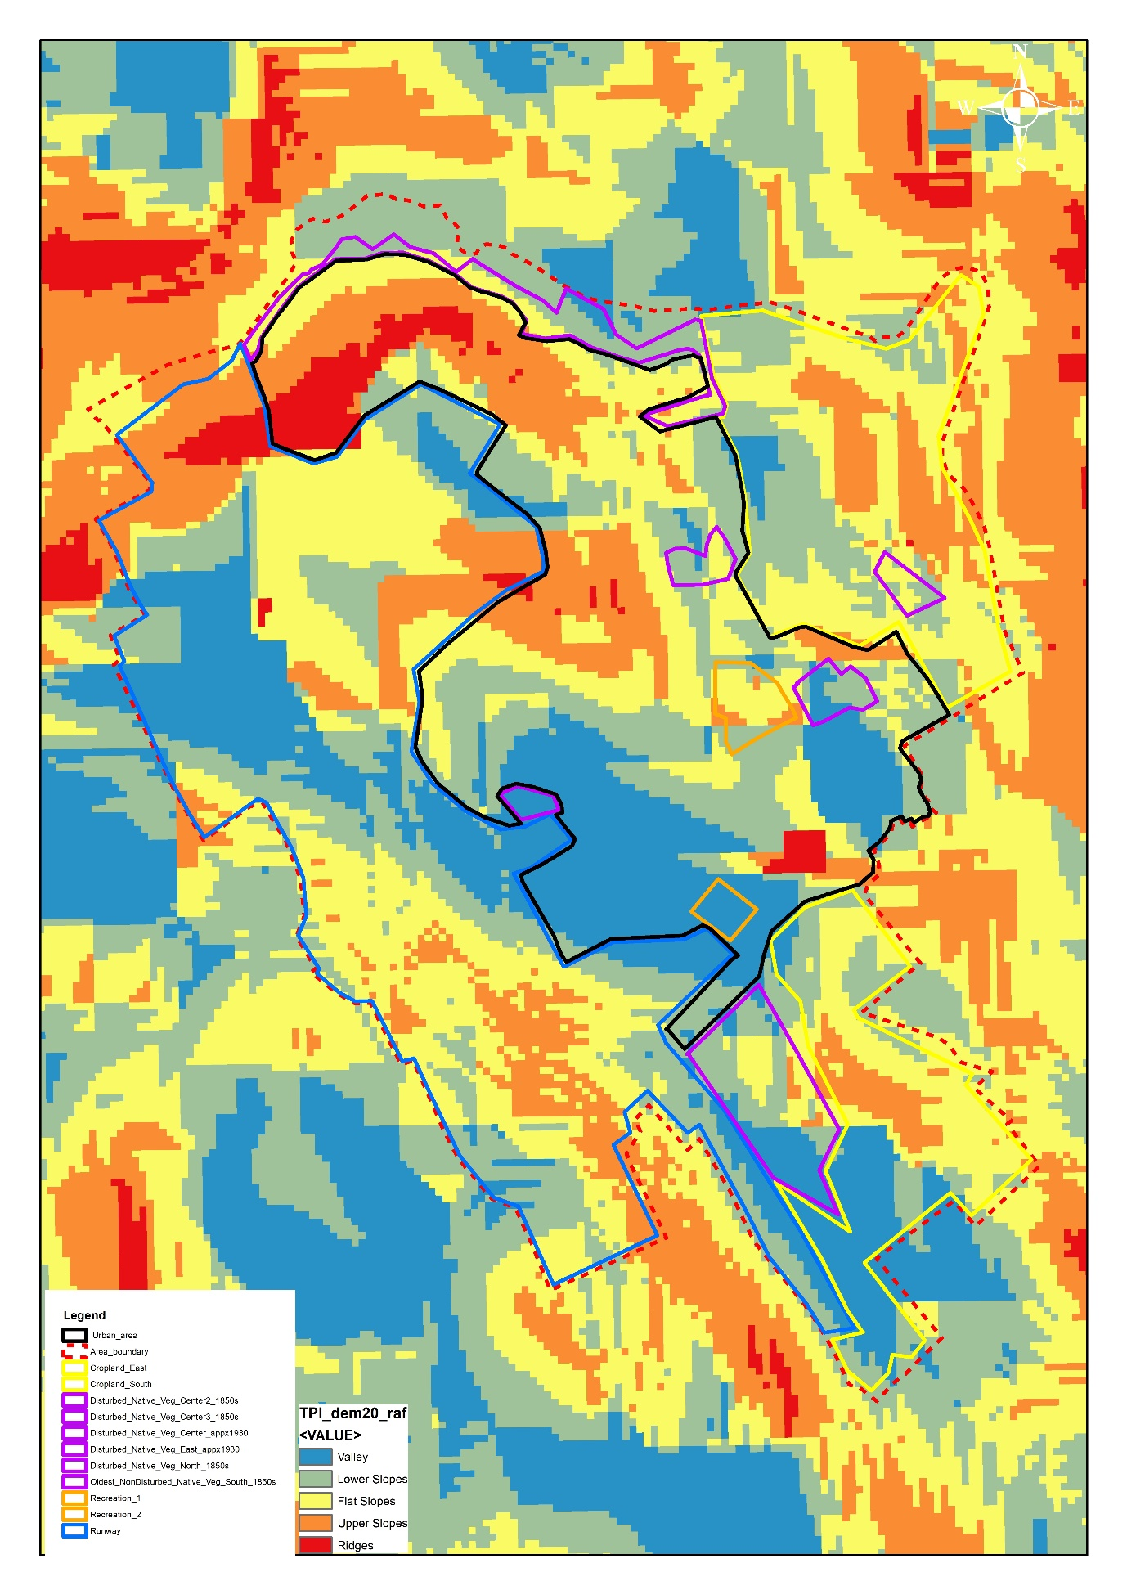
Figure A20. Topographic position index map across the RAF Leeming base.
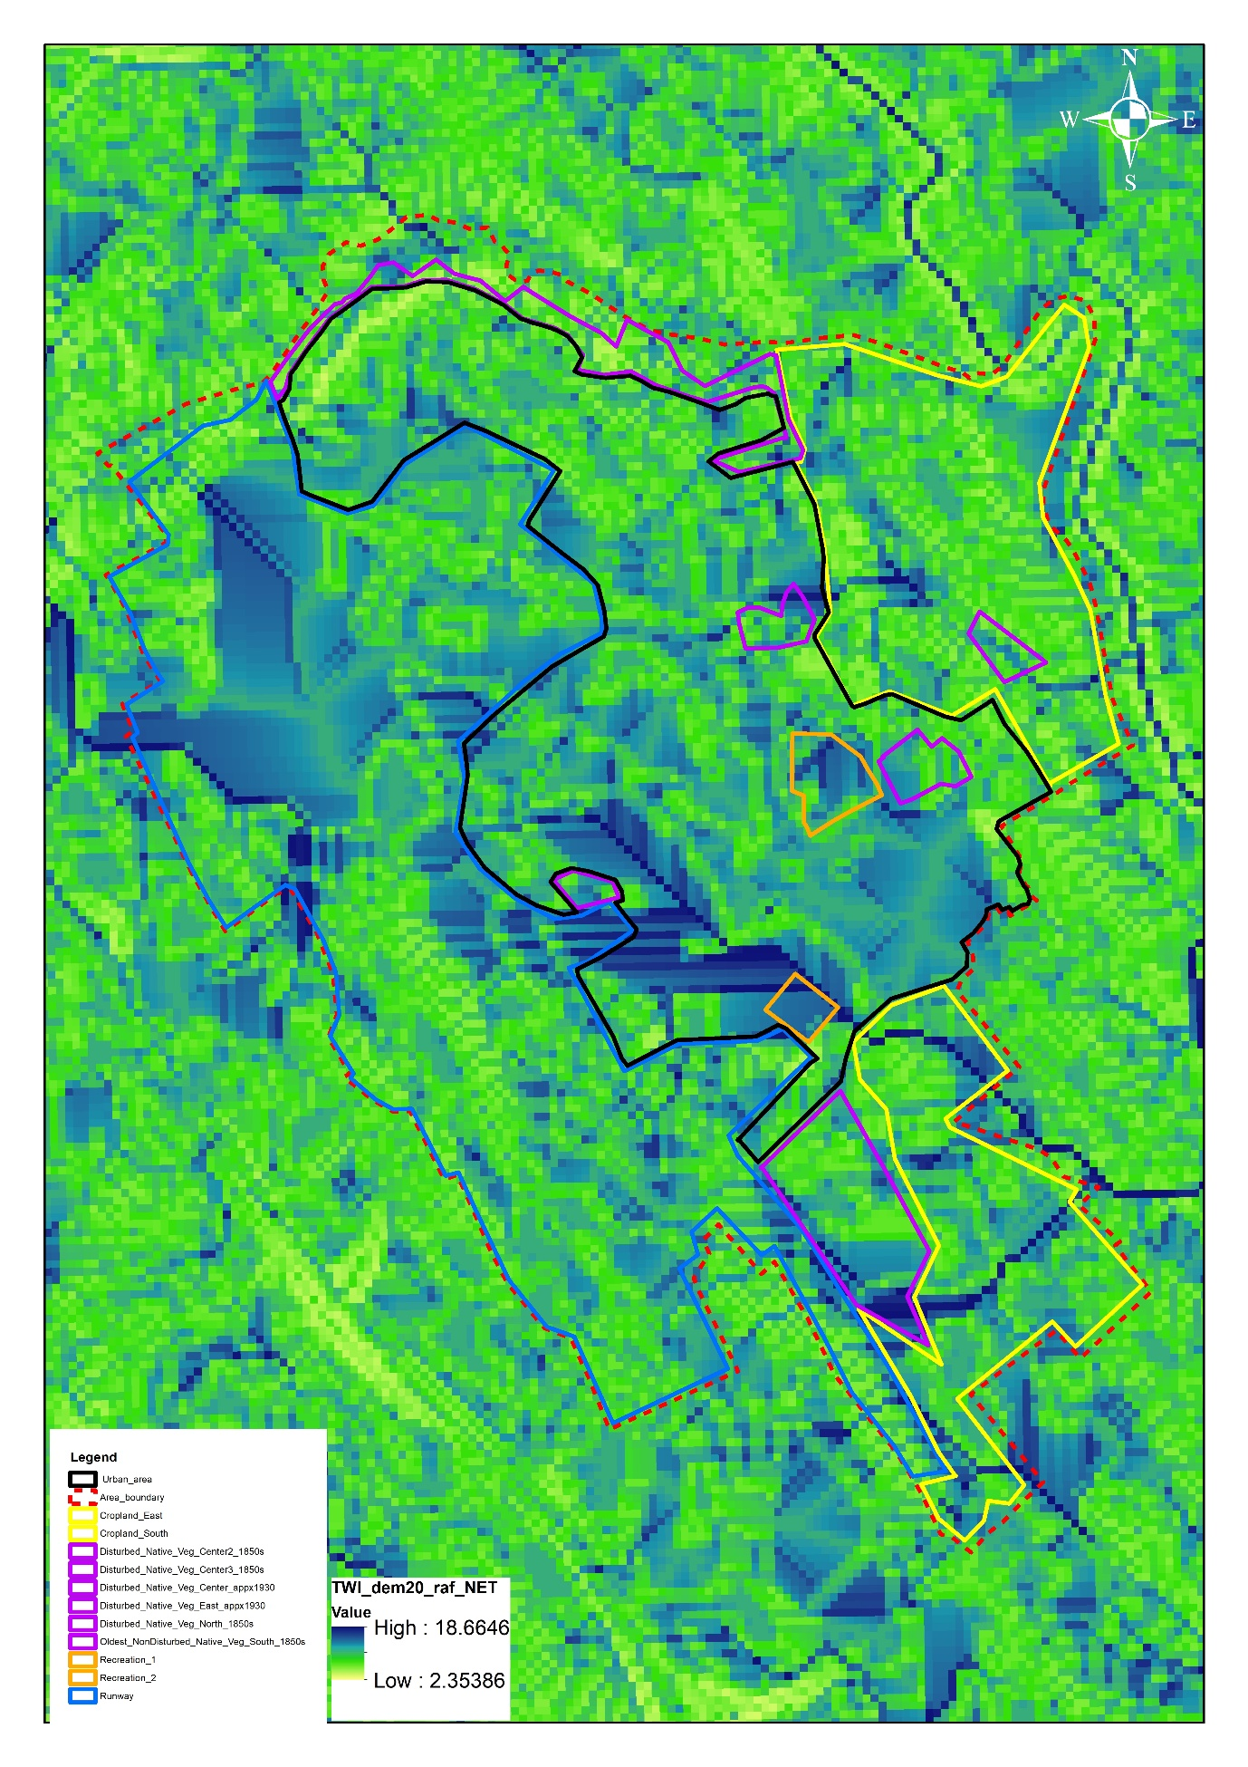
Figure A21. Topographic wetness index map across the RAF Leeming base.
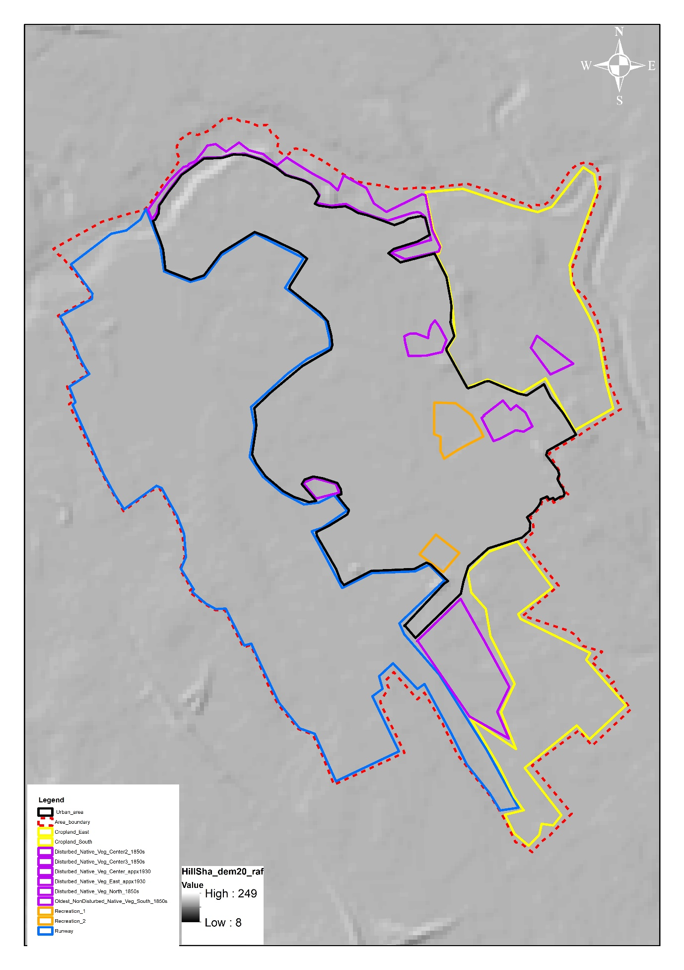
Figure A22. Hill shade map across the RAF Leeming base.
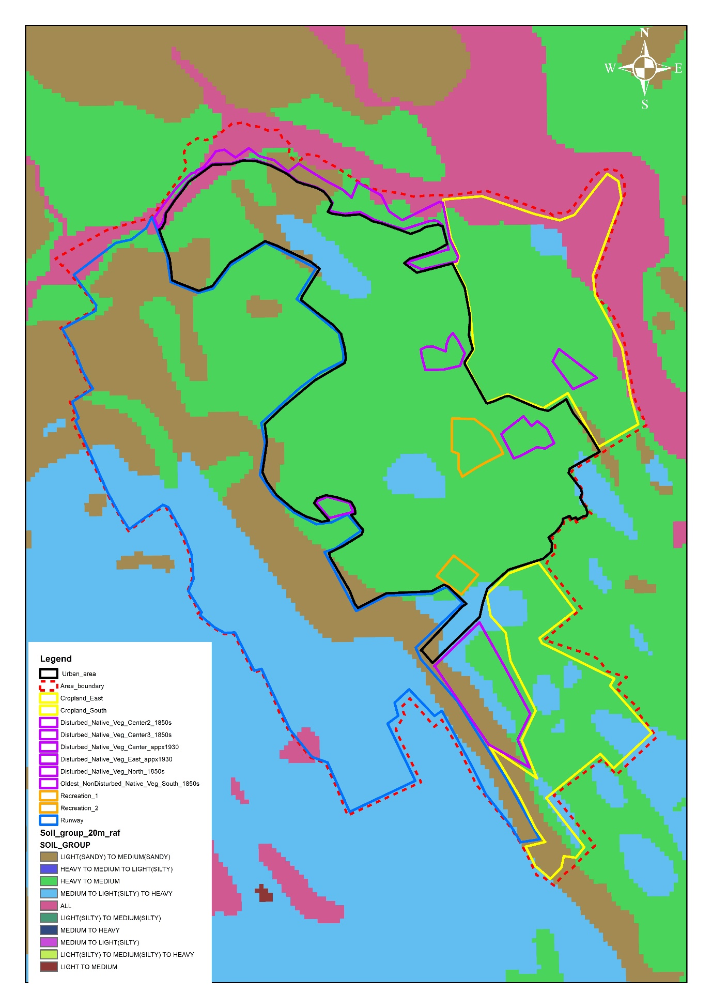
Figure A23. Soil group map across the RAF Leeming base.
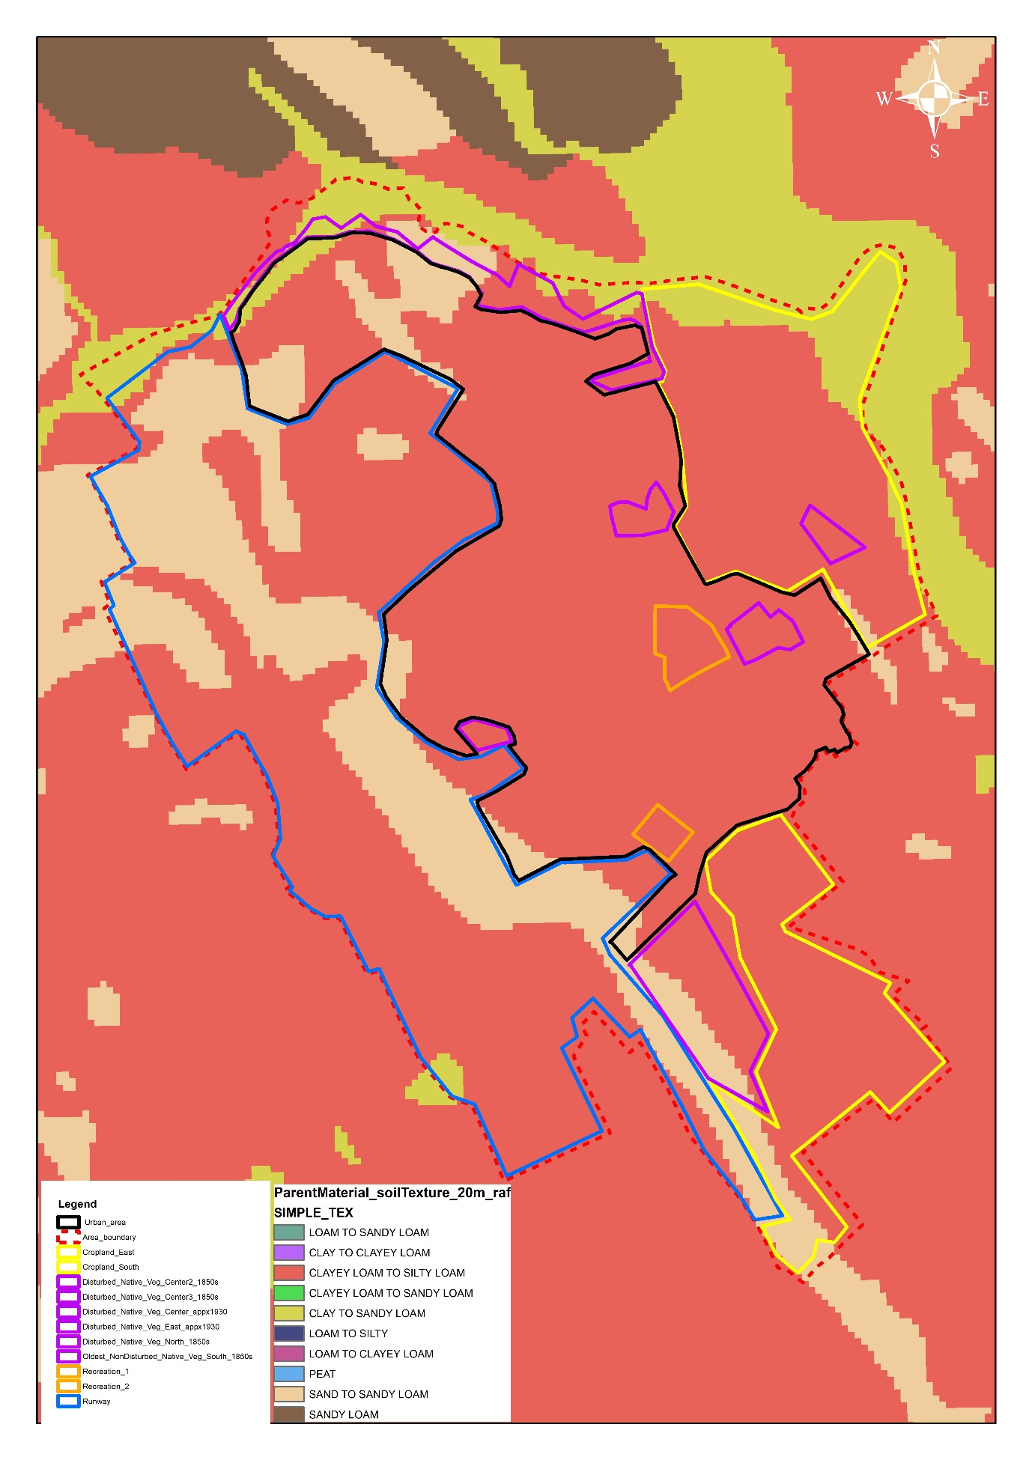
Figure A24. Soil texture map across the RAF Leeming base.
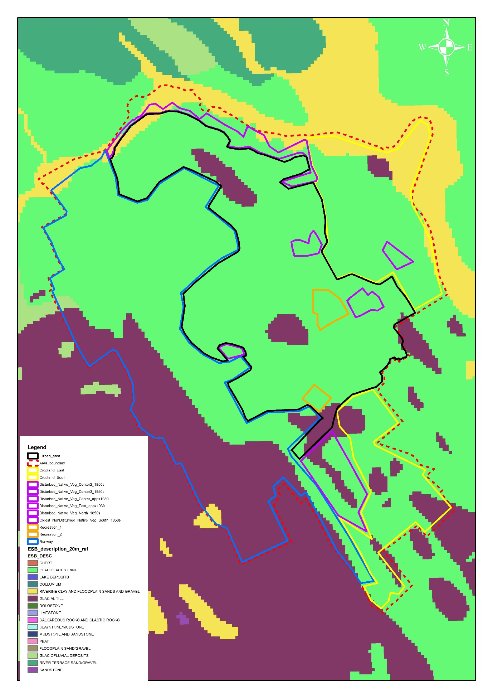
Figure A25. European Soil Bureau (ESB) for identification of parent material map across the RAF Leeming base.

