Supplementary Information

Supplementary Figure 1
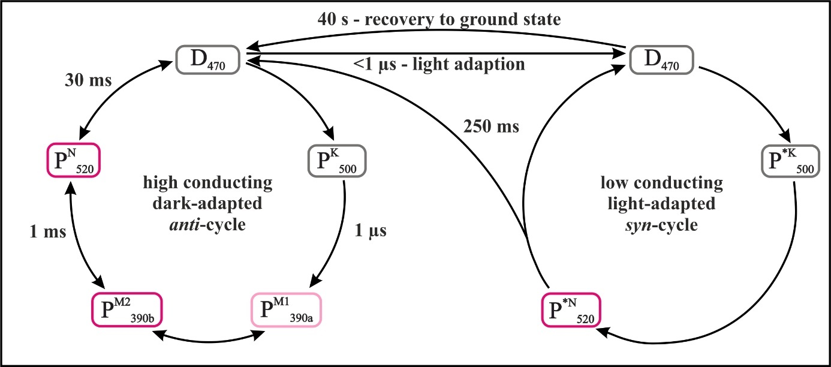
Supplementary Figure 1: Photocycle model of CrChR2 Model of the branched photocycle of CrChR2 (reproduced and modified from Kuhne et al.¹). The “dark-adapted” anti-cycle (left) exclusively comprises a C=N-anti-configuration of the retinal, is highly conducting and relatively fast. In the “light-adapted” syn-cycle (right), the retinal has a 13-cis, C=N-syn configuration. The syn-cycle is poorly conducting and decays at a slower rate. During continuous illumination, molecules are accumulated in the syn-cycle, which causes the inactivation of CrChR2.
Supplementary Figure 2
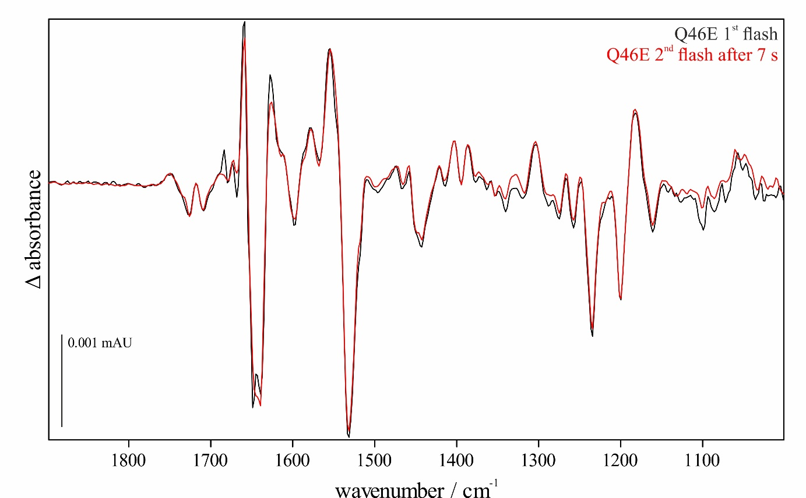
Supplementary Figure 2: Excitation spectra of the GtACR1 variant Q46E at different exposure times. The respective excitation spectra after one flash (black) and a second flash after 7 s (red) are shown. Similar to the GtACR1 WT, a large proportion of the proteins can be re-excited after 7 s. The time of the second flash was adapted to the lifetime of the mutant (see Supplementary Note 3 and Supplementary Table 1).

Supplementary Table 1: Determined half-lives t_{1/2} of all analysed samples obtained by rapid-scan FTIR measurements
Sample name | T₄/ ms | T₅/ ms | T₆/ ms
ACR1 WT 1st flash | 44 | 150 | 15890
ACR1 WT 2nd flash | 88 | 1438 | 93490
ACR1 WT 5th flash | 76 | 1849 | 68960
ACR1 WT continuous light | 203 | 3415 | 68290
ACR1 Q46E 1st flash | 230 | 965 | 30570
ACR1 Q46E 2nd flash | 171 | 2285 | 667100

Supplementary Table 2: FTIR marker bands that are important in connection with retinal proteins
Wavenumber / cm⁻¹ | associated group
1184 | protonated 13-cis retinal
1691 | pore formation, channel opening and conducting state
1708 | protonated E68
1644 | conformational changes during channel opening and closing
1529 | retinal C=C ground state
1444 | M intermediate

Supplementary Note 1:
The time at which 99% of the M intermediate was decayed was calculated as follows.
First, the decay constant k was calculated using the half-life (t_{1/2}) for the decay of M (T₅) as determined by the FTIR measurements
$$k= \frac{ln⁡(2)}{t_{\frac{1}{2}}}=\frac{\ln{(2)}}{150 ms}=0,0046 {ms}^{-1}$$
Finally, the point in time was calculated at which only 1% of the intermediate ($A=\frac{1}{100}A_{0})$ was still present
$$A=A_{0}⋅ⅇ^{-kt} ↔ t=\frac{\ln\left(\frac{A}{A_{0}}\right)}{-k}=\frac{\ln\left(\frac{1}{100}\right)}{- 0,0046 {ms}^{-1}}=996 ms$$
According to this calculation, 99% of the M intermediate should have decayed after 996 ms, i.e. 0.99 s.

Supplementary Note 2:
The percentage of the ground state and resulting from this the percentage of the N/O intermediate was calculated as follows.
First, the decay constant k was calculated using the half-life (t_{1/2}) for the decay of N/O (T₆) as determined by the FTIR measurements

$$k= \frac{ln⁡(2)}{t_{\frac{1}{2}}}=\frac{\ln{(2)}}{15890 ms}=4.36×{10}^{-5} ms$$
Finally, the percentage of how much N/O intermediate is still present after 1 s was calculated
$$A=A_{0}⋅ⅇ^{-kt} ↔ \frac{A}{A_{0}}=⋅ⅇ^{-kt}= ⅇ^{4.36×{10}^{-5} {ms}^{-1}×1000 ms} =0.96$$
According to this calculation, 96% of the proteins is still in N/O intermediate 1 s after the initial excitation, correspondingly 4% have already reached the ground state.

Supplementary Note 3:
The time at which 99% of the M intermediate in the GtACR1 variant Q46E was decayed was calculated as follows.
First, the decay constant k was calculated using the half-life (t_{1/2}) for the decay of M (T₅) as determined by the FTIR measurements
$$k= \frac{ln⁡(2)}{t_{\frac{1}{2}}}=\frac{\ln{(2)}}{965 ms}=0,0007 {ms}^{-1}$$
Finally, the point in time was calculated at which only 1% of the intermediate ($A=\frac{1}{100}A_{0})$ was still present
$$A=A_{0}⋅ⅇ^{-kt} ↔ t=\frac{\ln\left(\frac{A}{A_{0}}\right)}{-k}=\frac{\ln\left(\frac{1}{100}\right)}{- 0,0007 {ms}^{-1}}=6579 ms$$
According to this calculation, 99% of the M intermediate should have decayed after $6579$ ms, i.e. 6.6 s.

References
1 Kuhne J, Vierock J, Tennigkeit SA, et al. Unifying photocycle model for light adaptation and temporal evolution of cation conductance in channelrhodopsin-2. Proc Natl Acad Sci U S A. 2019;116(19):9380-9389. doi:10.1073/pnas.1818707116.

