Supplementary Information

Investigation of electrochemical properties and detection of the antiarrhythmic drug amiodarone in pharmaceutical and urine samples using a disposable pencil graphite electrode

Sülbiye DOĞAN, Abdulkadir LEVENT*

Batman University, Faculty of Science and Arts, Batman, Turkey
*Abdulkadir LEVENT (leventkadir@hotmail.com)

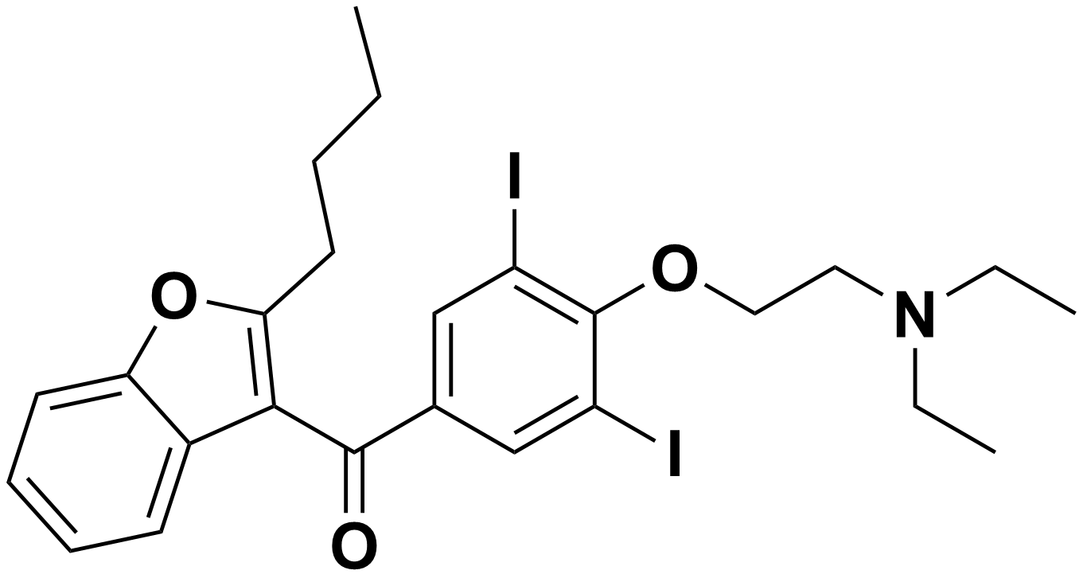
Figure SI 1. Chemical structure of AMD

Figure SI 2. (a) Cyclic voltammetry, and (b) EIS curves recorded in 2.5 mol/L [Fe(CN)₆]^{4-/3-} medium containing 0.1 mol/L KCl using bare PGE and E-PGE electrodes.

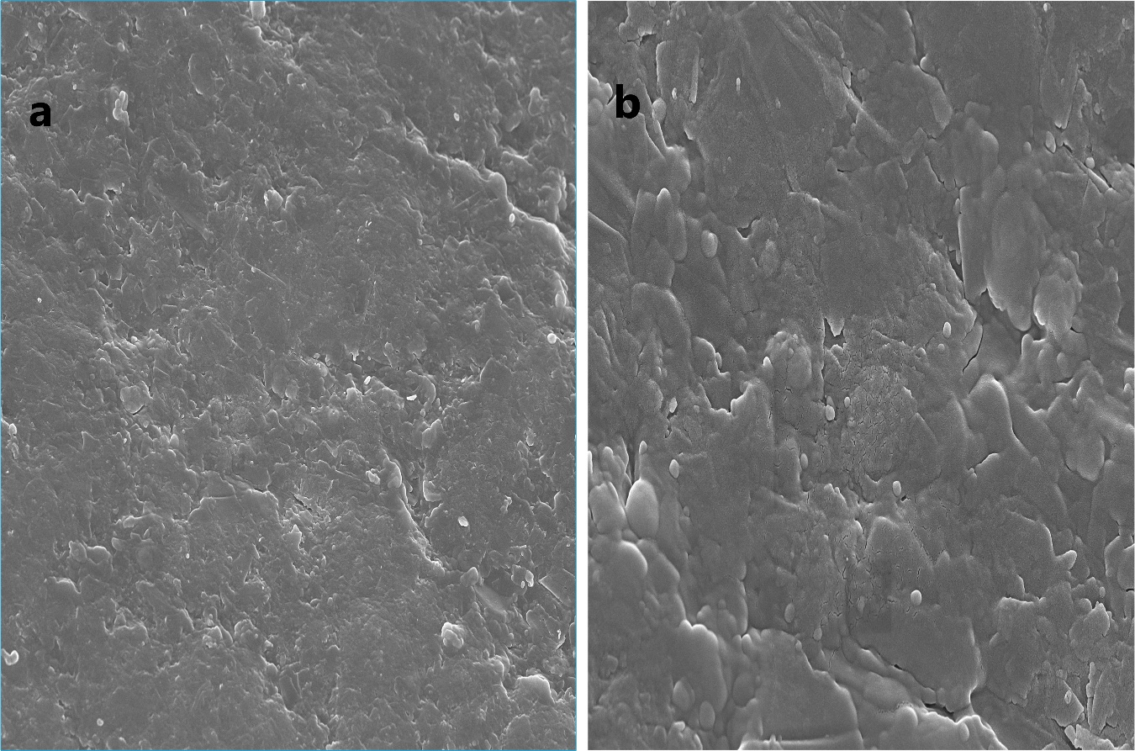
Figure SI 3. SEM images of (a) bare PGE, and (b) E-PGE

Figure SI 4. Plots of (a) root-square voltage scan rate vs. anodic current, (b) voltage scan rate vs. anodic current, and (c) logarithmic voltage scan rate vs. logarithmic anodic current for square-wave voltammograms recorded at different voltage scan rates (25 mV/s, 50 mV/s, 100 mV/s, 200 mV/s, 300 mV/s, 400 mV/s, and 500 mV/) for 0.682 mg/mL AMD on E-PGE in the BR(pH 5.0) supporting electrolyte.
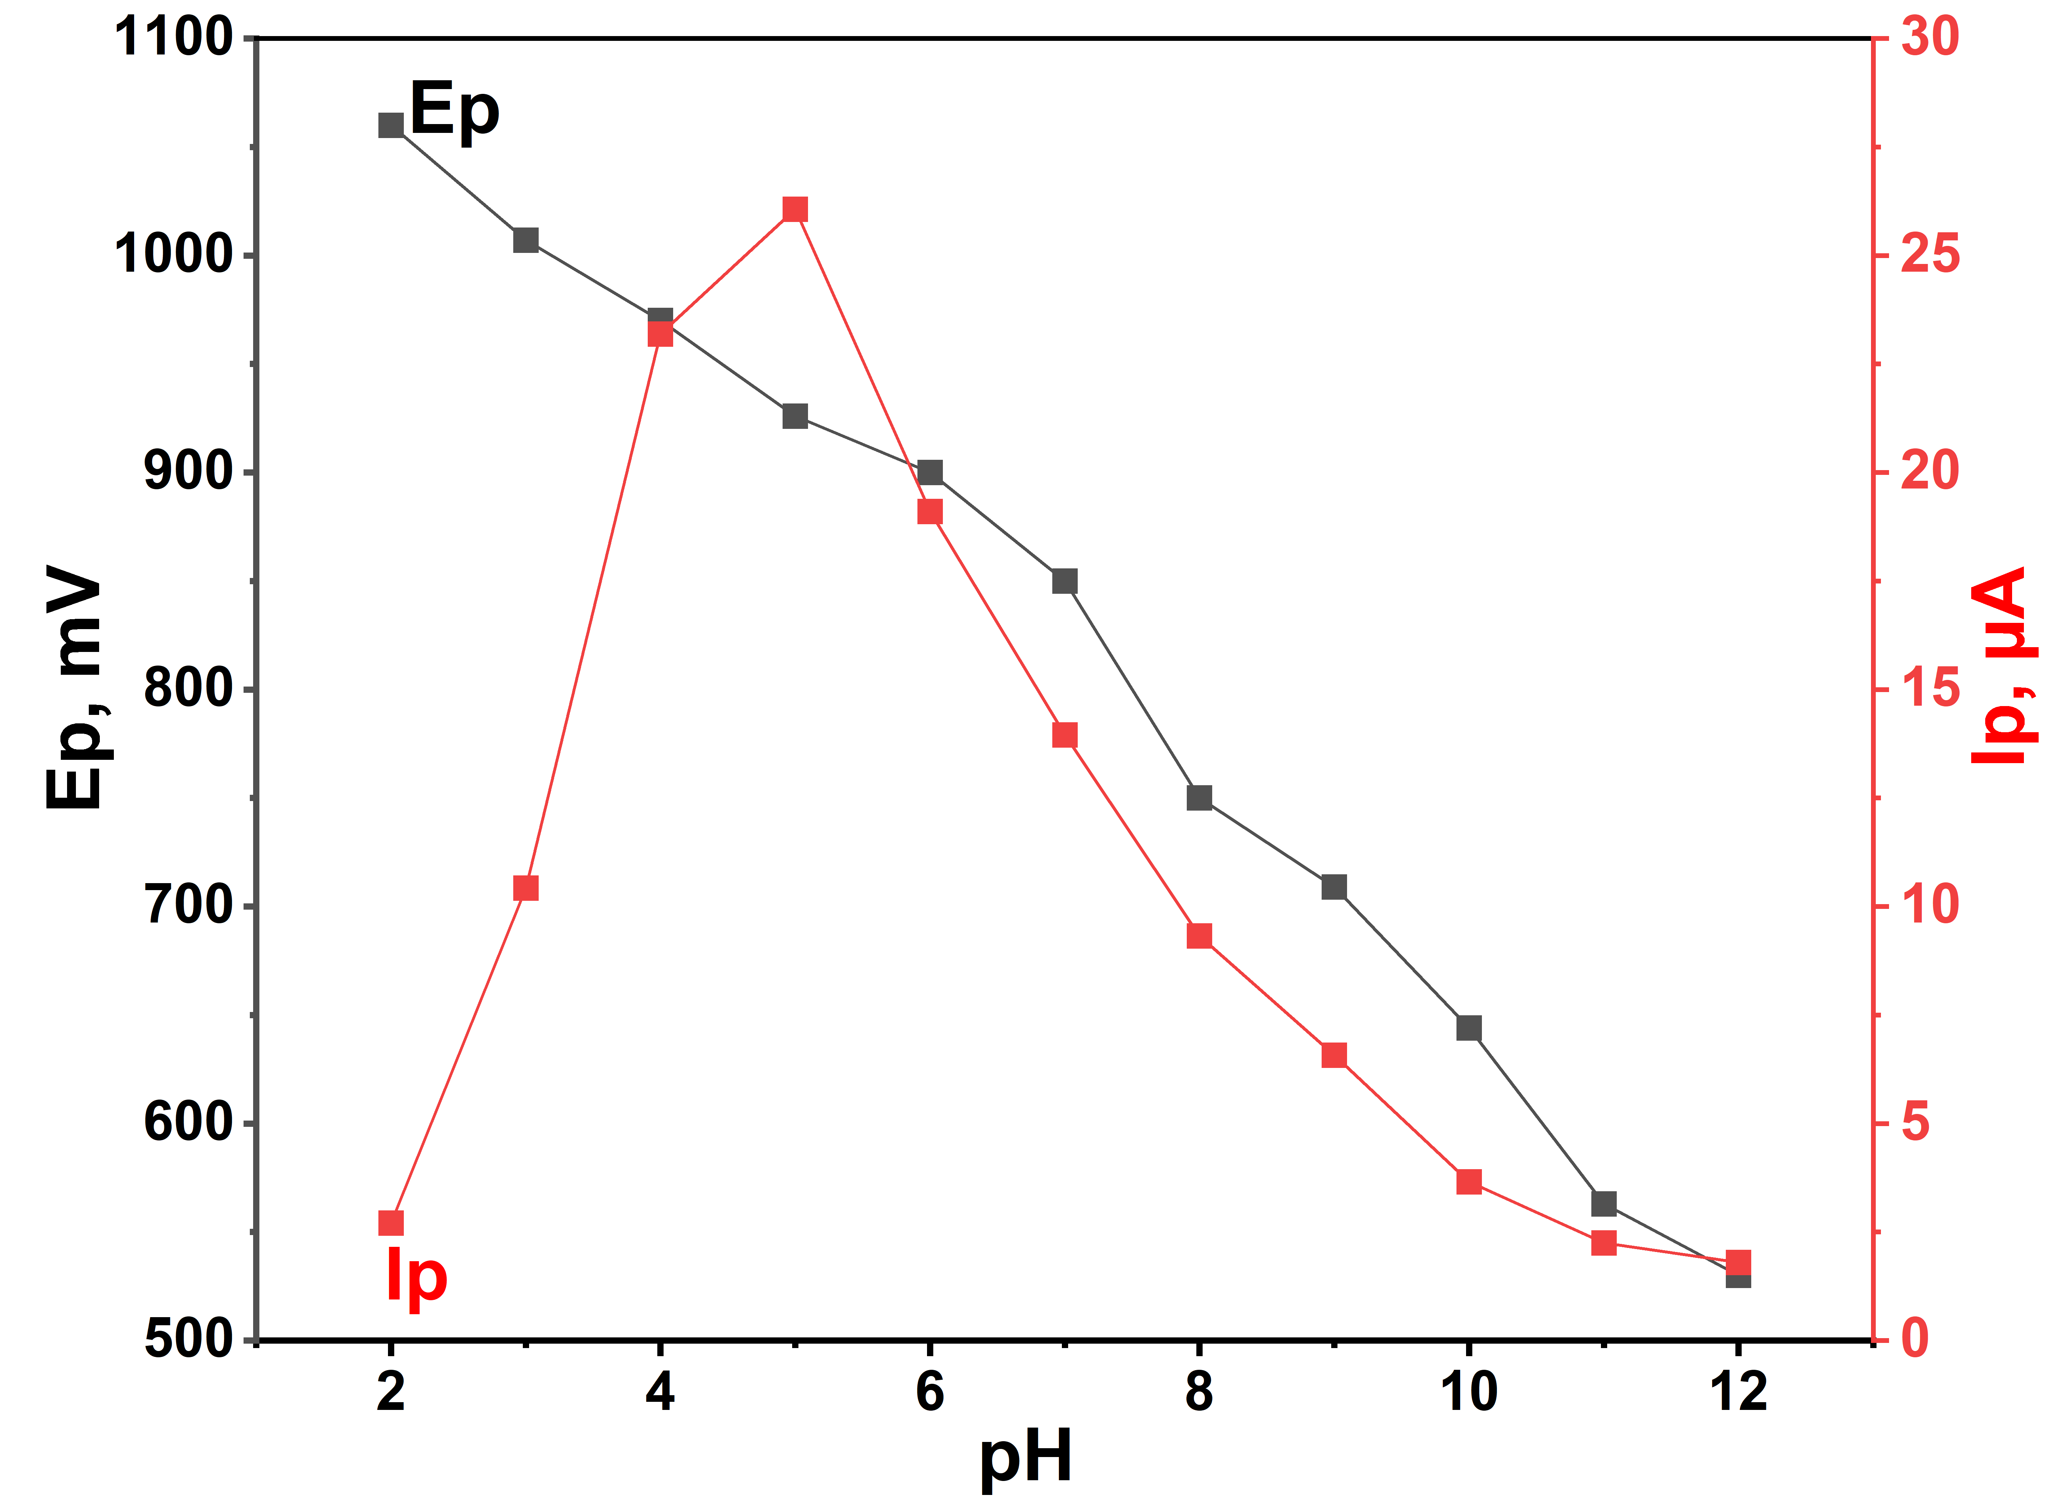
Figure SI 5. Plot of BR variation in anodic peak voltage and current for square-wave voltammograms recorded at different pH (2.0-12.0) for 0.136 mg/mL AMD on E-PGE

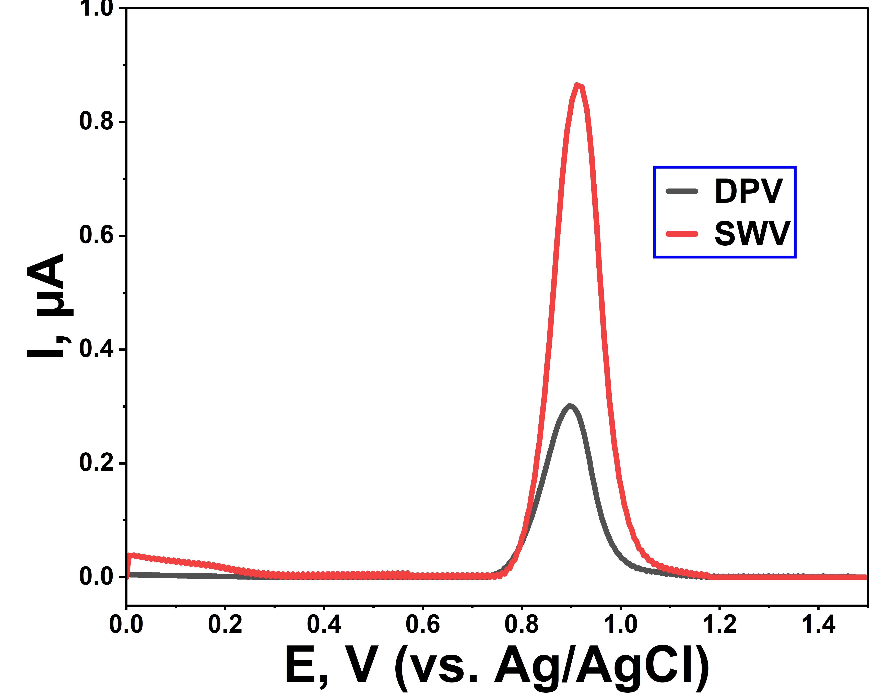
Figure SI 6. Square-wave and differential pulse voltammograms recorded in BR (pH 5.0) supporting electrolyte medium of 6.862 μg/mL AMD using E-PGE. Accumulation parameters: 0 V/30 s. Square-wave variables: step voltage, 0.004 V; amplitude, 0.03 V; frequency, 60 Hz. Differential pulse variables: step voltage 0.02 V; amplitude, 0.03; modulation time, 0.05 V; interval time, 0.5 V.

Figure SI 7. Square-wave voltammograms recorded for 0.102 mg/mL AMD on E-PGE in the BR (pH 5.0) supporting electrolyte for (a) deposition voltage (0 V-0.7 V), and (b) deposition time (0 s-150 s).

Figure SI 8. Square-wave voltammograms recorded for 0.102 mg/mL AMD on E-PGE in the BR (pH 5.0) (a) step voltage (0.001 V- 0.009 V), (b) modulation amplitude (0.01 V-0.08 V), and (c) frequency (10 Hz-90 Hz).

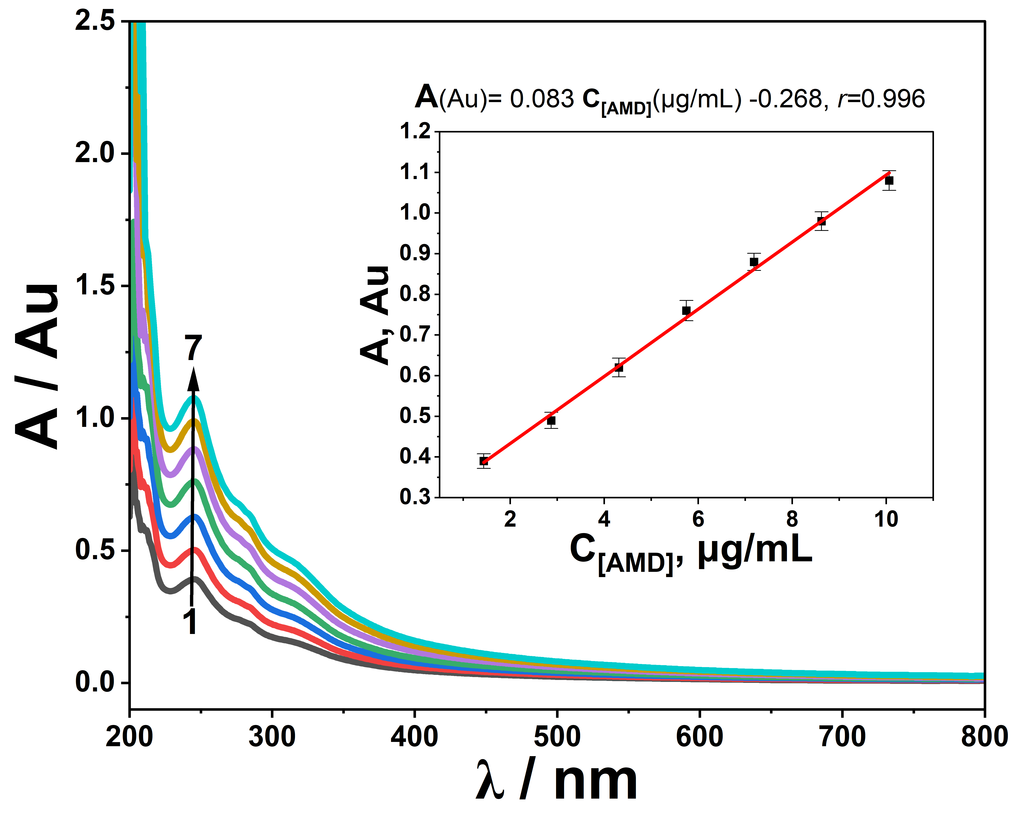
Figure SI 9. UV-visible spectra recorded for AMD at different concentrations (1: 1.44 µg/mL, 2:2.87 µg/mL, 3:4.31 µg/mL, 4:5.75 µg/mL, 5:7.19 µg/mL, 6:8.62 µg/mL, and 7:10.06 µg/mL)

