Appendix
Table A1. The association between RGE and partnership, employment, and the election result for SD, controlling for immigration and internal migration.
 | Partnership |  | Employment |  | SD vote
 | Women | Men | Women | Men | Women | Men
Change in RGE:
Change in women’s
education:
Rural areas | -0.864** | -0.459** | 0.044 | -0.065 | -0,051** | -0.047**
 | (0.010) | (0.079) | (0.036) | (0.042) | (0.014) | (0.013)
Urban areas | -0.740** | -0.267** | -0.0228 | 0.022 | -0.020 | -0.013
 | (0.117) | (0.091) | (0.037) | (0.045) | (0.015) | (0.013)
Change in men’s
education:
Rural area | 0.300* | 0.145 | 0.090 | 0.098 | 0.023* | 0.024*
 | (0.135) | (0.119) | (0.048) | (0.053) | (0.010) | (0.010)
Urban area | -0.161 | -0.033 | -0.008 | 0.058 | 0.047* | 0.047**
 | (0.178) | (0.177) | (0.045) | (0.070) | (0.018) | (0.014)
Change in education level:
Rural area | -1.163** | -0.604** | -0.047 | -0.163** | -0.074** | -0.071**
 | (0.160) | (0.122) | (0.040) | (0.051) | (0.020) | (0.019)
Urban area | -0.580** | -0.234 | -0.015 | -0.035 | -0.067** | -0.059**
 | (0.154) | (0.126) | (0.030) | (0.044) | (0.020) | (0.018)
Migration controls | yes | yes | yes | yes | yes | yes
Observations | 1,073,275 | 1,114,489 | 1,073,275 | 1,114,489 | 1,073,276 | 1,114,489
R-squared | 0.123 | 0.171 | 0.128 | 0.058 | 0.014 | 0.020
Number of areas | 458 | 458 | 458 | 458 | 458 | 458
Notes: See Table 1.

Table A2. The association between RGE and partnership, employment, and the election result for SD. Excluding foreign-born individuals from the sample.
 | Partnershi |  | Employment |  | SD vote
 | Women | Men | Women | Men | Women | Men
Change in RGE:
Change in women’s
Education:
Rural area | -0.865** | -0.463** | 0.110** | 0.050 | -0.062** | -0.059**
 | (0.113) | (0.010) | (0.031) | (0.034) | (0.014) | (0.014)
Urban area | -0.866** | -0.298** | 0.048 | 0.126** | -0.028 | -0.013
 | (0.158) | (0.010) | (0.033) | (0.037) | (0.020) | (0.016)
Change in men’s
Education:
Rural area | 0.224 | 0.0930 | 0.085 | 0.102* | 0.039** | 0.032**
 | (0.134) | (0.122) | (0.047) | (0.044) | (0.010) | (0.010)
Urban area | -0.563* | -0.223 | 0.005 | 0.0772 | 0.061** | 0.0643**
 | (0.226) | (0.169) | (0.039) | (0.040) | (0.019) | (0.014)
Change in education level:
Rural area | -1.089** | -0.556** | 0.025 | -0.052 | -0.100** | -0.091**
 | (0.169) | (0.135) | (0.038) | (0.034) | (0.018) | (0.018)
Urban areas | -0.303 | -0.075 | 0.043* | 0.049* | -0.090** | -0.078**
 | (0.173) | (0.137) | (0.020) | (0.024) | (0.016) | (0.017)
Observations | 790,955 | 832,788 | 790,955 | 832,788 | 790,956 | 832,788
R-squared | 0.154 | 0.191 | 0.052 | 0.036 | 0.018 | 0.023
Number of areas | 458 | 458 | 458 | 458 | 458 | 458
Notes: See Table 1.

Table A3. The association between RGE and partnership, employment, and the election result for SD. Unadjusted model without control variables.
 | Partnership |  | Employment |  | SD vote
 | Women | Men | Women | Men | Women | Men
Change in RGE:
Change due to women’s education
Rural area | -0.724** | -0.329** | 0.268** | 0.118** | -0.060** | -0.039**
 | (0.119) | (0.086) | (0.047) | (0.043) | (0.014) | (0.013)
Urban area | -0.595** | -0.066 | 0.329** | 0.281* | -0.028 | 0.001
 | (0.158) | (0.134) | (0.083) | (0.120) | (0.027) | (0.019)
Change due to
men's education:
Rural areas | 0.101 | -0.013 | 0.004 | 0.027 | 0.032** | 0.038**
 | (0.124) | (0.113) | (0.055) | (0.051) | (0.009) | (0.009)
Urban areas | -0.408* | -0.255 | 0.0748 | 0.0853 | 0.0563* | 0.070**
 | (0.189) | (0.222) | (0.088) | (0.124) | (0.023) | (0.016)
Change in education level:
Rural area | -0.824** | -0.316** | 0.263** | 0.091 | -0.092** | -0.077**
 | (0.171) | (0.116) | (0.057) | (0.049) | (0.018) | (0.017)
Urban area | -0.187 | 0.189 | 0.254** | 0.196** | -0.084** | -0.069**
 | (0.175) | (0.145) | (0.047) | (0.037) | (0.016) | (0.016)
Observations | 1,073,275 | 1,114,489 | 1,073,275 | 1,114,489 | 1,073,276 | 1,114,489
R-squared | 0.109 | 0.146 | 0.001 | 0.001 | 0.002 | 0.002
Number of areas | 458 | 458 | 458 | 458 | 458 | 458
Notes: See Table 1.

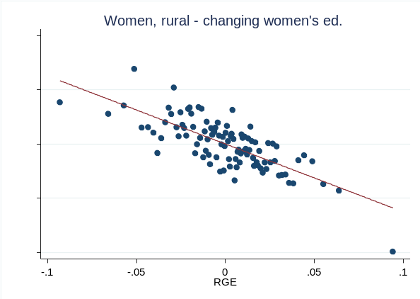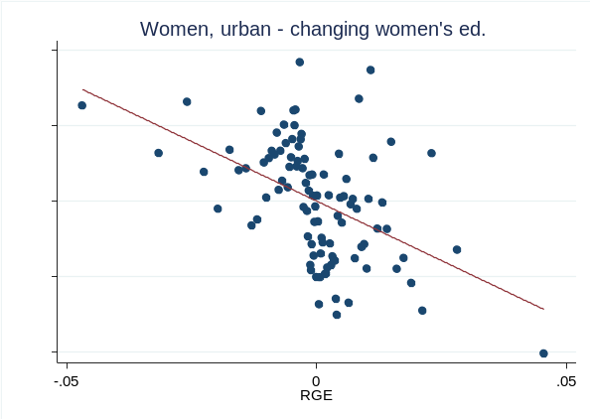
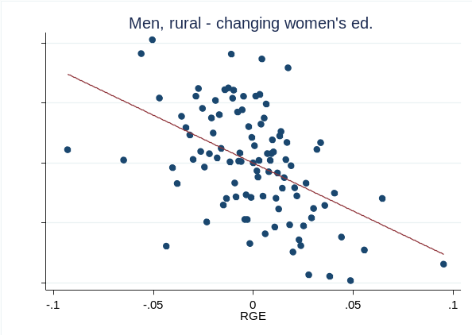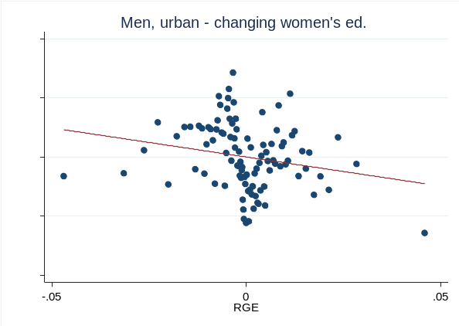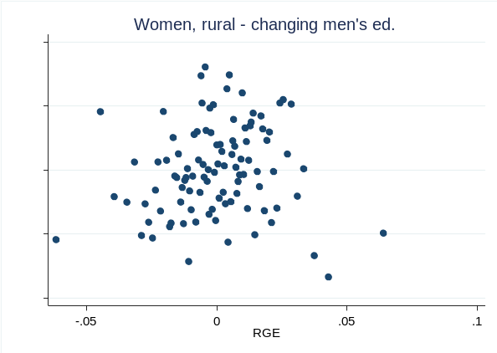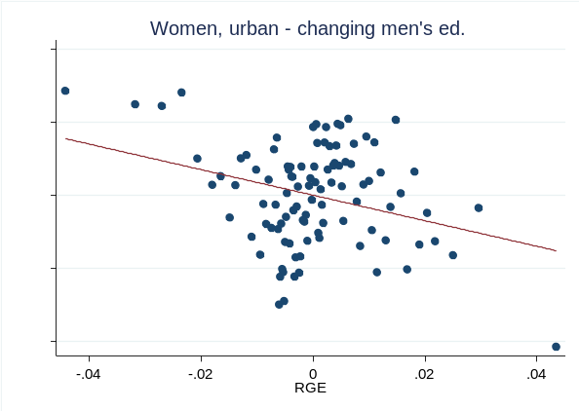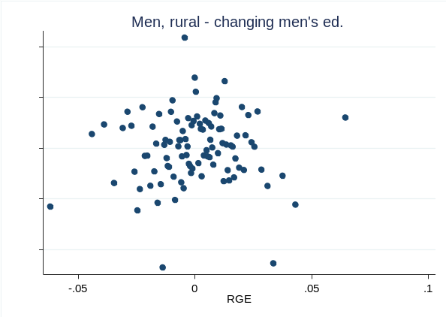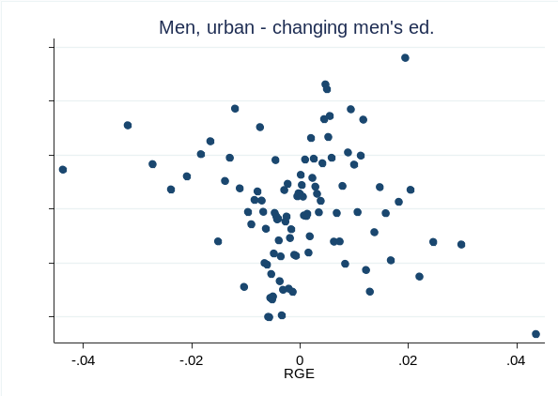
Figure A1. Relationship between partnership and RGE (controlling for area fixed effects and control variables). Significant relationships are indicated by a fitted line.
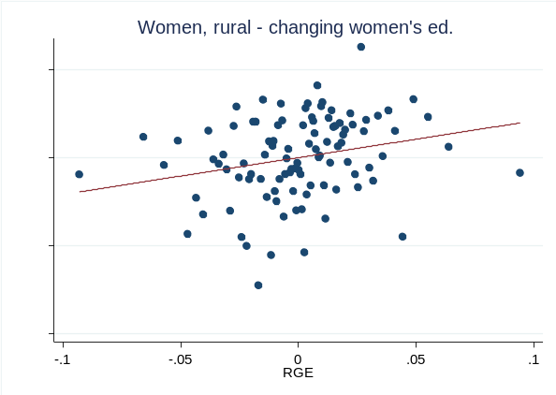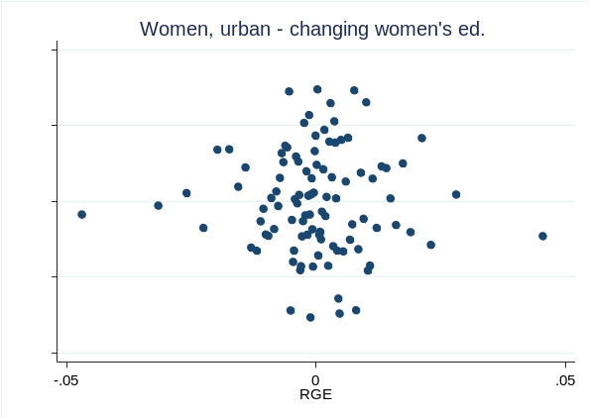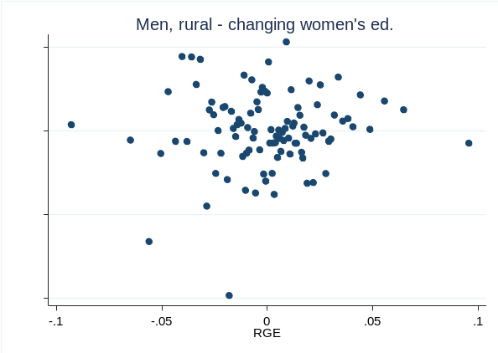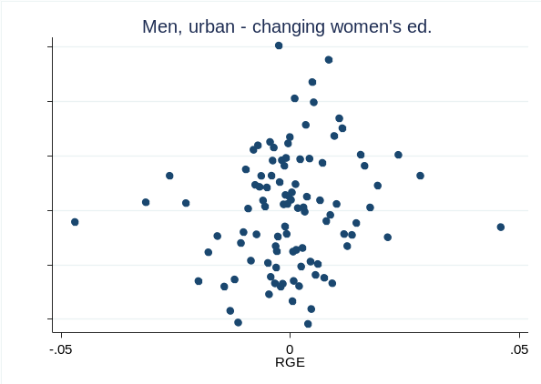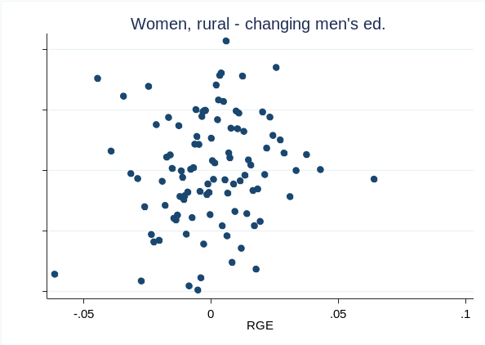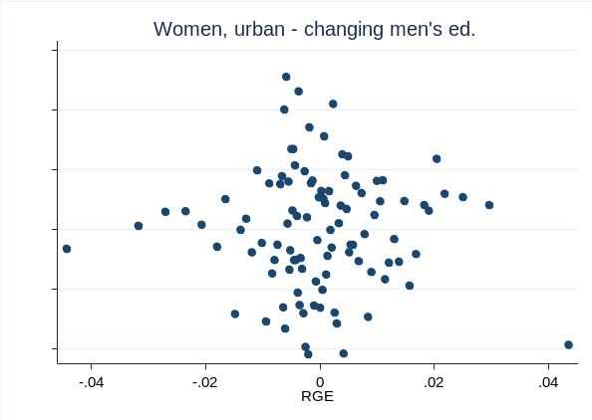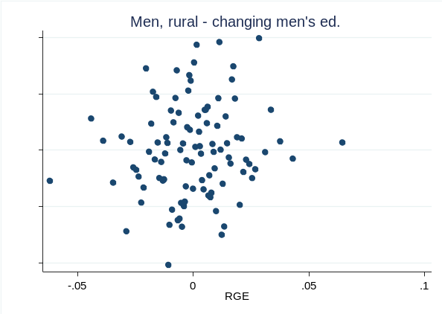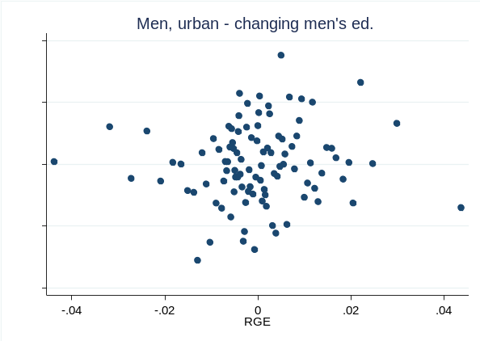Figure A2. Relationship between employment and RGE (controlling for fixed effects and control variables). Significant relationships are indicated by a fitted line.
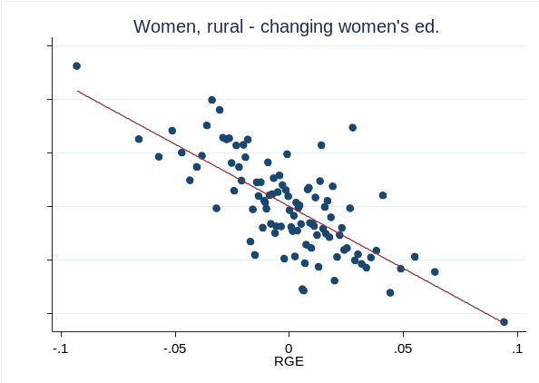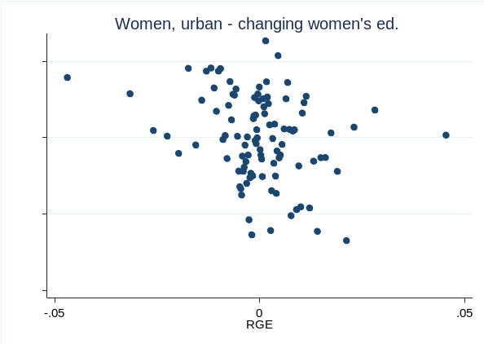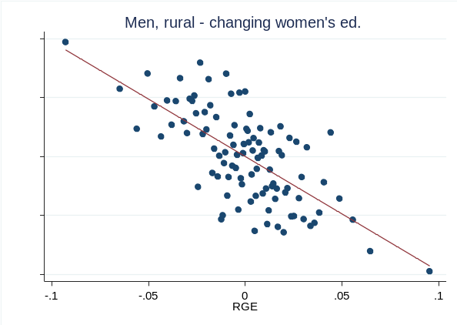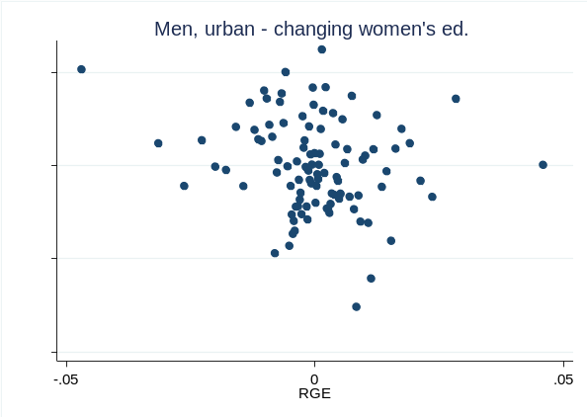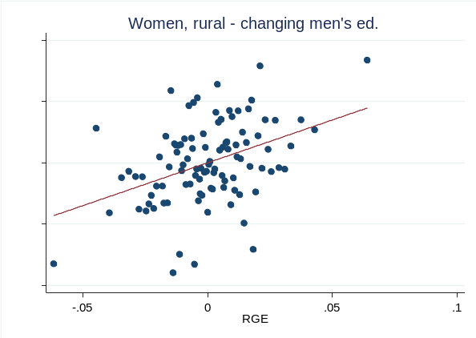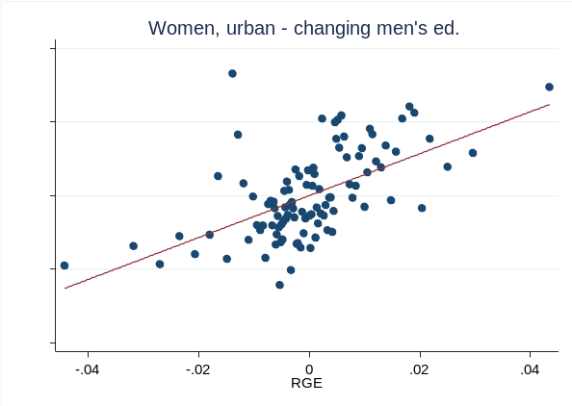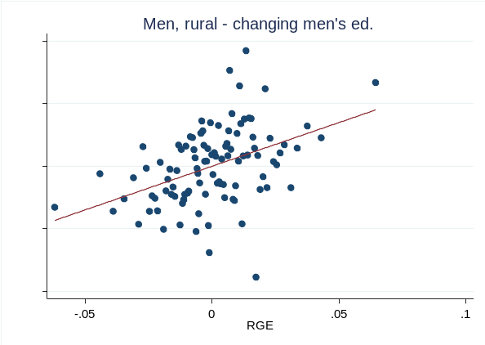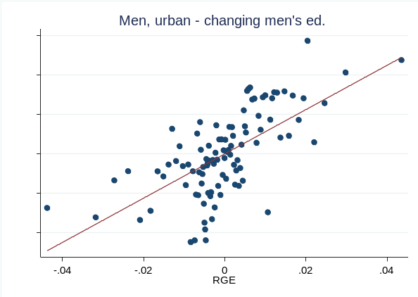
Figure A3. Relationship between election result for SD and RGE (controlling for area fixed effects and control variables). Significant relationships are indicated by a fitted line.

