Graphical summary
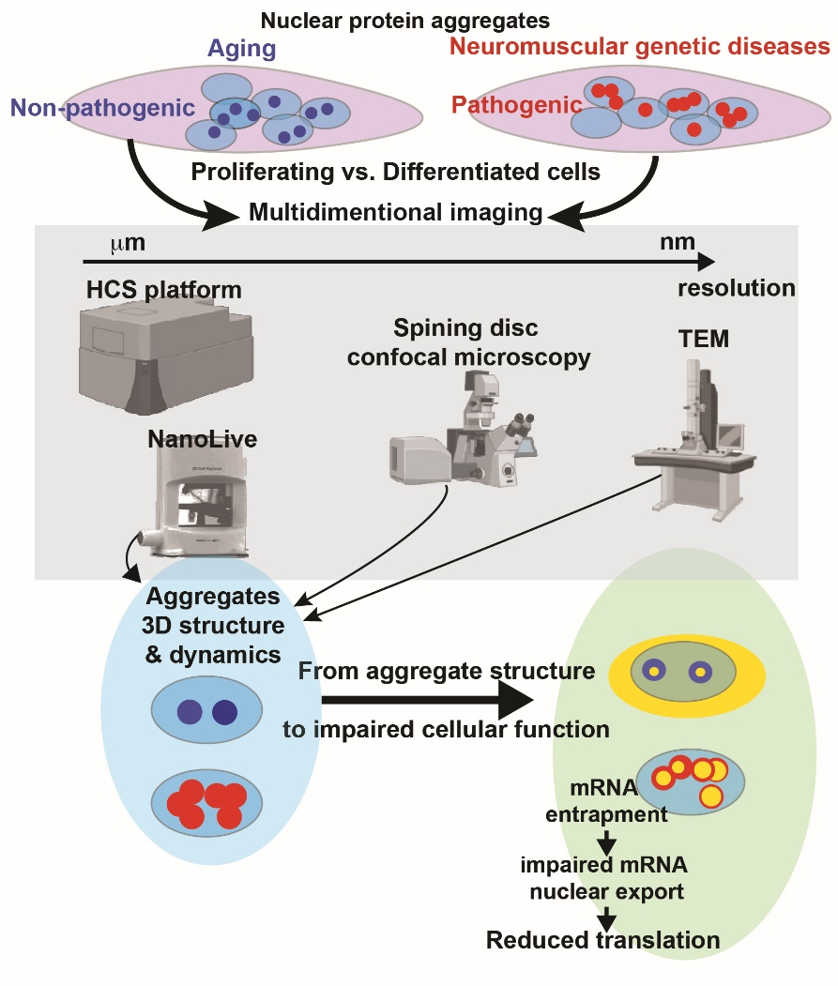
The accumulation of aggregation-prone proteins is a hallmark of aging cells. Pathogenic forms of these aggregates are associated with neurodegenerative, neuromuscular, and muscular diseases, yet the differences between pathogenic and non-pathogenic aggregates remain unclear. In this study, we created an inducible cell model to investigate the structural and molecular properties of nuclear protein aggregates in both undifferentiated and differentiated muscle cells. Through imaging at micro- to nanoscale resolutions, we identified key molecular and structural distinctions between non-pathogenic and pathogenic protein forms. We also linked these structural features to cellular function, providing new insights into the functional differences between pathogenic and non-pathogenic aggregates.

