Additional File 2

Hi-TARGET: A highly efficient, Thermoanaerobacter, CRISPR Type I-B-based, genome editing tool for the thermophilic acetogen Thermoanaerobacter kivui
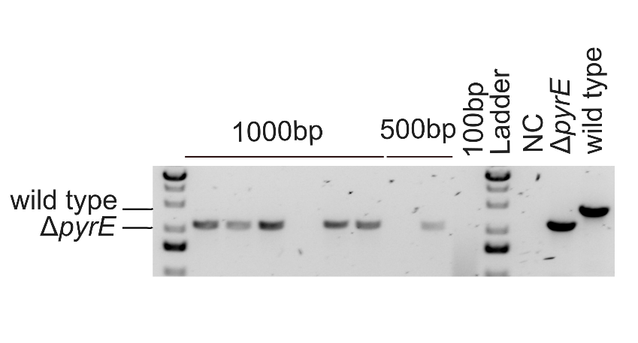
Fig. S1. Editing efficiency of CRISPR with Golden gate mix. PCR and gel electrophoresis targeting the pyrE locus. The localization of the wild type or ΔpyrE band is demonstrated on the left. The size of the homology arms is displayed on top. NC = negative control. Data are representative of 10 colonies per construct.

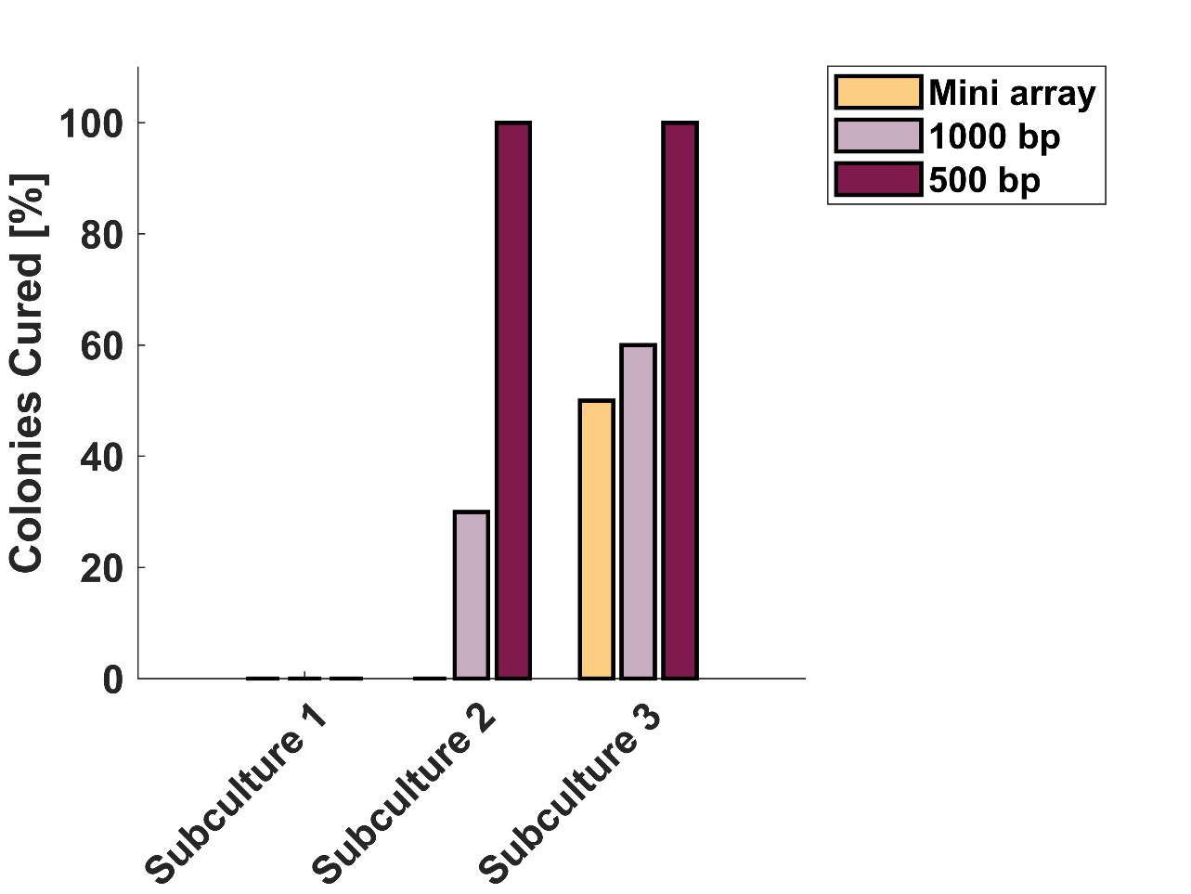
Fig. S2 Curing efficiency. The bars represent the fraction (%) of the colonies cured after 1, 2, or 3 subcultures. Clones were isolated and individually tested for growth on Kanamycin. Mini array: empty vector control, containing the direct repeats. 1000 bp: plasmid targeting the pyrE gene with 1000 bp HAs. 500 bp: plasmid targeting the pyrE gene with 500 bp of HAs. Colonies tested per sample: n=10.

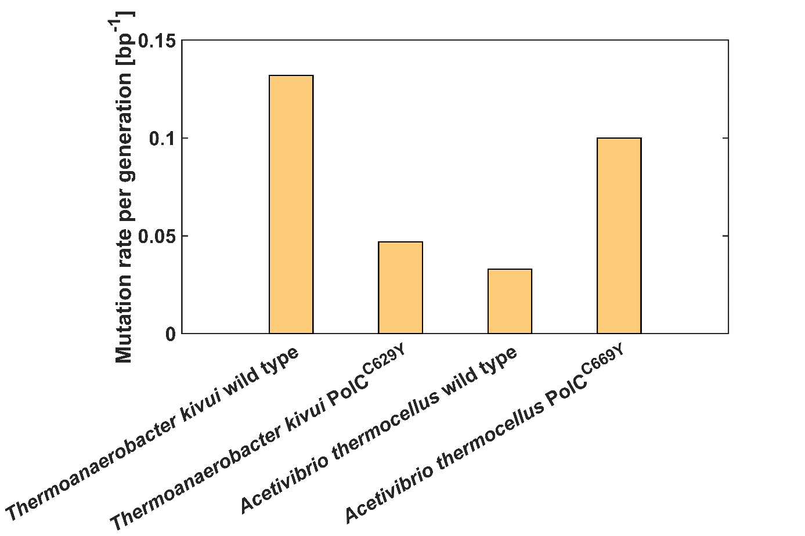
Fig. S3 Mutation rate. Comparison of the wild-type strain (wild type) mutation rate (based on synonymous mutations) and PolC mutant of T. kivui (polC^{C629Y}) and C. thermocellum (polC^{C669Y}). Direct comparison of the mutation rate between the organisms should be interpreted with caution due to variations in the methodological approach.

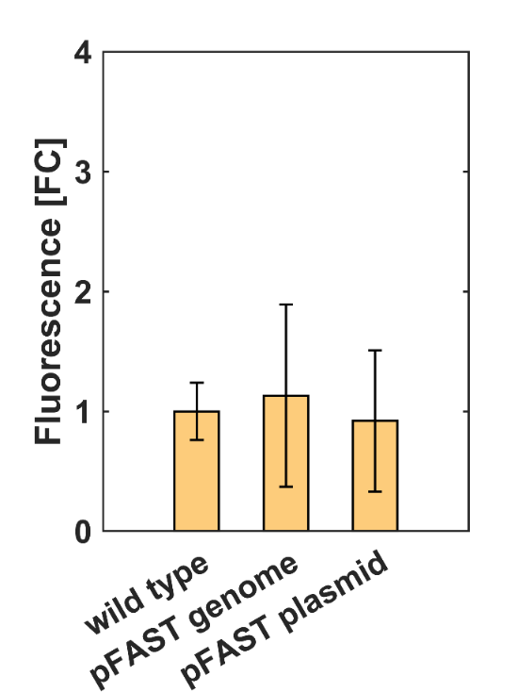

Fig. S4 Fluorescence at 66 °C. Log2-fold change difference of pFAST expressed from the genome or the plasmid compared to the wild-type strain, at 66 °C. Data represent three biological replicates (average ± standard deviation).

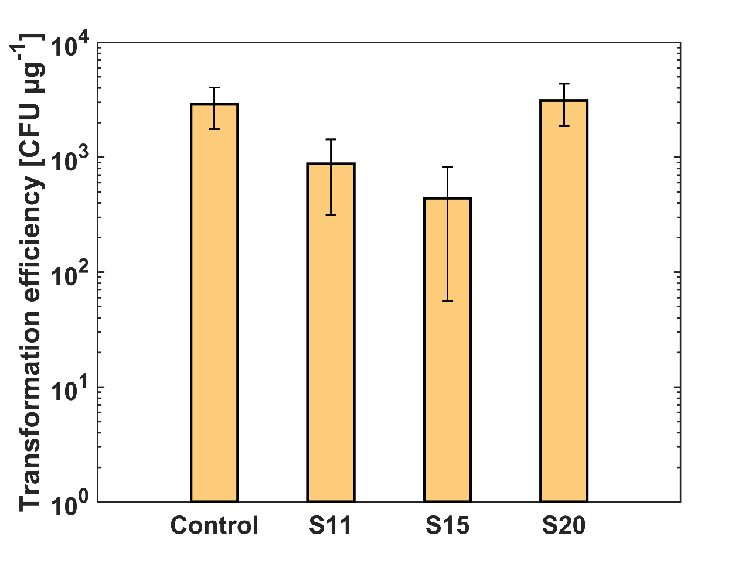

Fig. S5 Transformation efficiency of CRISPRi experiment.
Transformation efficiency of shorter spacer plasmids (S11: 11-bp, S15: 15-bp, S20: 20-bp) targeting the pFAST gene integrated in the ldh locus. No significant difference in transformation efficiency with the control. Control: SPF-B017, empty vector. Data represent three biological replicates (average ± standard deviation).

