Supplementary files for the manuscript below:

4D seismic tomography unveiling velocity increase prior to seismic swarms at the Tatun volcano group of Taiwan

by
Hsin-Chieh Pu, Cheng-Horng Lin*, Ya-Chuan Lai, Min-Hung Shih, and Yi-Heng Li

(*) Corresponding author: Cheng-Horng Lin
Email: lin@earth.sinica.edu.tw
Tel: 886-2-27839910 ext. 1521
Fax: 886-2-27839159

Submitted to Scientific Reports
on Dec. 20, 2024

revised on Feb. 13, 2025
revised on April 22, 2025

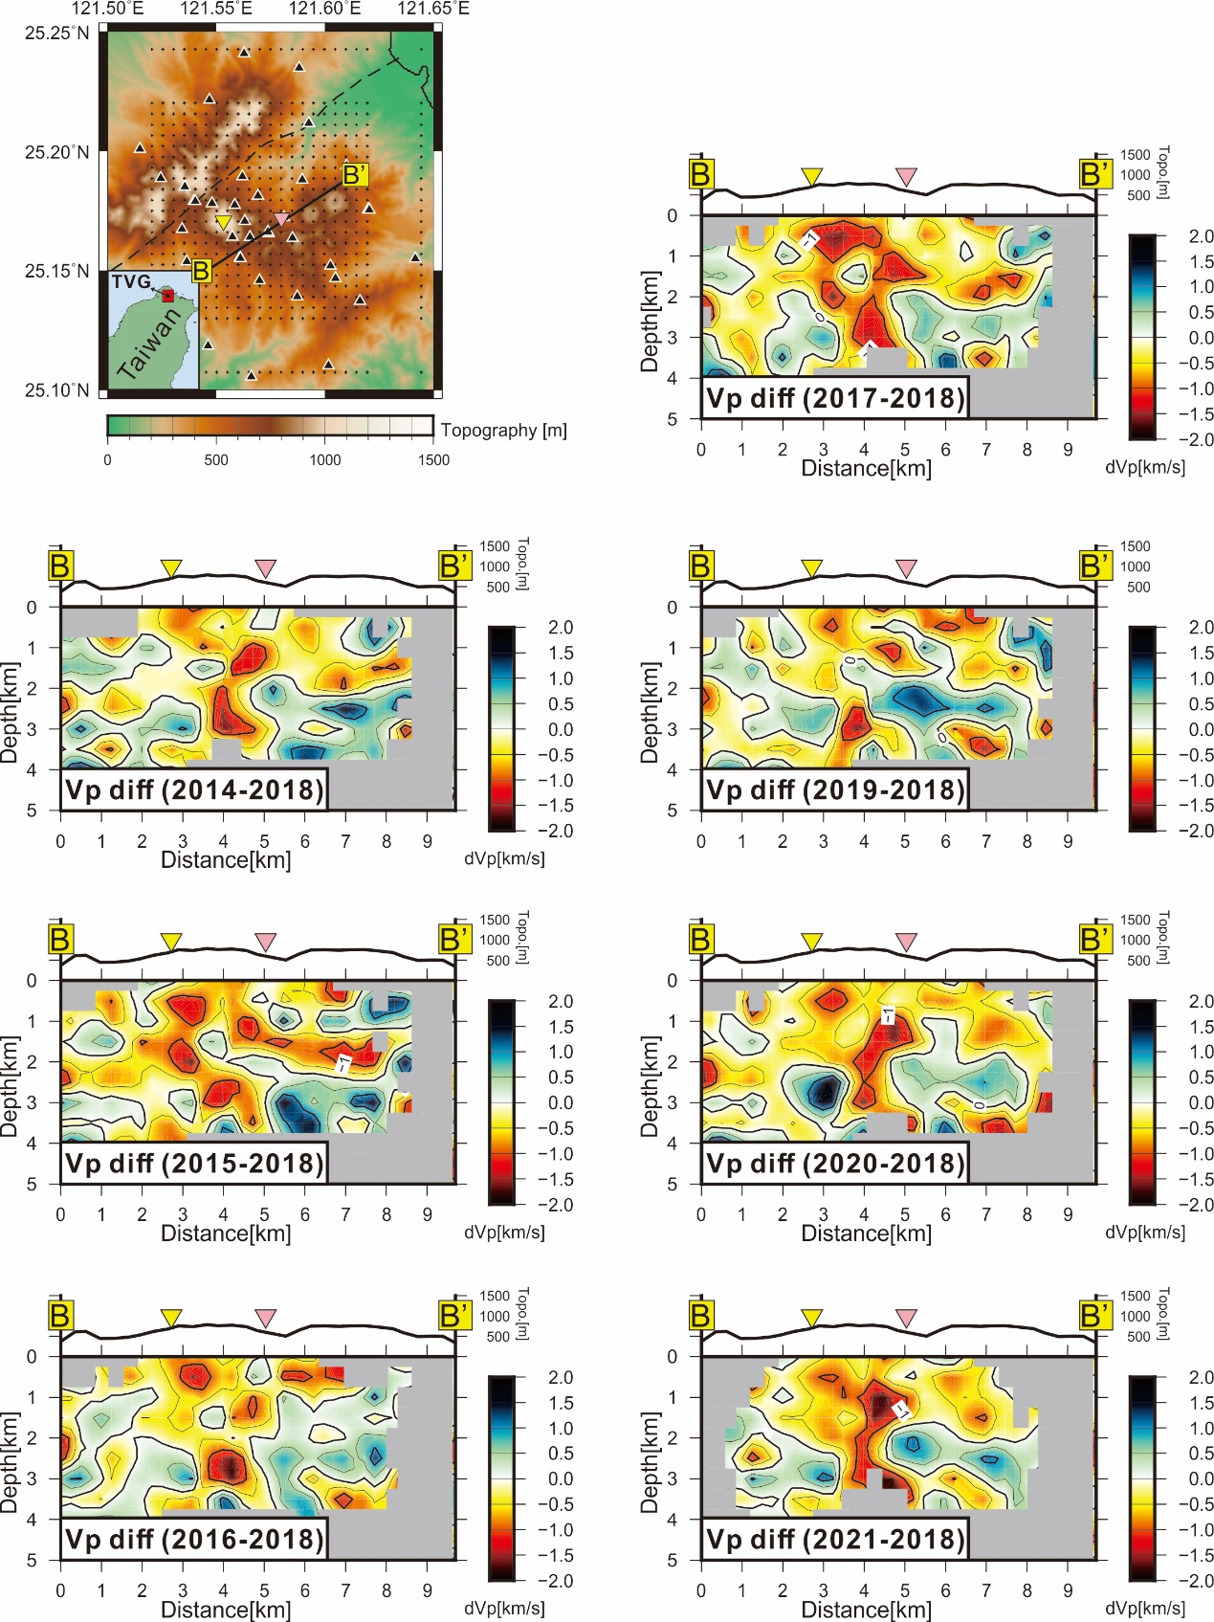
Figure A1. P-wave velocity differences between 2018 and each of the other years along the B-B’ profile.

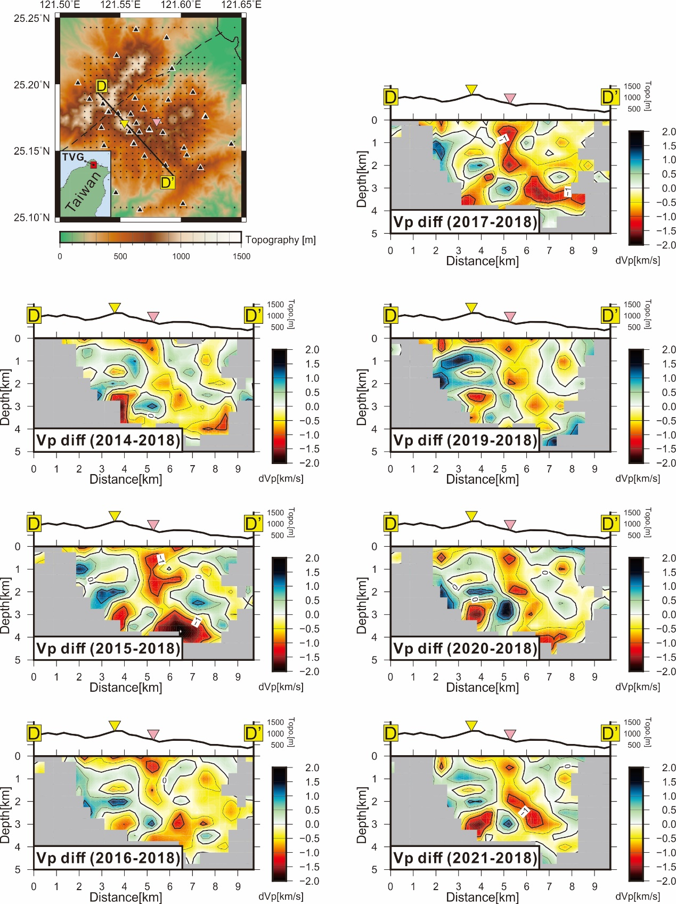
Figure A2. P-wave velocity differences between 2018 and each of the other years along the D-D’ profile.
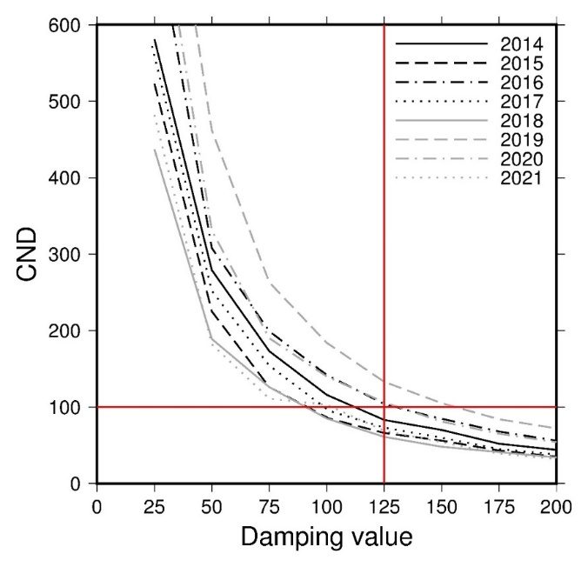
Figure A3. The trade-off plots between the damping value and CND in each year between 2014 and 2021.
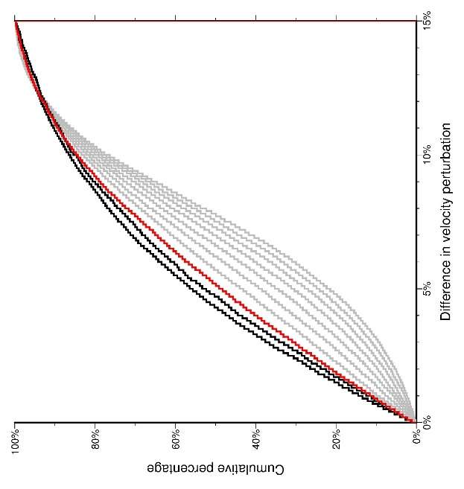
Figure A4. Cumulative percentages of the velocity perturbation differences between the predefined checkerboard model and inverted checkerboard tests under a series of smoothing constraints. Differences were calculated for each velocity grid with high ray density (DWS > 5) within a cubic region extending 5 km in longitude, 5 km in latitude, and 2.5 km in depth from the model center, using data collected between 2014 and 2021. The red line corresponds to a smoothing constrain of 1.5, while the gray and black lines represent results for smoothing constraint greater than 2 and less than 1, respectively.

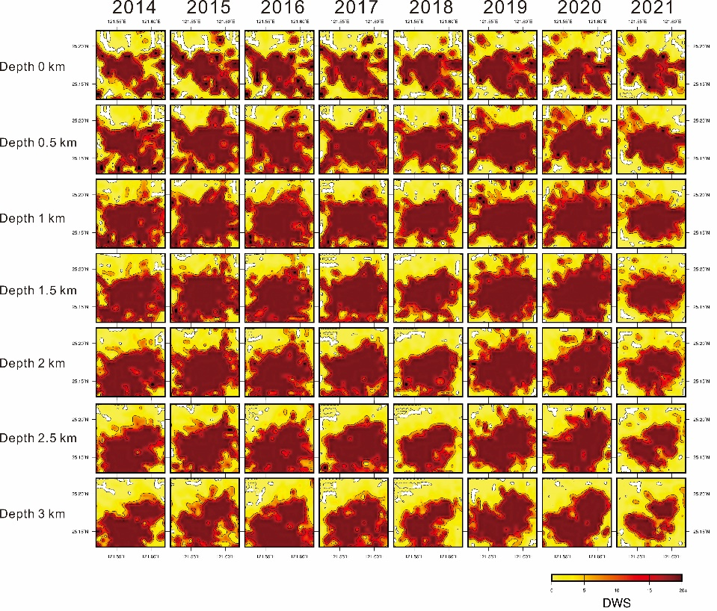
Figure A5. The DWS (Derivative Weight Sum) for P-wave at different depths in each year between 2014 and 2021.

Append Figure Captions
Figure A1. P-wave velocity differences between 2018 and each of the other years along the B-B’ profile.
Figure A2. P-wave velocity differences between 2018 and each of the other years along the D-D’ profile.
Figure A3. The trade-off plots between the damping value and CND in each year between 2014 and 2021.
Figure A4. Cumulative percentages of the velocity perturbation differences between the predefined checkerboard model and inverted checkerboard tests under a series of smoothing constraints. Differences were calculated for each velocity grid with high ray density (DWS > 5) within a cubic region extending 5 km in longitude, 5 km in latitude, and 2.5 km in depth from the model center, using data collected between 2014 and 2021. The red line corresponds to a smoothing constrain of 1.5, while the gray and black lines represent results for smoothing constraint greater than 2 and less than 1, respectively.
Figure A5. The DWS (Derivative Weight Sum) for P-wave at different depths in each year between 2014 and 2021.

