Extended data (Tables and Figures)
Table 1. Number of papers by keyword from database searching over the 1900-2020 (May) period
Keywords | Pubmed | Web of Science/MedLine
Human nature connectedness | 1 | 9
Human nature connection | 3 | 17
Empathy nature | 14 | 55
Emotional affinity nature | 0 | 4
Inclusion nature self | 0 | 4
Environmental identity | 22 | 253
Connectivity nature | 22 | 4
Nature relatedness | 16 | 41
Connect nature | 1 | 44
Love of nature/Love and care for nature | 11 | 243
Commitment to natural environment | 0 | 5
Environmental connectedness | 33 | 33
New Environmental Paradigm | 18 | 112
Anthropomorphism nature | 0 | 6
Anthropomorphism animal | 3 | 51
Biophilia | 11 | 110
Human plant relationship | 3 | 31
Human-animal relationship | 75 | 390
Human non-human relationship | 6 | 46

Table 2. Summary of meta-analyses from experimental data showing the R estimates, lower confidence interval at 95% (lCI), upper confidence intervals and 95% (uCI), number of individual papers n, number of effect sizes k, number of participants s, z and p values from the z-tests for each category as well as Q (residual heterogeneity) and its corresponding p value Qp for each model (one model per line) with lab and study as random effects.

Type of programs | R | lCI | uCI | n | k | s | z | p | Q | Qp
Contact with real nature | 0.18 | 0.13 | 0.23 | 25 | 70 | 4773 | 6.5 | <.00001 | 246 | <.00001
real nature + environmental education | 0.1 | 0.034 | 0.17 | 10 | 31 | 2352 | 2.9 | 0.004 | 109 | <.00001
real nature | 0.21 | 0.15 | 0.27 | 15 | 33 | 2290 | 7.1 | <.00001 | 86 | <.00001
real nature + mindfulness | 0.34 | 0.19 | 0.48 | 4 | 6 | 220 | 4.3 | <.0001 | 12 | 0.037
Other programs (without real nature) | 0.19 | 0.089 | 0.30 | 14 | 24 | 2328 | 3.5 | <.001 | 94 | <.00001
environmental education | 0.11 | -0.016 | 0.24 | 6 | 10 | 909 | 1.7 | 0.085 | 26 | 0.0017
virtual nature | 0.12 | 0.012 | 0.23 | 5 | 10 | 1113 | 2.2 | 0.03 | 13 | 0.17
mindfulness | 0.43 | 0.26 | 0.58 | 3 | 4 | 306 | 4.7 | <.0001 | 20 | <.00001
Note. Real nature + Environmental Education: Outdoor activities including scientific knowledge. Real Nature: Outdoor programs or experimental manipulations using exposure to real nature; Virtual nature: videos or pictures of nature administrate in an indoor setting. EE: educational programs or experimental manipulations involving transmission of naturalist or ecological knowledge in an indoor setting. Mindfulness: focusing on one self or surrounds in the present moment in an indoor setting; Real Nature + Mindfulness: practicing mindfulness in real nature.
Table 3. Summary of meta-analyses from correlational data showing the R estimates, lower confidence interval at 95% (lCI), upper confidence intervals and 95% (uCI), number of individual papers n, number of effect sizes k, number of participants s, z and p values from the z-tests for each category as well as Q (residual heterogeneity) and its corresponding p value Qp for each model (one model per line) with lab and study as random effects.
Category | R | lCI | uCI | n | k | s | z | p | Q | Qp
Nature conservation | 0.36 | 0.32 | 0.39 | 84 | 404 | 51633 | 18 | <.00001 | 9713 | <.00001
pro-environmental behavior | 0.35 | 0.32 | 0.39 | 54 | 168 | 36945 | 17 | <.00001 | 2098 | <.00001
pro-environmental values | 0.36 | 0.31 | 0.41 | 52 | 231 | 33793 | 12 | <.00001 | 8434 | <.00001
Human welfare | 0.23 | 0.20 | 0.27 | 50 | 477 | 30343 | 12 | <.00001 | 3422 | <.00001
Human health | 0.22 | 0.19 | 0.25 | 47 | 430 | 28558 | 13 | <.00001 | 2587 | <.00001
Humanist and social values | 0.28 | 0.10 | 0.45 | 8 | 38 | 3762 | 3 | 0.003 | 751 | <.00001
Lifestyle characteristics | 0.27 | 0.21 | 0.32 | 35 | 93 | 14335 | 8.8 | <.00001 | 1508 | <.00001
Environmental education | 0.25 | 0.14 | 0.35 | 10 | 11 | 6570 | 4.5 | <.00001 | 209 | <.00001
Real nature | 0.26 | 0.18 | 0.33 | 25 | 68 | 10304 | 6.7 | <.00001 | 1149 | <.00001
Mindfulness | 0.32 | 0.21 | 0.43 | 9 | 14 | 2539 | 5.3 | <.00001 | 89 | <.00001
Non-environmental values | -0.23 | -0.29 | -0.17 | 7 | 12 | 3174 | -7.3 | <.00001 | 34 | <.0001
materialistic values | -0.23 | -0.31 | -0.15 | 4 | 7 | 1324 | -5.5 | <.00001 | 11 | 0.082
Conservative political values | -0.23 | -0.34 | -0.11 | 3 | 5 | 1850 | -3.8 | 0.0001 | 23 | 0.0001
Note. Nature conservation: pro-environmental values (ecological, personal interest and appreciation of nature) and pro-environmental behaviours (self-reported and observed pro-environmental behaviours as well as pro-environmental intentions). Human welfare: psychological health (mental health, positive personality traits, academic performance), social well-being (happiness, social and psychological well-being), physical health (vitality, mobility) and humanist values (value of human beings including human freedom and progress, individually and collectively namely social values, community values, moral values and humanist values). Reversed effect sizes were used for negative mental health (e.g., depression), negative personality trait (e.g., neuroticism) and negative physical health (e.g., physical stress). lifestyle characteristics: contact with real nature (e.g., time spent in nature), environmental education (scientific or naturalist knowledge) and mindfulness practices (focusing on the present moment). non-environmental values: materialistic and utilitarian values (values focusing on wealth, possessions, image, and status including consumerism) and conservatism (political values emphasizing traditional social institutions).

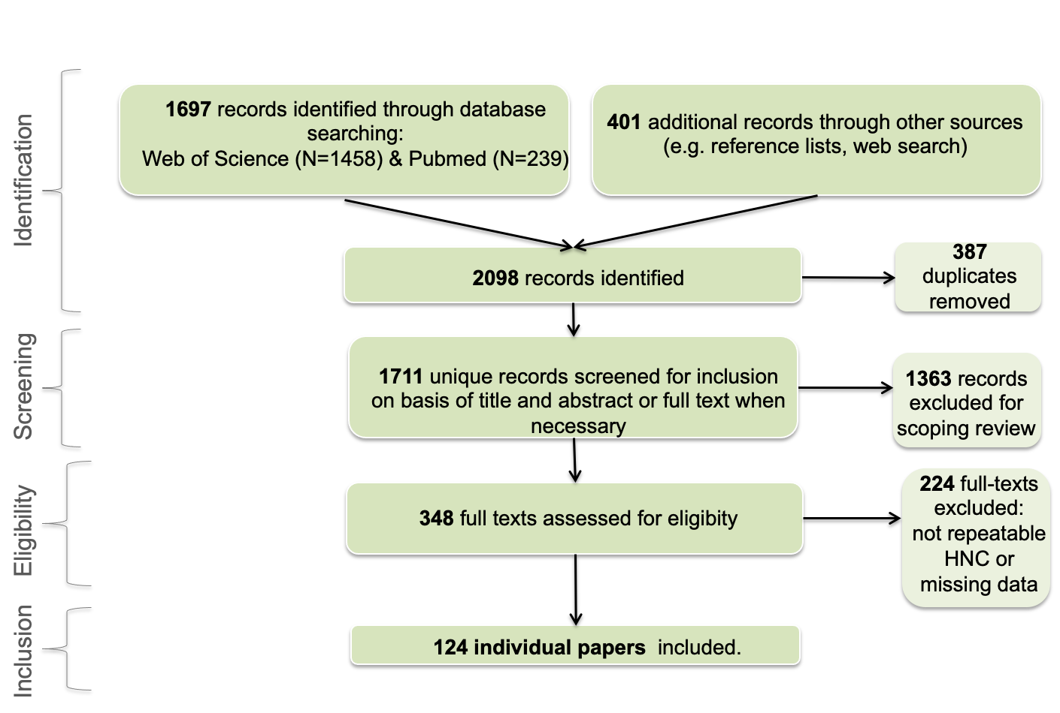 Figure 1. PRISMA flow diagram.
Figure 2. Description of all studies included in the review. A) Number of participants for children (<18 years old), young adults (18 to 25 years old), adults (26 to 40) and older adults (>40). B) Number of participants in function of HNC metrics. C) Number of participants by region is presented on the left while coloured map representing the number of participants by country, with grey referring to country without any data on the right. The EID scale was the least used scale. Most of the studies are strongly biased towards adults from industrialized countries.
Figure 3. R estimates from correlational data by HNC metrics. Each round represents the R estimate for each HNC metrics with n, k and s referring to the number of individual papers, number of effect sizes and number of participants respectively. Horizontal lines indicate the 95% confidence intervals for each factor and cross the vertical dot lines when non-significant.

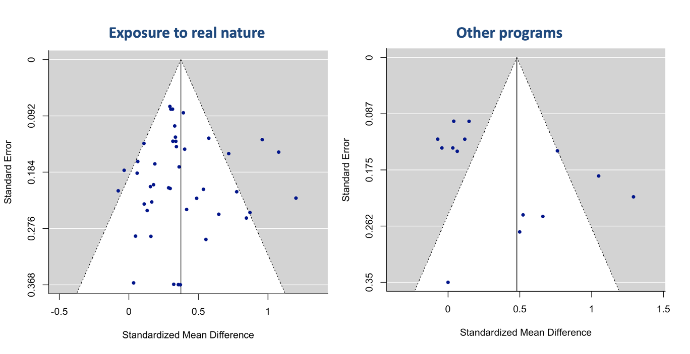
Figure 4. Funnels plots from the meta-analyses of experimental studies. Each dot represents effect size from one individual study.
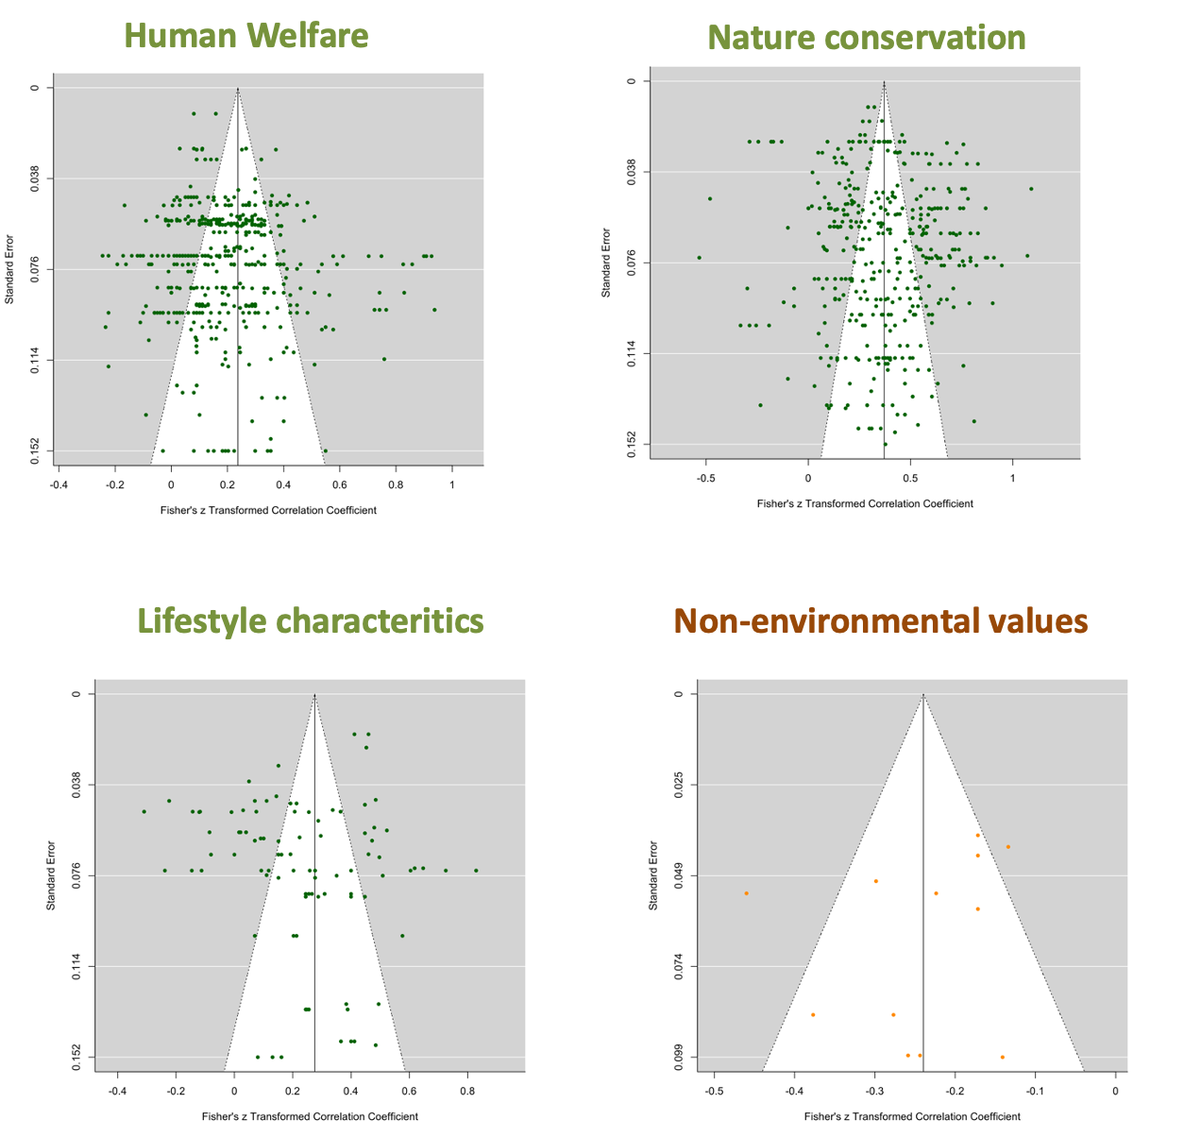
Figure 5. Funnels plots from the meta-analyses of correlational studies. Each dot represents effect size from one individual study.

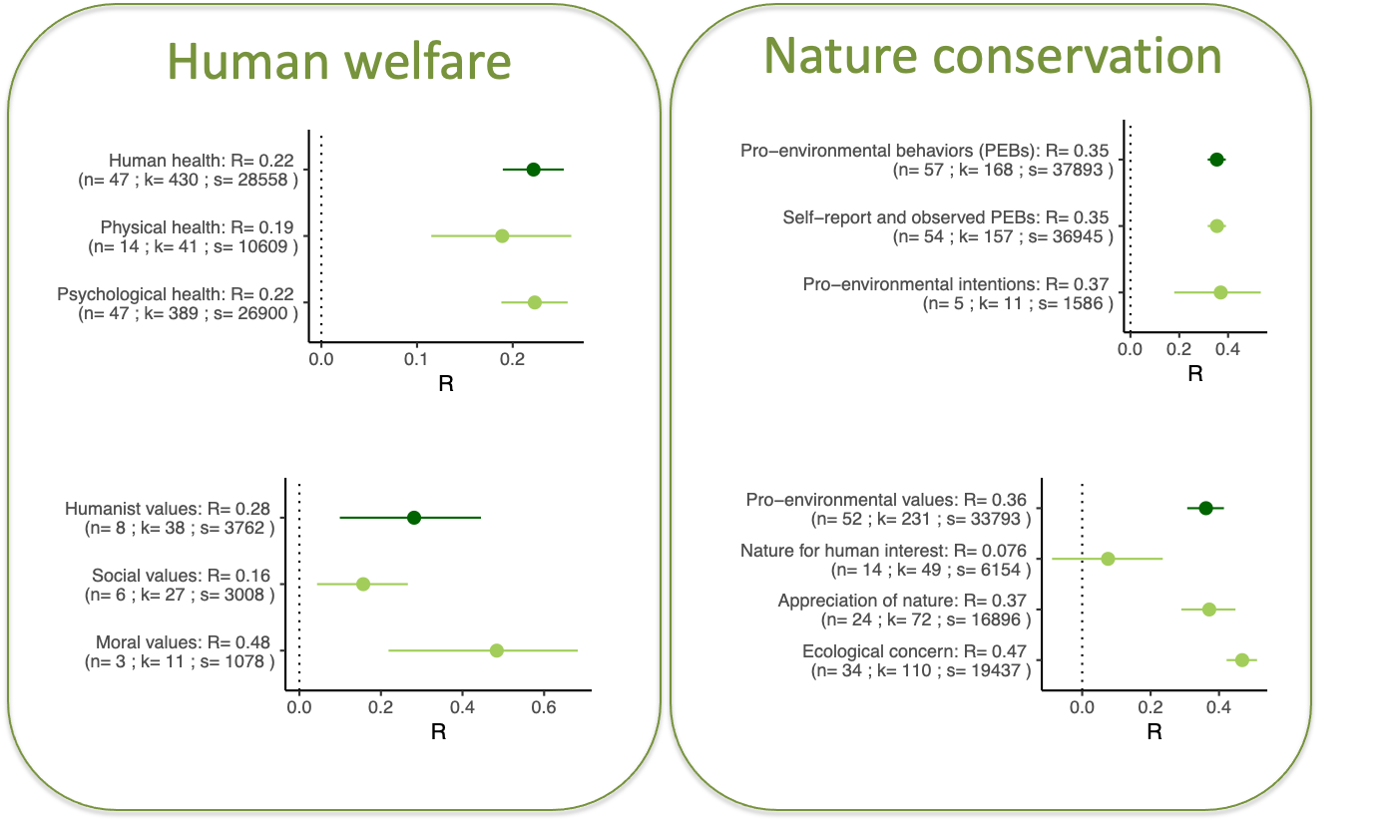
Figure 6. R estimates for each sub-category from human welfare (human health include physical and psychological health and humanist values include social and moral values) and nature conservation (pro-environmental behaviour (PEB) include observed and self-reported PEB and pro-environmental intentions while pro-environmental values include nature for human interest, appreciation of nature and ecological concern). Each round represents the R estimate for each factor with n, k and s referring to the number of individual papers, number of effect sizes and number of participants respectively. Horizontal lines indicate the 95% confidence intervals for each factor and cross the vertical dot lines when non-significant.

