Intestinal inflammation disrupts energy metabolism in layer pullets: Insights into energy partitioning and intestinal metabolomic profiling

Qiuyu Jiang¹, Bingjian Huang¹, Simiao Chen², Lihua Zhao¹, Zhibin Ban², Bingkun Zhang^{1,*}

¹ State Key Laboratory of Animal Nutrition and Feeding, College of Animal Science and Technology, China Agricultural University, Beijing, 100193, China.
² Laboratory of Animal Nutrition Metabolism, Jilin Academy of Agricultural Sciences, Gongzhuling, Jilin, 136100, China.

* Correspondence:
Bingkun Zhang
bingkunzhang@126.com

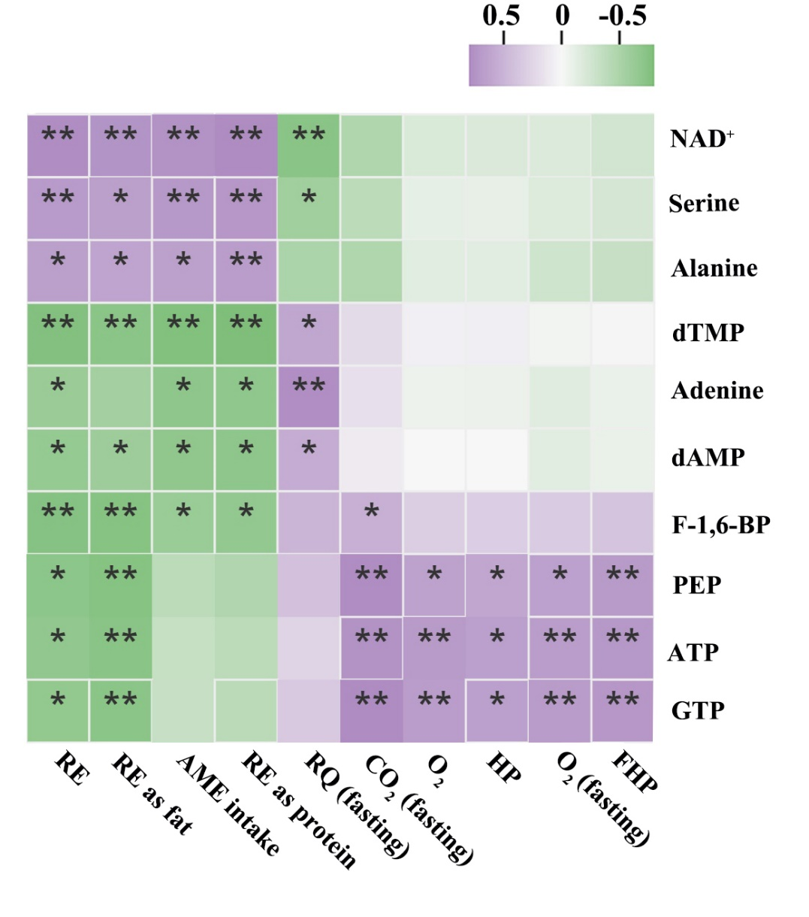
Fig. S1. Correlations between energy metabolites in ileal mucosa and whole-body energy homeostasis. Heatmap displays the pearson correlations filtered by criteria (r > 0.60 or < -0.60 and P < 0.05). The purple squares represent positive relationships (r > 0), and green squares indicate negative relationships (r < 0).

