Supplement 2

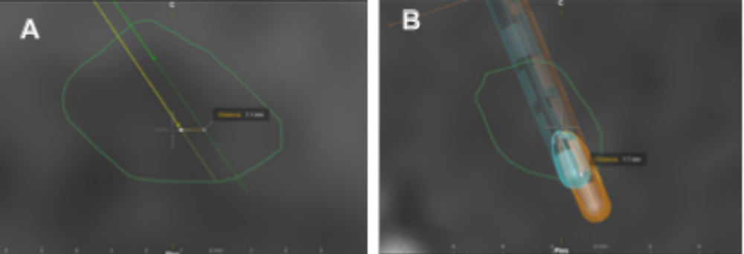

Supplementary Figure 1: A) Example of radial error measurement: the DBS electrode placement plan appears in green, and the actual implanted electrode in the brain is shown in yellow. A) Sagittal view of radial error measurement at the mid-level of the subthalamic nucleus (green line). We observe the anteroposterior or axial orientation of this error measurement. B) Example of vector error measurement. This is measured from the upper edge of the first contact of the planned electrode (blue) to the upper edge of the first contact of the implanted electrode (orange).
For each patient, the radiological errors of both implanted brain electrodes (right and left) were measured, and the average was determined for each variable (average radial and vector error per patient).

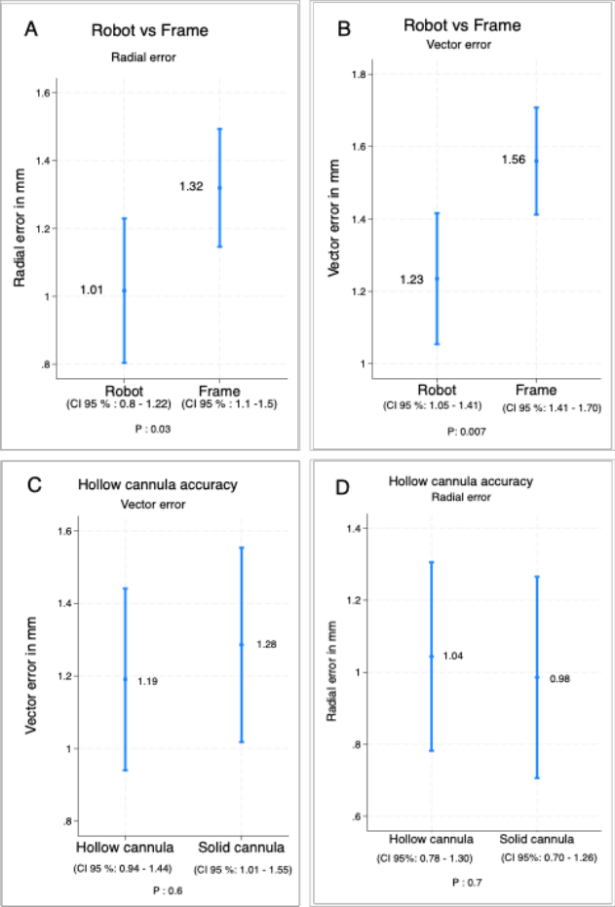

Supplementary Figure 2. A) and B) The radiological anatomical accuracy in DBS placement comparing the robotic arm vs. the stereotactic frame, while in C) and D), the accuracy of DBS placement using a hollow cannula vs. a solid cannula is shown. DBS: deep brain stimulation.

