Supplementary material

Solid-phase pyrolysis synthesis of nitrogen-doped carbon dots as logic-gate fluorescent probes for dual detection of Cu²⁺ and glutathione
Zhuoru Yao^{a, 1}, Cunjin Wang^{b}*^{,1}, Zixin Ma^{b}, Jing Zhang^{b}, Xiaoliang Zhao^{b}, Weijie Zhang^{b}, Huanxian Shi^{c}*

2.1. Chemical and materials
Cadmium chloride, L-cysteine (L-Cys), and zinc acetate were obtained from Kermel Chemical Reagent Co., Ltd. Copper chloride, ascorbic acid (AA), and 30% hydrogen peroxide (H₂O₂) were purchased from Tianjin Tianli Chemical Ltd. Glycine (Gly), dopamine hydrochloride (DA), and uric acid (UA) were acquired from Aladdin Reagent Shanghai Co., Ltd. Aspartic acid (L-Asp), L-phenylalanine (L-Phe), alanine (L-Ala), and L-lysine (L-Lys) were sourced from Kehao Bioengineering Co., Ltd. Folic acid (FA) was purchased from Shanghai IKA Biotechnology Co., Ltd. L-arginine (L-Arg) was obtained from leaf-derived organisms. Silver nitrate was supplied by Guangzhou Jinhuada Chemical Reagent Co., Ltd. Sodium chloride and barium chloride were provided by Tianjin Hengxing Chemical Reagent Manufacturing Co., Ltd. Potassium chloride was acquired from Tianjin Chemical Reagent III. Lead chloride and chromium nitrate were obtained from Tianjin Fuchen Chemical Reagent Factory. Manganese acetate was acquired from Tianjin Guangfu Fine Chemical Research Institute. Glutathione (Glu) was purchased from Shanghai Haohong Biomedical Technology Co., Ltd. Mercury chloride was obtained from Shanghai Chemical Reagent Purchasing Supply Station. Anhydrous calcium chloride was sourced from Hedong District Hongyan Reagent Factory. Ultrapure water was prepared using a Milli-Q system (Millipore, Bedford, MA, USA). All chemical reagents used in the experiments were of analytical grade and did not require further purification.

2.2. Instruments
The microstructure of N-L-Ser-CDs was examined using a transmission electron microscope (TEM, TF20, JEOL 2100F) operating at 200 kV. Photoluminescence (PL) lifetime measurements were conducted with an Edinburgh FLS 1000 spectrometer and F-7000 spectrofluorometer. Fluorescence spectra were analyzed using the F-7000 spectrofluorometer with excitation and emission slit widths set to 1 nm each. Fourier transform infrared (FTIR) spectra were obtained using a BRUKER VERTEX70 FT-IR spectrometer within the range of 4000-400 cm⁻¹, employing KBr pellets. X-ray diffraction (XRD) data were collected with a Rigaku D/MAX 3C powder diffractometer. UV-visible absorption spectra were recorded using a Shimadzu UV-3600 UV spectrophotometer. X-ray photoelectron spectroscopy (XPS) spectra were measured with a Kratos AXIS NOVA multifunction imaging electron spectrometer.

2.3. Fluorescence QY measurement
The fluorescence quantum yield (QY) of N-L-Ser-CDs was determined using a comparative method with quinine sulfate as the standard reference, as follows:
$φ_{x}=φ_{s}×\frac{{Grad}_{x}}{{Grad}_{s}}×\frac{{η_{x}}^{2}}{{η_{s}}^{2}}$. (1)
$Grad=\frac{I}{A}$ (2)
Quinine sulfate was dissolved in a 0.1 M sulfuric acid solution, with a quantum yield (QY) of 54%. In this context, $I$ represents the integral area of the fluorescence intensity, $η$ denotes the refractive index of the solvent, $φ$ is the quantum yield, and $A$ stands for the UV-visible absorbance. "$Grad$" refers to the slope obtained from the plot of integrated fluorescence intensity versus absorbance. The variables "$x$" and "$s$" denote the sample and the reference, respectively.

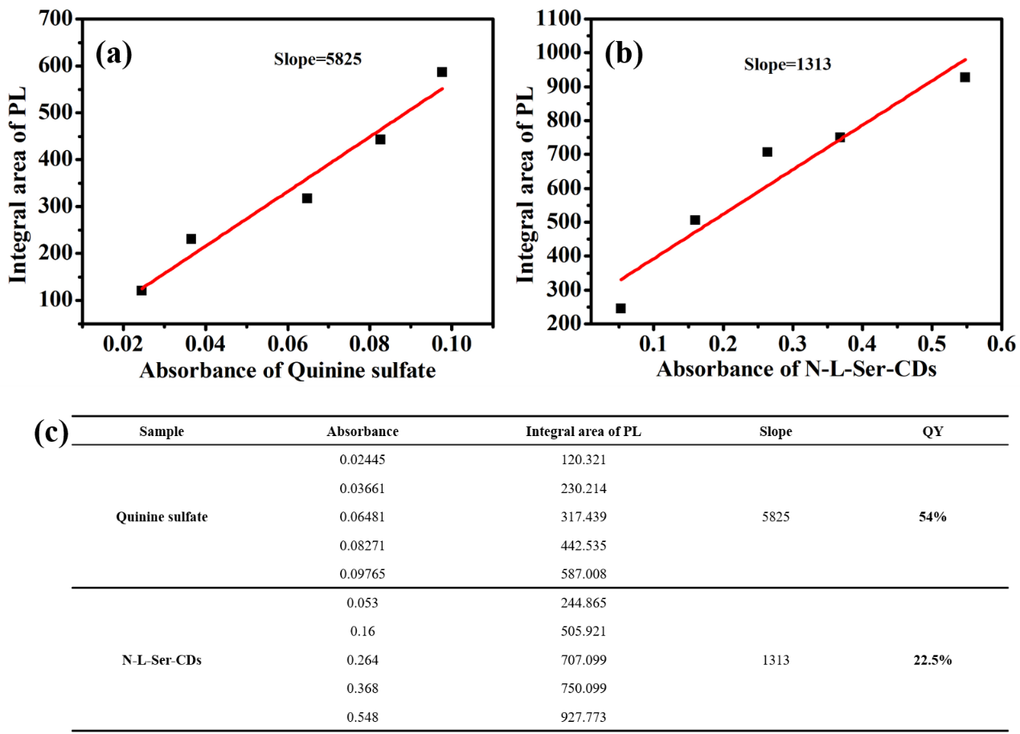
Fig. S1 The correlation between the fluorescence integral area and absorbance, and the corresponding data: (a) quinine sulfate, (b) N-L-Ser-CDs.

