Climate-driven variation in the phenology of juvenile Ixodes pacificus on lizard hosts

Samantha Sambado^{1*}, Amanda Sparkman², Andrea Swei³, Andrew J MacDonald⁴, Hillary S Young¹, Jordan Salomon⁵, Arielle Crews⁶, Kacie Ring¹, Stephanie Copeland¹, and Cheryl J Briggs¹

1. Ecology, Evolution & Marine Biology Department at University of California Santa Barbara, Santa Barbara, California, USA
2. Biology Department at Westmont College, Santa Barbara, California, USA
3. Biology Department at San Francisco State University, California, USA
4. Bren School of Environmental Science & Management at University of California Santa Barbara, California, USA
5. Ecology & Evolutionary Biology Program at Texas A&M University, College Station, Texas, USA
6. San Mateo County Mosquito and Vector Control, Burlingame, California, USA

*Correspondence: sbsambado@ucsb.edu

Supplementary information

TABLE OF CONTENTS
Additional file 1: Sampling location and frequency
Table S1. Location coordinates
Table S2. Location sample dates

Additional file 2: Location characteristics
Figure S1. Location sampling frequency
Figure S2. Lizards
Table S1. mean and sd per location

Additional file 3: Method details
Text S1. Additional details on Field methods
Text S2. Statistical method justifications
Figure S1. Covariate correlation and vif results

Additional file 4: Phenological metrics by climate regions
Figure S1. Distribution of juvenile burdens by CR3
Figure S2. Ticks per month and year by CR5
Table S1. Phenology metrics for all climate regions

Additional file 5: GAM results and diagnostics
Figure S1. GAM 1 results and diagnostics
Figure S2. GAM 2 results and diagnostics

ADDITIONAL FILE 1: Sampling location and frequency
Additional file 1: Table S1. Field sampling locations, including collector, geographic coordinates, and climate region (CR).
CR | Location | Collector | Latitude | Longitude
North Coast | McLaughlin | Sambado | 38.87289 | -122.43265
San Francisco Bay Area | Quail Ridge | Sambado | 38.48899 | -122.15171
San Francisco Bay Area | SLRP | Swei | 38.42810 | -122.62120
San Francisco Bay Area | SMI | Swei | 38.01881 | -122.57748
San Francisco Bay Area | CCSP | Swei | 38.00110 | -122.48930
San Francisco Bay Area | TIL | Swei | 37.89770 | -122.24520
San Francisco Bay Area | LFY | Swei | 37.87900 | -122.14240
San Francisco Bay Area | SLRP | Swei | 37.87900 | -122.14240
San Francisco Bay Area | PR | Swei | 37.61770 | -121.88970
San Francisco Bay Area | San Mateo | Sparkman | 37.55417 | -122.31306
San Francisco Bay Area | WDLP | Swei | 37.50610 | -122.30260
San Francisco Bay Area | PUG | Swei | 37.47870 | -122.29220
San Francisco Bay Area | FL | Swei | 37.47188 | -122.31080
San Francisco Bay Area | WH | Swei | 37.36250 | -122.23150
San Francisco Bay Area | HOS | Swei | 37.23260 | -121.92940
San Francisco Bay Area | WP | Swei | 37.22210 | -121.96650
San Francisco Bay Area | San Mateo | Sparkman | 37.16939 | -121.98051
San Francisco Bay Area | San Mateo | Sparkman | 37.16860 | -121.91160
Central Coast | Fort Ord | Sambado | 36.68491 | -121.77692
Central Coast | Hastings | Sambado | 36.38845 | -121.54774
Central Coast | Big Creek | Sambado | 36.07016 | -121.59829
Central Coast | Rancho Marino | Sambado | 35.53549 | -121.08241
Central Coast | San Luis Obispo | Sparkman | 35.31727 | -120.64722
Central Coast | San Luis Obispo | Sparkman | 35.30500 | -120.66250
San Joaquin Valley | Arid | Young | 35.02487 | -118.67928
San Joaquin Valley | Intermediate | Young | 34.97189 | -118.59146
San Joaquin Valley | Mesic | Young | 34.97189 | -118.58362
Central Coast | Sedgwick | Sambado | 34.69812 | -120.04715
Central Coast | Sedgwick Reserve | Sparkman | 34.69390 | -120.04170
Central Coast | Paradise Rd unburn | MacDonald | 34.55173 | -119.77865
Central Coast | Santa Barbara | Sparkman | 34.54694 | -119.69097
Central Coast | Santa Barbara | Sparkman | 34.47466 | -119.70511
Central Coast | Santa Barbara | Sparkman | 34.47110 | -119.68610
Central Coast | Santa Barbara | Sparkman | 34.45916 | -119.65430
Central Coast | Santa Barbara | Sparkman | 34.45083 | -119.67875
Central Coast | Santa Barbara | Sparkman | 34.44880 | -119.66100
Central Coast | Santa Barbara | Sparkman | 34.44388 | -119.59457
Central Coast | Santa Barbara | Sparkman | 34.42083 | -119.69819
Central Coast | Santa Barbara | Sparkman | 34.42080 | -119.69820
Central Coast | Coal Oil Point | Sambado | 34.41630 | -119.87790
Los Angeles | Santa Monica Mountains | Sparkman | 34.12030 | -118.93180
Los Angeles | Stunt Ranch | Sambado | 34.09381 | -118.65601
Los Angeles | Santa Cruz Island | Sparkman | 34.02320 | -119.76580
Los Angeles | Santa Cruz Island | Sambado | 34.00138 | -119.71451
Los Angeles | Santa Rosa Island | Sparkman | 33.97730 | -120.08960

Additional file 1: Table S2. The number of lizards sampled per location, year, and month. Climate regions (CR) area: NC = North Coast, SF = San Francisco Bay Area, CC = Central Coast, SJV = San Joaquin Valley, LA = Los Angeles.

Region | Location | Year | Feb. | March | April | May | June
NC | McLaughlin | 2021 | NA | NA | 6 | 4 | 2
SF | Quail Ridge | 2021 | NA | NA | 4 | 2 | 2
SF | SLRP | 2018 | NA | NA | 10 | NA | NA
SF | SMI | 2018 | NA | NA | 1 | NA | NA
SF | SMI | 2019 | NA | NA | 11 | 3 | NA
SF | CCSP | 2018 | NA | NA | 18 | NA | NA
SF | CCSP | 2019 | NA | NA | 16 | NA | NA
SF | TIL | 2019 | NA | NA | NA | 5 | NA
SF | LFY | 2018 | NA | NA | 15 | NA | NA
SF | LFY | 2019 | NA | NA | NA | NA | 16
SF | SLRP | 2019 | NA | NA | NA | 22 | NA
SF | PR | 2019 | NA | NA | NA | 5 | NA
SF | San Mateo | 2015 | NA | NA | NA | NA | 10
SF | San Mateo | 2016 | NA | NA | NA | 9 | NA
SF | San Mateo | 2017 | NA | NA | NA | 23 | 2
SF | San Mateo | 2018 | NA | NA | NA | 13 | 2
SF | San Mateo | 2019 | NA | NA | NA | 5 | NA
SF | San Mateo | 2021 | NA | NA | NA | 7 | NA
SF | San Mateo | 2022 | NA | NA | NA | 14 | NA
SF | WDLP | 2018 | NA | NA | 9 | NA | NA
SF | WDLP | 2019 | NA | NA | NA | 3 | NA
SF | PUG | 2019 | NA | NA | 15 | NA | NA
SF | FL | 2018 | NA | NA | 4 | NA | NA
SF | FL | 2019 | NA | NA | NA | 3 | NA
SF | WH | 2018 | NA | NA | 15 | NA | NA
SF | WH | 2019 | NA | NA | 17 | NA | NA
SF | HOS | 2018 | NA | NA | NA | 17 | NA
SF | HOS | 2019 | NA | NA | 17 | NA | NA
SF | WP | 2018 | NA | NA | NA | 16 | NA
SF | WP | 2019 | NA | NA | 15 | NA | NA
SF | San Mateo | 2018 | NA | NA | NA | 1 | NA
SF | San Mateo | 2018 | NA | NA | NA | 1 | NA
CC | Fort Ord | 2021 | NA | NA | 2 | 15 | 15
CC | Hastings | 2021 | NA | NA | 7 | 15 | 15
CC | Big Creek | 2021 | NA | NA | 12 | 15 | 15
CC | Rancho Marino | 2021 | NA | NA | 15 | 15 | 15
CC | San Luis Obispo | 2019 | NA | NA | NA | 10 | NA
CC | San Luis Obispo | 2019 | NA | NA | NA | 11 | NA
SJ | Arid | 2018 | NA | NA | 33 | NA | NA
SJ | Intermediate | 2018 | NA | NA | NA | 62 | NA
SJ | Mesic | 2018 | NA | NA | NA | 2 | NA
CC | Sedgwick | 2021 | NA | 8 | 9 | 8 | 12
CC | Sedgwick Reserve | 2021 | NA | 4 | NA | 3 | NA
CC | Sedgwick Reserve | 2022 | NA | NA | 2 | NA | NA
CC | Paradise Rd unburn | 2014 | 11 | 13 | 25 | 10 | NA
CC | Santa Barbara | 2019 | NA | NA | NA | 2 | NA
CC | Santa Barbara | 2019 | NA | NA | NA | NA | 13
CC | Santa Barbara | 2021 | NA | NA | NA | NA | 8
CC | Santa Barbara | 2022 | NA | NA | NA | NA | 1
CC | Santa Barbara | 2018 | NA | NA | NA | 23 | NA
CC | Santa Barbara | 2019 | NA | NA | NA | 6 | 11
CC | Santa Barbara | 2021 | NA | NA | NA | NA | 7
CC | Santa Barbara | 2022 | NA | NA | NA | NA | 3
CC | Santa Barbara | 2022 | NA | NA | NA | NA | 2
CC | Santa Barbara | 2019 | NA | NA | NA | 13 | NA
CC | Santa Barbara | 2022 | NA | NA | NA | NA | 2
CC | Santa Barbara | 2019 | NA | NA | NA | 34 | 9
CC | Santa Barbara | 2021 | NA | NA | NA | 7 | 12
CC | Santa Barbara | 2021 | NA | NA | NA | NA | 1
CC | Santa Barbara | 2022 | NA | NA | NA | NA | 2
CC | Santa Barbara | 2014 | NA | NA | 3 | 1 | NA
CC | Santa Barbara | 2016 | NA | 1 | NA | NA | NA
CC | Santa Barbara | 2018 | NA | 2 | NA | 3 | NA
CC | Santa Barbara | 2019 | NA | NA | NA | 9 | 1
CC | Santa Barbara | 2021 | NA | NA | NA | 1 | 1
CC | Coal Oil Point | 2021 | NA | 1 | 1 | 8 | 2
LA | Santa Monica Mts. | 2014 | NA | NA | NA | 6 | NA
LA | Santa Monica Mts. | 2017 | NA | NA | NA | 1 | NA
LA | Stunt Ranch | 2021 | NA | 9 | 15 | 12 | 15
LA | Santa Cruz Island | 2013 | NA | NA | NA | NA | 4
LA | Santa Cruz Island | 2014 | NA | NA | NA | 8 | 13
LA | Santa Cruz Island | 2015 | NA | 28 | NA | 17 | NA
LA | Santa Cruz Island | 2016 | NA | 26 | NA | 43 | NA
LA | Santa Cruz Island | 2017 | NA | 4 | NA | 66 | NA
LA | Santa Cruz Island | 2018 | NA | 15 | NA | 17 | 4
LA | Santa Cruz Island | 2019 | NA | 44 | NA | 29 | NA
LA | Santa Cruz Island | 2021 | NA | 11 | NA | 14 | NA
LA | Santa Cruz Island | 2022 | NA | 6 | NA | 6 | NA
LA | Santa Cruz Island | 2021 | NA | NA | 3 | 8 | 9
LA | Santa Rosa Island | 2015 | NA | NA | NA | 16 | NA
LA | Santa Rosa Island | 2016 | NA | NA | 20 | 5 | NA
LA | Santa Rosa Island | 2018 | NA | 2 | NA | NA | NA
LA | Santa Rosa Island | 2019 | NA | 8 | 3 | NA | NA
LA | Santa Rosa Island | 2021 | NA | 23 | NA | 34 | NA
LA | Santa Rosa Island | 2022 | NA | 28 | NA | 22 | NA

ADDITIONAL FILE 2: Location characteristics
Additional file 2: Figure S1. Bar graph displaying the frequency of visits to various locations, colored by climatic region and arranged from northern to southern latitude. The black dashed line indicates locations that were visited at least three times. 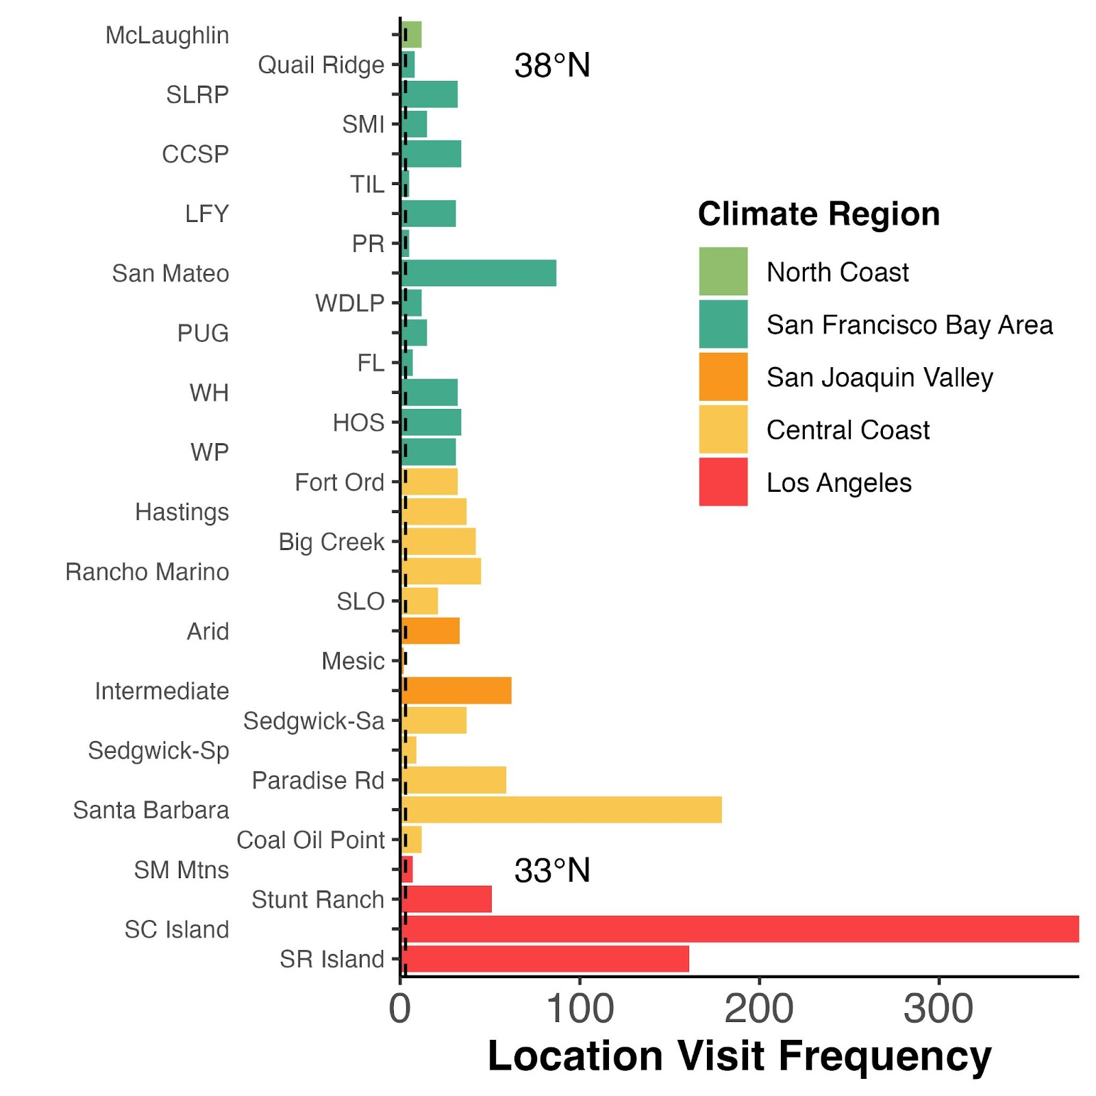

Additional file 2: Figure S2. Box plots illustrating the number of lizards sampled at each location during individual sampling dates. The colors of the box plots correspond to different climatic regions.

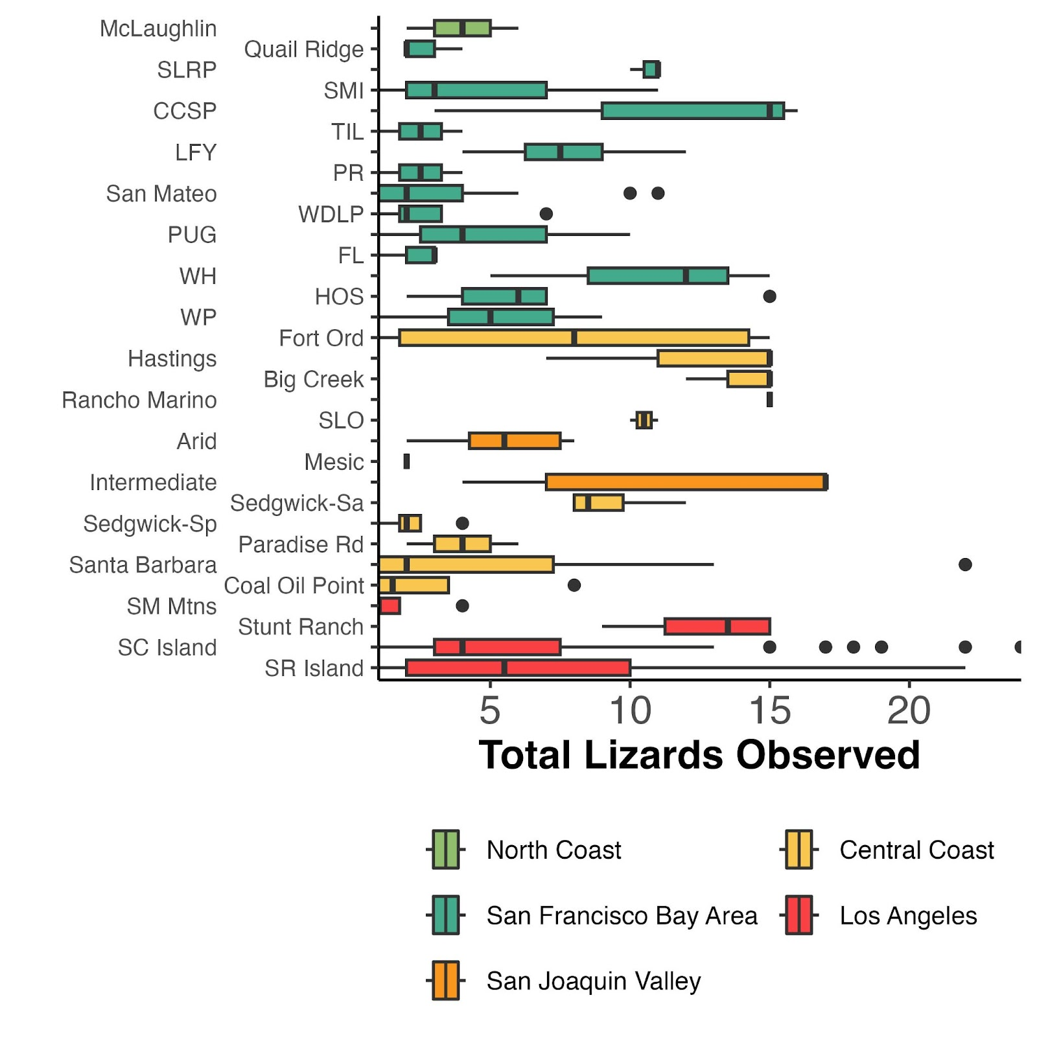

Additional file 2: Table S1. Mean and standard deviation (sd) of abundance for all ticks, larval ticks, and nymphal ticks per individual lizard, per location.

LOCATION | TOTAL TICKS |  | LARVAE |  | NYMPHS
 | Mean | SD | Mean | SD | Mean | SD
McLaughlin | 6.833 | 6.394 | 2.583 | 3.579 | 4.25 | 5.61
Quail Ridge | 11 | 9.258 | 3.75 | 2.866 | 7.125 | 7.06
SLRP | 30.9 | 30.113 | 17.8 | 31.538 | 12.7 | 8.028
SMI | 7.8 | 7.58 | 0.467 | 0.516 | 7.333 | 7.761
CCSP | 47.206 | 33.462 | 25.324 | 27.377 | 21.882 | 13.137
TIL | 31.4 | 26.605 | 21 | 25.328 | 10.4 | 5.595
LFY | 11.774 | 9.014 | 8.871 | 7.877 | 2.903 | 2.534
SLRP | 15.591 | 12.339 | 7.636 | 9.801 | 7.955 | 6.137
PR | 5.4 | 0.894 | 4.6 | 1.342 | 0.8 | 0.447
San Mateo | 7.741 | 8.156 | NA | NA | NA | NA
WDLP | 19.75 | 15.662 | 11.417 | 12.288 | 8.333 | 5.71
PUG | 4.333 | 7.49 | 2.6 | 6.367 | 1.733 | 2.086
FL | 29.714 | 19.872 | 22.714 | 18.09 | 7 | 5.292
WH | 30.062 | 26.109 | 12.906 | 16.528 | 17.156 | 14.065
HOS | 32.559 | 30.348 | 23.059 | 25.943 | 9.5 | 7.867
WP | 4.645 | 4.765 | 3.194 | 3.728 | 1.452 | 1.69
San Mateo | 5 | NA | NA | NA | NA | NA
San Mateo | 5 | NA | NA | NA | NA | NA
Fort Ord | 8 | 9.449 | 6.281 | 7.924 | 1.719 | 2.02
Hastings | 4.919 | 8.2 | 2.703 | 5.821 | 2.216 | 3.065
Big Creek | 1.643 | 2.151 | 0.619 | 1.011 | 1.048 | 1.652
Rancho Marino | 12.2 | 11.565 | 5.333 | 7.173 | 6.867 | 5.983
San Luis Obispo | 5.8 | 4.315 | NA | NA | NA | NA
San Luis Obispo | 0.455 | 0.688 | NA | NA | NA | NA
Arid | 0.545 | 1.46 | NA | NA | NA | NA
Intermediate | 1.113 | 2.025 | NA | NA | NA | NA
Mesic | 1 | 1.414 | NA | NA | NA | NA
Sedgwick | 4.405 | 5.166 | 1.622 | 3.277 | 2.784 | 3.787
Sedgwick Reserve | 3.111 | 4.137 | NA | NA | NA | NA
Paradise Rd unburn | 4.932 | 4.164 | 4.034 | 3.429 | 0.898 | 1.078
Santa Barbara | 5.5 | 2.121 | NA | NA | NA | NA
Santa Barbara | 0.636 | 0.902 | NA | NA | NA | NA
Santa Barbara | 1.4 | 2.185 | NA | NA | NA | NA
Santa Barbara | 1 | 0 | NA | NA | NA | NA
Santa Barbara | 1.8 | 2.541 | NA | NA | NA | NA
Santa Barbara | 0 | 0 | NA | NA | NA | NA
Santa Barbara | 1 | NA | NA | NA | NA | NA
Santa Barbara | 1 | 0 | NA | NA | NA | NA
Santa Barbara | 2.696 | 4.527 | NA | NA | NA | NA
Coal Oil Point | 0.167 | 0.389 | 0 | 0 | 0.167 | 0.389
Santa Monica Mnts | 3.714 | 2.628 | NA | NA | NA | NA
Stunt Ranch | 1.627 | 2.039 | 0.353 | 0.996 | 1.275 | 1.65
Santa Cruz Island | 2.109 | 4.806 | NA | NA | NA | NA
Santa Cruz Island | 1.45 | 2.089 | 0.25 | 0.55 | 1.2 | 1.963
Santa Rosa Island | 0.497 | 1.848 | NA | NA | NA | NA

ADDITIONAL FILE 3: Method details
Additional file 3: Text S1. Additional details on field methods
For Sambado data:
Lizard surveys began after 11:00 AM at each plot. Western fence lizards (Sceloporus
occidentalis) were captured using a 0.5 m fishing pole with a dental floss lasso at the tip (1). Each plot was surveyed for a duration of twenty minutes. When a lizard was captured, the timer was paused and resumed upon the lizard’s release at the capture site. Tick burdens were assessed on the ears and nuchal pouches. To prevent double sampling of individuals within a month, white-out paint was applied to the lizard's back. Each month, the paint was applied to a specific body part to denote new collections: March - head, April - neck, May - midback, and June - tail. If no lizards were observed during the 20-minute survey, additional searching was conducted off the plot in areas with more suitable habitat (e.g., fallen logs, exposed rocks, near cover boards) for another 10 minutes within a 100 m radius.

For Sparkman data:
Western fence lizards (Sceloporus occidentalis), southern alligator lizards (Elgaria multicarinata), and side-blotched lizards (Uta stansburiana) were captured using crappie fishing poles with a lasso finishing line at the tip, from under cover boards, or by hand. Upon capture, each lizard was examined for tick burdens on the ears and nuchal pouches. Lizards were permanently marked with a micro-brand, or temporarily marked with a small dot of nail polish on the ventral portion of the trail to ensure individuals were not sampled twice.

For Swei data:
Lizards were located by visual surveys along transect lines within the 0.5-ha sampling grid totaling 495 m at each site. Encounters included for this study were western-fence lizards (Sceloporus occidentalis), and southern alligator lizards (Elgaria multicarinata). Slip-noosing, a standard herpetological procedure, was used to sample lizards for attached ticks. All attached ticks were removed with fine-tipped forceps and placed into 70% ethanol. Each animal was individually marked allowing for abundance assessment before they were released at the point of capture. Later in lab, all recovered ticks were counted, identified to species and life stage under a stereomicroscope.

For MacDonald data:
Western fence lizards (Sceloporus occidentalis) are important hosts for immature I. pacificus (2). They are also non-competent hosts for B. burgdorferi s.s. in California, because they cleanse ticks of infection with the pathogen (3). Sceloporus occidentalis abundance was estimated using a “sight–re-sight” protocol in which five of the ten transects of each of the six trapping grids were surveyed for S. occidentalis between mid-March and mid-May, 2014. Sceloporus occidentalis were marked with a diluted latex paint mixture using a tree-marking gun (1). Three different colors of paint were used, one for each of three consecutive days to determine encounter history (1). Sceloporus occidentalis were also captured using nooses at each of the six sites between early March and early May 2014 in order to estimate tick burdens. Data from fire plots were omitted from analysis. Data from burned plots were excluded from this study.

For Young data:
Western fence lizard populations were surveyed using a mark-recapture approach at all plots in July of 2016 and in June of 2017 & 2018. This timing encompasses the decline from peak I. pacificus juvenile tick questing activity in this region that typically occurs from April through mid-June (4). At each plot, lizards were surveyed along six, fifty-meter, evenly spaced transect lines, ten-meters apart. Sighted lizards were sprayed on their dorsum with dilated latex paint mixture using an Idico hand tree-marking gun (Idico Products Co., Miami, FL, USA), enabling the marking of lizards from five to ten meters away. This marking was temporary, lasting only until the lizard's next molt (1). Surveying occurred in each plot on three consecutive days between 10 am and 4 pm in warm weather with limited wind or cloud cover, using a different paint color each day to determine a lizard’s encounter history.

In June of 2018 and 2019 any sighted lizards within the plots were captured, if possible, using a fishing pole with a fishing line-constructed noose at its end. Captured lizards were weighed, measured (snout to vent and snout to tail), and sexed. Any ticks found on the animal were removed with sterile tweezers and placed in 70% ethanol. On the lizard, the area where the tick(s) were removed was wiped down with an ethanol wipe to clean and prevent infection. In 2018 plots were searched for 60 minutes and in 2019 plots were searched for 120 minutes.

References

- Swei, A., R. S. Ostfeld, R. S. Lane, and C. J. Briggs. 2011. Impact of the experimental removal of lizards on Lyme disease risk. Proceedings of the Royal Society B: Biological Sciences 278:2970–2978.

- Casher, L., R. Lane, R. Barrett, and L. Eisen. 2002. Relative importance of lizards and mammals as hosts for Ixodid ticks in northern California. Experimental & Applied Acarology 26:127–143.

- Lane, R. S., and G. B. Quistad. 1998. Borreliacidal factor in the blood of the western fence lizard (Sceloporus occidentalis). The Journal of Parasitology 84:29–34.

- MacDonald, A. J. 2018. Abiotic and habitat drivers of tick vector abundance, diversity, phenology and human encounter risk in southern California. PLOS ONE 13:e0201665.

Additional file 3: Supplemental Text 2. Statistical Methods justifications
Although many climate metrics may influence our outcome of juvenile tick abundances per lizard, we want to avoid multicollinearity in our generalized additive models (GAM). To find the best fit GAM, we explored the construction of many different versions including primary climate variables (near-surface specific humidity (sph; kg/kg), maximum temperature (tmmx; °C), and minimum temperature (tmmn; °C)) or derived climate variables (drought index (pdsi)) or seasonal climate averages (mean maximum and minimum temperature in each season (spring, summer, fall, winter)) or cumulative degree days (CDD) for each year and location from January 1st to March 31st. After many model iterations, we decided the best fit GAM that balanced biological hypotheses and simplicity included the terms: monthly maximum temperature, monthly specific humidity, and monthly drought index (pdsi). We evaluated the multicollinearity of these predictors in all models using the `car` package which produced vif < 2 (as seen in the code screen shot).
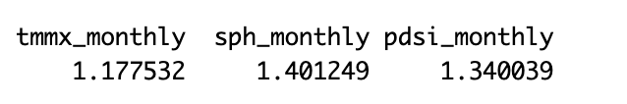
Additional file 3: Supplemental Figure 1. Correlation plot displaying the relationship between numeric values in the dataset. The correlation coefficient (Corr = ⍴) indicates the strength and direction of the relationship, with a perfect positive correlation of 1 shown in red and a perfect negative relationship of -1 shown in blue. 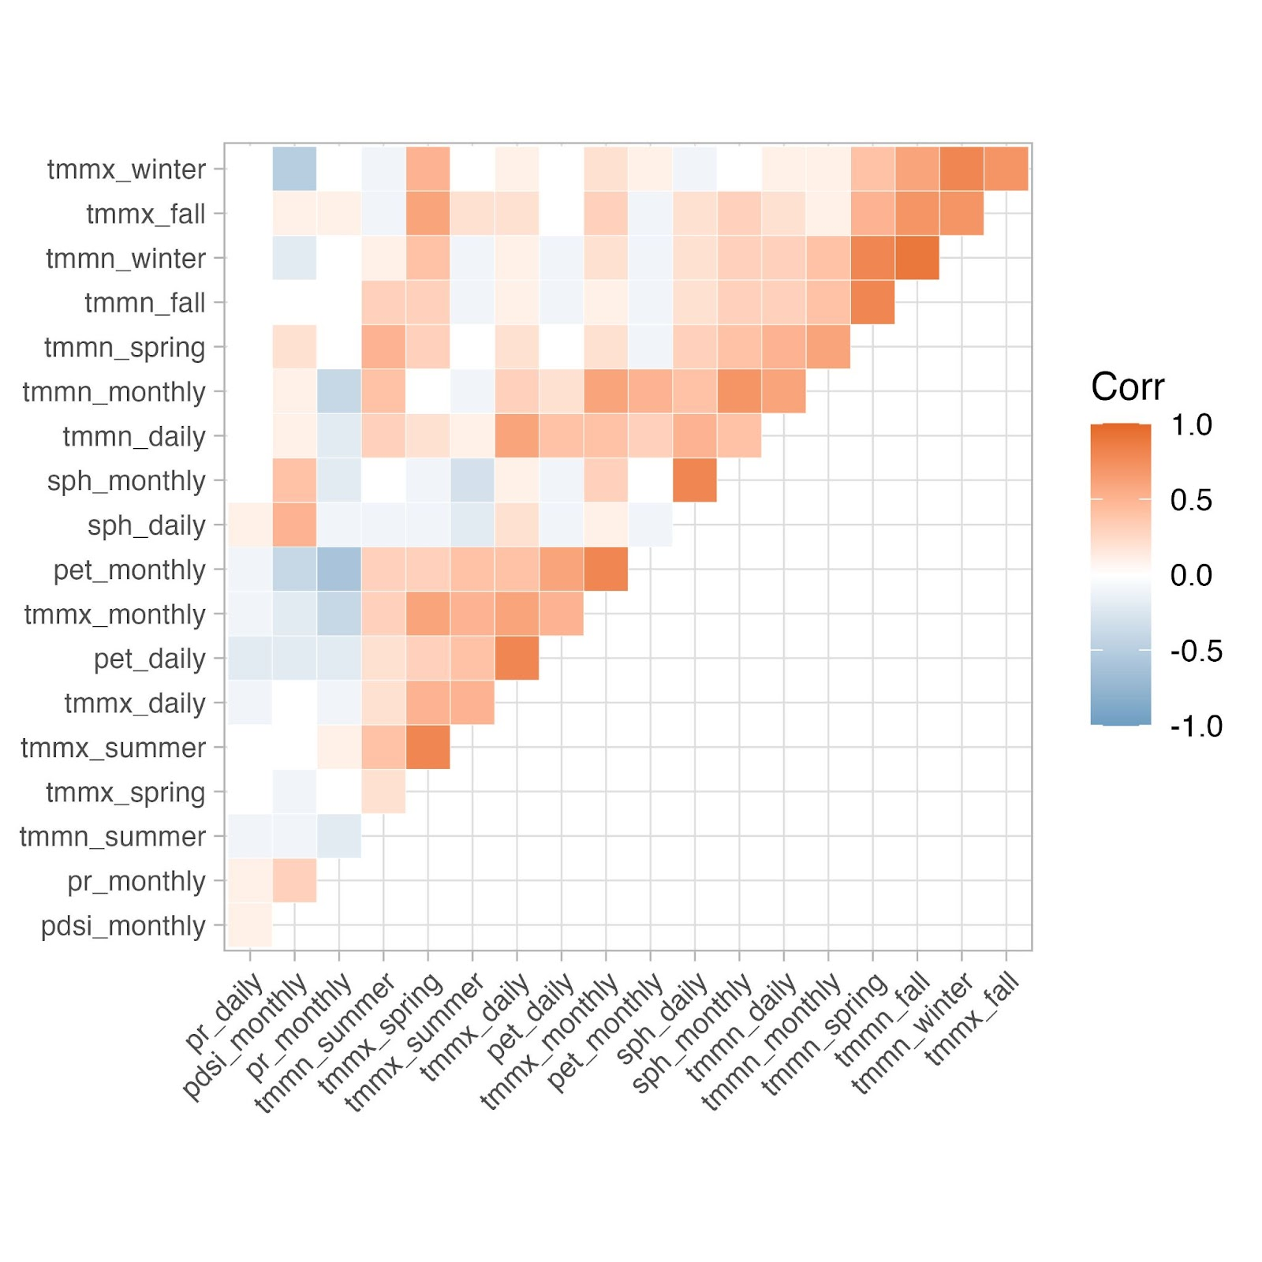

ADDITIONAL FILE 4: Phenological metrics by climate regions
Additional file 4: Figure S1. Histogram showing the distribution of mean abundances of (A) larvae and (B) nymphs on individual lizards by climate regions.

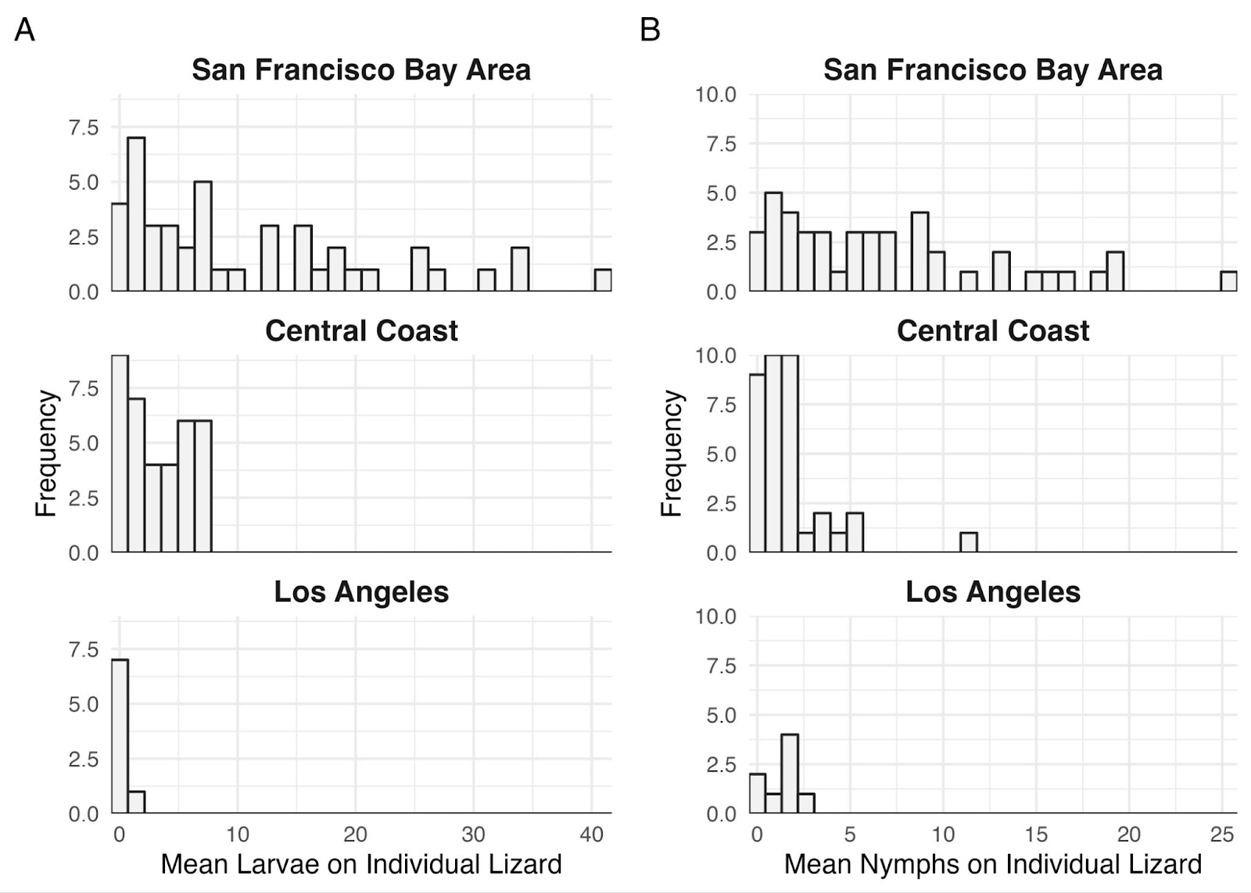

Additional file 4: Figure S2. Box plots illustrating the abundance of juvenile ticks on individual lizards, by month and year. Points are colored-coded by climatic region.
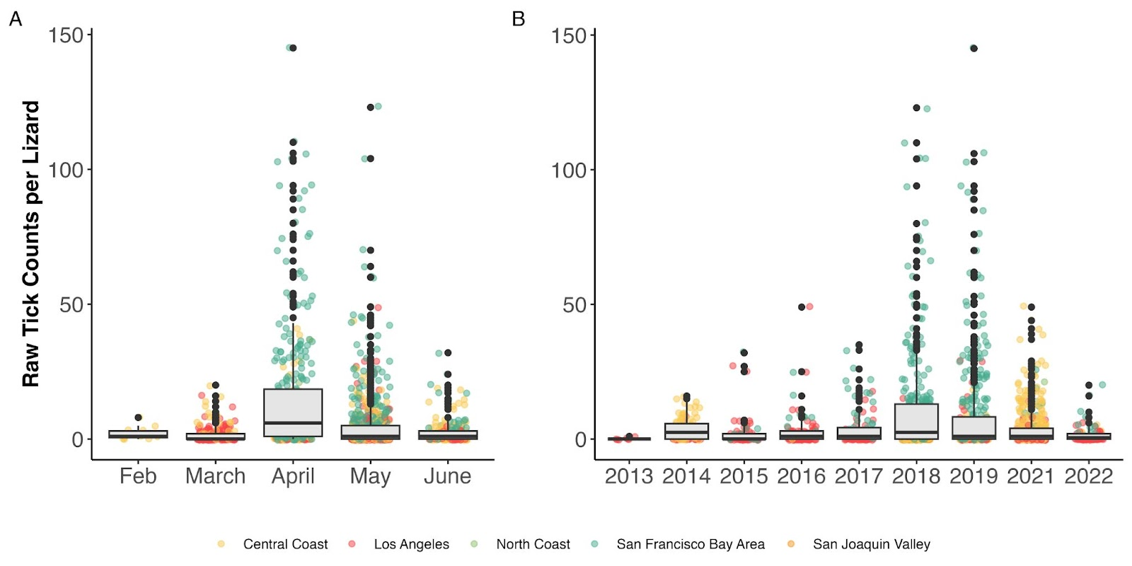

Additional file 4: Table S1. Phenological metrics for larvae, nymphs, and total ticks (larvae and nymphs) for all climate regions. KDE = kernel density estimation. Climate regions (CR) are: NC = North Coast, SF = San Francisco Bay Area, CC = Central Coast, SJV = San Joaquin Valley, LA = Los Angeles.

 |  | NC | SF | SJV | CC | LA
Abundance  (mean± sd) | Larvae | 2.58 ± 3.58 | 12.6 ± 19.1 | NA | 3.32 ± 5.5 | 0.32 ± 0.9
Abundance  (mean± sd) | Nymphs | 4.25 ± 5.61 | 9.39 ± 10.7 | NA | 2.56 ± 3.9 | 1.25 ± 1.7
 | Total | 6.83 ± 6.39 | 18.40 ± 23.07 | 0.92 ± 1.85 | 3.84 ± 6.62 | 1.64 ± 4.0
Overlap Metrics | KDE | 0.42 | 0.89 | NA | 0.32 | 0.30
Overlap Metrics | Jaccard Index | 0.55 | 0.47 | NA | 0.38 | 0.22
Peak Mean Burden  (Julian date) | Larvae | 97 | 144 | NA | 101 | 104
Peak Mean Burden  (Julian date) | Nymphs | 97 | 119 | NA | 101 | 104
 | Total | 97 | 110 | 110 | 101 | 131
Phenological Dates  (Julian date) | Start date
Phenological Dates  (Julian date) | Larvae | 97 | 94 | NA | 63 | 83
Phenological Dates  (Julian date) | Nymphs | 97 | 94 | NA | 63 | 83
Phenological Dates  (Julian date) | Total | 97 | 94 | 110 | 63 | 63
Phenological Dates  (Julian date) | End date
Phenological Dates  (Julian date) | Larvae | 125 | 156 | NA | 160 | 164
Phenological Dates  (Julian date) | Nymphs | 153 | 156 | NA | 160 | 164
Phenological Dates  (Julian date) | Total | 153 | 173 | 135 | 174 | 176
Phenological Dates  (Julian date) | Length of season
Phenological Dates  (Julian date) | Larvae | 28 | 62 | NA | 97 | 81
Phenological Dates  (Julian date) | Nymphs | 56 | 62 | NA | 97 | 81
Phenological Dates  (Julian date) | Total | 56 | 79 | 25 | 111 | 113

ADDITIONAL FILE 5: GAM model results and diagnostics
Additional file 5: Figure S1. GAM model results and diagnostics for larval abundance per lizard. The autocorrelation smoothing spline s(lat, lon) was unable to converge so this model does not correct for autocorrelation, but still includes the smooth terms for primary climate variables.
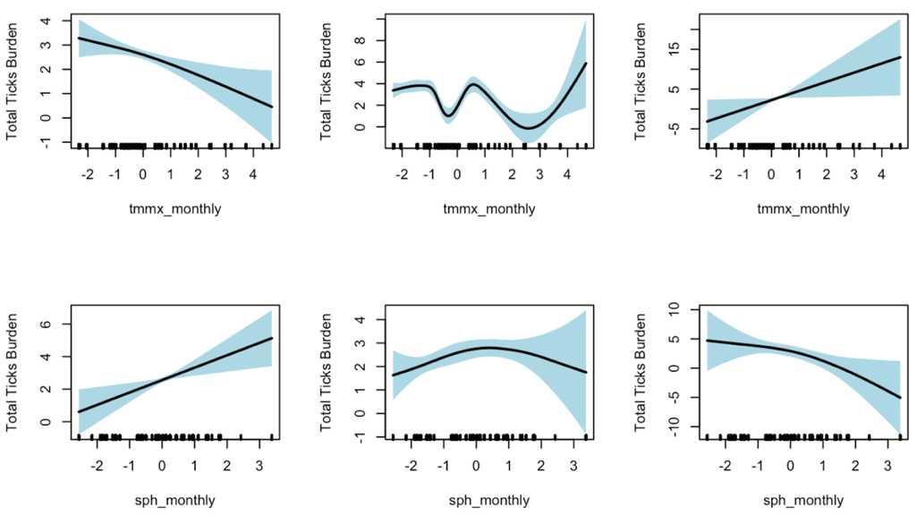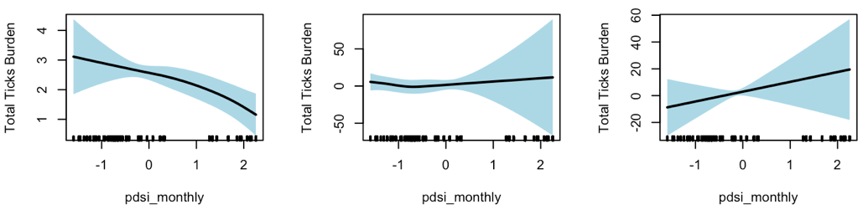

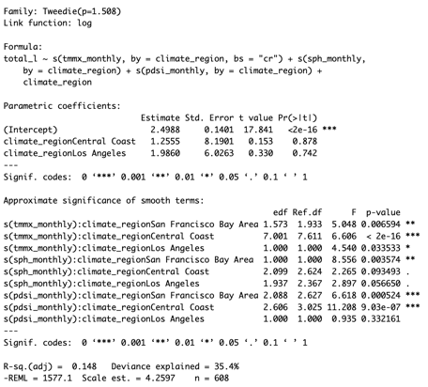
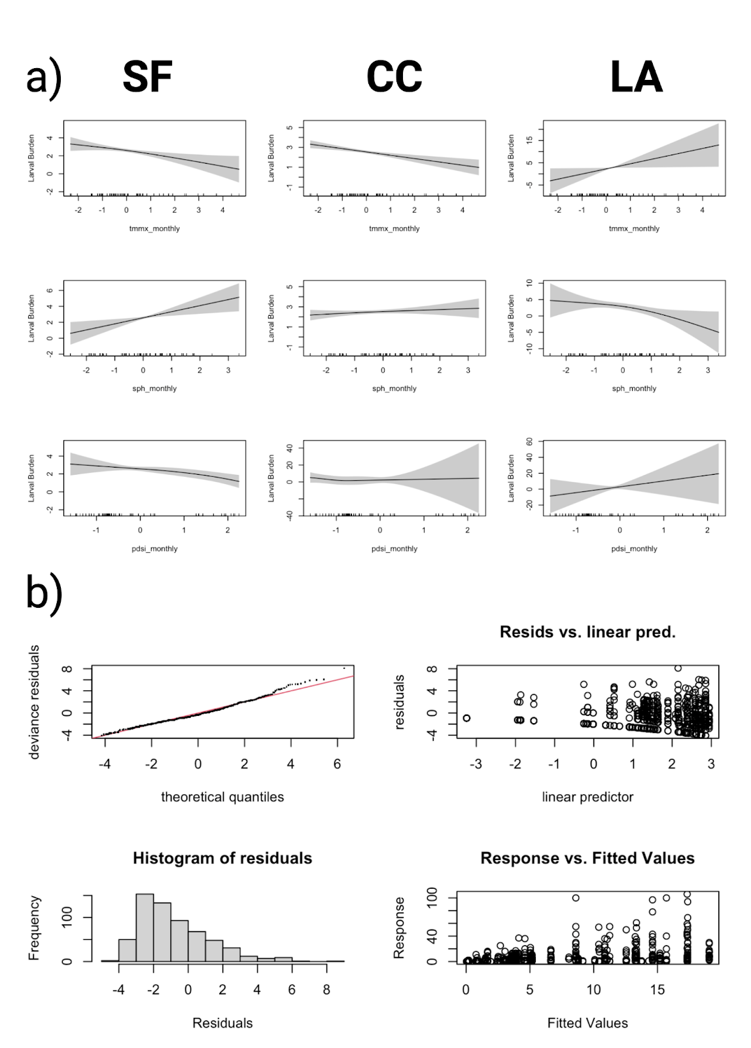
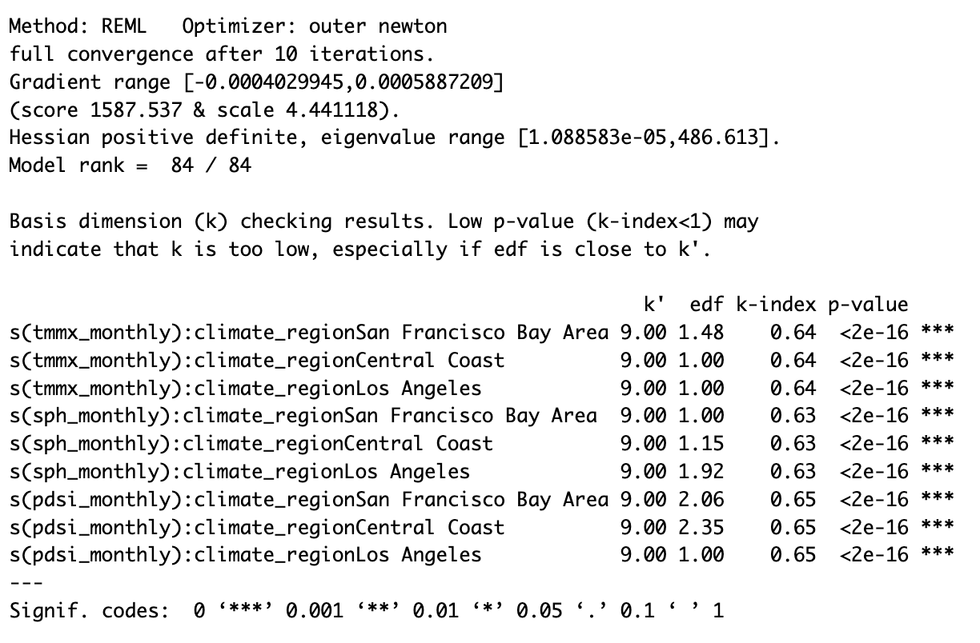

Additional file 5: Figure S2. GAM model results and diagnostics for nymphal abundance per lizard. The autocorrelation smoothing spline s(lat, lon) was unable to converge so this model does not correct for autocorrelation, but still includes the smooth terms for primary climate variables.
