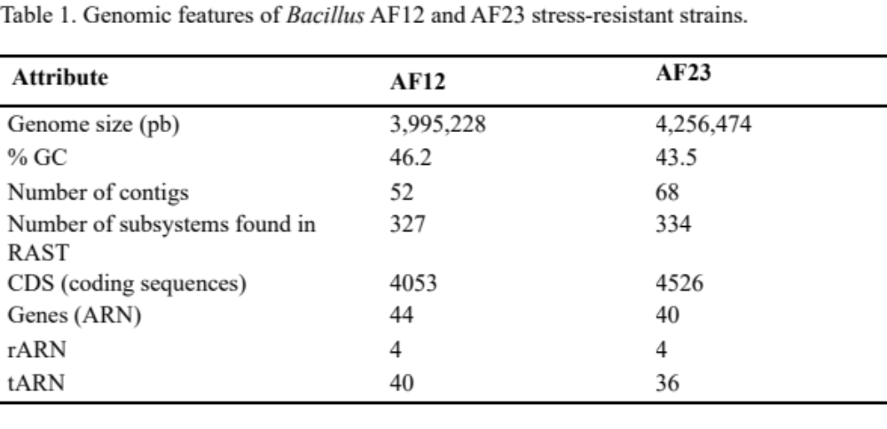
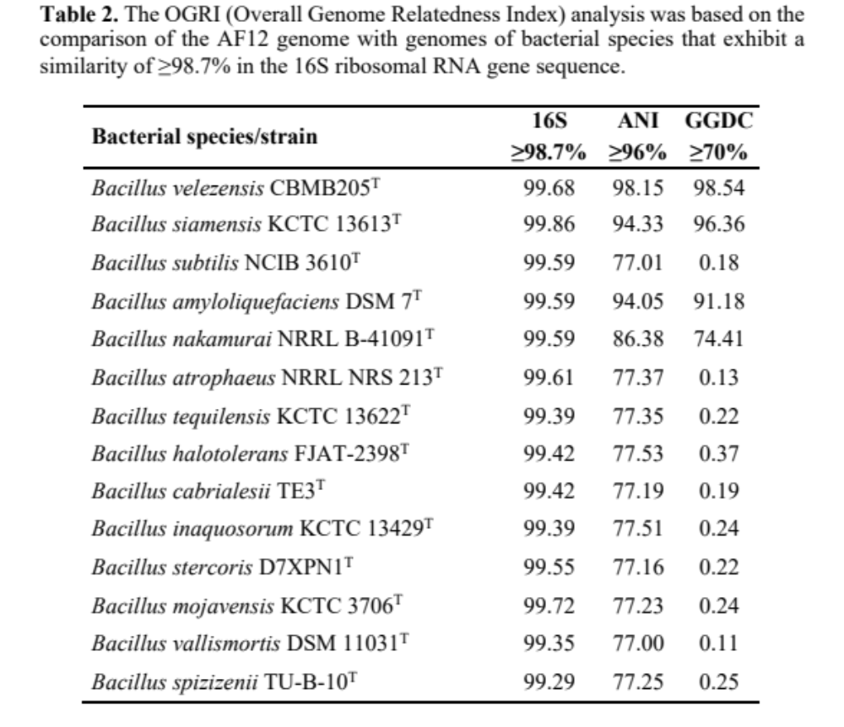

Table 3. The OGRI (Overall Genome Relatedness Index) analysis was based on the comparison of the AF23 genome with genomes of bacterial species that exhibit a similarity of ≥98.7% in the 16S ribosomal RNA gene sequence.

Cepa | 16S | ANI | GGDC
Cepa | ≥98.7% | ≥96% | ≥ 70%
Bacillus halotolerans FJAT-2398^{T} | 100% | 98.9 | 97.92
Bacillus mojavensis KCTC 3706^{T} | 99.91 | 98.9 | 94.91
Bacillus tequilensis KCTC 13622^{T} | 99.73 | 87.27 | 68.14
Bacillus cabrialesii T3^{T} | 99.73 | 87.62 | 89.84
Bacillus inaquosorum KCTC 13429^{T} | 99.73 | 88.23 | 86.05
Bacillus stercoris D7XPN^{T} | 99.7 | 86.94 | 88.79
Bacillus spizizenii TU-B-10^{T} | 99.74 | 88.07 | 86.59
Bacillus nakamurai NRRL B-41091^{T} | 99.66 | 77.6 | 0.21
Bacillus subtilis NCIB 3610^{T} | 99.52 | 87.48 | 89.9
Bacillus vallismortis DSM 11031^{T} | 99.42 | 87.1 | 69.94
Bacillus velezensis CBMB205 | 99.35 | 77.27 | 0.19
Bacillus siamensis KCTC 13613^{T} | 99.39 | 77.33 | 0.18
Bacillus atrophaeus NRRL NRS 213^{T} | 99.29 | 88.48 | 7.45
Bacillus amyloliquefaciens DSM 7^{T} | 99.25 | 77.1 | 0.15
Bacillus glycinifermentans GO-13^{T} | 98.71 | 72.95 | 0

