SUPPLEMENTAL RESULTS
Computational Complexity Analysis
We analyzed the required computational resources to perform MSC and other benchmark methods (CIDR, SC3 and SNN at multiple resolutions (γ=0.4, 0.8 and 1.2) for Louvain clustering) on different single-cell transcriptome data with varying numbers of cells.
We curated a set of publicly available scRNA-seq data whose sizes vary from small sized cohorts (< 10,000 cells) to atlas-sized cohorts (> 100,000 cells) to evaluate how the required computational resources scale with data sizes. These include PBMC of healthy donors from 10x Genomics (PBMC 3k: 2,700 cells, PBMC 8k: 8,364 cells), melanoma tumors (Jerby Arnon et al. 2018: 7,186 cells from metastatic melanoma)(1), PBMCs of influenza, COVID-19 infected and healthy controls (Lee et al. 2020: 62,301 cells)(2), and breast tumors (Wu et al. 2021: 92,232 cells)(3) and human colon cancer atlas (HCCA; 333,212 cells)(4) (see Methods for data processing details).
While MSC is flexible to handle different similarity and dissimilarity measures, we selected the Euclidean distances by the principal components to objectively compare the runtimes and required memories for different clustering methods, especially for those dependent on Euclidean distances. We used the first 30 principal components (PCs) for the smaller data sets (PBMC 3k, PBMC 8k, Jerby Arnon et al. 2018 and Lee et al. 2020), and 50 PCs for the larger data sets (Wu et al. 2021, HCCA) to commensurate with the increasing number of cell populations for the larger data.
We tested different methods on high performance computing (HPC) units with 2.9 GHz Intel Cascade Lake 8268 processors at Icahn school of medicine at Mount Sinai (ISMMS). We utilized parallel computations with 8 cores for methods with available parallel functionalities (SC3 and MSC), and assigned 8GB of memory per each core. These numbers were deliberately selected to simulate the available computing resources for personal computers (PCs) or laptops supporting multi-core computing.
The runtimes differed greatly amongst the clustering methods (Supplemental Figure 3A). For the smaller data sets with sizes < 10,000 cells, SNN-based clustering at multiple resolutions showed the shortest runtimes (< 100s) across the data sets while MSC, CIDR and SC3 showed comparable runtimes (< 3,000s). For the larger data sets over 10,000 cells, SNN-based clustering still showed the best runtimes, followed by MSC. On the other hand, CIDR and SC3 could not be performed due to excessive memory usages (> 128GB) for data sets > 10,000 cells while MSC and SNN based clusterings maintained tractable memory usages under 50GB (Supplemental Figure 3B) .
The longer MSC runtimes compared to the SNN-based clustering are expected due to several additional steps in MSC to explore the cell hierarchies in an unsupervised manner. These additional steps include the unsupervised search for the granular clustering solutions within the pool of cells to realize the major cell types, followed iterative subclustering to search the meaningful cell subsets to eventually identify the data-driven cell hierarchy.
We summarized how the runtimes from different methods scales with the data size (n) through analyzing the overall computational complexity, $O\left(n\right)\sim n^{η}$, where η is the scaling factor. MSC and SNN clusterings showed similar complexity of η ~ 1.3, while SC3 showed η ~ 2 and CIDR showed η ~ 2.7. These imply that, for doubling the number of cells in the single-cell data, MSC and SNN will be expected to increase the runtime by 2.46 times, SC3 runtime to increase by 4 times, and CIDR runtime to increase by 6.5 times.
Overall, MSC is a scalable clustering method to analyze from small to atlas-sized single-cell cohorts with feasible computational resources on personal machines. With access to high performance computing, MSC can be further parallelized to improve the overall runtime.
SUPPLEMENTAL FIGURES
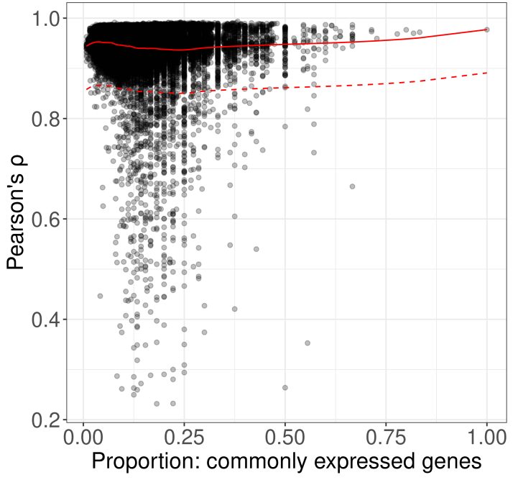
Supplemental Figure 1. Scatter plot of pairwise Pearson’s correlation (ρ) against the proportion of commonly expressed genes in the respective cell pairs in LEN for PBMC 8k.
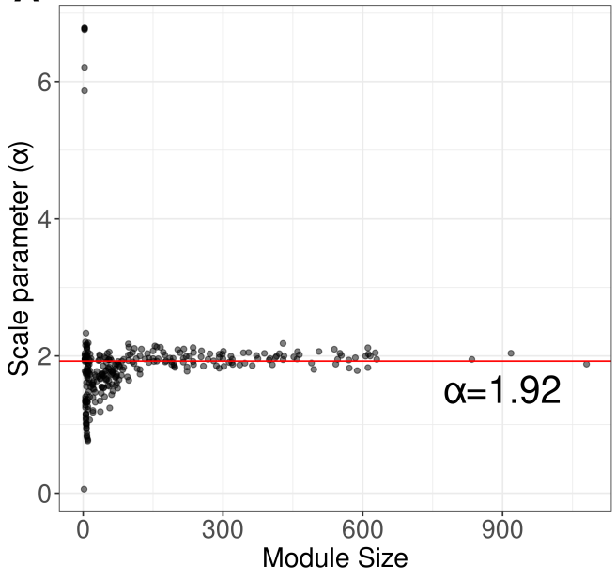
Supplemental Figure 2. Scatter plot to calculate the compactness scaling parameter (α) for PBMC 8k data set. X-axis: Module sizes randomly sampled from selecting random nodes and traversing two links to identify closely connected nodes. Y-axis: Scaling parameters with $υ\left(α_{o}\right)=1$.

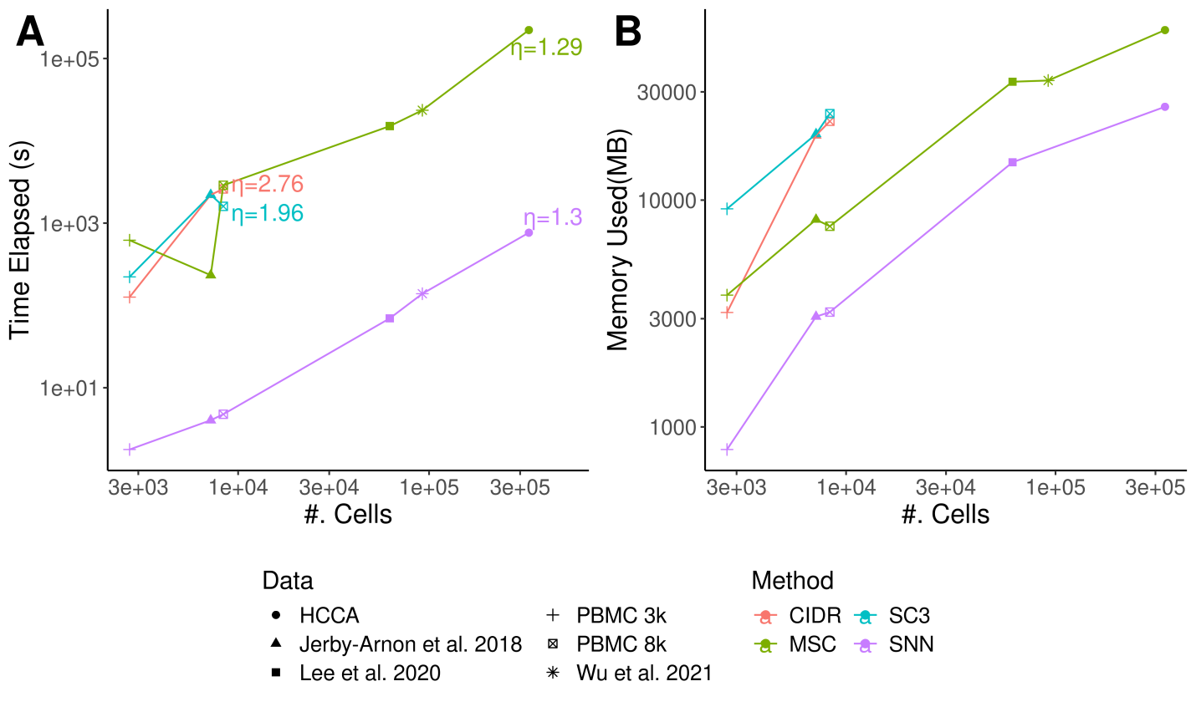
Supplemental Figure 3. Computational complexity analysis for different clustering methods. Different methods are labeled in different colors, and different single-cell data are labeled as different shapes as shown in the bottom legend. A. Plot of runtime for different clustering methods (y-axis) against single-cell transcriptome data sets with varying numbers of cells (x-axis). The axes are in log10 scales. The scaling exponents (η) for the runtimes at different numbers of cells are labeled for each method. B. Plot of memory (y-axis) against single-cell transcriptome data sets with varying numbers of cells (x-axis).

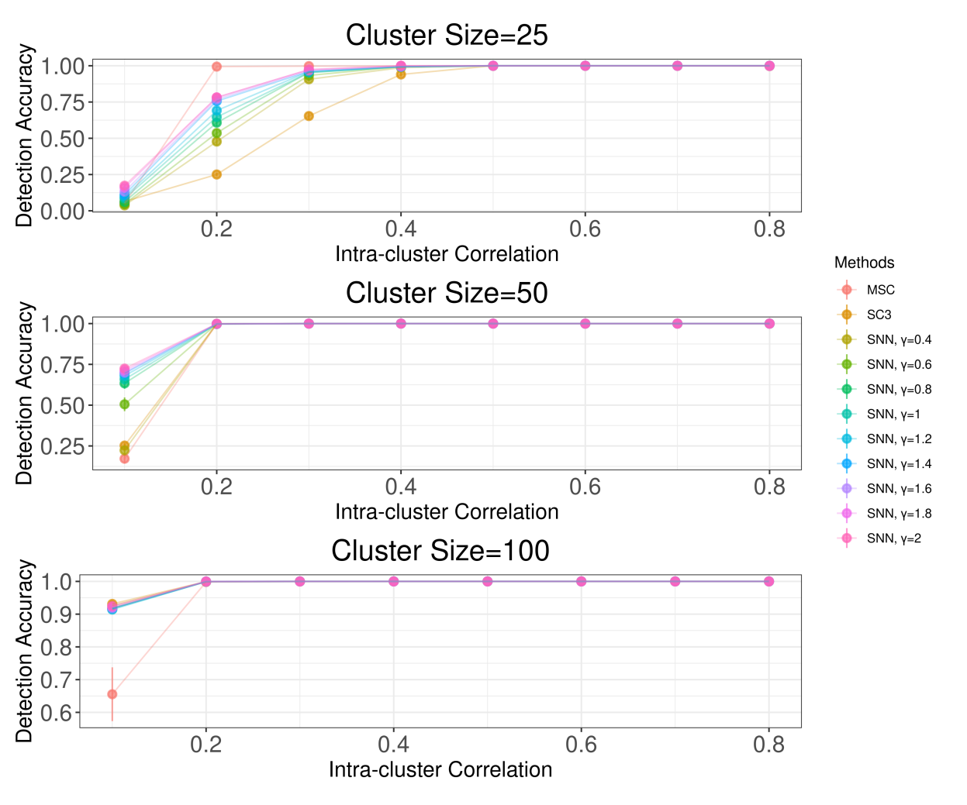
Supplemental Figure 4. Detection rates of individual ground-truth clusters, stratified by sizes.
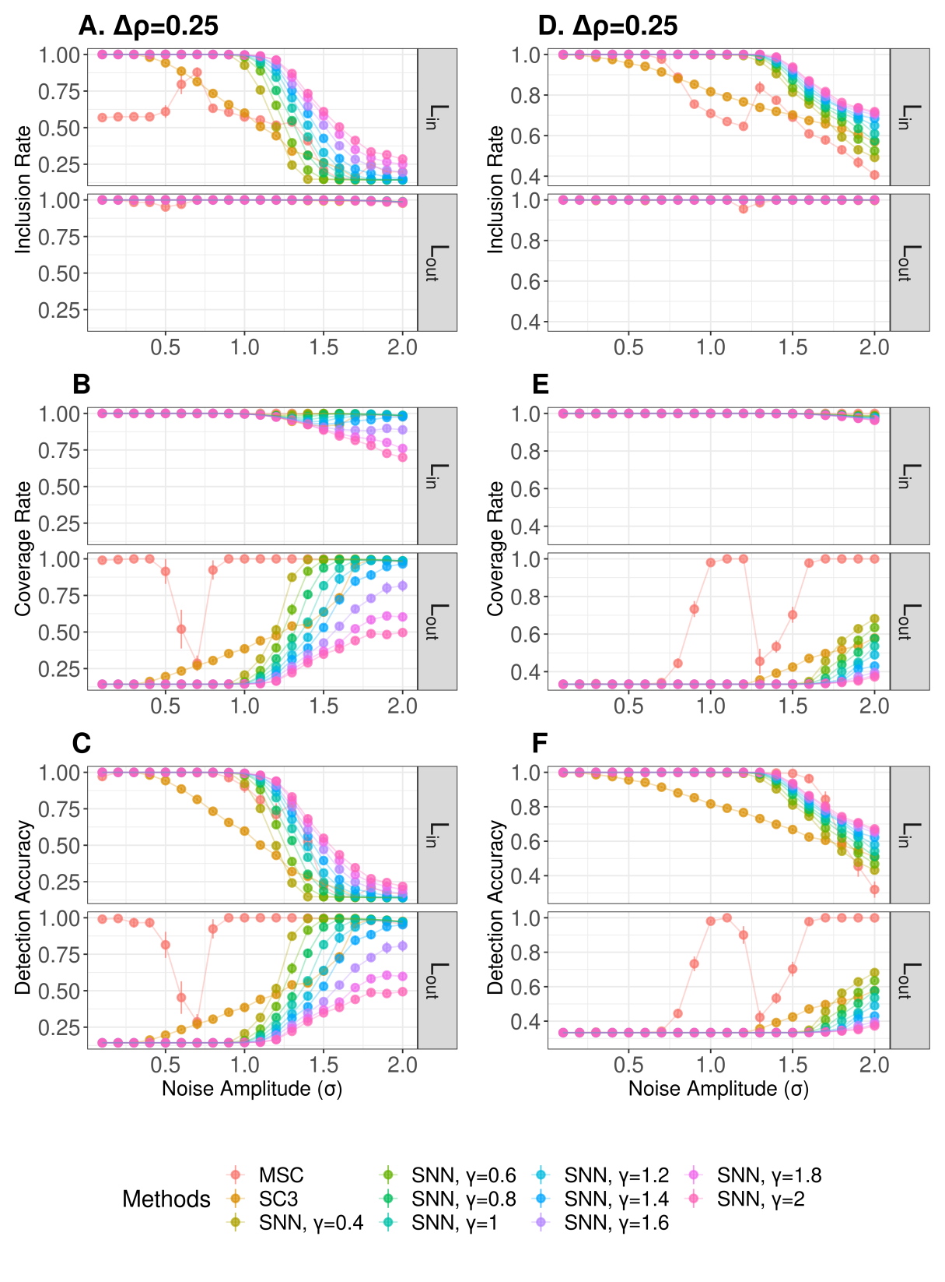
Supplemental Figure 5. Detection of clusters with two-layer hierarchy (layers labeled as L1 and L2), separating different layers by ∆ρ=0.25. For the simulated cluster hierarchy with regular clusters, the inclusion rate (A), coverage rate (B) and accuracy rate (C) are shown in A-C. For the simulated cluster hierarchy with irregular clusters, the inclusion rate (D), coverage rate (E) and accuracy rate (F) are shown in D-F.
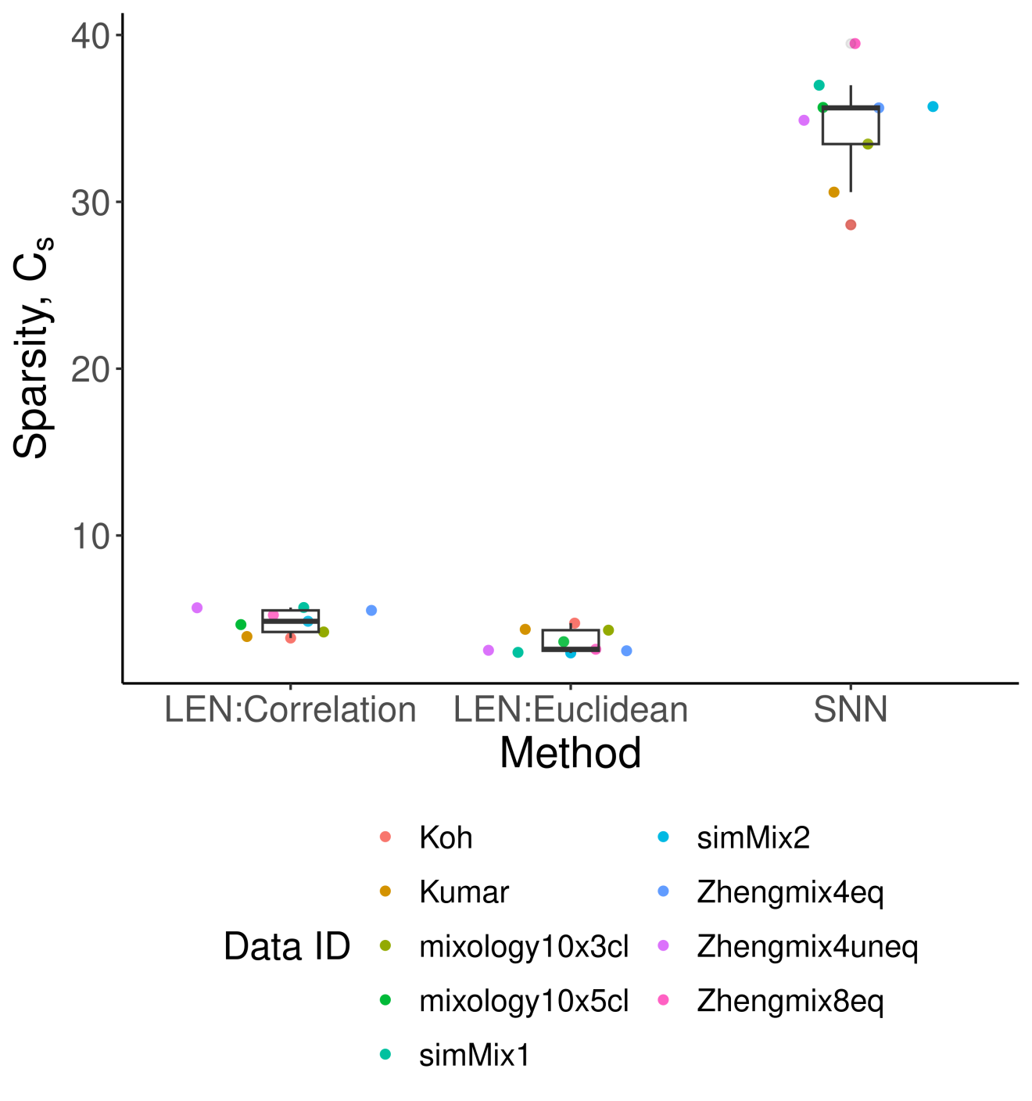
Supplemental Figure 6. Sparsity of LENs and SNNs for different gold standard scRNA-seq data sets. Sparsities (C_{s}) of LENs constructed from Pearson’s correlations (LEN:Correlation), Euclidean distance (LEN:Euclidean) and SNNs are shown.
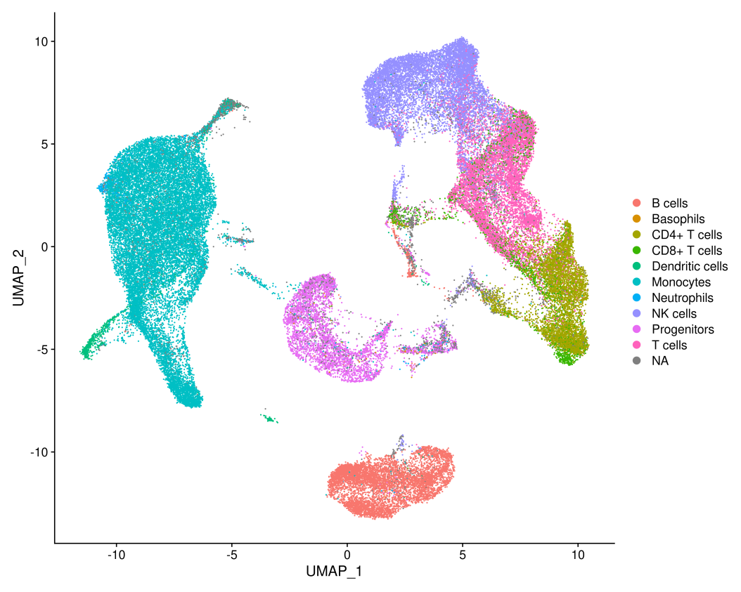
Supplemental Figure 7. Inferred cell types of Lee data set by SingleR with the Monaco collection as the reference set.
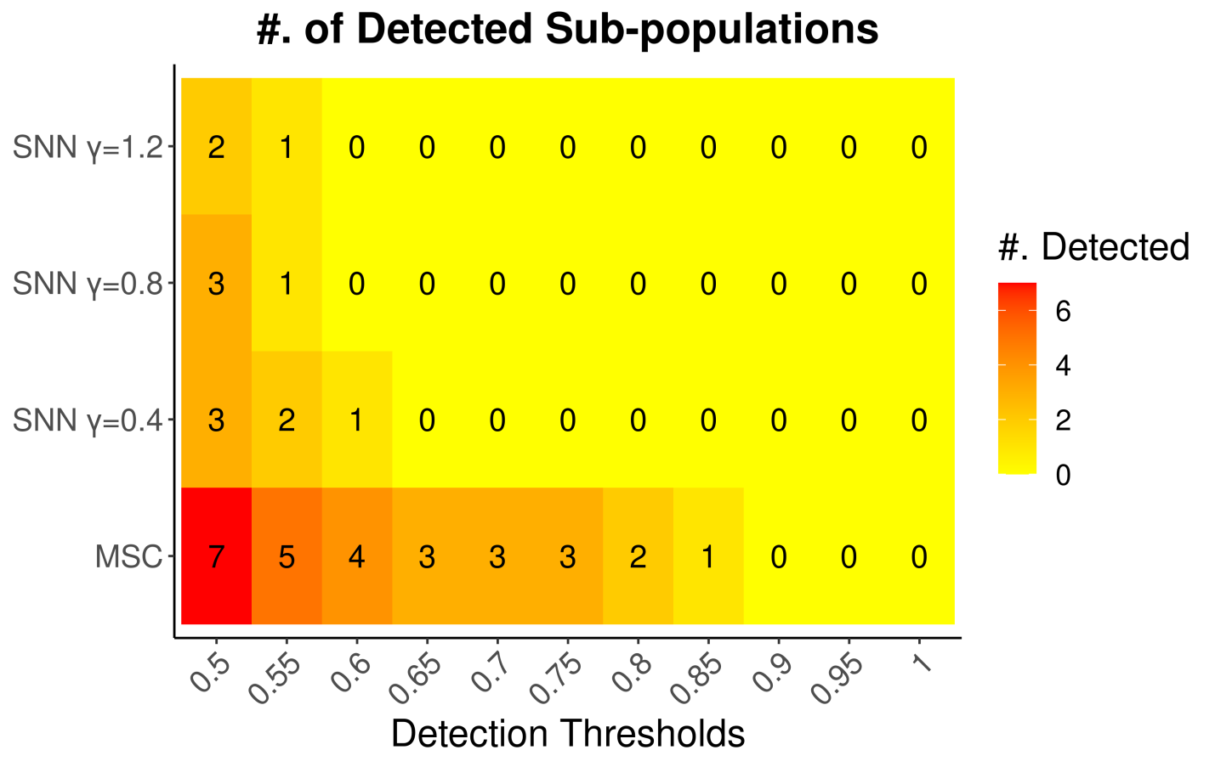
Supplemental Figure 8. Number of detected immune subsets by different methods (y-axis) and detection accuracy threaholds (x-axis) for Lee data set.

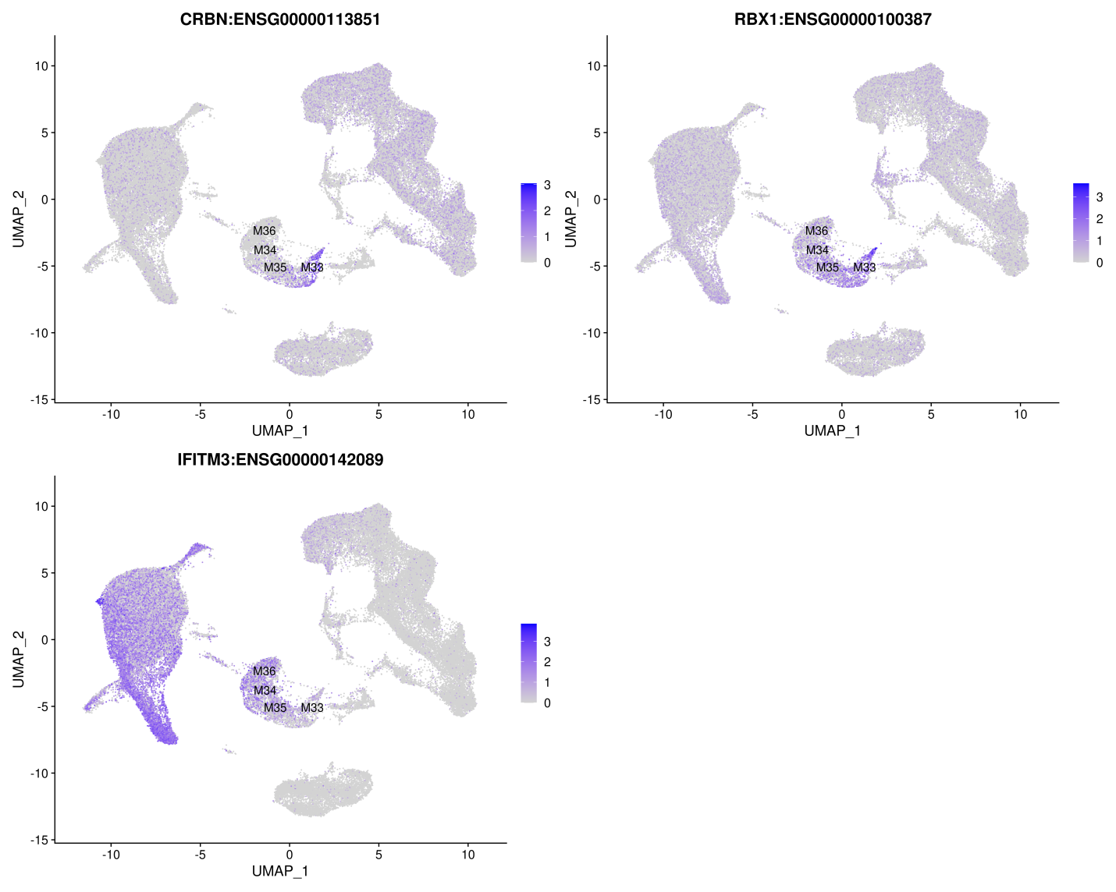
Supplemental Figure 9. UMAP plots showing marker expressions for platelet subpopulations identified by MSC. Respective gene names are shown on top of each panel, and the child clusters of the major platelet cluster M16 in Figure 5A are marked.
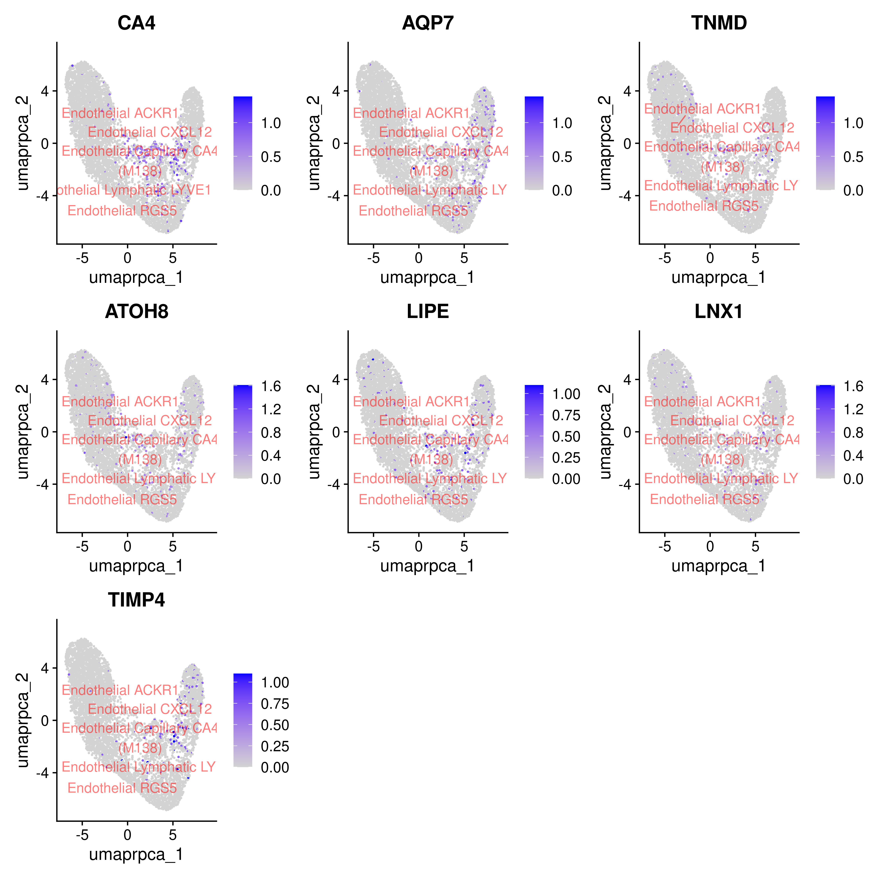
Supplemental Figure 10. UMAP plots to show M138-specific marker expressions in endothelial cells.
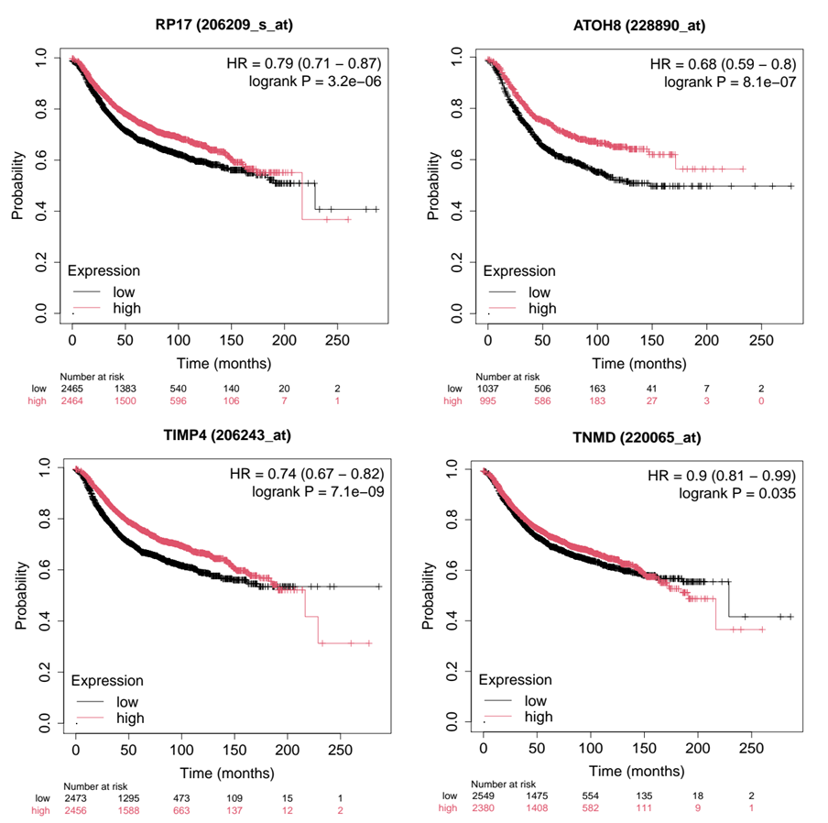
Supplemental Figure 11. Kaplan-Meier plots to show prognostic significance of stratifying breast cancer patients by median expressions of M138-specific markers in predicting relapse-free survival across bulk transcriptome of 7,830 samples from 55 independent studies(5). Four markers (CA4 (also known as RP17), ATOH8, TIMP4 and TNMD) out of the 6 tested genes with significant stratification by logrank p-value < 0.05 are shown.

SUPPLEMENTARY DATA
Supplementary Data 1. A. Meta data for individual cells from PBMC 8k data set. It includes inferred cell types in column, “inferred.cell.type.broad”, for major cell types from PBMC, and more specific subtypes in “inferred.cell.type.fine”. B. Multi-scale clusters identified MSC in .GMT format. C. Table of MSC identified clusters. For each cluster in each row, it specifies its parent cluster, cluster compactness and size.
Supplementary Data 2. Meta data for individual cells from Lee et al. 2020 data set. It includes inferred cell types in column, “inferred.cell.type.broad”, for major cell types from PBMC, and more specific subtypes in “inferred.cell.type.fine”. B. Multi-scale clusters identified MSC in .GMT format. C. Table of MSC identified clusters. For each cluster in each row, it specifies its parent cluster, cluster compactness and size.
Supplementary Data 3. A. Meta data for single-cell transcriptome of breast cancers from Wu et al. 2021. B. Clustering results from SNN-based Louvain clustering at γ=0.4, 0.8 and 1.2. C. Multi-scale clusters identified MSC in .GMT format. D. Table of MSC identified clusters. For each cluster in each row, it specifies its parent cluster, cluster compactness and size. E. Jaccard index between MSC clusters and best mapped cell types, minor cell types and subsets by supervised subclustering in Wu et al. 2021. F. Jaccard index between MSC clusters and best mapped SNN-based Louvain clusters at different resolutions. G. Differential expression statistics of M138-specific markers. Only includes list of significant markers genes (FDR < 0.05, fold change > 1) for M138 within endothelial cells. H. Clinical meta data for TCGA breast cancer cohort. Last columns include ssGSEA scores within each subtype and all primary tumor samples. I. Clinical meta data for METABRIC breast cancer cohort. . Last columns include ssGSEA scores within each subtype and all primary tumor samples.
REFERENCES
1. Jerby-Arnon L, Shah P, Cuoco MS, Rodman C, Su MJ, Melms JC, Leeson R, Kanodia A, Mei S, Lin JR, Wang S, Rabasha B, Liu D, Zhang G, Margolais C, Ashenberg O, Ott PA, Buchbinder EI, Haq R, Hodi FS, Boland GM, Sullivan RJ, Frederick DT, Miao B, Moll T, Flaherty KT, Herlyn M, Jenkins RW, Thummalapalli R, Kowalczyk MS, Canadas I, Schilling B, Cartwright ANR, Luoma AM, Malu S, Hwu P, Bernatchez C, Forget MA, Barbie DA, Shalek AK, Tirosh I, Sorger PK, Wucherpfennig K, Van Allen EM, Schadendorf D, Johnson BE, Rotem A, Rozenblatt-Rosen O, Garraway LA, Yoon CH, Izar B, Regev A. A Cancer Cell Program Promotes T Cell Exclusion and Resistance to Checkpoint Blockade. Cell. 2018;175(4):984-97 e24. Epub 2018/11/06. doi: 10.1016/j.cell.2018.09.006. PubMed PMID: 30388455; PMCID: PMC6410377.
2. Lee JS, Park S, Jeong HW, Ahn JY, Choi SJ, Lee H, Choi B, Nam SK, Sa M, Kwon JS, Jeong SJ, Lee HK, Park SH, Park SH, Choi JY, Kim SH, Jung I, Shin EC. Immunophenotyping of COVID-19 and influenza highlights the role of type I interferons in development of severe COVID-19. Sci Immunol. 2020;5(49). Epub 2020/07/12. doi: 10.1126/sciimmunol.abd1554. PubMed PMID: 32651212; PMCID: PMC7402635.
3. Wu SZ, Al-Eryani G, Roden DL, Junankar S, Harvey K, Andersson A, Thennavan A, Wang C, Torpy JR, Bartonicek N, Wang T, Larsson L, Kaczorowski D, Weisenfeld NI, Uytingco CR, Chew JG, Bent ZW, Chan CL, Gnanasambandapillai V, Dutertre CA, Gluch L, Hui MN, Beith J, Parker A, Robbins E, Segara D, Cooper C, Mak C, Chan B, Warrier S, Ginhoux F, Millar E, Powell JE, Williams SR, Liu XS, O'Toole S, Lim E, Lundeberg J, Perou CM, Swarbrick A. A single-cell and spatially resolved atlas of human breast cancers. Nat Genet. 2021;53(9):1334-47. Epub 2021/09/09. doi: 10.1038/s41588-021-00911-1. PubMed PMID: 34493872.
4. Pelka K, Hofree M, Chen JH, Sarkizova S, Pirl JD, Jorgji V, Bejnood A, Dionne D, Ge WH, Xu KH, Chao SX, Zollinger DR, Lieb DJ, Reeves JW, Fuhrman CA, Hoang ML, Delorey T, Nguyen LT, Waldman J, Klapholz M, Wakiro I, Cohen O, Albers J, Smillie CS, Cuoco MS, Wu J, Su MJ, Yeung J, Vijaykumar B, Magnuson AM, Asinovski N, Moll T, Goder-Reiser MN, Applebaum AS, Brais LK, DelloStritto LK, Denning SL, Phillips ST, Hill EK, Meehan JK, Frederick DT, Sharova T, Kanodia A, Todres EZ, Jane-Valbuena J, Biton M, Izar B, Lambden CD, Clancy TE, Bleday R, Melnitchouk N, Irani J, Kunitake H, Berger DL, Srivastava A, Hornick JL, Ogino S, Rotem A, Vigneau S, Johnson BE, Corcoran RB, Sharpe AH, Kuchroo VK, Ng K, Giannakis M, Nieman LT, Boland GM, Aguirre AJ, Anderson AC, Rozenblatt-Rosen O, Regev A, Hacohen N. Spatially organized multicellular immune hubs in human colorectal cancer. Cell. 2021;184(18):4734-52 e20. Epub 2021/08/28. doi: 10.1016/j.cell.2021.08.003. PubMed PMID: 34450029; PMCID: PMC8772395.
5. Gyorffy B. Survival analysis across the entire transcriptome identifies biomarkers with the highest prognostic power in breast cancer. Comput Struct Biotechnol J. 2021;19:4101-9. Epub 2021/09/17. doi: 10.1016/j.csbj.2021.07.014. PubMed PMID: 34527184; PMCID: PMC8339292.

